Traveler Title | Cold Mass Assembly Traveler
Traveler Abstract | This traveler details the steps required to complete the cavity string assembly outside of the cleanroom, including the welding of the couple process tubing, installation of inner magnetic shield and installation of MLI. This subassembly makes up the cold mass inside of the SNS PPU high beta cryomodule.
Traveler ID | SNSPPU-CM-ASSY-CMA
Traveler Revision | R1
Traveler Author | M. Wiseman
Traveler Date | 18-Feb-20
NCR Informative Emails
NCR Dispositioners
D3 Emails
Approval Names | M. Wiseman | G. Cheng | E. Daly | J.Fischer
Approval Signatures
Approval Dates
Approval Title | Author | Reviewer | Project Manager

References | List and Hyperlink all documents related to this traveler. This includes, but is not limited to: safety (THAs, SOPs, etc), drawings, procedures, and facility related documents.
Cavity String - Cold Mass Assembly  104211500-M8U-8200-A002 | 2K Thermal MLI Insulation Subassembly  104211300-M8U-8200-A009 | Inner Magnetic Shield Assembly  104211200-M8U-8200-A001 rA | Tuner Assembly  104211400-M8U-8200-A001 | Cavity String - Clean Room Assembly  104211500-M8U-8200-A001
SNS Cryomodule  Assembly/Alignment??? (T. Whitlatch???) | 11141-S-0029 Rev. B UHV Leak Check

Revision Note
R1 | Initial release of this Traveler.

Step No. | Instructions | Data Input
0 | Cold Mass Cavity String Assembly | [[CMASSSN]] <<CMASSSN>>
1 | Identify the serial number of the cavity string assembly (HXX) and enter in data input box | [[CSTSN]] <<CSTSN>>  [[CSTTech]] <<SRF>>  [[CSTDate]] <<TIMESTAMP>>  [[CSTComments]] <<COMMENT>>

Step No | Instructions | Data Inputs
2 | Move cavity string assembly from clean room to CM assembly bench using transfer bench.  Procedure:  - Mate up cavity string bench and CM transfer bench.  - Tie benches together.  - Install lockdowns onto transfer bench.  - Record vacuum pressure, close the beamline valve, isolating the ion pump, and then turn off ion pump.  - Ensure links and lockdowns installed BEFORE moving cavity string (lollipops tight, lockdowns tight, benches tied together tight).  - Move cavity string from clean room onto transfer bench.  - Install additional lockdowns.  - Move transfer bench to CM assembly area.  - Mate the benches and tie together.  - Transfer cavity string onto assembly rails.  - Align coupler #1 over target and lockdown string.  - Install additional lockdowns.  - Re-establish cavity vacuum by turning on the ion pump, once vacuum is established, open the beamline valve.  Record vacuum pressure level. | [[VacLevelBeforeMove]] <<TEXT>>  [[BeforeTech]] <<SRF>>  [[BeforeDate]] <<TIMESTAMP>>  [[BeforeComment]] <<COMMENT>>
[[MoveTech]] <<SRF>>
[[MoveDate]] <<TIMESTAMP>>
[[MoveComment]] <<COMMENT>>
[[VacLevelAfterMove]] <<TEXT>>
[[AfterTech]] <<SRF>>
[[AfterDate]] <<TIMESTAMP>>
[[AfterComment]] <<COMMENT>>

Step No | Instructions | Data Inputs
3 | Record caviy serial numbers:  North (Return End Can) 1 – 2 – 3 – 4 South (Supply End Can) | [[CAVSN1]] <<CAVSN>>  [[CAVSN2]] <<CAVSN>>  [[CAVSN3]] <<CAVSN>>  [[CAVSN4]] <<CAVSN>>  [[CavTech]] <<SRF>>  [[CavDate]] <<TIMESTAMP>>
4 | Record Beamline Flange Diameters:  North End Return 2 – 3 – 4 – 5 – 6 – 7 – 8 – 9 South End Supply  ~4.889” | [[Flange2]] <<FLOAT>>  [[Flange3]] <<FLOAT>>  [[Flange4]] <<FLOAT>>  [[Flange5]] <<FLOAT>>  [[Flange6]] <<FLOAT>>  [[Flange7]] <<FLOAT>>  [[Flange8]] <<FLOAT>>  [[Flange9]] <<FLOAT>>  [[FlangeTech]] <<SRF>>  [[FlangeDate]] <<TIMESTAMP>>
5 | Install coupler tophat instrumentation (heaters, Cu plates, thermocouples, snap switches) | [[TPHTSN]] <<TPHTSN>>  [[TPHTTech]] <<SRF>>  [[TPHTDate]] <<TIMESTAMP>>  [[TPHTComment]] <<COMMENT>>

Step No | Instructions | Data Inputs
6 | Install MLI Blankets on helium vessel ends and under tuner mounting area. | [[HVMLITech]] <<SRF>>  [[HVMLIDate]] <<TIMESTAMP>>
7 | Install 2K circuit – weld 3” helium return line bellows, 3” supply and return headers, crossover flex lines, and ¾” end caps.  Procedure:  - Pull wires through wire loop inside He vessel heads.  - Install bellows/pull heater through separate feedthru ports in double tophat bridging areas.  - Pull liquid level wires through the 3” return header.  - Install G10 standoffs to protect wires during welding.  - Weld all components using appropriate procedure and Cu cooling block.  - Verify header to header length of cavity string as per to drawing number 104211500-M8U-8200-A002 = 227.4” (Actual maybe 0.09” long due to lollipop tooling)  - Verify gate valve to gate valve length = 220.18” | [[Welder2KC]] <<SRF>>  [[Weld2KCDate]] <<TIMESTAMP>>  [[Weld2KCComment]] <<COMMENT>>
8 | Wire and install cryogenic feedthrus as per 104212000-M8U-8200-A001 rA. | [[InstFTTech]] <<SRF>>  [[InstFTDate]] <<TIMESTAMP>>
9 | Cold shock all weld-joints, explosion joints and feedthrus. | [[ColdShockTech]] <<SRF>>  [[ColdShockDate]] <<TIMESTAMP>>  [[ColdShockComment]] <<COMMENT>>

Step No | Instructions | Data Inputs
10 | Install tuner frames, heat stationing straps with indium, and motor housings. Do not install harmonic assy at this time.  104211400-M8U-8200-A001  Note: Leave tuner frames loose for frequency setting. | [[TUNSN1]] <<TUNSN>>  [[TUNSN2]] <<TUNSN>>  [[TUNSN3]] <<TUNSN>>  [[TUNSN4]] <<TUNSN>>  [[PIEZOSN1]] <<PIEZOSN>>  [[PIEZOSN2]] <<PIEZOSN>>  [[PIEZOSN3]] <<PIEZOSN>>  [[PIEZOSN4]] <<PIEZOSN>>  [[TunTech1]] <<SRF>>  [[TuneDate1]] <<TIMESTAMP>>  [[TunComment1]] <<COMMENT>>
11 | Measure cavity frequencies (passband) and record.  Acceptable range: 803.950 to 804.060 MHz  **NOTE: When naming the files, use letters and numbers only, no symbols, no spaces. In place of a space, you may use a dash or underscore.**  Note: Cavities are under vacuum and helium vessels are at atmosphere. | [[FreqTech]] <<SRF>>  [[FreqDate]] <<TIMESTAMP>>  [[FreqFile]] <<FILEUPLOAD>>  [[FreqComment]] <<COMMENT>>
12 | Set tuner hard stops on helium vessel head to 803.9 +/- 0.05 MHz using network analyzer. | [[TunStpTech]] <<SRF>>  [[TunStpDate]] <<TIMESTAMP>>

Step No | Instructions |  | Data Inputs
13 | Install and set the limit switches, switches to open one revolution from either hard stop. Leave the high frequency switch on. |  | [[SwtchTech]] <<SRF>>  [[SwtchDate]] <<TIMESTAMP>>
14 | Record and install the harmonic drives, stepper motors, and motor Mu metal covers on cavities 1 and 4; on cavities 2 and 3 only install the harmonic drive cup and retainer ring.  Note: Wave generators to be set 5/8” from the adapter plate to the outer face on the generator. |  | [[HMDRSN1]] <<HMDRSN>>  [[HMDRSN2]] <<HMDRSN>>  [[HMDRSN3]] <<HMDRSN>>  [[HMDRSN4]] <<HMDRSN>>  [[SMSN1]] <<SMSN>>  [[SMSN2]] <<SMSN>>  [[SMSN3]] <<SMSN>>  [[SMSN4]] <<SMSN>>  [[TunTech2]] <<SRF>>  [[TuneDate2]] <<TIMESTAMP>>  [[TunComment2]] <<COMMENT>>
15 | Leak check 2K circuit.  Bag all joints to be leak checked.  **NOTE: When naming the file, use letters and numbers only, no symbols, no spaces. In place of a space, you may use a dash or underscore.** |  | [[LkChk2KCTech]] <<SRF>>  [[LkChk2KCDate]] <<TIMESTAMP>>  [[LkChk2KCFile]] <<FILEUPLOAD>>  [[LkChk2KCComment]] <<COMMENT>>
16 | Install 24 CERNOX diodes (Lakeshore) onto helium vessels, beampipe flanges, coupler flanges and coupler outer conductor bodies as per schematic. Record serial numbers by location as installed (attach document). Diodes shall be securely attached with indium foil and screw. Heat-station all wires to the same surface the diode is mounted on, and route remaining wire to hole in the primary magnetic shielding. |  | [[DiodeTech]] <<SRF>>  [[DiodeDate]] <<TIMESTAMP>>  [[DiodeComment]] <<COMMMENT>>
 | [[DCXCUSN1]] <<DCXCUSN>> | [[DCXCUSN2]] <<DCXCUSN>> |  | [[DCXCUSN3]] <<DCXCUSN>>
 | [[DCXCUSN4]] <<DCXCUSN>> | [[DCXCUSN5]] <<DCXCUSN>> |  | [[DCXCUSN6]] <<DCXCUSN>>
 | [[DCXCUSN7]] <<DCXCUSN>> | [[DCXCUSN8]] <<DCXCUSN>> |  | [[DCXCUSN9]] <<DCXCUSN>>
 | [[DCXCUSN10]] <<DCXCUSN>> | [[DCXCUSN11]] <<DCXCUSN>> |  | [[DCXCUSN12]] <<DCXCUSN>>
 | [[DCXCUSN13]] <<DCXCUSN>> | [[DCXCUSN14]] <<DCXCUSN>> |  | [[DCXCUSN15]] <<DCXCUSN>>
 | [[DCXCUSN16]] <<DCXCUSN>> | [[DCXCUSN17]] <<DCXCUSN>> |  | [[DCXCUSN18]] <<DCXCUSN>>
 | [[DCXCUSN19]] <<DCXCUSN>> | [[DCXCUSN20]] <<DCXCUSN>> |  | [[DCXCUSN21]] <<DCXCUSN>>
 | [[DCXCUSN22]] <<DCXCUSN>> | [[DCXCUSN23]] <<DCXCUSN>> |  | [[DCXCUSN24]] <<DCXCUSN>>

Step No | Instructions | Data Inputs
17 | Fabricate and place MLI over rod supports, bellows, and cones.  NOTE: Leave access for alignment arms. | [[SpprtsMLITech]] <<SRF>>  [[SpprtsMLIDate]] <<TIMESTAMP>>
18 | Apply MLI to crossovers, FPC bodies, beamline bellows and 3” helium return bellows (15 layers).  All 2K areas should now be covered. | [[BLMLITech]] <<SRF>>  [[BLMLIDate]] <<TIMESTAMP>>
19 | Install primary magnetic shielding onto the helium vessels, ensure a tight fit. Cut out to be 2” x 8”, tape cutouts back in place. Install reducing rings first, keeping them straight and square. Tape in place using Mylar tape. Test fit nitronic rods, but do not install them at this time.  104211200-M8U-8200-A001 rA  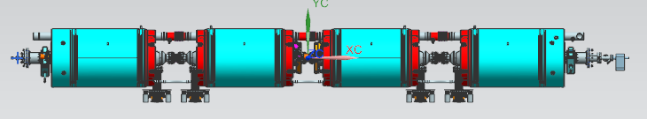 | [[IMAGSN]] <<IMAGSN>>  [[IMAGTech]] <<SRF>>  [[IMAGDate]] <<TIMESTAMP>>  [[IMAGComment]] <<COMMENT>>
20 | Install, label and weld ¼” coupler cooling lines with G10 supports to helium vessel. Form exhaust lines to ensure the bridging areas are clearly accessible after thermal shield and space frame are installed. | [[WelderCplr]] <<SRF>>  [[WeldCplrDate]] <<TIMESTAMP>>  [[WeldCplrComment]] <<COMMENT>>

Step No | Instructions | Data Inputs
21 | Leak check ¼” coupler lines – five circuits.  **NOTE: When naming the file, use letters and numbers only, no symbols, no spaces. In place of a space, you may use a dash or underscore.** | [[LkChkCplrTech]] <<SRF>>  [[LkChkCplrDate]] <<TIMESTAMP>>  [[LkChkCplrC1File]] <<FILEUPLOAD>>  [[LkChkCplrC2File]] <<FILEUPLOAD>>  [[LkChkCplrC3File]] <<FILEUPLOAD>>  [[LkChkCplrC4File]] <<FILEUPLOAD>>  [[LkChkCplrC5File]] <<FILEUPLOAD>>  [[LkChkCplrComment]] <<COMMENT>>
22 | Weld the four coupler bellows to the FPC flanges.  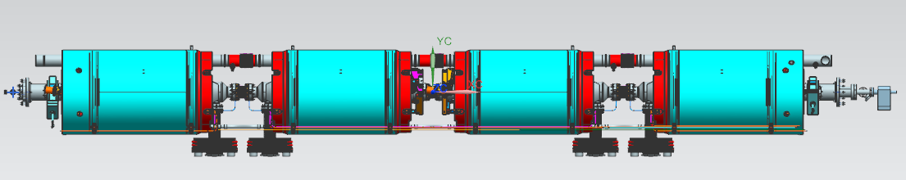 | [[WelderFPC]] <<SRF>>  [[WeldFPCDate]] <<TIMESTAMP>>  [[WeldFPCComment]] <<COMMENT>>

Step No | Instructions | Data Inputs
23 | Leak check the four coupler bellows and record.  **NOTE: When naming the file, use letters and numbers only, no symbols, no spaces. In place of a space, you may use a dash or underscore.** | [[LkChkCplrBLTech]] <<SRF>>  [[LkChkCplrBLDate]] <<TIMESTAMP>>  [[LkChkCplrBLCav1File]] <<FILEUPLOAD>>  [[LkChkCplrBLCav2File]] <<FILEUPLOAD>>  [[LkChkCplrBLCav3File]] <<FILEUPLOAD>>  [[LkChkCplrBLCav4File]] <<FILEUPLOAD>>  [[LkChkCplrBLComment]] <<COMMENT>>
24 | Install two ¾” IPS heat exchange lines onto helium vessels using G-10 supports. Position them axially as per 104211500-M8U-8200-A002  Note: Ensure clamps allow movement axially for alignment. After alignment the pipes should be anchored in one location, tuner side of cavity 3.  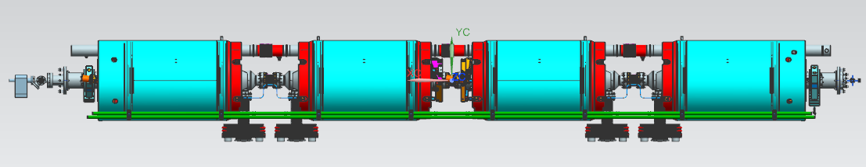 | [[IPSTech]] <<SRF>>  [[IPSDate]] <<TIMESTAMP>>
25 | Install Field probe flex cables. Be sure to maintain clearance between the tuner frame and Cu strap. | [[FPTech]] <<SRF>>  [[FPDate]] <<TIMESTAMP>>  [[FPComment]] <<COMMENT>>
26 | Perform TDR and record findings. | [[TDRTech]] <<SRF>>  [[TDRDate]] <<TIMESTAMP>>  [[TDRFile]] <<FILEUPLOAD>>

Step No | Instructions | Data Inputs
27 | Install remaining inner magnetic shielding, 104211200-M8U-8200-A001 rA  Route the field probe cables and instrumentation wires out through holes in magnetic shield as required. Protect the wires from sharp edges.  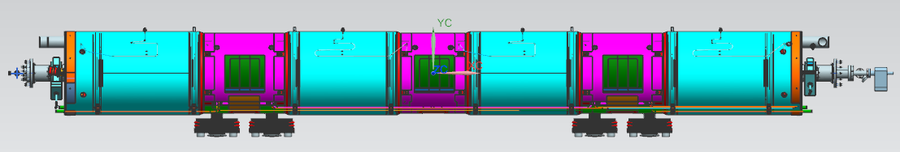 | [[MagTech]] <<SRF>>  [[MagDate]] <<TIMESTAMP>>  [[MagComment]] <<COMMENT>>
28 | Install 2K MLI over cavity string assembly.  104211300-M8U-8200-A009 | [[MLI2KTech]] <<SRF>>  [[MLI2KDate]] <<TIMESTAMP>>  [[MLI2KComment]] <<COMMENT>>
29 | Confirm SNS cold mass assembly is complete and acceptable for the next step of assembly. Assembly completed as per 104211500-M8U-8200-A002. Record assembly drawing number and revision.  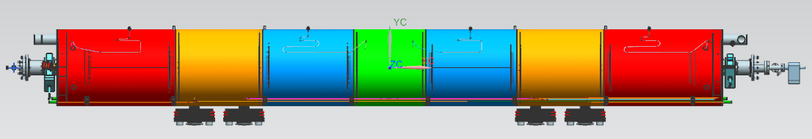 | [[CMassComplTech]] <<SRF>>  [[CMassComplDate]] <<TIMESTAMP>>  [[CMassDrawing]] <<FILEUPLOAD>>  [[CMassComment]] <<COMMENT>>

