C75 High Pressure Rinse Procedure
Document Number: | CP-C75-CAV-CHEM-HPRN | Approval Date: | 19-FEB-2020
Revision Number: | Initial Release | Periodic Review Date: | 01-FEB-2022
Document Owner: | Ashley Mitchell

Purpose and Scope

This procedure describes the steps for preparing a C75 cavity for HPR to setting up a C75 cavity for drying after HPR. HPR is the last interior cleaning process before vertical RF test or cavity string/pair assembly; therefore it has direct impact on the RF performance of the cavity. Great care should be taken during HPR process, to ensure the proper cleaning of the cavity interior without introducing contamination. Always check glove cleanliness visually and by nitrogen blowing when in doubt, especially before removing/attaching covers from/to cavity flanges.

NOTE:
High Pressure Rinsing (HPR) takes place in the Cleanroom. The user MUST follow the necessary protocol to gain entrance into the Cleanroom. Failure to do so will compromise the cleanliness of the work environment.

- This procedure applies to the new SPEC High Pressure Rinse (HPR) tool that was installed and commissioned in June 2015.
- Only properly trained and qualified operators shall operate the HPR tool (upon approval from the Production Chemistry Work-center supervisor or Cavity Production Group leader)
- Personnel access into the processing chamber shall be accomplished via portable stairs or step ladder. Portable stairs/step ladders must be stowed in a location so that it does not interfere with the ceiling mounted emergency fire door.
- The HPR tool shall only be operated when the Ultra-Pure Water (UPW) system is fully operational.
- The HPR wand head is not to be removed by the operator. If the wand head needs to be removed or replaced, contact the SRF Technical Support Group.
- Deviations from this procedure require approval from the Production Chemistry Work center supervisor, Cavity Production Group leader, PI, or SOTR and documentation of the deviance.

References
New HPR Procedure | Original HPR Procedure
Cleanroom Rules and Restrictions | LCLS-II Production Cavity HPR Procedure

Terms and Definitions

- HPR – High Pressure Rinse.
- DI – Deionized water, also referred to as ultra-pure water (UPW).

Process Details

SAFETY:
Individual must keep safety as the first priority in the process; before beginning any job, the user must assure they have the correct PPE for the individual job. Maintaining the level of safety and secure nature of the work area is paramount. Assure personal safety by using caution in movement and taking necessary steps to avoid unnecessary personnel in the immediate area.

BEFORE HPR:
- Don new gloves.
  - Throughout process, check glove cleanliness visually and by nitrogen blowing over the particle counter when in doubt, especially before removing/attaching covers from/to cavity flanges.
- Begin with a clean, degreased cavity.
- Inspect the flanges and sealing surfaces of the cavity, if any questionable marks, scratches, or stains are present; contact your supervisor or the PI/SOTR.
- If the cavity was not already caged, install in a C75 cage.
  - The FPC should be on the “shorter” side of the cage and facing to the left or right of the brackets.
  - The HOMs should be facing away and to the side of the brackets.
  - No flanges should be facing the brackets once caged.
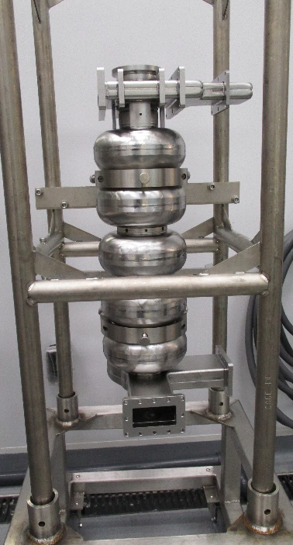 | 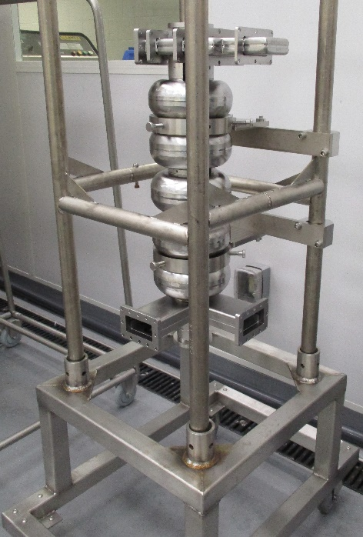
- C75 cavities use the Production Nozzle which is normally installed and ready for use on a regular basis.
  - Consult with PI/SOTR if necessary.
  - If a nozzle change is necessary, contact the SRF Technical Support Group.
- Transfer caged cavity into the HPR cabinet:
  - If cavity was recently HPR’d, check the logbook for cage alignment notes.
  - Open processing chamber doors.
  - Once doors have raised fully and safety latch has engaged, remove the wand shield and set to the side in the cabinet.
  - Verify that the wand has fully retracted into the protective cone.
    - Do not attempt to load the processing cabinet unless the wand is fully retracted and in the “load” position.
  - Attach the BackTech (with the longer adapter) to the cage/cavity tooling, secure the cage, and lift the cavity.
  - Insert cavity into HPR processing chamber. Manipulate BackTech lift cart to align and insert cavity cage legs into the turntable sockets.
  - C75 cavities are normally rinsed with the FPC in the top right position.
  - Disconnect Back-Tech lift cart from cage/cavity tooling. Return the BackTech to the storage area.
  - Firmly press down on cage/cavity tooling to verify that all four legs are fully seated into the turntable sockets.
- Align cavity to HPR wand:
  - Using the remote, manually raise wand to align the lower nozzles just inside the lower cavity flange.
  - Rotate the turntable while watching the distance between the internal surface of the cavity and the wand head.
    - This either is typically done by sight, using the built in camera, or using the retractable mirror.
    - The wand head must be at least ¼” (7 mm) from the internal cavity wall for the entire 360° rotation.
    - Do not allow the wand to contact the cavity at any time.
    - If shims are required, lower the wand and install shims under cage/cavity tooling as needed for alignment. Repeat this step until the lower flange of the cavity is aligned with wand head.
    - Contact the Chemistry work-center supervisor if the cavity cannot be aligned to the above specifications.
  - Record the “bottom” measurement in the log book.
  - Manually raise wand to the upper cavity flange. Use the built-in camera or a mirror to watch the wand as it travels through the cavity.
    - Do not allow the wand to contact the cavity at any time.
  - When the wand head reaches the upper flange, rotate the turntable while watching the distance between the internal surface of the cavity and the wand head.
    - The wand head must be at least ¼” (7 mm) from the internal cavity wall for the entire 360° rotation.
    - Do not allow the wand to contact the cavity at any time.
    - Lower the wand and adjust shims under cage/cavity tooling as needed for alignment. Repeat this step until the cavity is aligned with wand head.
    - Contact the Chemistry Work-center supervisor if the cavity cannot be aligned to the above specifications.
  - Record the “top” measurement. Take wand top position number when the tip is even with top flange surface, round down to the nearest tenth, then subtract 0.1 inch. (e.g. 52.39 52.2).
  - Record shim location(s) if used.
  - Attach a blank to the top flange of the cavity securely. This is a minimum requirement to protect the filters in the top of the HPR cabinet.
    - C75 cavities use a Gore-Tex gasket ring that sits proud seated in a groove of a niobium blank on the top beam line flange only.
      - If the Gore-Tex does not sit high enough to protect the blank from touching the flange, replace the gasket or contact the PI/SOTR/ supervisor.
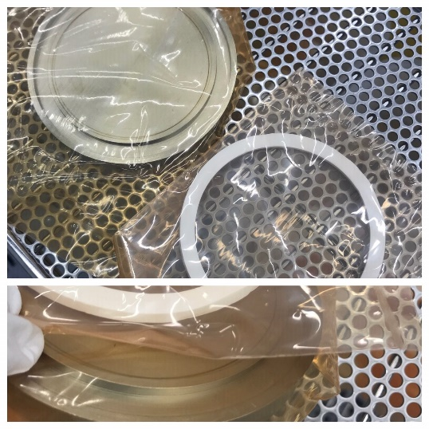 | 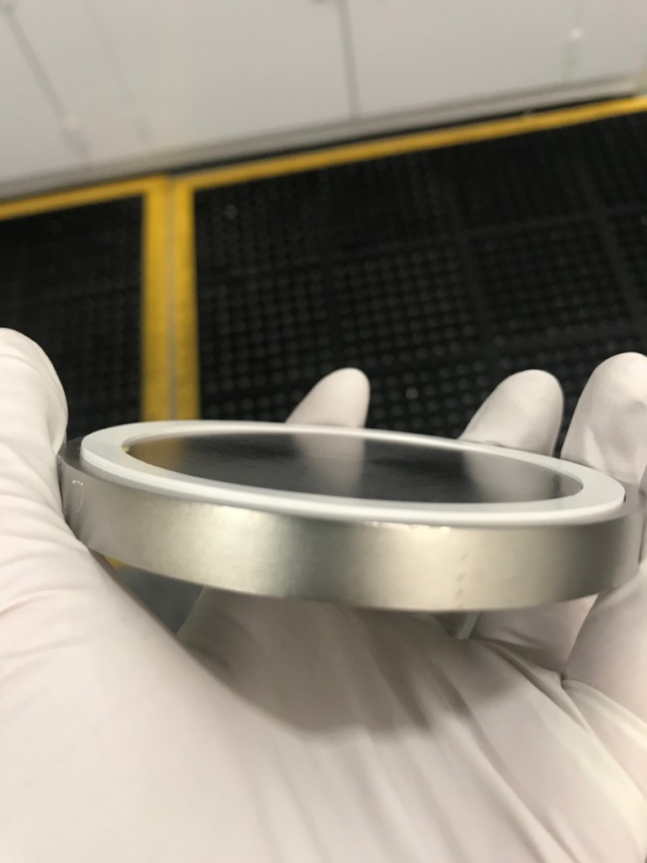
    - Blanks used during the HPR run should not have Gore-Tex where the HPR water can touch it directly (i.e. a Gore-Tex O-ring on a blank is acceptable, but a solid piece over a flange is not).
  - Close processing chamber door.
  - On the HPR software control panel, access the “Motors” screen and return the lift to the “idle” position.

HPR
- Start HPR processing:
  - On the HPR software control panel, put the machine into “Auto” mode.
  - On the Recipe screen, modify the “low limit” and “high limit” values in the appropriate recipe with data recorded previously in 4.1.
  - The lift speed is typically set to 0.4 in/min. Table speed is normally set to 2 rpm.
  - Select the appropriate rinse water temperature.
    - Ambient is typical, but it may be run hot.
    - Note: If using hot water, the cavity may be warm to the touch after the HPR.
  - Ensure you have the correct number of passes listed in the recipe and save the changes.
    - C75 first rinse - 2 passes
    - C75 second rinse - 4 passes
  - Load the modified recipe and verify that all values are correct for the cavity in the processing chamber.
  - Press the “Start” button on the front of the cabinet to begin HPR processing.
  - Verify the wand reaches the programmed “high limit” from recipe.
  - Verify the pump pressure is between 1250 - 1300 psi on the HPR software control panel.
    - Adjust pump pressure “Set point” on the Setup screen if adjustment to the pump speed is necessary.
- Any deviations from the typical parameters require PI/SOTR approval and must be documented in both handwritten and electronic logbooks.
- Record all pertinent HPR data in both handwritten and electronic logbooks:
  - Date
  - Cavity ID
  - Cage Number
  - Technician/Operator Name(s); who put the cavity in and who took it out
  - Top measurement
  - Bottom measurement
  - Start Time
  - DI Plant Resistivity (MOhm)
  - Pump Pressure (PSI)
  - Pump Controller (%)
  - Inlet Resistivity
  - Number of passes
  - Notes on cavity orientation or deviations from the “normal” parameters.

AFTER HPR, REMOVAL FROM HPR TOOL:
- Enter the cleanroom enough ahead of time to prepare clamps and covers for cavity removal.
  - Bring the wide four wheeled cart near the HPR as you will need it after removing the cavity.
- Don new gloves and blow with nitrogen over the particle counter to remove any particles.
  - Throughout process, check glove cleanliness visually and by nitrogen blowing over the particle counter when in doubt, especially before removing/attaching covers from/to cavity flanges. Change gloves if they do not blow down.
- Prepare the blanks to cover any cavity openings.
  - C75 uses Gore-Tex gaskets and mirrored stainless steel blanks.
  - Blow the pre-cleaned blanks, gaskets, and clamps over the particle counter until particle-free.
  - Place them on a new wipe on a cleanroom cart. The cart should be away from the direction of nitrogen spray.
  - The gaskets are placed on top of the mirror side of the corresponding blank with the mirrored / clean side facing up.
  - Gore-Tex gaskets need extra care because they directly face the cavity inner surface.
  - Position cart carefully near HPR cabinet.
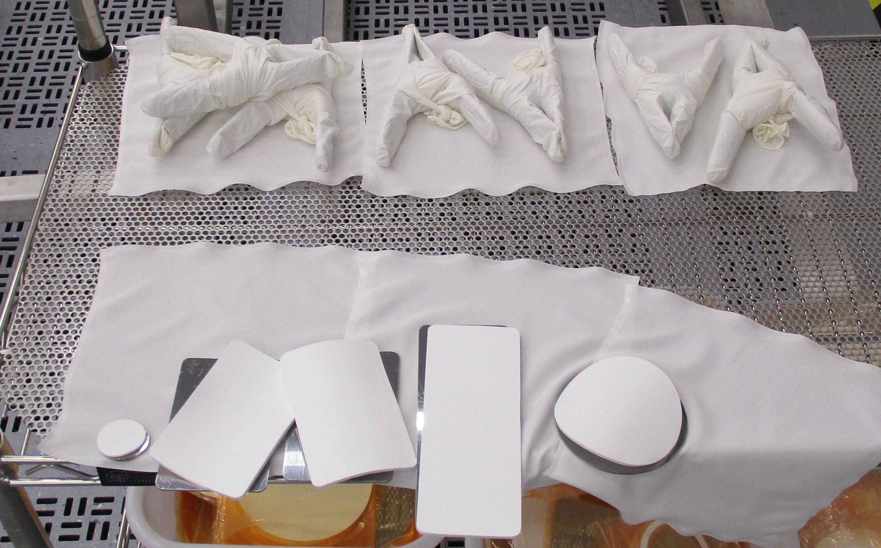
- Once HPR is complete, open the cabinet door.
  - Wait for the safety mechanism at the top of the door to engage before leaning into or entering the cabinet.
- Cover openings on cavity with blanks:
  - Open processing chamber doors. Verify that the wand has fully retracted into the protective cone.
    - Do not attempt to unload the processing cabinet unless the wand is fully retracted and in the “load” position.
  - First Rinse for C75 – work down from the top FPC to the HOMs and Field Probe and finally the bottom Beam Line.
    - Use only ONE clamp to secure the Gore-Tex and blank to the FPC, HOMs, and Field Probe flanges.
    - Use TWO clamps for the beam line flanges.
    - Center the clamp on the FPC and HOM flanges.
      - Position the FPC clamp so that it does not interfere with removal of the beam line blank.
    - It may be necessary to rotate the turntable to access the HOM and Field Probe flanges.
    - Do not replace the blank already installed on the top flange of the cavity unless directed to do so by the PI/SOTR.
    - End with the FPC opening facing towards the front or back of the cabinet (¼ turn from “home”).
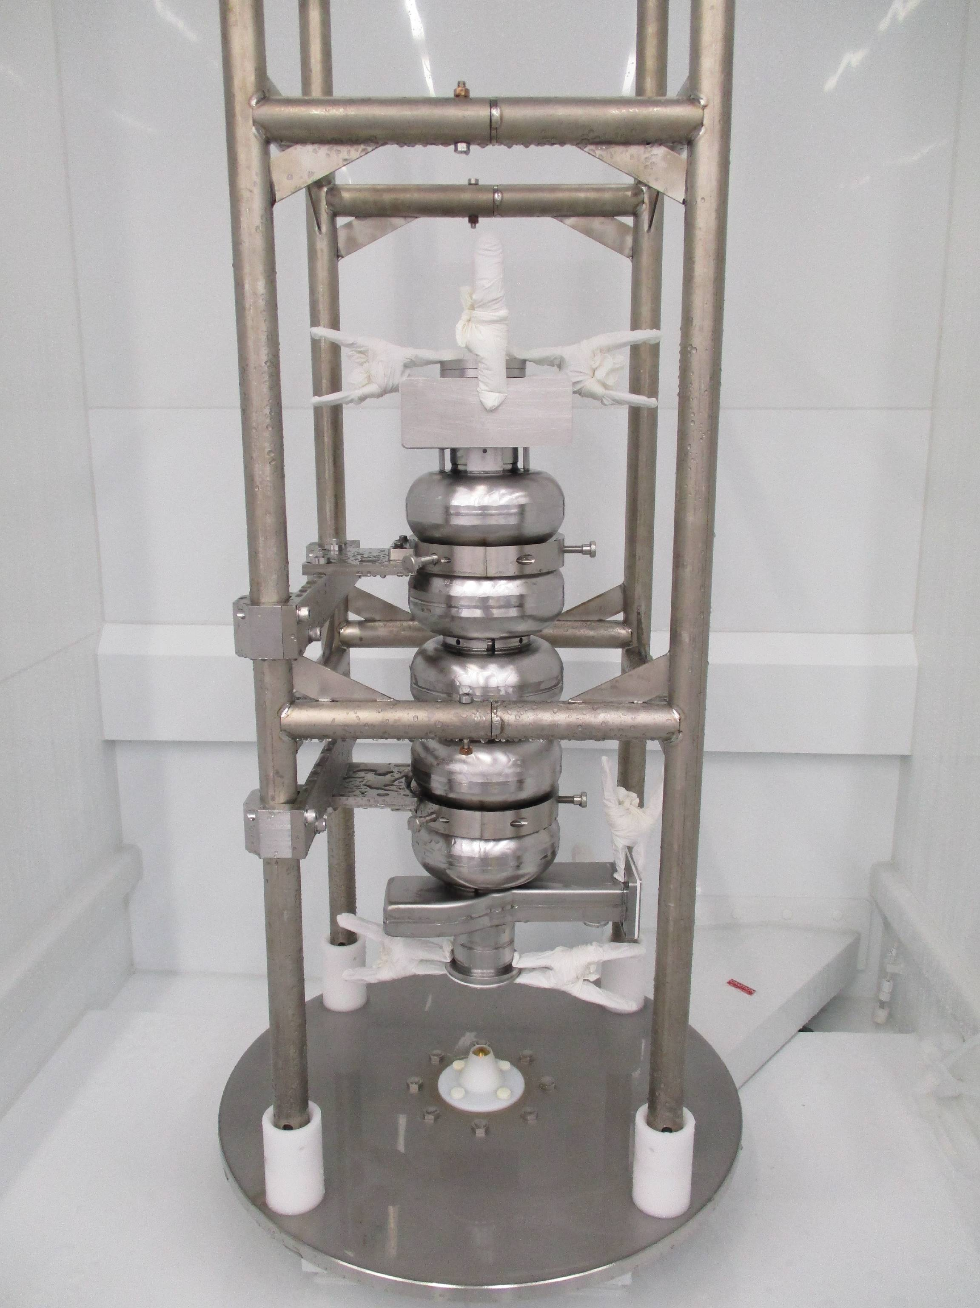
  - Second Rinse for C75 – only the bottom beam line flange should need to be covered.
    - Use TWO clamps to secure the Gore-Tex and blank to the flange.
    - It may be necessary to rotate the turntable to access some flanges.
    - Do not replace the blank already installed on the top flange of the cavity unless directed to do so by the PI/SOTR.
    - End with the cavity in the “home” position (FPC to the right).
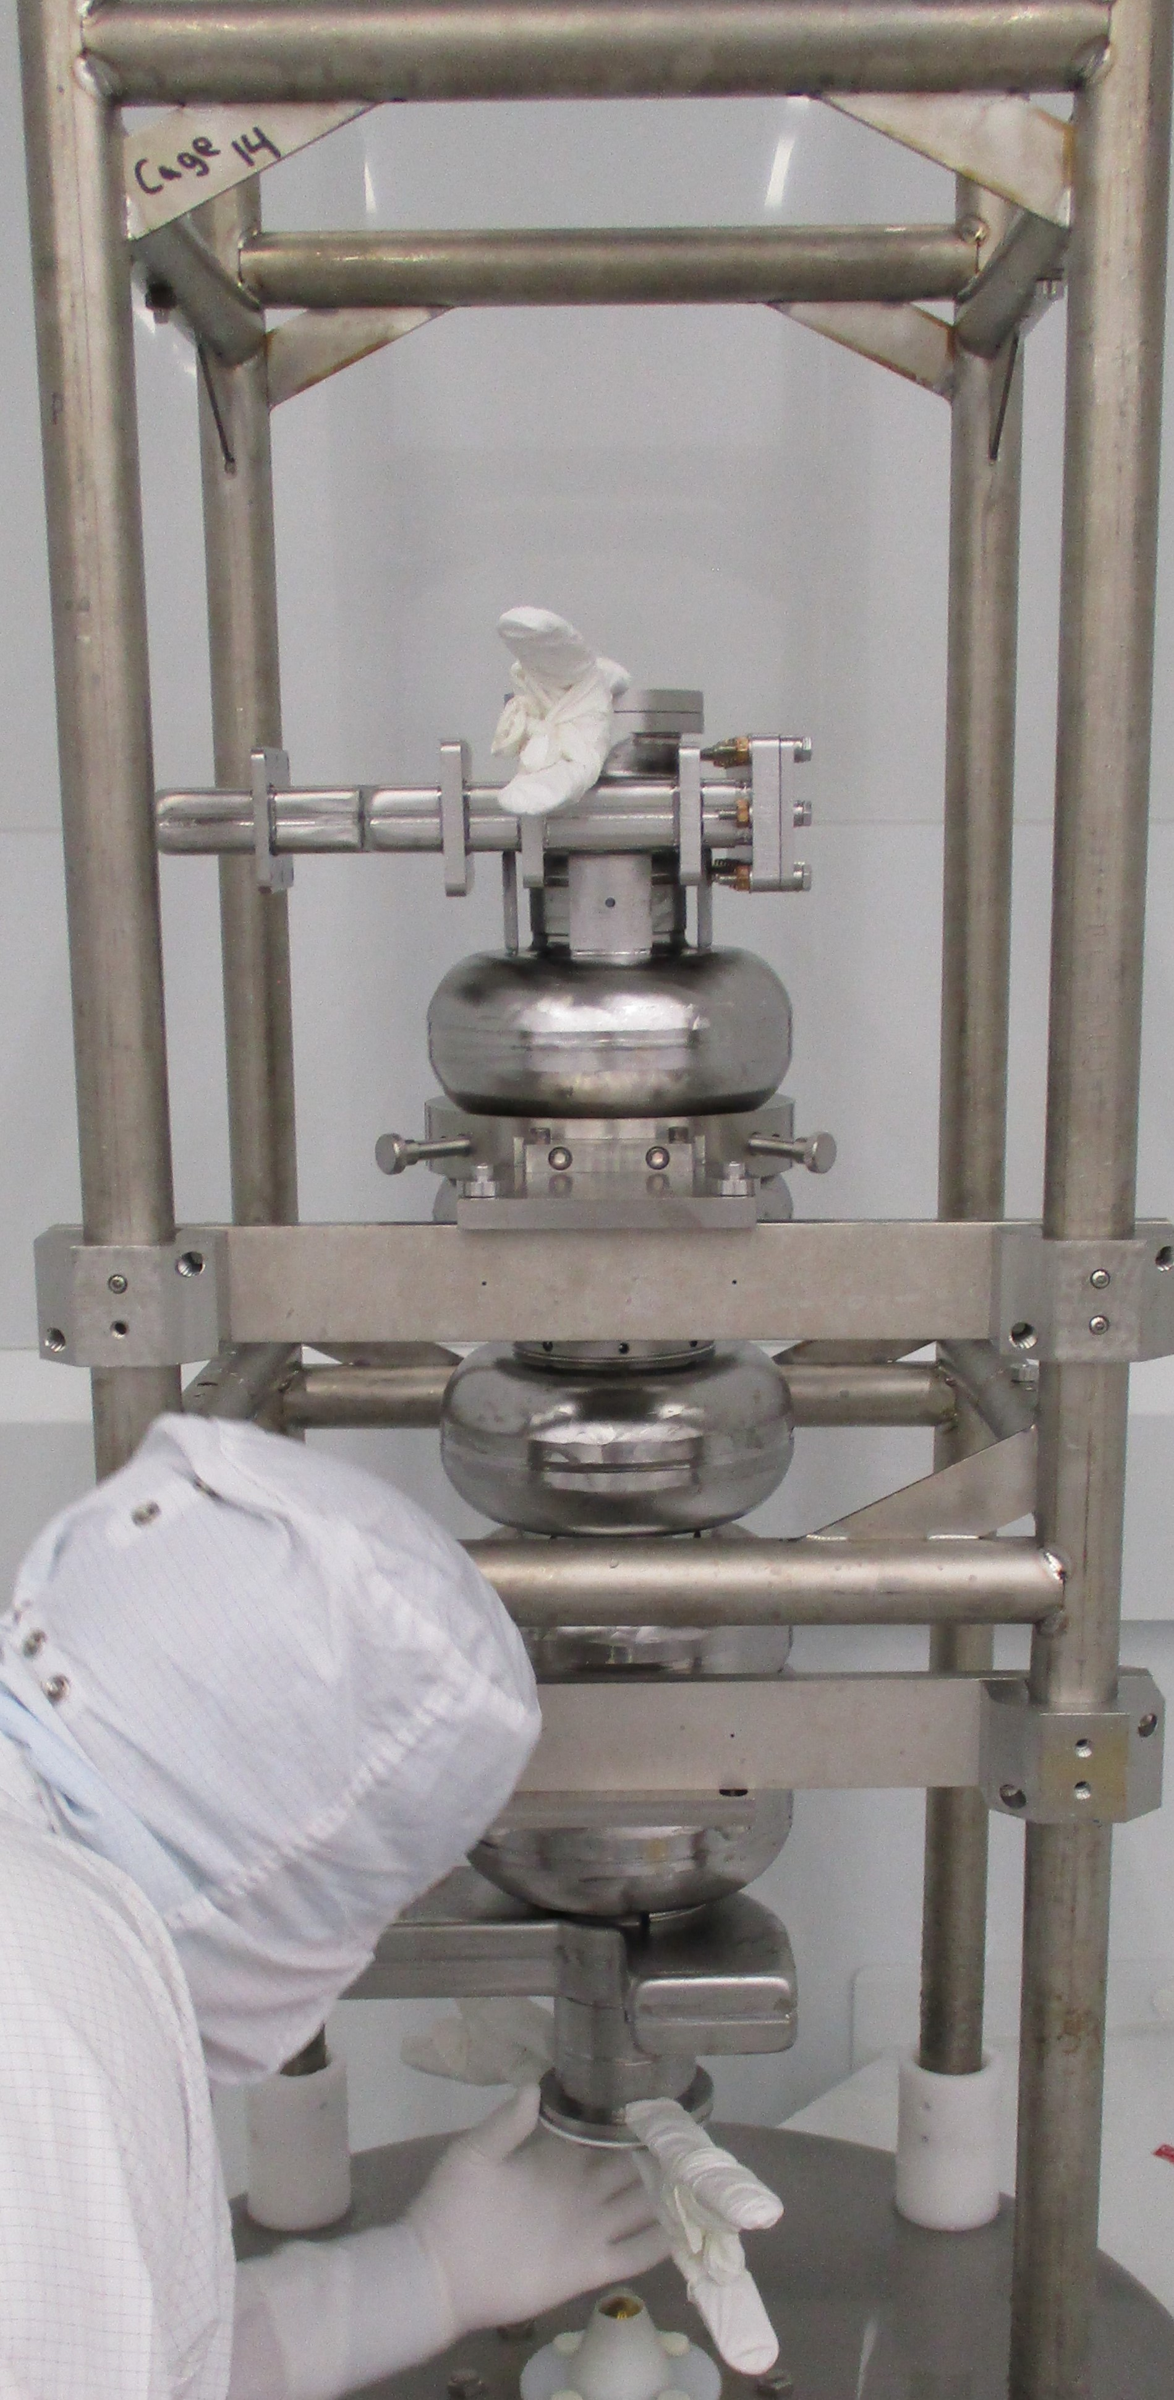
- Remove cavity from HPR cabinet:
  - Attach the Back-Tech lift cart to the cage/cavity tooling.
  - Lift and remove cavity from HPR processing chamber.
  - Replace protective HPR wand cover.
  - Close HPR processing chamber doors.
  - Re-home the turntable if necessary.

Draining, tilt the cavity to remove any trapped water
- First Rinse for C75 – (cavity completely disassembled)
  - Moving slowly (it should take about 20 seconds), tilt the cavity 90° so the HOM opening is facing down.
  - With clean gloves, remove the HOM blank and Gore-Tex and let the cavity drain for a minimum of 30 seconds.
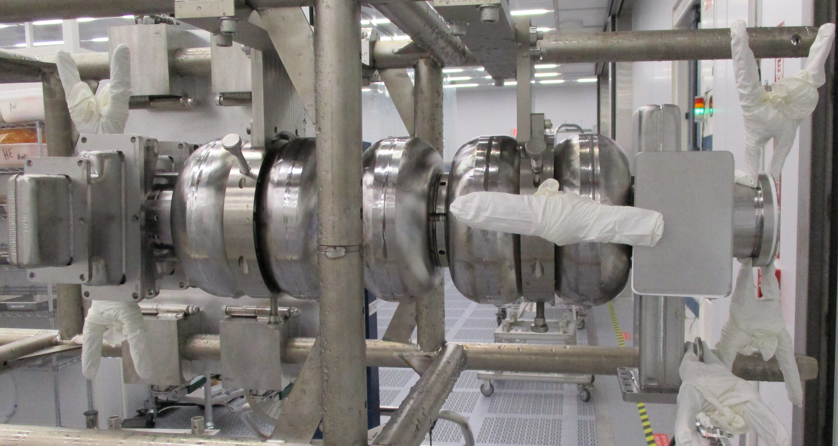
  - Cover the HOM as per step 4.3.5.b.
  - Lower the cage into the wide four-wheeled cart and turn the cavity back ¼ turn to “home” so the brackets face the BackTech and the FPC is at the upper right if you are standing behind the BackTech.
  - Raise the cavity again.
  - Moving slowly (it should take about 20 seconds), tilt the cavity 90° so the FPC opening is facing down.
  - With clean gloves, remove the FPC blank and Gore-Tex and let the cavity drain for a minimum of 30 seconds.
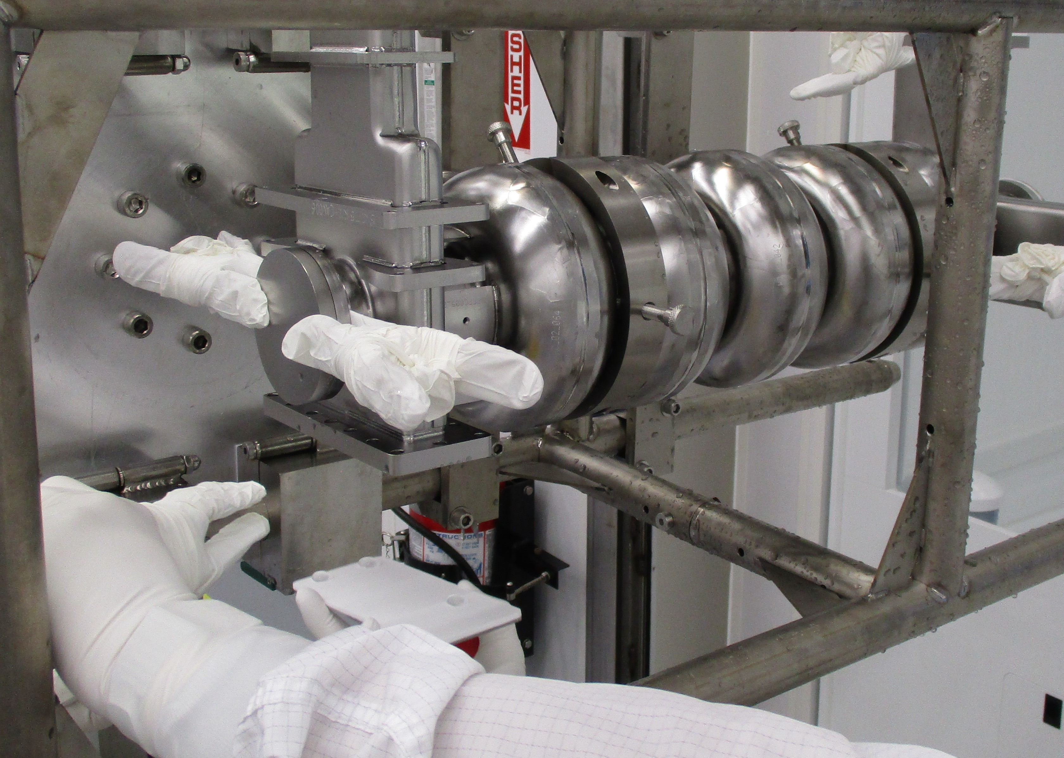
  - Cover the FPC as per step 4.3.5.b.
  - Moving slowly (it should take about 20 seconds), tilt the cavity 90° so the other HOM opening is facing down.
  - With clean gloves, remove the HOM blank and Gore-Tex and let the cavity drain for a minimum of 30 seconds.
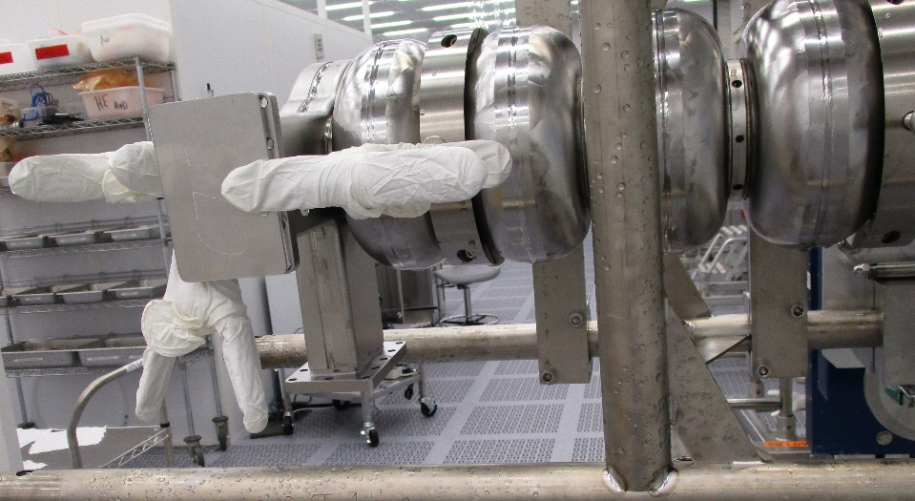
  - Cover the HOM as per step 4.3.5.b.
  - Return the cage to the four-wheeled cart.
- Second Rinse for C75 – (top and bottom flanges not assembled)
  - Moving slowly (it should take about 20 seconds), tilt the cavity about 60° so the FPC opening is facing down and hold for a minimum of 30 seconds.
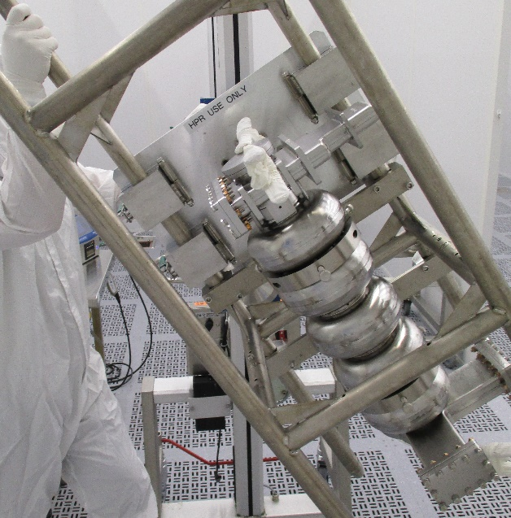
  - Slowly, go through the upright position (do not let cavity go upside down) and rotate the cage to the opposite side, about 60° from upright, and hold for a minimum of 30 seconds.
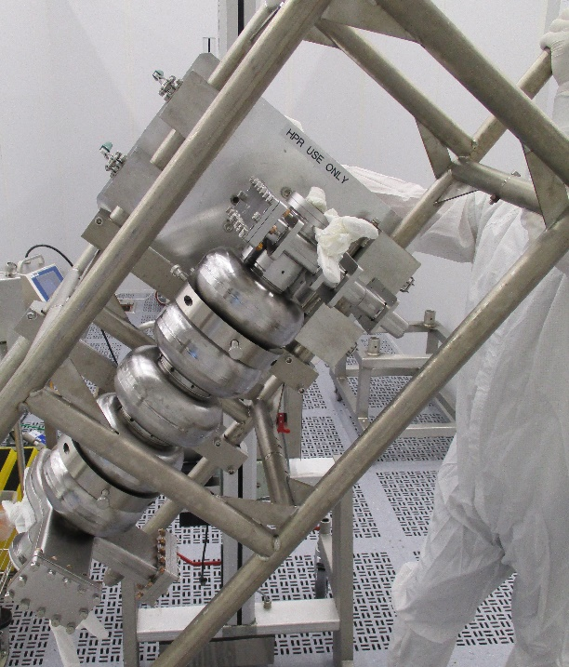
  - Slowly rotate the cavity back to the upright position.
  - With clean gloves, remove the bottom blank and let the cavity drain for a minimum of 30 seconds before covering as per step 4.3.5.c.
  - Lower the cage into the wide four-wheeled cart and turn the cavity ¼ turn.
  - Raise the cavity again.
  - Moving slowly (it should take about 20 seconds), tilt the cavity 90° so the second HOM opening is facing up.
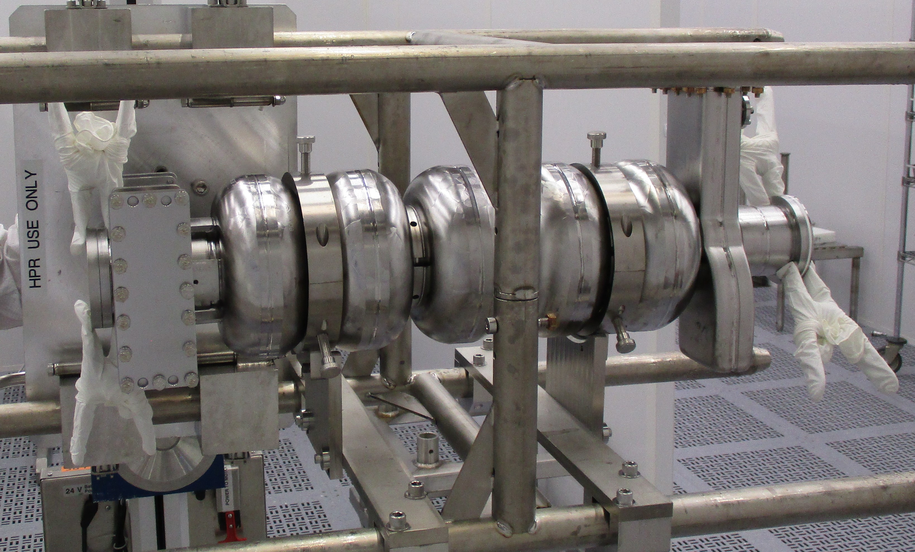
  - Hold for a minimum of 30 seconds.
  - Return the cage to the four-wheeled cart and turn back ¼ turn to the “home” position where the brackets face the BackTech.
- Transfer cage/cavity tooling to a four wheeled cart if not in one already.
- Return the BackTech to the storage area.

DRYING
- If the cavity is to dry in the clean room:
  - Push the cavity in the four wheeled cart to an appropriate area (drying bay) out of the way of regular foot-traffic.
  - Lift the cage and cavity up with a BackTech so that the top blank can be reached without stretching or leaning over the cavity.
    - If a BackTech is not available, contact your supervisor before leaving the cage in the roll cart.
  - Don new gloves and blow with nitrogen to check for particles.
  - Carefully remove each blank beginning at the top and working from back to front around the cavity towards the bottom.
    - The hand that actuated the clamps (which may be dirty) should not be used to remove the blanks/gaskets. Remove blanks with a lifting motion and move away from the side so your body and gloves stay clear of the cavity opening.
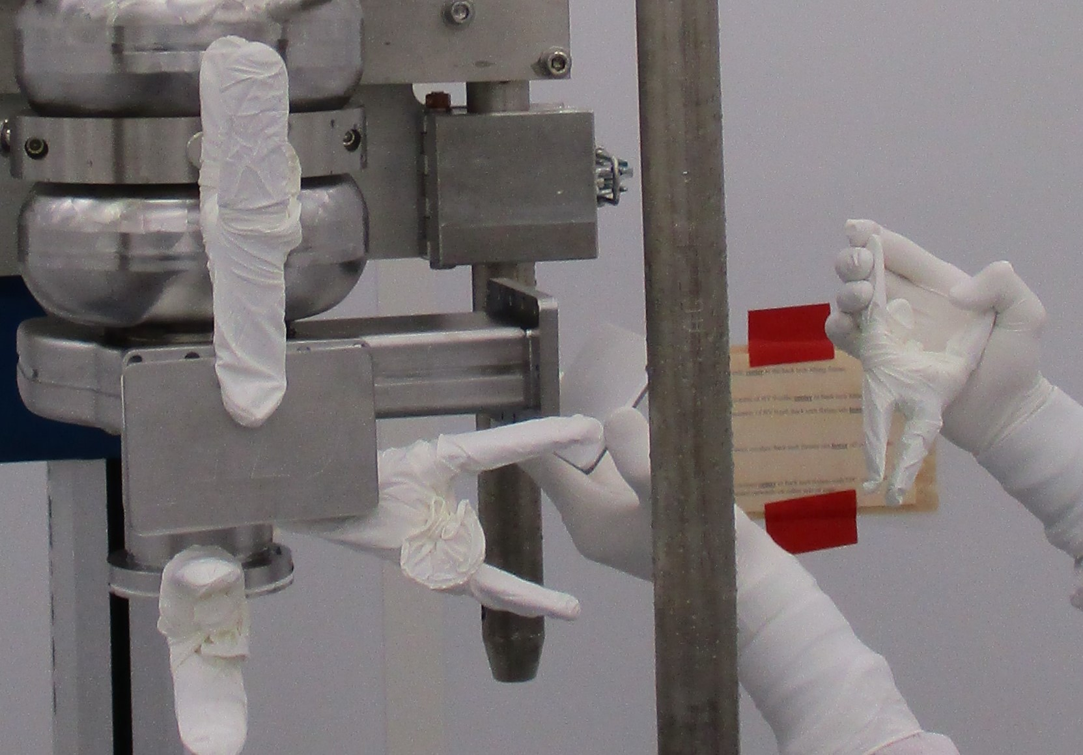
    - After removing the upper blanks, raise the cavity to the final elevated dry position.
    - Verify your gloves are still clean after touching the BackTech control module with a particle check. Don new gloves and blow with nitrogen to check for particles if necessary.
1st HPR | 2nd HPR
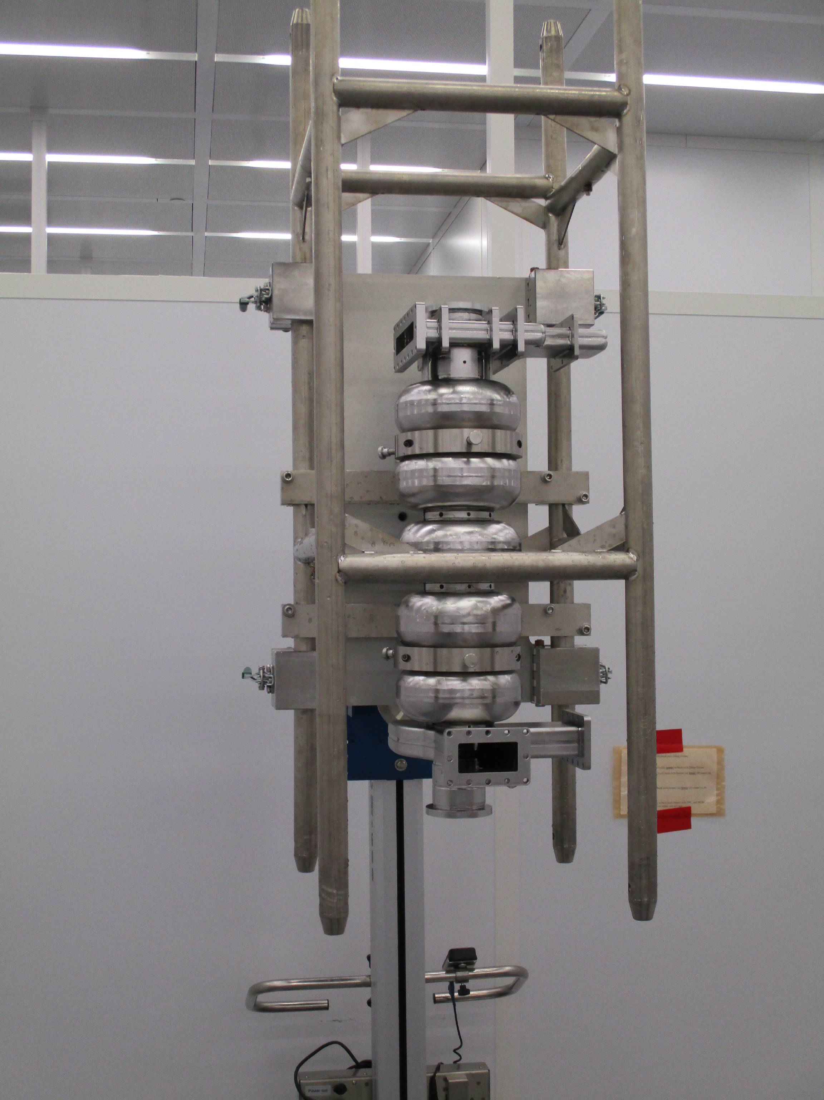 | 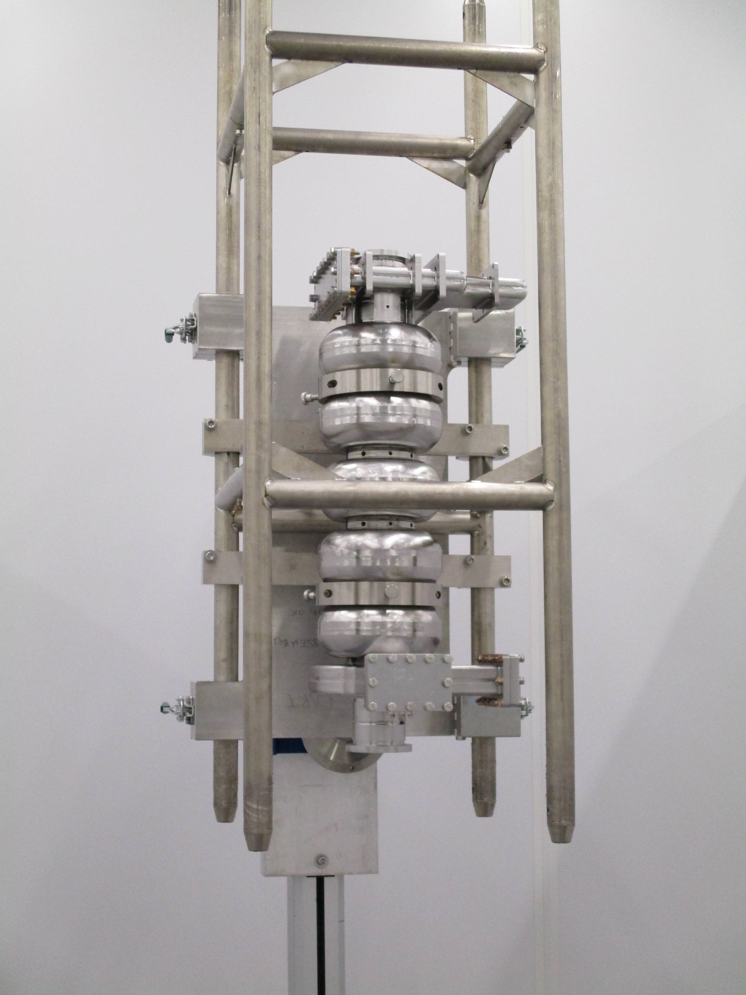
  - Once finished, slowly back out of drying area. Do not re-enter the drying area once all ports are open.
  - Place a cart or chain at the entrance to the drying area to deter unwanted entry.
  - Place the removed blanks in the pass through for cleaning or leave for the assembly group to blank the cavity if necessary.

Revision History

Rev # | Revision or update: | Effective:
Release | Initial Release for C75 | 2/19/2020

Approvals

Approved by: | Signature: | Date:
Document Owner | Ashley A Mitchell
Approver 1 | Gianluigi Ciovati
Approver 2 | Kirk Davis

