Traveler Title | SNS PPU Thermal Shield Inspection Traveler
Traveler Abstract | Traveler defines inspection process for the SNS PPU Thermal Shield
Traveler ID | SNSPPU-CST-INSP-TS
Traveler Revision | -
Traveler Author | Matt Marchlik
Traveler Date | 15-Apr-20
NCR Informative Emails | Marchlik, kwilson, edaly
NCR Dispositioners | marchlik, kwilson, edaly
D3 Emails
Approval Names | M. Marchlik | K. M. Wilson | A. DeKerlegand | E.F. Daly
Approval Signatures
Approval Dates
Approval Title | Author | Reviewer | Reviewer | Project Manager

References | List and Hyperlink all documents related to this traveler. This includes, but is not limited to: safety (THAs, SOPs, etc), drawings, procedures, and facility related documents.
104211100-M8U-8200-A002-RevA (THERMAL SHIELD ASSEMBLY) |  | 104211100-M8U-8200-A003-RevA (50K SHIELD SUBASSY) | 104211100-M8U-8200-A025 (SUPPLY END THERMAL SHIELD ASSY)
104211100-M8U-8200-A014 (RETURN END THERMAL SHIELD ASSY) |  | 104211100-M8U-8200-A042 (SHIELD BELLOWS ASSEMBLY) | 104211100-M8U-8200-A040 (SUPPORT ASSY)

Revision Note
- | Initial release of this Traveler.

Step No. | Instructions |  |  | Data Input
General handling guidelines: When moving the assembly alone and not installed in a spaceframe, it should be supported/lifted at three points: At the center and approximately four feet from each end. The thermal shields shall be handled according to standard cleaning and handling practices.
1 | Initial Inspection:
 | Technician Name  Date of Inspection  Serial Number of part |  |  | [[TechName]] <<SRF>>  [[InspectionDate]] <<TIMESTAMP>>  [[TPHTSN]] << TPHTSN>>
 | Is the assembly clean, free from dust, oil, finger prints or other contaminants? |  |  | [[PartCleanOk]] <<YESNO>>
 | Inspect all of the sheet metal panels of the assembly and verify that there are no ding/dents that exceed ¼” in depth. |  |  | [[PanelsOk]]<<YESNO>>
 | Bellows:  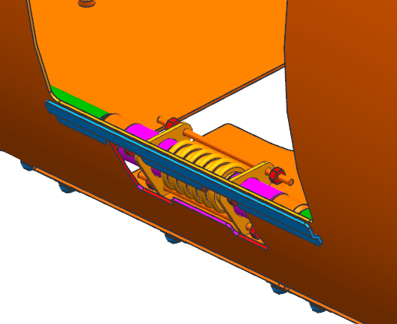  - The access panels above the bellows should be removed to provide access to the bellows and replaced after inspection.  - Visually inspect the three bellows assemblies in the helium line and verify that they are free from dings/dents greater than .02” in depth and are free from gouges in the convolutions.  - Verify that the bellows are straight, not squirmed. |  |  | [[BellowsOk]]<<YESNO>>
 | Heat Stations:  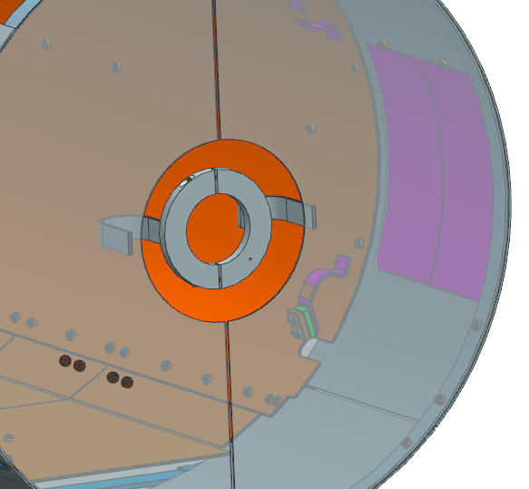  - Verify the thermal heat stations are installed on both ends of the shield assemblies and that the thermal strapping braze joints look to be in good condition.  - The shipping restraint may be removed for the inspection and shall be replaced afterwards. |  |  | [[heatstationOk]]<<YESNO>>
 | Space Frame Mounts:  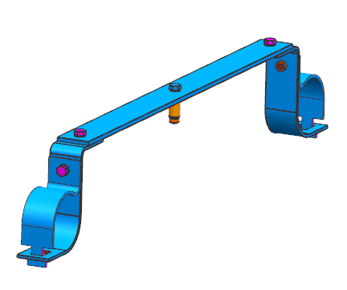  Verify that all 32 of the G11 space frame mounts are accounted for and installed correctly and securely. |  |  | [[MountsOk]]<<YESNO>>
 | End Supports:  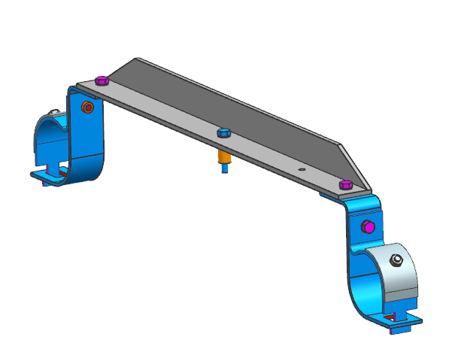  Verify that both end shield supports assemblies are installed securely and correctly. |  |  | [[SupportOk]]<<YESNO>>
 | Field Probe Cable Intercepts:  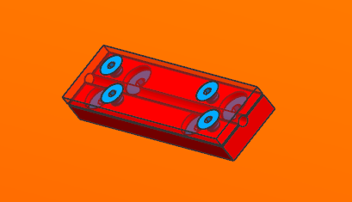  Verify that all four of the field probe cable thermal intercept blocks are accounted for and installed securely. |  |  | [[InterceptOk]]<<YESNO>>
 | He line braze:  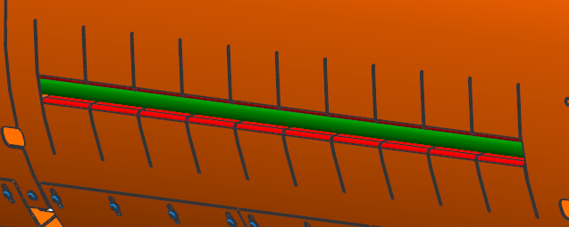  - Verify that the helium lines is brazed properly to the thermal contraction fingers.  - Verify that there is not exidation around the braze region from remnant flux as shown in the image below.  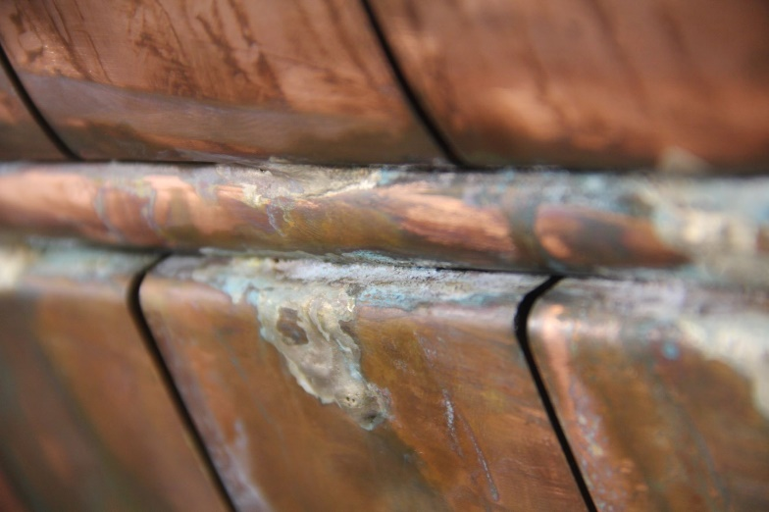 |  |  | [[BrazeOk]]<<YESNO>>
 | Nitronic Rod Thermal Intercept:  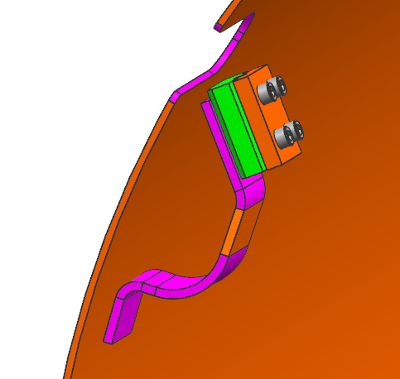  - Verify that all 32 nitronic rod thermal intercepts are brazed to the shield adequately.  - Verify that there is not exidation around the braze region from remnant flux. |  |  | [[RodinterceptOk]]<<YESNO>>
 | Comments:  Upload photos of any damage. |  |  | [[VisualInspComment]] <<COMMENT>>  [[VisualInspPhoto]] <<FILEUPLOAD>>
2 | Dimensional Inspection:
 | Dimensionally inspect the thermal shield assemblies with serial numbers ending in 001, 003 and 006. |  |  | [[DimcheckOk]] <<YESNO>>  [[DimcheckComment]] <<COMMENT>>
Drawing Number |  | Description | Drawing Value | Measured Value | Within Tolerance
N/A |  | Overall Length: From outer face of end extensions | 228.61” +/- .25” | [[MeasLength]] <<FLOAT>> <<YESNO>>
N/A |  | Outer diameter of the shield | 27.97” +/- .25”  Or  28.19” +/- .25” | [[MeasOD]] <<FLOAT>> <<YESNO>>
N/A |  | FPC penetration local center to center distance, 2 places.  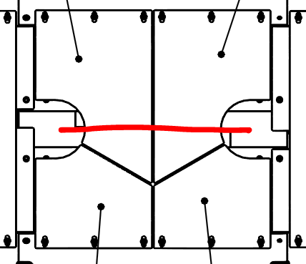 | 15.80” +/- .25” | [[MeasFPC1]] <<FLOAT>> <<YESNO>>
N/A |  | FPC penetration pair to pair. Measure distance between centers of the two center FPC penetrations. | 93.04” +/- .25” | [[MeasFPC2]] <<FLOAT>> <<YESNO>>
3 | Storage:
 | Replace all components that have been removed for inspection and ensure the bellows covers are replaced. |  |  | [[StorageTech]] <<SRF>>  [[StorageDate]] <<TIMESTAMP>>

