|  |  |  |  |  |
| --- | --- | --- | --- | --- |
| C75 Flange BCP Procedure | | | | |
| **Document Number:** | CP-C75-CAV-CHEM-BCPFL | **Approval Date:** | 24-FEB-2020 | | |
| **Revision Number:** | Initial Release | **Periodic Review Date:** | 01-MAR-2022 | | |
| **Document Owner:** | Ashley Mitchell |  | |  |

## 

# Purpose and Scope

This document covers the use of the acid wet benches located in the Production Chemistry room in the TLA for processing 5-cell C75 cavities with Buffered Chemical Polish (BCP). This process removes impurities from the surface of five cell C75 style niobium cavity flanges.

# References

|  |  |
| --- | --- |
| [CP-C50R-CHEM-FLG](https://jlabdoc.jlab.org/docushare/dsweb/Get/Document-74640/CP-C50R-CHEM-FLG-R1.pdf) | [CP-STP-CAV-CHEM-ACID](https://jlabdoc.jlab.org/docushare/dsweb/Get/Document-141848/CP-STP-CAV-CHEM-ACID-R1.pdf) |
| [Production Chemistry Room OSP](https://mis.jlab.org/mis/apps/mis_forms/operational_safety_procedure_form.cfm?entry_id=83800) | [CP-STP-CAV-CHEM-USC](https://jlabdoc.jlab.org/docushare/dsweb/Get/Document-132367/CP-STP-CAV-CHEM-USC-R2.pdf) |
| [Etch Rate Calculator](https://jlabdoc.jlab.org/docushare/dsweb/Get/Document-155720/Sample%20Thickness.xlsx) |  |

# Terms and Definitions

1. **BCP** – Buffered Chemical Polish, an acid mixture composed of Hydrofluoric acid, Nitric acid, and Phosphoric acid. Typically in a 1:1:1 or 1:1:2 ratio.

# Process Details

## Safety

1. Follow the Production Chemistry Room OSP for the appropriate PPE and room procedures prior to beginning any acid work.
   1. BCP contains HF (hydrofluoric acid), Phosphoric acid, and nitric acid.
2. All activities involving the use of acids shall be performed in the acid fume hood with a properly operating fume extraction system (scrubber).
3. Ensure safety showers, city water, and hoods are functional as per the room OSP.
4. Do not attempt to hold a C75 cavity by hand while performing acid work as this may result in serious personnel injury.  Use only approved fixtures and tooling to support the cavity when it is in the proximity of open containers of acid.

## Preparation

1. Refer to CP-STP-CAV-CHEM-ACID for the BCP acid mixing procedure and preparation.
2. The cavity must be clean and dry before the etching process is started.
   1. Follow the cavity degreasing procedure if necessary.
3. Prior to acid etching activities, ensure that materials used during the etching process are compatible with chemicals being utilized and an appropriate size for the flange.

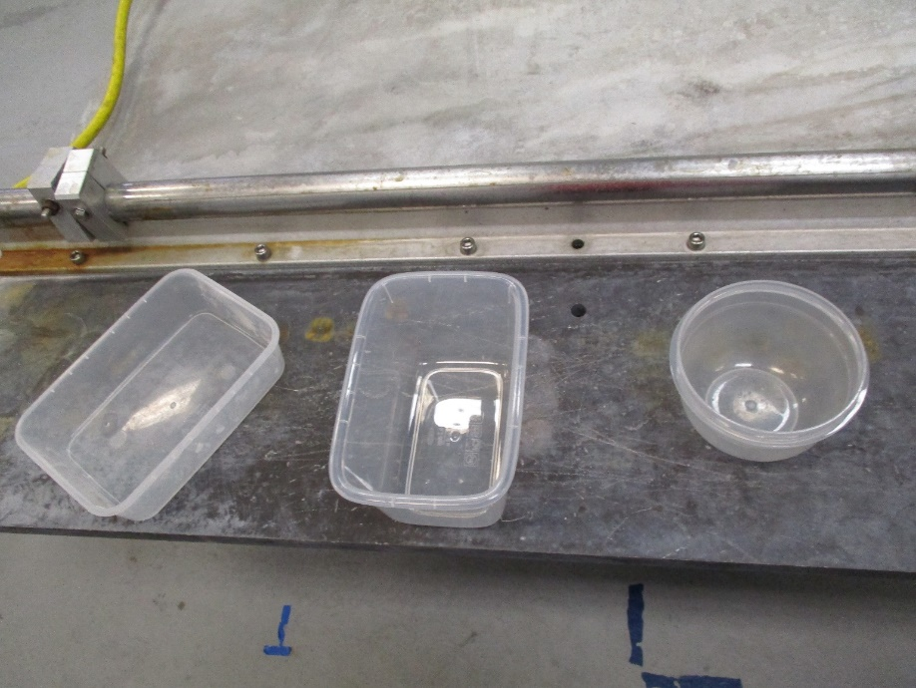

* 1. Containers should be as small as possible to accommodate the flange being etched for ease of handling.
     1. Examples are shown above.
  2. The container for the HOM flange needs to be deep enough to cover the field probe with acid as well as the flange.

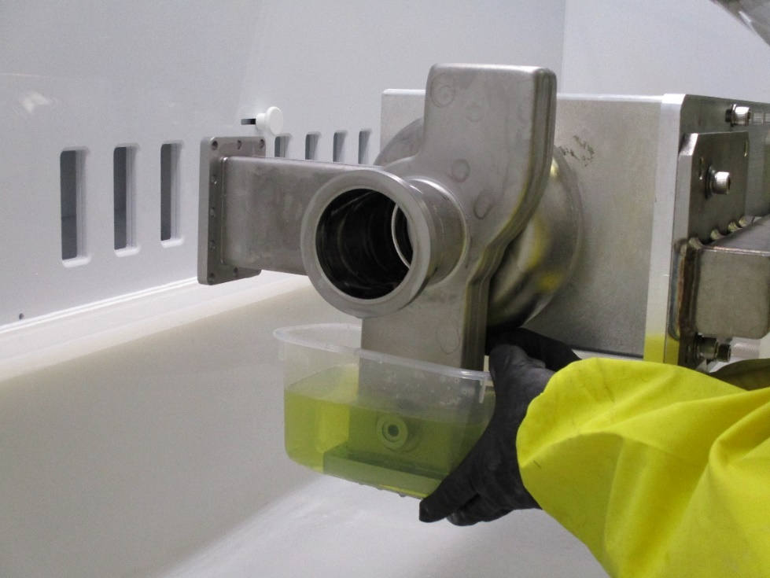

* 1. A prop or acid-safe jack may be used to hold the container and lower the cavity into the acid instead of raising the container to the flange.
  2. A “spent acid” container for used acid should be set to the side in the hood. Fresh acid should be used for each flange to ensure a consistent etch rate and avoid overheating the acid.

1. Ensure the BackTech is charged and the appropriate C75 fixture is installed.
2. Install the cavity into the BackTech.

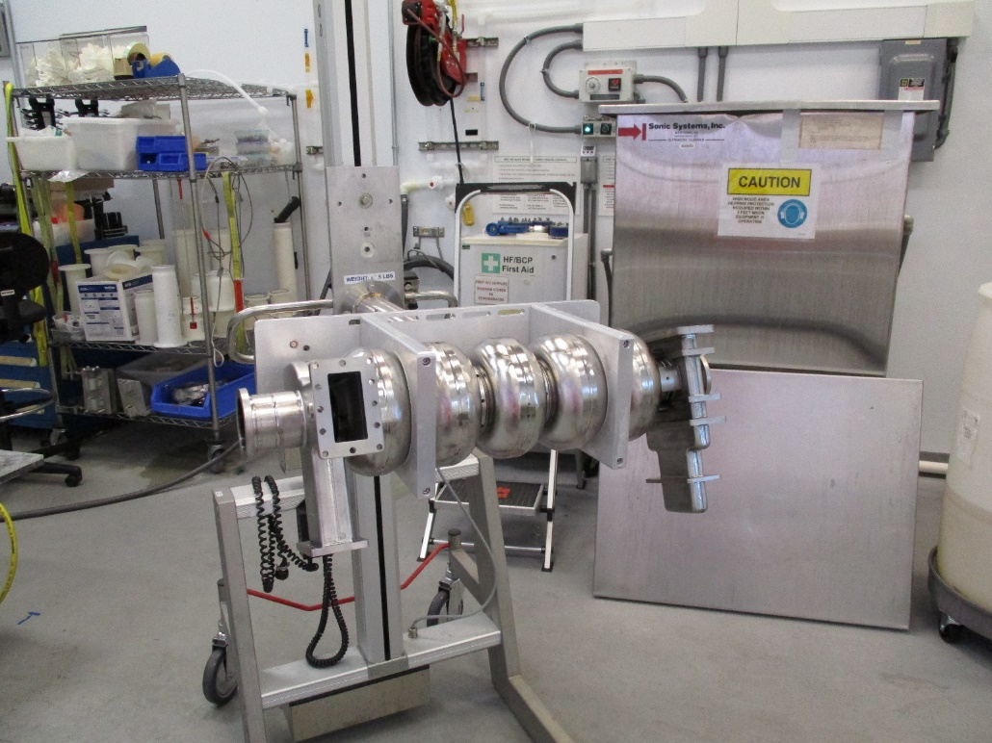

* 1. Additionally, the C50 horizontal cavity support fixture may be used.

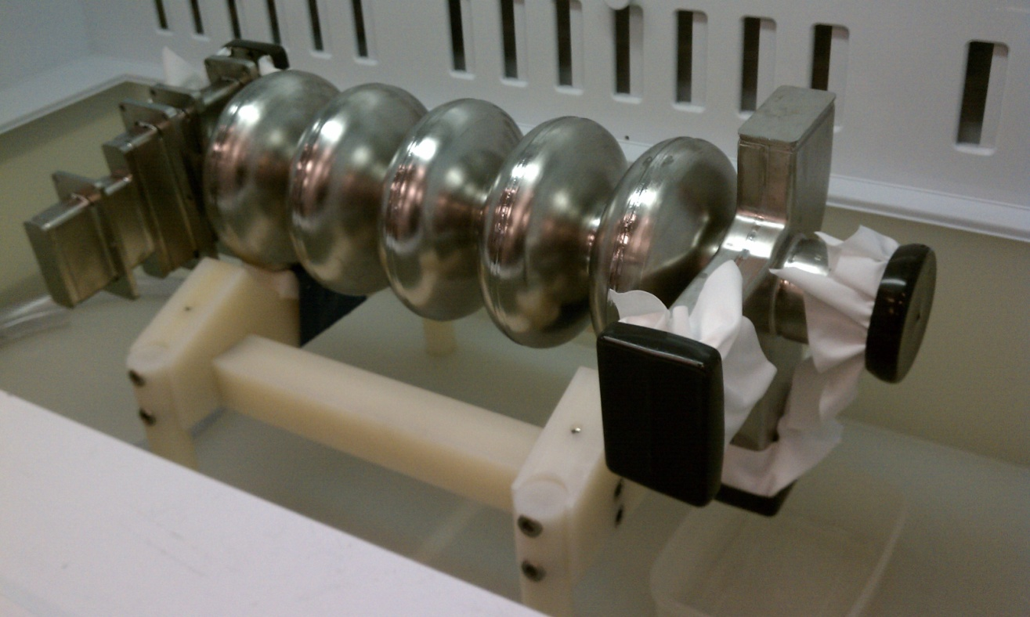

* 1. If manually lifting the cavity into the fixture, a second technician may be necessary to avoid and undue ergonomic strain.

1. Prior to flange etching, inspect the entire cavity for flaws, and thoroughly inspect the HOM’s, FPC, Field Probe, and Beam Tube sealing surfaces for scratches, dents, dings, residual indium, and any other irregularities that may be present. If any are found, record them and promptly notify your supervisor and/or the PI/SOTR.
   1. If indium is present on the flanges, it may be necessary to perform a soak in nitric acid for 20-30 minutes prior to the BCP etch.
2. If necessary, perform a dry run with water.
3. Calculate the etch time.
   1. 10-15 microns is the standard removal for C75 flange BCP. It generally takes 90 seconds to etch a flange.
   2. Fresh BCP 1:1:1 yields an average etch rate of ~8µm/min at a temperature of 20°C.
   3. When using previously used acid, take an etch rate sample and adjust the time to achieve the desired removal.
      1. [Etch Rate Calculator](https://jlabdoc.jlab.org/docushare/dsweb/Get/Document-155720/Sample%20Thickness.xlsx)
   4. The technician can implement an ice bath into the procedure to maintain a lower temperature if necessary.
4. Don appropriate PPE.

## Etching

The order in which the flanges are etched is not critical to the process, but care should be taken to rinse the etched flange and inside of the cavity thoroughly to avoid acidic water standing inside the cavity or staining from the BCP “smoke”. The rinse water should be drained between flanges by tilting the cavity to ensure it does not get into the BCP acid. Care should be taken not to introduce water into the BCP mixture as it can alter the etch rate.

1. Bring the C75 cavity into the hood and position it so the flange is easily reachable.
   1. Care should be taken not to bump or damage the flanges when moving the cavity into, out of, and inside the hood.
   2. If damage is suspect, contact the PI/SOTR or supervisor immediately.
2. Turn on DI water.
3. Transfer the bottle of BCP acid to the hood.
4. Transfer the BCP to a smaller, easy to pour container if necessary.

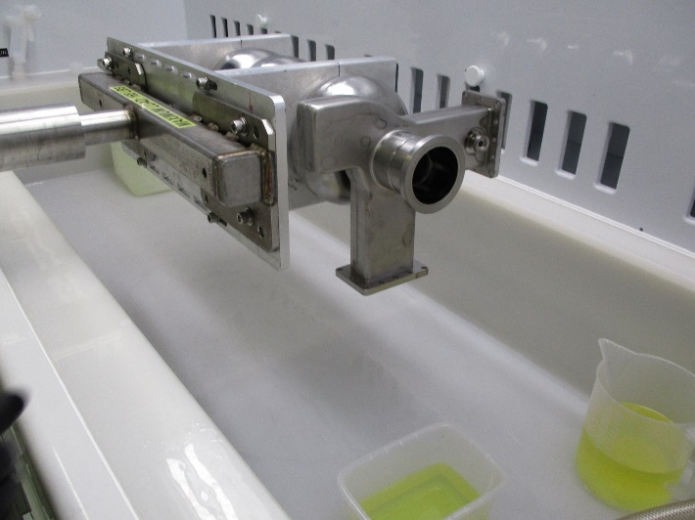

1. Pour only the amount of acid that is needed in an appropriately sized container for the flange to be etched.
2. Slowly submerge each flange to be etched into the acid for the prescribed amount of time.
   1. This can be accomplished by raising the container to the flange or lowering the cavity flange to the container.
   2. The acid should be agitated by carefully moving the container while submerged.

|  |  |
| --- | --- |
| J:\Travelers and Procedures\C75\C75 flangeBCP\IMG_0116.JPG | J:\Travelers and Procedures\C75\C75 flangeBCP\IMG_0125.JPG |
| J:\Travelers and Procedures\C75\C75 flangeBCP\IMG_0114.JPG | J:\Travelers and Procedures\C75\C75 flangeBCP\IMG_0098.JPG |
| J:\Travelers and Procedures\C75\C75 flangeBCP\IMG_0109.JPG | |

1. After the prescribed time has elapsed, carefully remove the flange from the acid.
2. Thoroughly rinse the flange and cavity immediately.

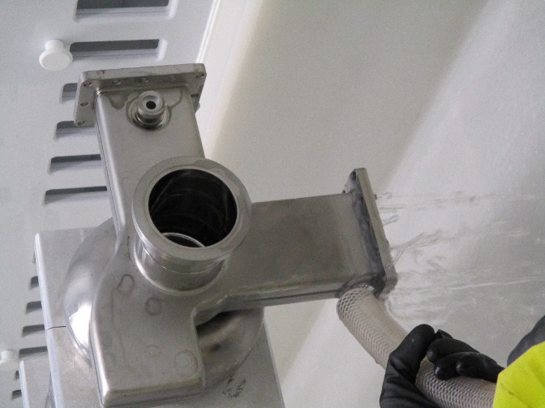

1. Discard the used acid into the “spent acid” container to the side of the hood.
2. Repeat as needed for additional flanges.
3. Return acid to the storage container.
4. When etching is complete, perform a final rinse of the entire cavity inside and out.

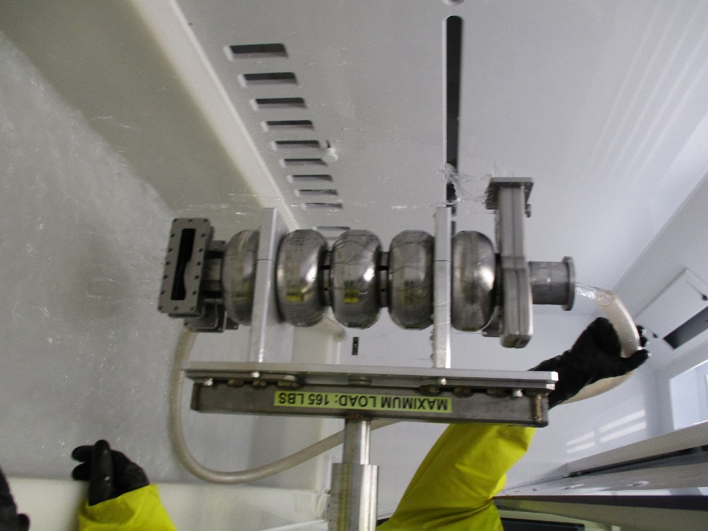

1. Dry and inspect the flanges.
   1. The flange sealing surface must be stain-free. If it is not, etch the flange again to remove the stains.
   2. Additionally, HF may be applied to the flange with a Q-tip to remove stains.
2. Ensure all acid containers are closed and sealed. Thoroughly rinse off the mixed acid container with DI water and return it to the acid storage cabinet. If necessary, allow acid to cool prior to storage.
3. Meticulously rinse off all process hardware, the BackTech, associated containers and tooling.
4. Clean up the hood, rinse all surfaces with DI water, and test with pH paper.
5. Rinse PPE.
6. Squeegee floor around work area to remove any excess water resulting from rinse process.

## Inspection and Cleaning

1. Dry and inspect the HOM’s, FPC, Field Probe, and Beam Tube sealing surfaces. If any irregularities are found, record them and promptly notify your supervisor and/or the PI/SOTR.
2. The cavity must be ultrasoniced to clean and remove any residual acid.
3. Follow the cavity USC degreasing procedure to proceed.

# **Revision History**

|  |  |  |
| --- | --- | --- |
| Rev # | Revision or update: | Effective: |
| Release | Initial Release | 02/24/2020 |
|  |  |  |

# **Approvals**

|  |  |  |  |
| --- | --- | --- | --- |
| Approved by: | Name: | Signature: | Date: |
| **Document Owner** | Ashley A Mitchell |  |  |
| **Reviewer** | Gianluigi Ciovati |  |  |
| Approver | Kirk Davis |  |  |