|  |  |  |  |
| --- | --- | --- | --- |
| Nitrile Glove Covering of Spring Clamp | | | |
| **Document Number:** | CP-STP-CLRM-TOOL-SPCLMP | **Approval Date:** | 17-Dec-2019 |
| **Revision Number:** | Initial Release | **Periodic Review Date:** | 17-Dec-2022 |
| **Document Owner:** | Ashley Mitchell |  |  |

## 

# Purpose and Scope

This procedure details the containment of one Anodic, Inc. Stainless Steel Chem-Clamp (McMaster-Carr Spring Clamp part numbers 4954A21 and 4954A24) using two ISO 4/Class 10 compatible nitrile rubber gloves for the purpose of mitigating contamination of clean surfaces by particles produced in the use and handling of clamps.

**Note:** This procedure was originally written in October 2019 by Jennifer Hare, but was not released. Ownership was assumed by Ashley Mitchell since Ms. Hare is no longer with the Lab.

# References

N/A

# Terms and Definitions

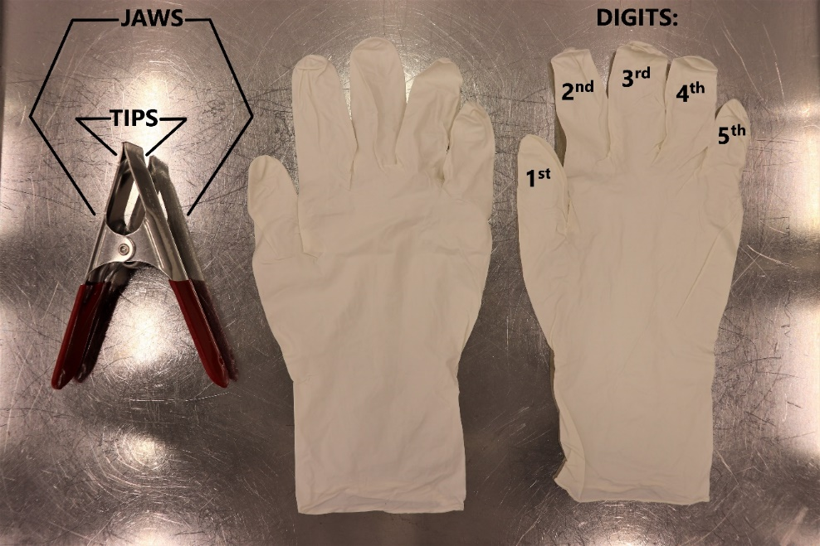

# Process Details

1. Prepare a workspace in an ISO 4/Class 10 environment by wiping down a solid surface using a lint free wipe dampened with isopropyl alcohol.
   1. Although manipulations of the glove and clamp may be most easily performed while holding both in the air, taking this step will minimize chances of cross contamination while staging.
2. Don new gloves or particle check with nitrogen before proceeding.
3. One stainless steel chem-clamp and two size XL nitrile rubber gloves are required to produce one covered clamp. Ensure that the gloves are unused and the clamp has been chemically cleaned and is free of organic residues.
4. Fit the 4th and 5th digits of one glove around the jaws of the clamp.  
     
   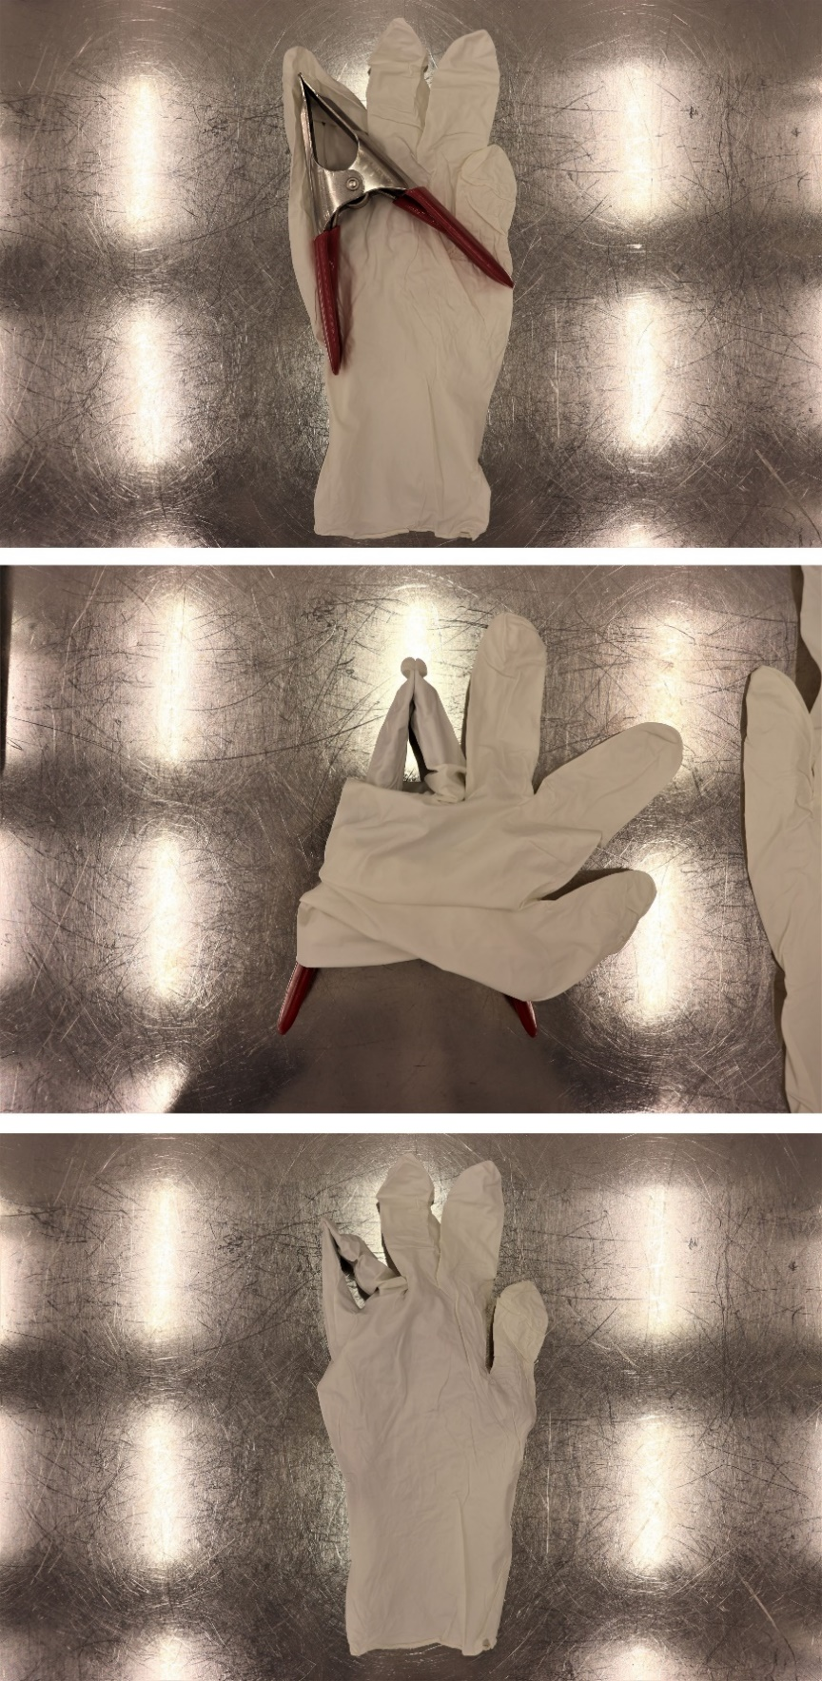
5. Fit the 1st and 2nd digits of the glove around the handles of the clamp. When laid flat on a tabletop the 3rd digit should now protrude away from the clamp in one direction, and the wrist should protrude away from the clamp in the other direction.  
     
   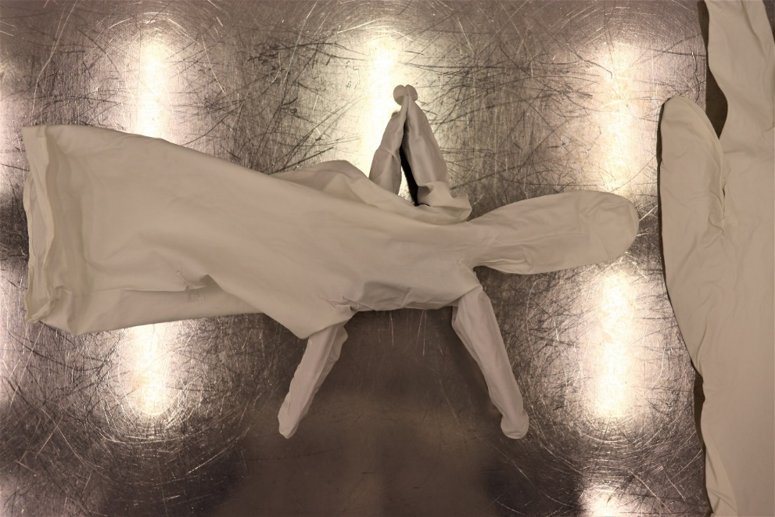
6. Gather the wrist material and snugly wrap it one-and-a-half turns around the handle on the side from which it protrudes.  
     
   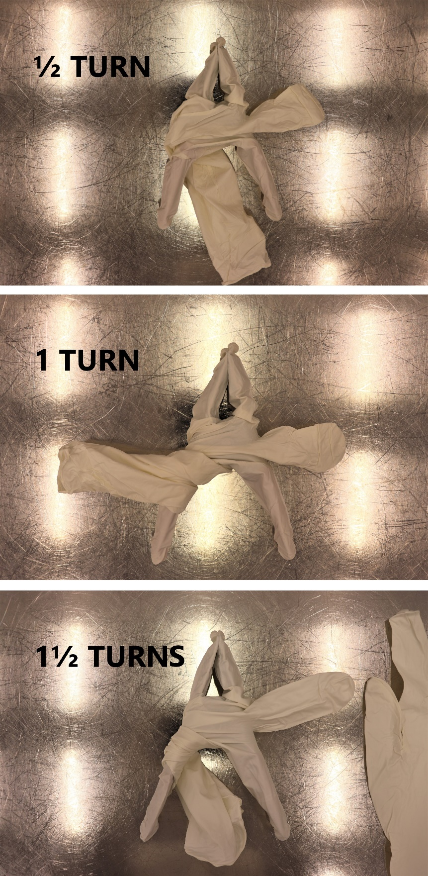
7. Holding the wrist material in place, pull the 3rd digit a half turn around the handle on the side from which it protrudes in the opposite direction as that chosen in step e).
   1. Both the wrist and the 3rd digit should now be gathered in between the handles, just below the spring.
8. Tie the wrist and the 3rd digit together in a secure overhand knot.  
     
   
9. Using the remaining glove, repeat steps d) through g) with the now singly-gloved clamp.
10. Tie the wrist and 3rd digit together in a secure reef (square) knot.  
      
    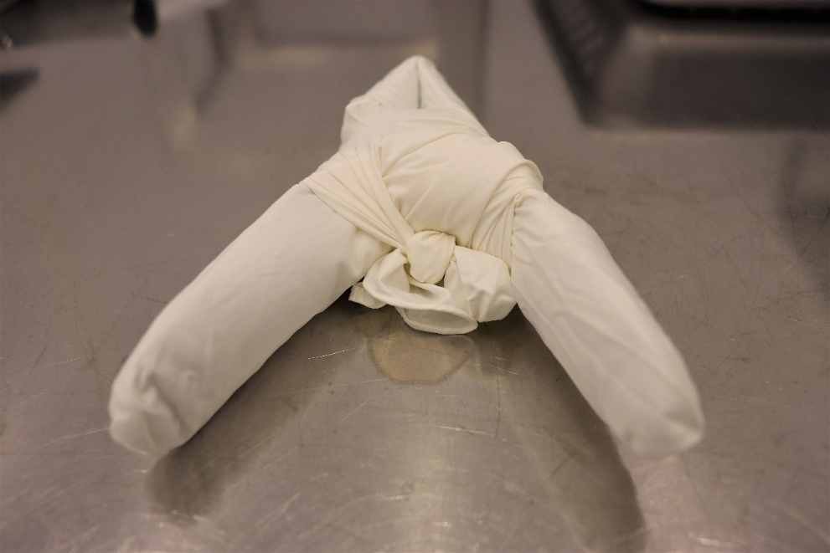
11. Prior to use, nitrogen clean the doubly-gloved clamp to meet the following specifications:

* Zero particles on the 0.3 μm scale of a particle counter for a duration of 10 consecutive seconds for the tips.
* Twenty or fewer particles on the 0.3 μm scale of a particle counter for a duration of 10 consecutive seconds for all remaining areas.

Do not use if each specification cannot be met within twenty 10-second cycles.

1. If the gloved clamps have been previously used, inspect closely for holes, contaminants, and other signs of wear, particularly around the clamp tips. Do not use if its condition is distinguishable from a newly covered clamp.

# **Revision History**

|  |  |  |
| --- | --- | --- |
| Rev # | Revision or update: | Effective: |
| Release | Initial Release | 12/17/2019 |
|  |  |  |

# **Approvals**

|  |  |  |
| --- | --- | --- |
| Approved by: | Signature: | Date: |
| **Document Owner** | Ashley Mitchell | 12/17/2019 |
| **SRF Assembly Group Leader** | Danny Forehand |  |
| **SRF Cavity Processing Group Leader** | Kirk Davis |  |
| LCLSII Scientific Lead | Ari Palczewski |  |