

Traveler Related

Common Procedures

|  |  |  |  |
| --- | --- | --- | --- |
| Procedure Title | Cleaning of CapaciTorr NEG pump | | |
| Procedure ID | **CP-STP-CM-CLN-NEG** | | |
| Procedure Description | Cleaning procedure for installation of the CapaciTorr NEG pump on the girder or cryomodule pump drop | | |
| Revision | R1 | | |
| Author | **Sign**: | | **Date**: |
| **Name**: Gianluigi Ciovati | |
| Reviewer | **Sign**: | | **Date**: |
| **Name**: Danny Forehand | |
| Revision Notes | *Describe any changes between revisions here.* | | |
| R1: Initial Release | | |
|  | | |
|  | | |
|  | | |
| **References** | *List and Hyperlink all documents related to this procedure.* | | |
| [CapaciTorr HV 200 Operator's Manual](https://jlabdoc.jlab.org/docushare/dsweb/Get/Document-211690/Manual%20CapaciTorr%20HV%20200.pdf) |  |  | |
|  |  |  | |
|  |  |  | |

The CapaciTorr NEG pump is typically shipped in a sealed plastic bag inside a sealed metal can.

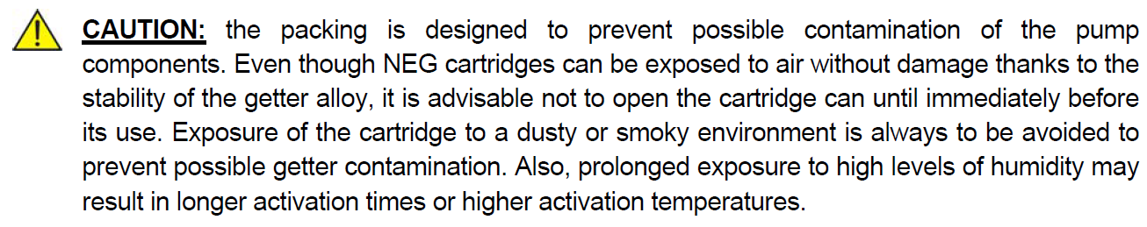

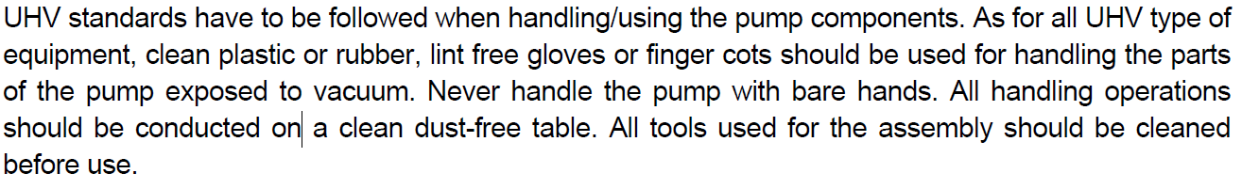

The pre-cleaning of the pump should be done in the R&D or Production Chem Rooms.

1. Open the metal can and retrieve the sealed plastic bag with the pump inside.
2. Wear clean room compatible gloves
3. Open the sealed plastic bag and retrieve the pump
4. Remove the cartridge steel holder, shown in Fig. 1

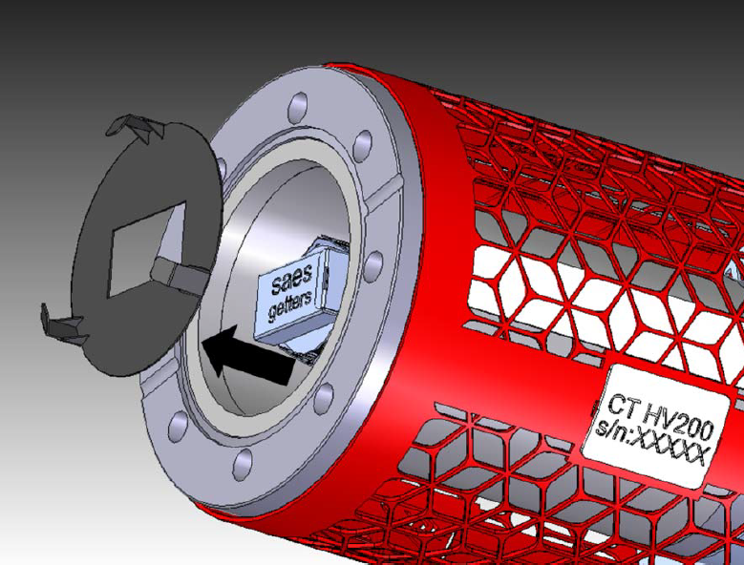

Fig. 1. Cartridge steel holder

1. Remove the three set screws near the plug-side of the pump, as shown in Fig. 2, and slide out the external shield

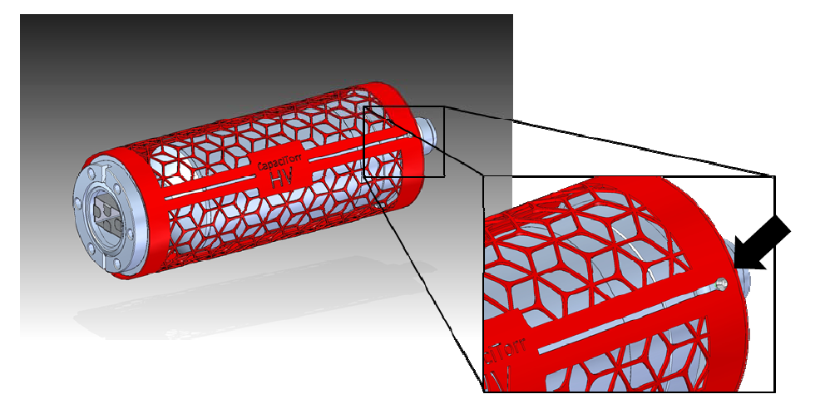

Fig. 2. Set-screws to be removed to allow removing the external shield.

1. Wipe the external shield thoroughly with a class-10 compatible, lint free wipe wet with isopropanol. Replace the wipe if dirt is visible on it during wiping
2. Repeat step 6 to clean all the external surfaces of the body of the pump and the flange
3. Blow thoroughly both internal (cartridge) and external surface of the pump with an ionized nitrogen gun, with a minimum pressure of 50 psi, for 5 minutes.
4. Place the pump and the external shield with set screws in separate plastic bags and place them in the pass-thru.
5. Inside the clean room, open the bag with the pump and thoroughly blow the internal and external surfaces with an ionized nitrogen gun with a minimum pressure of 50 psi in front of the particle counter, until the particle count is less than 10 for particles size > 0.3 m, when blowing on the cartridge.
6. The pump is ready to be connected to the assembly through its CF35 flange.
7. Step 10 should be repeated for the external shield, however it is advised to mount the external shield on the pump body once the assembly on which the pump has been mounted to is outside of the clean room.