|  |  |  |  |
| --- | --- | --- | --- |
| C75 Gate Valve Degreasing | | | |
| **Document Number:** | CP-C75-CPR-CHEM-GTVC | **Approval Date:** | 04-May-2020 |
| **Revision Number:** | Initial Release | **Periodic Review Date:** | 04-May-2022 |
| **Document Owner:** | Gregory Grose |  |  |

## 

# Purpose and Scope

The purpose of this document is to clearly define the procedure for degreasing and cleaning C75 gate valves for use in cavity pair assemblies.

# References

HOM load and gate valve baking procedure [CP-C50R-CPR-BAKE-COMP](https://jlabdoc.jlab.org/docushare/dsweb/Get/Document-75178/CP-C50R-CPR-BAKE-COMP-R1.pdf)

Production Chemistry Rooms OSP [SRF-19-83800-OSP](https://mis.jlab.org/mis/apps/mis_forms/operational_safety_procedure_form.cfm?entry_id=83800)

# Terms and Definitions

1. **PPE**: As referenced in this document, PPE is an acronym for Personal Protective Equipment.
2. **UHV**: As referenced in this document, UHV is an acronym for Ultra High Vacuum.
3. **DI/UPW:** As referenced in this document, UPW is an acronym for Ultra Pure Water, and can be used interchangeably with D.I.W. or DI Water (De-Ionized Water).
4. **USC**: As referenced within this document, USC is an acronym for Ultra Sonic Cleaner. Ultrasonic, USC, and sonic are used interchangeably in this procedure. The container or tank may also be referred to as a bath.
5. **Tanks**: As referenced within this document, tanks refer to the cleaning reservoir of an Ultra Sonic Cleaner and may also be referred to as a bath.
6. **Component**: For the simplicity of this procedure, the terms cavities, components, and/or parts are considered interchangeable and will be generally referred to as “component”.

# Process Details

**Safety:** Individual must keep safety as the first priority in the process; before beginning any job, the user must assure they have the correct PPE for the individual job. Maintaining the level of safety and secure nature of the work area is vital. Refer to the work-center OSP for specifics.

**Required PPE is as follows:**

* 1. Vinyl or Nitrile Gloves
  2. Safety Glasses
  3. Ear Muffs/ Ear Plugs (*optional)*

**NOTE:** Be extremely careful when handling valves, they have many sealing surfaces that are easily damaged. Always wear particle-free gloves while handling valves.

**\*\*\*CAUTION\*\*\***

**Do not allow the standpipe assembly or bellows assembly flanges to separate**

**during any part of this procedure. Doing so will result in damage to the valve.**

**Position carriage in intermediate travel range when placing in holding fixture.**

**(See Drawing in this procedure)**

1. Don a new pair of nitrile gloves. To prevent excessive exposure to particulate in air, the user is to perform all actions within the laminar flow hood (when possible).
2. Inspect component(s) for excessive damage (chips/scratches); if part has pre-existing impairment notify owner. If the valve bonnet or valve body appears excessively soiled or greasy, perform the following:
   1. Wipe all oil and marker off with acetone.
   2. Measure 4 oz. of detergent Micro90 into a small container. (Ensure detergent is compatible with material to be cleaned)
   3. Use TX 1009B Alpha Wipe or equivalent to apply detergent directly to the part’s exterior. Additional wipers, brushes or other means may be necessary to pre-clean heavily soiled components.
   4. Thoroughly rinse component with UPW.
   5. Repeat steps b – d until heavy soil, oil, etc. has been removed.
3. Components shall be cleaned in the Ultrasonic Cleaner (USC):
   1. Close drain valve of USC.
   2. Secure valves in the Teflon hanging fixture as shown in the figure below.
4. 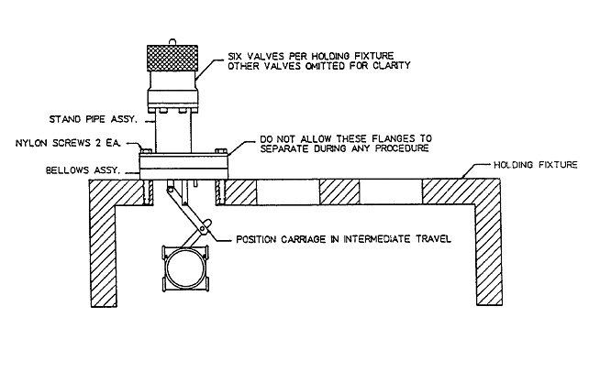
   1. Place the Teflon hanging fixture with up to six (6) valves in an appropriately sized USC.

***NOTE: Position components in such a way as to prevent critical surfaces from touching each other during the ultrasonic cleaning process; failure to do so could result in damage to the part.***

* 1. Fill the tank to the top of the lower flange under the Teflon block with UPW.

***NOTE: Do not operate the USC when the water level is less than 5” deep. Damage to the ultrasonic transducers and/or heaters will result.***

* 1. Add Micro90 to the USC (1.25 oz/gal).
     1. About 300 ml (small USC) or 600 ml (large USC) of Micro90 detergent is added to the USC to create a 1-2% solution.
  2. Turn on the USC heater and set the temperature to ~130°F (54°C).
  3. Turn on USC and allow the component(s) to clean for 50 minutes. This time may be adjusted if the water is preheated.

***NOTE: The UPW/detergent temperature shall be at least 130°F (54°C) for a minimum of 15 minutes.***

1. Don a fresh pair of vinyl/nitrile gloves and turn off the USC. Inspect the component(s) for cleanliness. If the parts do not appear to be clean, return the component(s) to the ultrasonic bath and repeat step 4f above. If the parts appear to be clean, continue.
2. After ultrasonically cleaning the component(s), rinse them in UPW as follows:
   1. Thoroughly rinse the both interior and exterior of part with DI water hose until no soap bubbles are visible (approximately 5 minutes)..
   2. Agitate in first rinse basin 3 times, repeat in the second and third basin.
   3. Rinse again with DI water hose.
3. Remove excess water on the valve components using filtered compressed nitrogen.
4. Park valve(s) in a laminar flow hood or appropriately clean area until a technician from the Assembly Group can install the rubber o-ring in the valve.
   1. This should be performed on the same day and ideally immediately after the previous cleaning steps.
5. Transfer valve components to the C75 bake oven and perform low temperature bake as per the [HOM load and gate valve baking procedure.](https://jlabdoc.jlab.org/docushare/dsweb/Get/Document-75178/CP-C50R-CPR-BAKE-COMP-R1.pdf)
   1. This is typically set for ~10+ hours at 100°C in the nitrogen oven.
   2. The nitrogen flow should be set to 50 PSI and 50 CFM.
6. Bag the components:
   1. Ensure components have dried completely before bagging.
   2. If necessary, dry component with filtered nitrogen.
   3. Bag and seal each component separately.
   4. Repeat process until all components are bagged.
   5. Transport bagged components to the next work center.

# **Revision History**

|  |  |  |
| --- | --- | --- |
| Rev # | Revision or update: | Effective: |
| Release | Initial Release | 04-May-2020 |
|  |  |  |

# **Approvals**

|  |  |  |  |
| --- | --- | --- | --- |
| Approved by: | Name: | Signature: | Date: |
| **Document Owner** | Gregory Grose |  |  |
| **Reviewer** | Ashley Mitchell |  |  |
| Scientific Lead | Gianluigi Ciovati |  |  |
| Project Lead | Kurt Macha |  |  |