C75 MLI Fabrication and Installation

Document Number: | CP-C75-CM-INST-MLI | Approval Date: | TBD
Revision Number: | Rev 1a | Periodic Review Date: | TBD
Document Owner: | John Fischer | Department Owner: | SRF Ops

Purpose and Scope

This procedure will outline how MLI is to be handled, blankets fabricated and installed. Proper MLI installation techniques are necessary to minimize thermal influence on temperature sensitive systems. These systems require a multi layer, highly reflective foil with separating material; such as Cerex or equivalent polyester web-type spacer. Materials must meet JLAB Specs-11141S0038 (DAM) and 11141S0039 (Reemay-2250)

Terms and Definitions

DAM- double aluminized mylar
Reemay- polyester spun separator material- used between the layers of DAM
Cerex- same material as Reemay

Roles and Responsibilities

The following actions are to be performed by knowledgeable, authorized Technicians only. Consult the Group Lead for details.

Procedure

Procedure Material Handling and Blanket Fabrication
1 | Visually inspect the materials to be used (Double aluminized mylar and polyester spun material) Materials should be free of oils and dust, without tears or missing coating, rolled onto 3” center cores. Use JLAB Specs 11141S0038, 11141S0039 as a guide.
2 | Materials are to be loaded into the Rolling Rack for blanket fabrication. Use proper lifting techniques and verify all fasteners are tight once rolls are installed. Loose materials and the rolling rack should be covered when not in use.  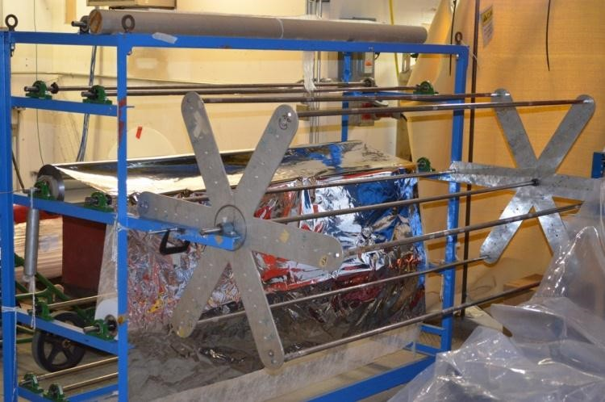
3 | Adjust the outer rolling frame to achieve the proper blanket size. Move the threaded rods where needed.  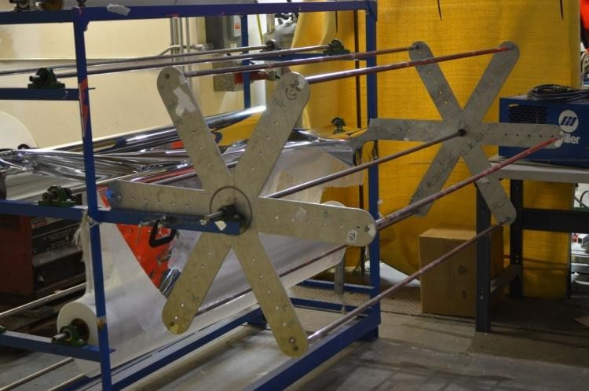
4 | Secure 1 ply each of mylar and poly spun material to the rolling frame spanner, roll the required # of layers which is noted on the specific drawing of the assembly (one layer = 1 ply of each material).

 | 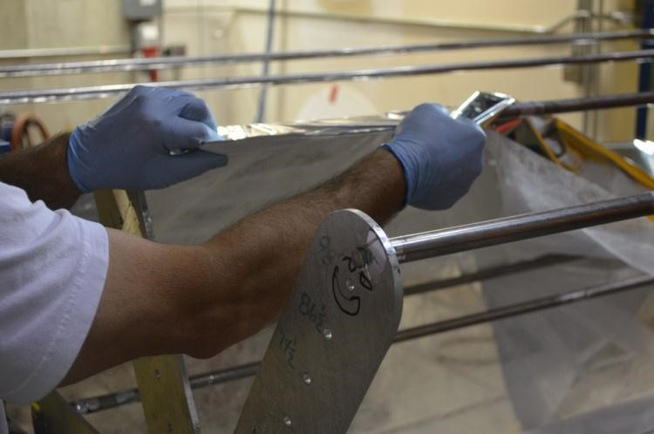
5 | Verify the layer count, once satisfied; install nylon tags around all edges and sporadically throughout to hold the blanket together. Mark and cut the blanket from the rolling spit.  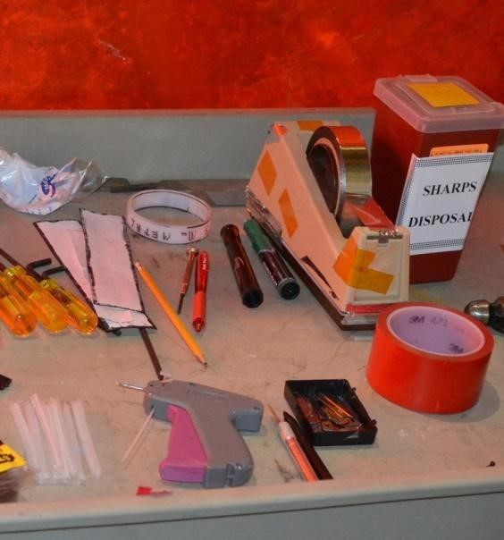
6 | Lay blanket on clean surface and trim to finish size and shape. When trimming, use sharp xacto blade and straight edge. Dispose of used blades properly. (work area blade disposal containers) Add nylon tags where required.  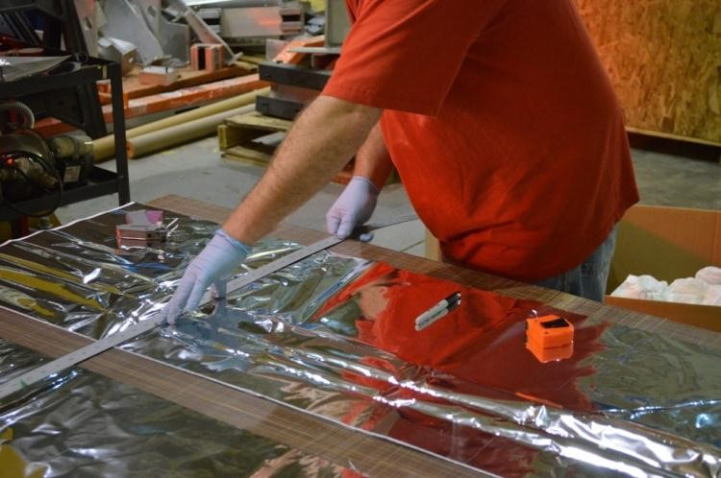
7 | Store blankets in cleans containers until used.

Blanket Installation
1 | Wearing clean gloves, wrap the blanket around the surface to be covered.
2 | When possible, use multiple blankets and stagger the seams a minimum of 2”. Example: if the requirement is 10 layers, fabricate 2 blankets consisting of 5 layers.  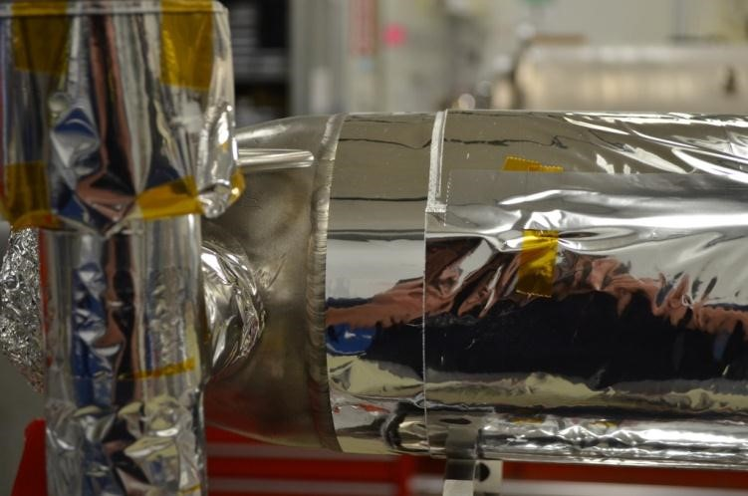
3 | Tack similar layers of blankets together, verify the final fit. Reduce thermal shorts by butting the edges against one another, (DO NOT OVERLAP) and taping only to the same layer.  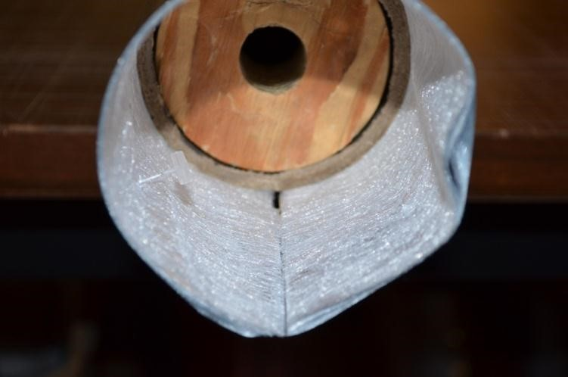
4 | Add nylon tacks where needed to hold the blankets in position or keep edges together.
5 | Tape all butted seams with Mylar tape.  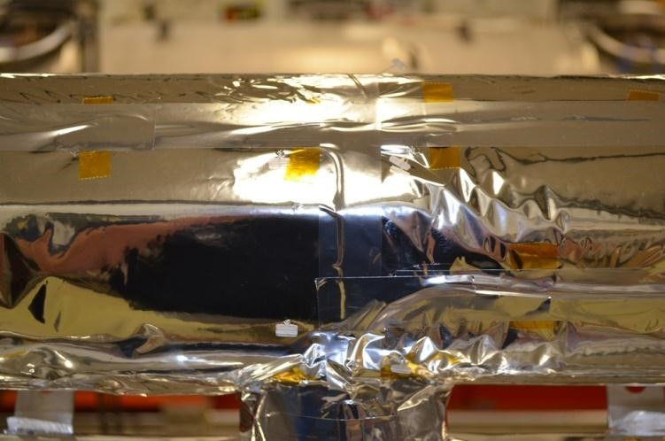
6 | At areas where access doors or openings are required in the MLI, it is acceptable to use Kapton tape around edges across unsimilar layers.  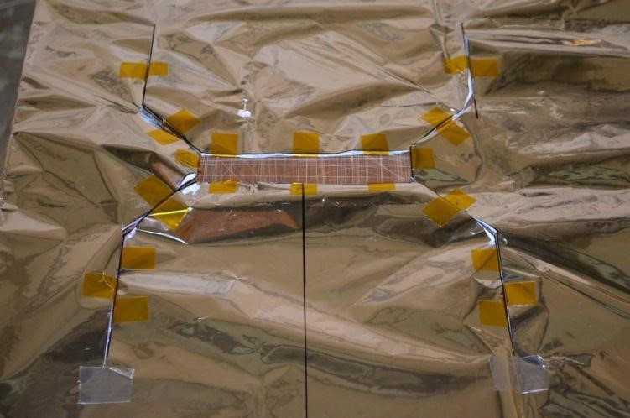
7 | This picture is a representation of a completed 2K circuit MLI layer on a C100 Cold Mass.  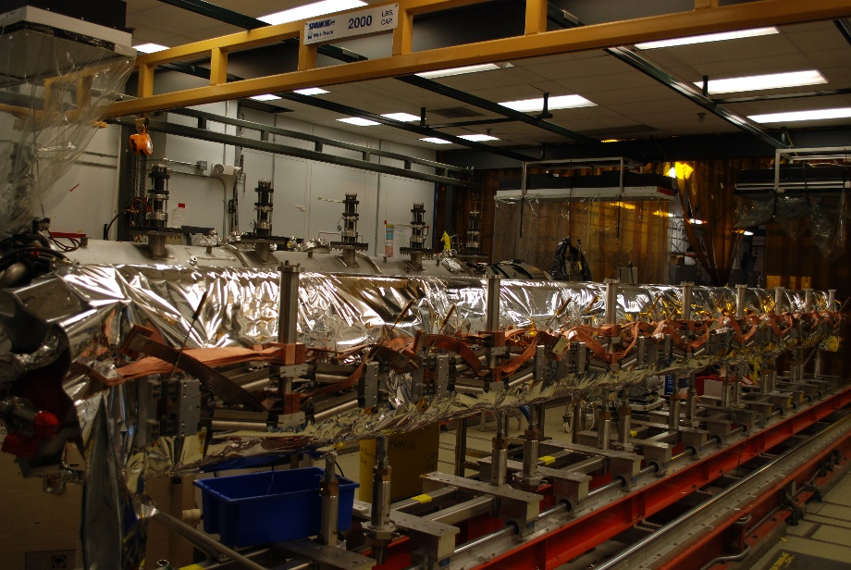

Release and Revision History

Rev # | Revision or update: | Effective:
A | Initial version | 5/5/2020

Approvals

Approved by: | Signature: | Date:
Document Owner | John Fischer | 5/5/2020
Document Reviewer | Ken Worland
C75 Project Manager | Kurt Macha

