C75 Cavity Degreasing Procedure
Document Number: | CP-C75-CAV-CHEM-USC | Approval Date: | 14- May-2020
Revision Number: | - | Periodic Review Date: | 18-Feb-2022
Document Owner: | Alex Wildeson

Purpose and Scope

The purpose of this procedure is provide the steps necessary to ultrasonically clean and cavity in a safe and repeatable manner.

SAFETY:
Individual must keep safety as the first priority in the process; before beginning any job, the user must assure they have the correct PPE for the individual job. Maintaining the level of safety and secure nature of the work area is paramount. Assure personal safety by using caution in movement and taking necessary steps to avoid unnecessary personnel in the immediate area

References

Standard Cavity Degreasing Procedure

Production Chemistry Rooms OSP

Terms and Definitions

- DI/UPW: Deionized (DI) and Ultra-Pure Water (UPW) are used interchangeably in this procedure and may also be referred to as simply water.
- Ultrasonic, USC, and sonic: are used interchangeably in this procedure. The container or tank may also be referred to as a bath.
- PI/PM/SOTR: Principal Investigator, Project Manager, Subcontracting Officer Technical Representative. Someone otherwise in charge of the project or item in question. A supervisor may also be utilized if needed.

Process Details

- Don appropriate PPE:
  - A fresh pair of Class 100 cleanroom compatible nitrile gloves and safety glasses.
  - See room OSP and posted signs for guidance on hearing protection.
- Prepare the 300 gallon USC tank in room 1044.
  - Close the drain valve.
  - Open the DI water valve to start filling the tank.
    - The tank takes about 14 minutes to fill; a timer may be set to ensure the technician closes the valve before the tank overflows.
  - Use the three switches behind the tank to turn on the power, and heat.
- Visually inspect the cavity and flanges for pre-existing damage (chips, scratches, gouges).
  - Contact supervisor or PI/PM if damage is noticed.
  - Note: Some cavities require precleaning (especially if recently lapped). Pre-clean cavities as necessary to remove excessive dirt or residue.
- Transfer cavity to the US using the overhead crane and cavity holding fixture.
  - Ensure the cavity and flanges do not contact the sides of the tank as this could cause damage.
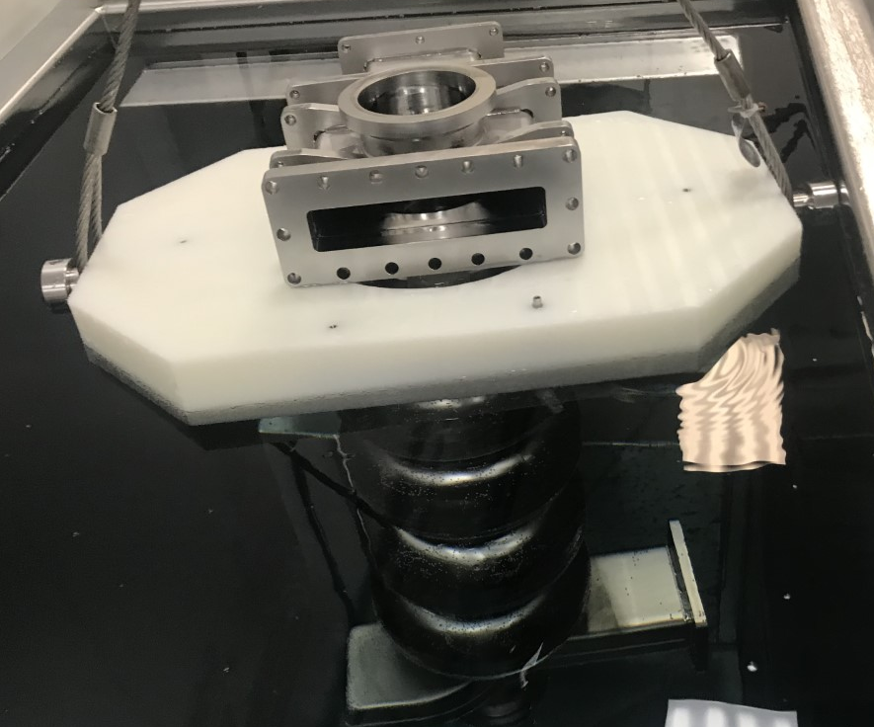

- Once the tank is full, add 1-2% Liquinox (~2.6L) to the tank, pouring the majority of the liquid into the cavity.
- Turn on the switch for the ultrasonic and set the timer for 60 minutes.
  - This time may be shortened (15-30 minutes) if the water was preheated.
- After the USC timer stops, don a fresh pair of nitrile gloves and open the drain valve to empty the tank.
  - Turn off the three switches for power, heat, and USC.
- Rinse cavity thoroughly, for approximately 20 minutes (internally and externally), using the DI water hose next to the tank.
  - Once the tank is empty, use the DI water to rinse the inside of the ultrasonic tank with the valve open to wash out any sediment that might have settled to the bottom.
- Remove the cavity carefully, avoiding contact with any surfaces and the flanges to avoid damage.
  - Tip the cavity slightly to allow pooled water to exit from the HOM and FPC areas.
- Allow cavity to dry in a vertical position for several hours (overnight is preferred) in the laminar flow area of the water room.
- Once dry, don a new pair of nitrile gloves, and prepare the cavity for the next workstation.
  - This generally involves bagging the cavity in nylon bagging material or placing in a cage to move into the clean room pass through.

Revision History

Rev # | Revision or update: | Effective:
Release | Initial Release | 5/14/2020

Approvals

Approved by: | Signature: | Date:
Document Owner | Alex Wildeson | 14-May-2020
Reviewer | Ashley Mitchell
Project Lead | Kurt Macha
Scientific Lead | Gianluigi Ciovati

