|  |  |  |  |
| --- | --- | --- | --- |
| Ionized Nitrogen Parts Cleaning | | | |
| **Document Number:** | CP-C75-CPR-CLN-ION | **Approval Date:** | 22- Feb-2018 |
| **Revision Number:** | R1 | **Periodic Review Date:** | 18-Feb-2022 |
| **Document Owner:** | G. Ciovati |  |  |

## 

# Purpose and Scope

This procedure describes the Ionized nitrogen cleaning of parts for the C75 project

# References

# Terms and Definitions

# Process Details

Spraying with ionized N2 should occur at a distance of about 1 ft from the particle counter collector and in such a way that particulates that might be removed from a surface would be directed towards the particle counter collector.

The following specifications apply to this procedure:

**Spec. 1:** Particle counts are to be zero on all scales except 0.3 µm, which can be zero or 1 in ten seconds.

**Spec. 2:** Particle counts can be 1 count per second or less on the 1µm scale.

The steps to clean parts for C75 assemblies are outlined below:

1. All associated hardware and flanges should already be UHV cleaned, bagged and ready in the production pass-through.
2. The parts cart shall be cleaned off with alcohol and several clean-room wipes spread out for the parts to rest on. Remove the associated hardware from the pass-through and layout on a table to ensure all the parts are there.
3. The table above which parts are going to be cleaned shall be sprayed with ionized N2 until the counts drop below 1 on all scales **before** any of the parts are blown off. If this particle count cannot be achieved by spraying N2, the table will need to be wiped down with DI water and be allowed to dry prior to checking its cleanliness again.
4. Appropriate sized dust covers for all flanges (stainless covers with Gore-Tex gaskets, shown in Fig. 1) will be sprayed until they meet or exceed Spec. 2 on the particle counter and placed on cart.

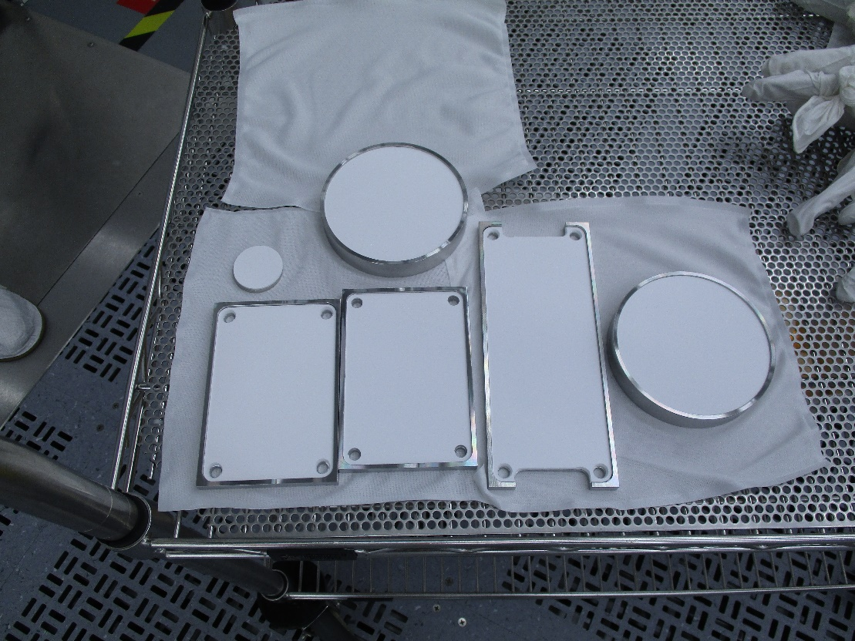

**Fig. 1**. Stainless Steel dust covers with Gore-Tex gaskets for C75 cavities.

1. The tips of an appropriate number of spring clamps wrapped with gloves shall be sprayed until they reach or exceed Spec 2 on the particle counter and placed on cart.
2. Dust covers can now be placed on assembly in accordance with the appropriate assembly procedure.
3. As the assembly parts (elbows, HOM loads, inner adapter, doglegs, Nb blanks) are removed from the bags, they shall be inspected visually for any defects that might cause problems with sealing during the assembly. If any scratches or defects are found, the part shall not be used for the assembly. If the issue cannot be resolved immediately, the assembly will be delayed until replacement or repaired parts are available.
4. As parts are placed on the cart, ensure that they are laid out in a manner that allows the assembly tech to pick up the needed pieces without reaching over any parts that will be used later in the assembly.
5. If the assembly will require any number of sub-assemblies, perform the following steps. If no sub-assemblies are needed move on to the next step.
   1. Any hard-metal gaskets needed for sub-assemblies can be sprayed with ionized N2 until they are able to meet or exceed Spec. 1on the particle counter. Place the gaskets on the parts cart.
   2. Any indium wire gasket shall be cleaned and formed in accordance with the appropriate procedure.
   3. At this time all the sub-assembly flanges shall be sprayed with the ionized nitrogen until all counts reach Spec. 2on the particle counter. They shall then be placed on a cloth wiper on the parts cart.
   4. These parts can now be put together and made into the appropriate sub-assemblies or for parts requiring the indium wire gasket, the In wire can now be pressed onto the flange.
   5. The sub-assemblies or assembly parts with In wire can now be sprayed again until they reach or exceed Spec. 1 on the particle counter.
6. All flanges and associated hard-metal gaskets shall be sprayed with ionized N2 until they reach or exceed Spec. 1 on the particle counter. Parts can be carefully placed on cart.
7. Press the indium wire gasket onto the surface of the assembly part in accordance with the appropriate procedure.
8. Spray the surfaces on which the In wire was pressed on with ionized N2 until Spec. 1 is met or exceeded.
9. Two bolts(studs) and associated nuts(nut plates) and washers for each flange shall be sprayed until they reach or exceed Spec. 1 on the particle counter and set on a cloth on the parts cart. *Any bolts shall be held by their threads and the heads sprayed first. Then spray the threads to Spec. 1 and place on the cart.
10. For the assembly of the inner adapter, all 16 silver plated bolts should be sprayed with ionized N2. For the assembly of the two end dishes, all 16 silver plated bolts should be sprayed with ionized N2.
11. All tools to be used during assembly shall also be sprayed until they reach or exceed Spec. 2 and placed on the cart.
12. After all the proceeding steps are satisfied, the cart can be moved to the assembly area.

# **Revision History**

|  |  |  |
| --- | --- | --- |
| Rev # | Revision or update: | Effective: |
| Release | Initial Release | 4/16/2010 |
| A | Changes made to procedure | 7/15/2011 |

# **Approvals**

|  |  |  |
| --- | --- | --- |
| Approved by: | Signature: | Date: |
| **Document Owner** | G. Ciovati |  |
| **Reviewer** | D. Forehand |  |
| **Reviewer** | K. Davis |  |
| Project Manager | K. Macha |  |