Traveler Title | C75 Tuner Assembly Traveler
Traveler Abstract | This assembly traveler outlines the necessary processes and checkpoints to correctly assemble the C75 Tuner Assembly. This work is to be performed by authorized, knowledgeable, and properly trained CMA staff.
Traveler ID | C75-CU-ASSY-TUNE
Traveler Revision | R1
Traveler Author | John Fischer
Traveler Date | 19-May-20
NCR Informative Emails | reilly,fischer,worland,macha,cheng
NCR Dispositioners | Fischer,macha,cheng
D3 Emails | reilly,fischer,worland,macha,cheng
Approval Names | John Fischer | Ken Worland | Kurt Macha | Gary Cheng
Approval Signatures
Approval Dates
Approval Title | Author/CMA Lead | Technical Reviewer | Project Manager | Engineering Review/Magnetic Hygiene

References | List and Hyperlink all documents related to this traveler. This includes, but is not limited to: safety (THAs, SOPs, etc), drawings, procedures, and facility related documents.
11126-0001 HV Magnetic Hygiene | 11126-0001 HV Magnetic Hygiene 2 | 11161-0001 Tuner Assembly Magnetic Hygiene | 11161-0001_Tuner sub-assemblies Magnetic Hygiene | JL0041512-A-HOM Stiffener Assembly Dwg
JL0042398-B Helium Vessel Magnetic Shielding Dwg | CP-C75-CU-RWRK-FTRT | CP-C75-CU-RWRK-TUNC | CP-C75-CU-TUNE-TUNC

Revision Note
R1 | Initial release of this Traveler.

Step No. | Instructions | Data Input
1 | Receive the cavity pair  - Record beamline vacuum, time , date, and cavity serial numbers.  - Start ion pump if in place.  - Ensure all thumbscrews and locks are tight.  - Verify serial numbers are correct.  - Visually inspect cavities, note any findings.  - Tape valve handles, to ensure they stay in the closed position  - Assign a Cryounit sequence number and record | [[BeamlineVacuum]] <<SCINOT>>  [[Date1]] <<TIMESTAMP>>  [[CavitySNLeft1]] <<SN>>  [[CavitySNRight1]] <<SN>>  [[CUSN]] <<CUSN>>  [[Comment1]] <<COMMENT>>  [[CMATech1]] <<SRF>>
2 | Review the CMM data, ensure any out of tolerance features are still usable by consulting the SME. Generate the necessary D3/NCR to document any variation. | [[CMATech2]] <<SRFCMP>>  [[Date2]] <<TIMESTAMP>>  [[Comment2]] <<COMMENT>>
3 | Install 2 fluxgates onto the Cavity Pair as shown in the attached document, then initiate them. The signals are to be live and shared via the web. Fluxgate Installation Document  Record the date, starting and finishing time of the major assembly steps identified in the spreadsheet “C75-01 assembly activities logbook” while going through the tuner assembly steps. Enter the data to the worksheet corresponding to the cryounit being worked on. This sheet will be uploaded at the end of this Traveler.  C75-01Assembly Activities Logbook | [[ElectricalTech3]] <<SRF>>  [[CMATech3]] <<SRFCMP>>  [[Date3]] <<TIMESTAMP>>  [[Comment3]] <<COMMENT>>
4 | Gather, measure, and demagnetize the tuner items and hardware following the Magnetic Hygiene Procedure CP-C75-CM-HYG’s sections applicable to the Tuner Assembly. Upload any comments, such as deviations from the magnetic hygiene procedure. | [[CMATech4]] <<SRFCMP>>  [[Date4]] <<TIMESTAMP>>  [[Comment4]] <<COMMENT>>
5 | Verify the Tuner cell holders have been machined to fit the C75 cell shape.C75 Cell Holder Modification Dwgs  Rework the Tuners, Drives, and Rotary Feedthrus using the Referenced Procedures. Complete and upload the Checklist.  CP-C75-CU-RWRK-FTRT, CP-C75-CU-RWRK-TUNC, C75 Tuner Assembly Check List | [[CMATech5]] <<SRFCMP>>  [[CellHolderMachined]] <<YESNO>>  [[TunerDriveReworked]] <<YESNO>>  [[RotaryFTReworked]] <<YESNO>>  [[Date5]] <<TIMESTAMP>>  [[Comment5]] <<COMMENT>>  [[TunerCheckList]] <<FILEUPLOAD>>
6 | Assemble the swivel type cell holders onto the outboard cells of the cavities. One on each cavity.  C75 Tuner Top Assembly Dwg | [[SwivelCellHolderSNleft6]] <<SN>>  [[SwivelCellHolderSNright6]] <<SN>>  [[CMATech6]] <<SRF>>  [[Date6]] <<TIMESTAMP>>  [[Comment6]] <<COMMENT>>
7 | Assemble the fixed type cell holder assembly onto the inboard cell of the cavity. One on each cavity. | [[LeftCellHolderSN7]] <<SN>>  [[RightCellHolderSN7]] <<SN>>  [[CMATech7]] <<SRF>>  [[Date7]] <<TIMESTAMP>>  [[Comment7]] <<COMMENT>>
8 | Install the cell holder caps and positioners.  **CAUTION: Keep the cell holders loose, cavities could be crushed if hardware is too tight.** | [[CMATech8]] <<SRF>>  [[Date8]] <<TIMESTAMP>>  [[Comment8]] <<COMMENT>>
9 | Shim to achieve .014 to .020 clearance between the cell and cell holder. **If clearance exceeds .020, machine the cell holder cap to achieve proper clearance.**  * N O T E *  It may be necessary to adjust the nylon centering  screws to achieve 0.014 to 0.020 clearance. | [[CMATech9]] <<SRF>>  [[Date9]] <<TIMESTAMP>>  [[Comment9]] <<COMMENT>>
10 | When the proper clearance is achieved, install the nylon jamb nuts onto the cell holder centering screws. Upload the shim documentation record.  Shim documentation work sheet found at;Shim Documentation Worksheet | [[CMATech10]] <<SRF>>  [[Date10]] <<TIMESTAMP>>  [[Comment10]] <<COMMENT>>  [[ShimDocumentation10]] <<FILEUPLOAD>>
11 | Ensure that all hardware that will become inaccessible when the swivel yolk assemblies are installed are tight  before proceeding to the yoke installation. | [[CMATech11]] <<SRF>>  [[Date11]] <<TIMESTAMP>>  [[Comment11]] <<COMMENT>>
12 | Install the swivel yoke assembly onto the swivel cell holder. | [[SerialNoLeft12]] <<SN>>  [[SerialNoRight12]] <<SN>>  [[CMATech12]] <<SRF>>  [[Date12]] <<TIMESTAMP>>  [[Comment12]] <<COMMENT>>
13 | Install the reworked ball screw shaft assembly. Then ensure that the movement of the gimbals in the yokes are shimmed properly for play and swing.  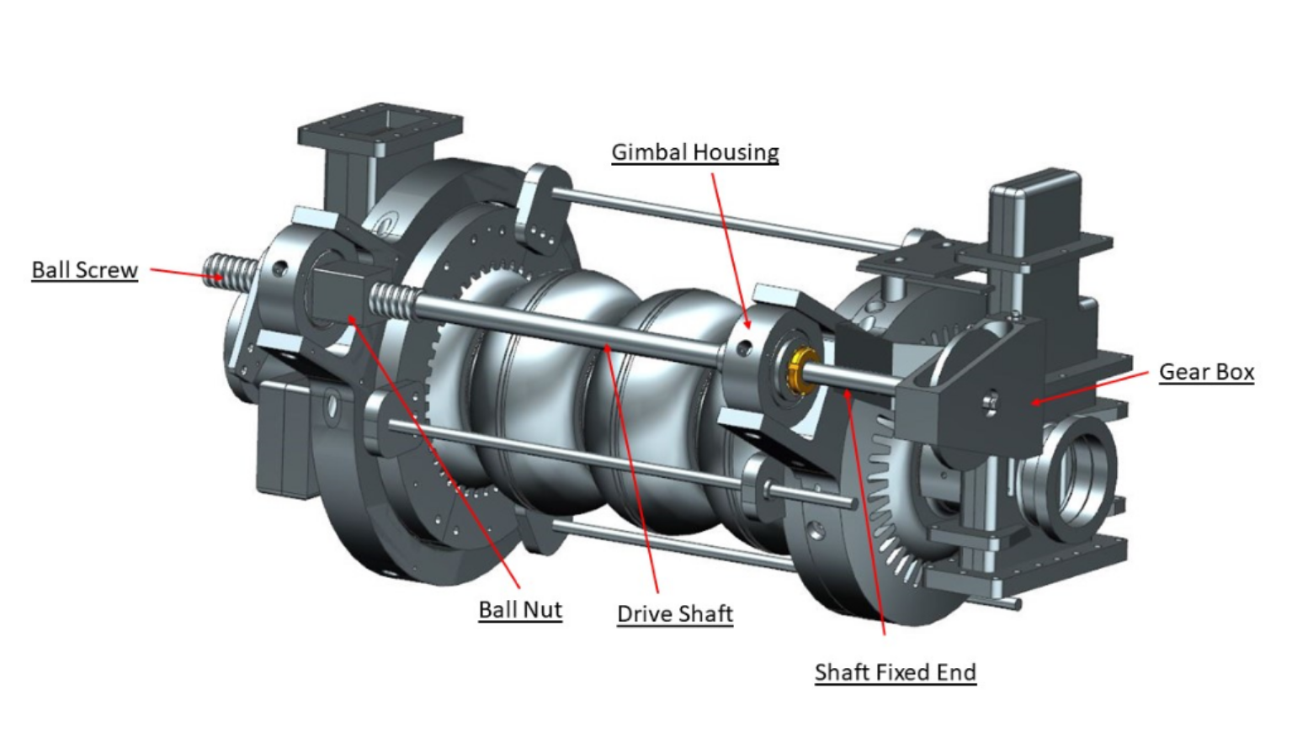 | [[CMATech13]] <<SRF>>  [[Date13]] <<TIMESTAMP>>  [[Comment13]] <<COMMENT>>
14 | Measure then adjust the drive link to make the cell holders. Temporarily install the fulcrum bar and matchmark. Remove and drill a ½”hole. | [[CMATech14]] <<SRF>>  [[Date14]] <<TIMESTAMP>>  [[Comment14]] <<COMMENT>>
15 | Once drilled, install the fulcrum bar and ½” pin. Place tie wire into the pin holes to keep it in place.  (note: ream ½” dia. hole with .501 reamer) | [[CMATech15]] <<SRF>>  [[Date15]] <<TIMESTAMP>>  [[Comment15]] <<COMMENT>>
16 | Loosely install three stop struts per cavity, orient them 120 degrees apart as shown in the view in step 21. | [[CMATech16]] <<SRF>>  [[Date16]] <<TIMESTAMP>>  [[Comment16]] <<COMMENT>>
17 | Tighten the fasteners on the ball screw shafts, these will be covered in the following steps. | [[CMATech17]] <<SRF>>  [[Date17]] <<TIMESTAMP>>  [[Comment17]] <<COMMENT>>
18 | Install the wiring harness, diodes (2 midplane only), and limit switches. Verify all instrumentation.  Cryounit Wiring Diagram | [[ElectricalTech18]] <<SRF>>  [[Date18]] <<TIMESTAMP>>  [[Comment18]] <<COMMENT>>
19 | Calculate, record, and set hardstops and limit switches using the following documents that are found in  CP-C75-CU-TUNE-TUNC. C75 Tuner Offset Calculation Worksheet, C75 NWA Worksheet | [[CMATech19]] <<SRF>>  [[Date19]] <<TIMESTAMP>>  [[Comment19]] <<COMMENT>>  [[TunerOffset19]] <<FILEUPLOAD>>  [[AnalyzerWorksheet19]] <<FILEUPLOAD>>
20 | Once the hardstops have been set, adjust the spring gaps to 1.70”. | [[CMATech20]] <<SRF>>  [[Date20]] <<TIMESTAMP>>  [[Comment20]] <<COMMENT>>
21 | Install the HOM support brackets (x4), and the center cavity hanger support brackets (x2) .Do not put stress onto the indium seal joints.  JL0041512 HOM Stiffener Bracket Assembly Dwg  JL0044517 Center Cavity Hanger Support Dwg  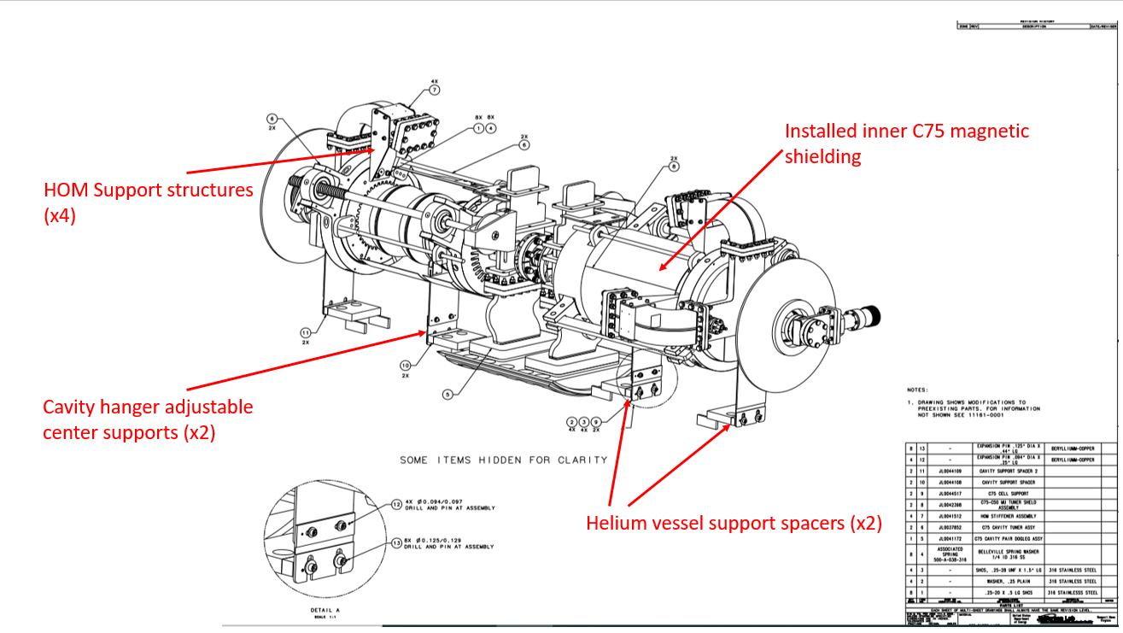 | [[CMATech21]] <<SRF>>  [[Date21]] <<TIMESTAMP>>  [[Comment21]] <<COMMENT>>
22 | Check all of the Tuner Assembly and HOM Stiffener fasteners for tightness. | [[CMATech22]] <<SRF>>  [[Date22]] <<TIMESTAMP>>  [[Comment22]] <<COMMENT>>
23 | Re-check all fasteners are tight. | [[Comment23]] <<COMMENT>>  [[Technician23]] <<SRF>>  [[Date23]] <<TIMESTAMP>>
24 | Install the inner magnetic shielding over the cavities and cell holders. Do not distort the material, shielding  factor could be harmed.  JL0042398 Cavity Magnetic Shielding Dwg  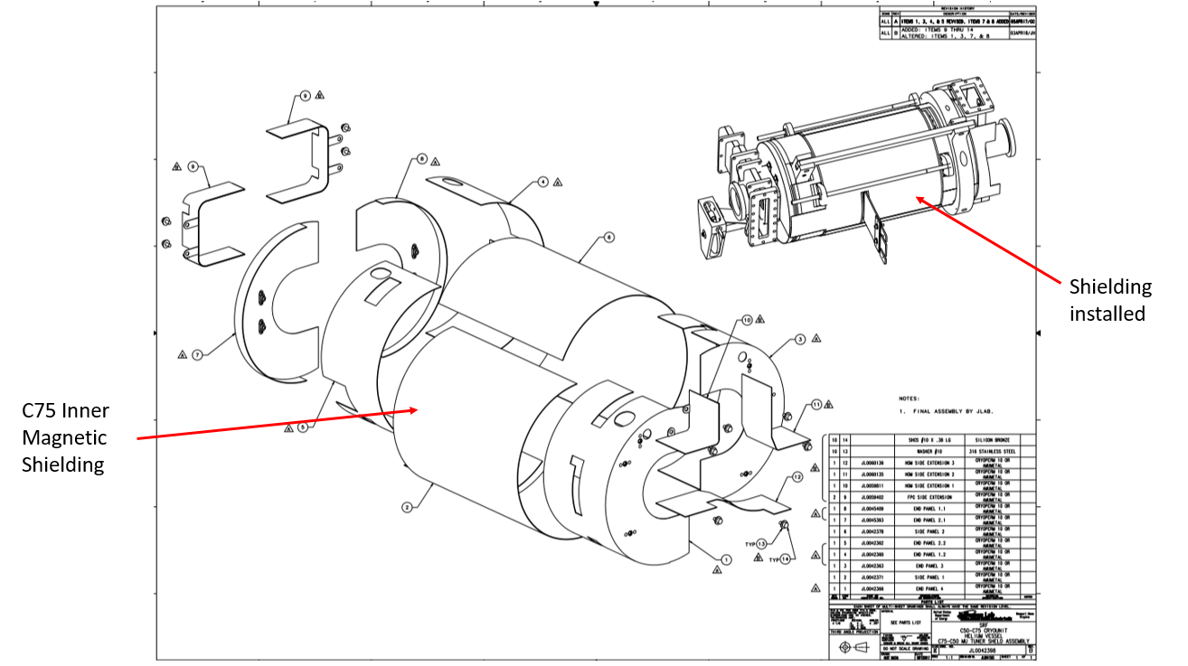 | [[CMATech24]] <<SRF>>  [[Date24]] <<TIMESTAMP>>  [[Comment24]] <<COMMENT>>
25 | Install the G=10 drive assembly onto the ¼” shaft on the right angle drive. Align the holes between the mating parts and install the roll pin. Tighten the secondary fasteners in the flex coupling.  G-10 Drive Assembly Dwg | [[CMATech25]] <<SRF>>  [[Date25]] <<TIMESTAMP>>  [[Comment25]] <<COMMENT>>
26 | Hold-point for Supervisor inspection and sign off.  Review, then upload the “Magnetic Hygiene Record Spreadsheet”  Cavity is ready to be installed into the Helium Vessel. | [[Supervisor26]] <<SRF>>  [[Date26]] <<TIMESTAMP>>  [[Comment26]] <<COMMENT>>  [[Mag Hygiene2]] <<FILEUPLOAD>>

