**1. Overall view of LCLS-II NCRs**

As of May 2020, the total number of NCRs in LCLS-II is 1956. These NCRs were generated by 44 travelers. Figure 1 and Figure 2 show the number of NCRs for each traveler, with the travelers organized by different standards.

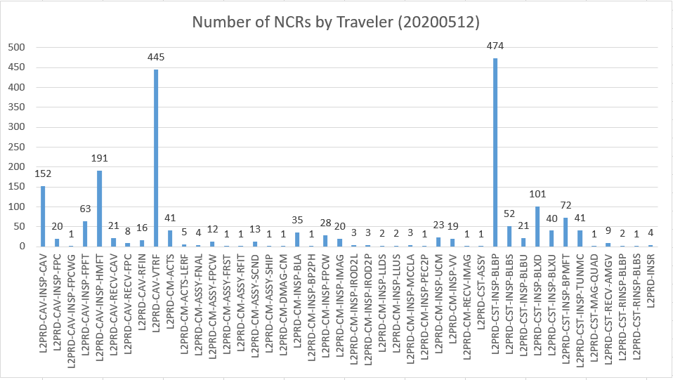

Figure 1. Number of NCRs generated by L2PRD travelers, organized by traveler name, from A to Z

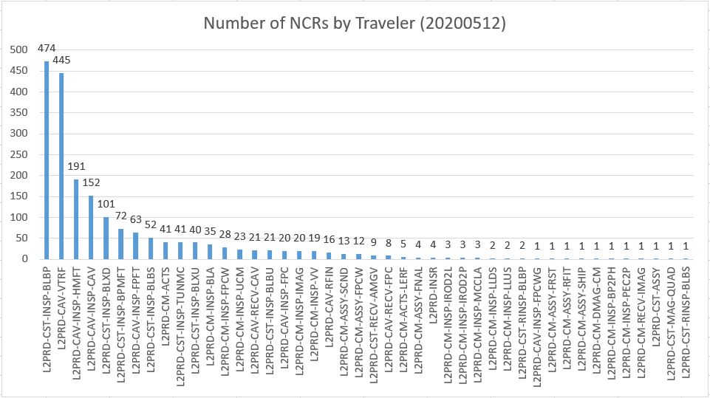

Figure 2. Number of NCRs generated by L2PRD travelers, organized by number of NCRs, from largest to smallest

Table 1 shows the NCR summary for components with more than 100 NCRs generated, e.g. the first 5 travelers from the left in Figure 2. Considering some components have very similar structure and function, such as: short beamline bellows and production beamline bellows, HOM feedthrough and field probe feedthrough, they are grouped together in Table 1. The types of defects for some of the components are summarized in Figure 3-6.

Table 1. NCR summary for selected components

|  |  |  |  |
| --- | --- | --- | --- |
| **Component name** | **Number of NCRs** | **Process** | **Types of defects** |
| Beamline bellows (BLBP,BLBS) | 526 | Inspection | See Figure 3 |
| Cavity | 445 | VTRF | Q0,FE,Eacc,Qext2,Qhom,Vacuum,Frequency,KLorenze |
| Feedthrough (HMFT,FPFT) | 254 | Inspection | See Figure 4 |
| Cavity | 152 | Inspection | See Figure 5 |
| Long spool (BLXD) | 101 | Inspection | See Figure 6 |

Figure 3. NCR types in beamline bellows inspection, short (BLBS) and regular (BLBP)

Figure 4. NCR types in cavity feedthrough inspection, HOM probe feedthrough and field probe feedthrough

Figure 5. NCR types in cavity inspection

Figure 6. NCR types in long spool inspection

There are 22 check boxes (equivalent to type of defects, classification, and categories in this research) in the L2PRD NCR traveler:

* [1] Shipping Damage;
* [2] Dimensional;
* Surface Form: [3] Roughness, [4] Flatness, [5] Parallelism;
* Surface Damage: [6] Scratches, [7] Dings, [8] Delamination, [9] Plating;
* Surface contamination: [10] Stains, [11] Oxidation, [12] Residues;
* RF Components: [13] Inspection Failure, [14] RF Test Failure, [15] Leak Test Failure;
* [16] CMTF RF Performance;
* [17] VTA RF Performance;
* Cryomodule: [18] Vacuum, [19] RF, [20] Instrumentation, [21] Mechanical;
* [22] Other.

They seem to be organized according to some general guideline in the LCLS-II NCR traveler, but it is not very clearly defined if each category applies to all components or certain component. It is up to each user to assign one or more categories for each NCR. Among the 22 categories, DELAMINATION [8] was never used. Figure 7 shows the number of NCRs for each category. Figure 8 shows an overall view of the classification breakdown for each traveler.

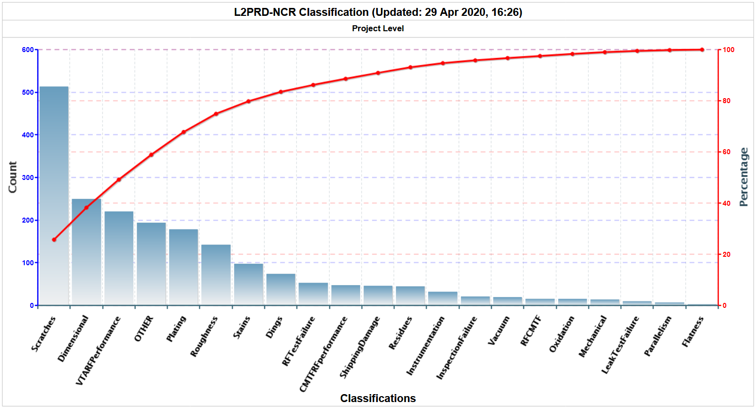

Figure 7. Number of NCRs for each category for LCLS-II

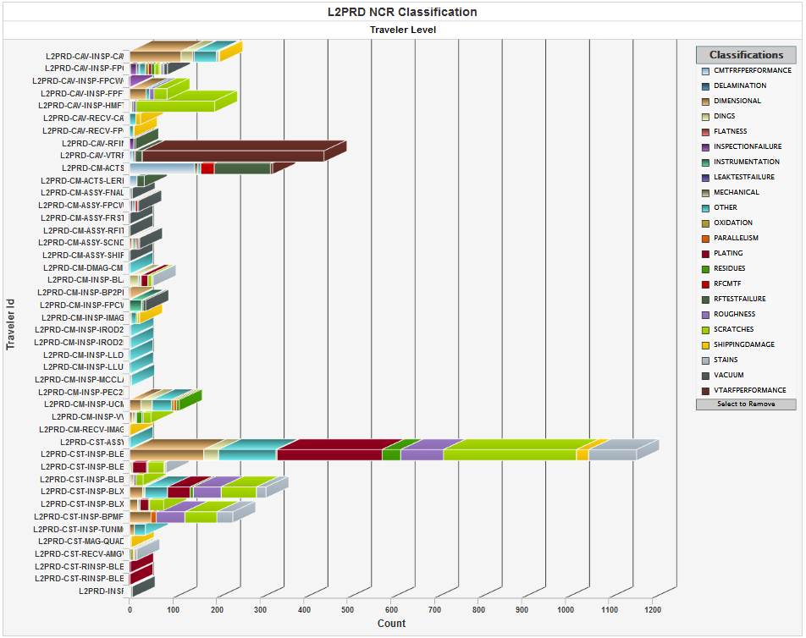

Figure 8. Overall view of number of NCRs for each LCLS-II traveler with classification breakdown

**2. Zooming in on “OTHER” category in LCLS-II NCRs**

There are 191 NCRs with “Other” category selected. Table 2 shows more details of the component, number of NCR associated with “Other” category, the process prompting the NCR, and description of the issue that is not covered in existing NCR category.

Table 2. Summary of NCRs with “Other” category selected

|  |  |  |  |  |
| --- | --- | --- | --- | --- |
| **Part** | **Count** | **Process** | **Sub-count** | **Issue** |
| CAV (cavity) | 50 | Inspection | 32 | Mag, Torq, Burst disk, RAV, Config, Bellows |
| Receiving | 14 | Indicator |
| VTRF | 4 | Qext2, Emax |
| BLBP (BL bellows) | 39 | Inspection | 39 | Burr on SS, Mag, Weld, Blister |
| TUNMC (tuner) | 23 | Inspection | 23 | Missing item, Mag |
| FPC | 14 | Inspection | 6 | Shipping, Knife edge, Ceramic |
| Receiving | 8 | Shipping, Documentation |
| BLXD (long spool) | 12 | Inspection | 12 | Weld, SS defects |
| IMAG (mag shield) | 12 | Inspection | 12 | Weld seam, Missing caps, Open gap, Dent, Scratch |
| UCM | 11 | Inspection | 11 | Weld, Missing items, Configuration deviation |
| FPFT (field probe) | 5 | Inspection | 5 | Braze, Threads |
| CM | 4 | Assembly | 1 | Warm coupler damage |
| DMAG | 1 | Magnetic field |
| ACTS | 2 | FPC tuner, Piezo tuner |
| IROD2L (invar rod) | 3 | Inspection | 3 | Weld |
| IROD2P (invar rod) | 3 | Inspection | 3 | Weld |
| BLA | 2 | Inspection | 2 | Residue, Braze |
| BLXU (short spool) | 2 | Inspection | 2 | SS defects, Weld |
| LLUS (liquid level) | 2 | Inspection | 2 | Heater |
| VV | 2 | Inspection | 2 | Threads, Seal concern |
| AMGV (gate valve) | 1 | Receiving | 1 | Configuration deviation |
| CST (string) | 1 | Assembly | 1 | Tooling |
| HMFT (HOM probe) | 1 | Inspection | 1 | Center connector |
| LLDS (liquid level) | 1 | Inspection | 1 | Heater |
| MAG (magnet) | 1 | Inspection | 1 | Shipping |
| MCCLA (MC coupling line) | 1 | Inspection | 1 | Weld |
| End Switch Bracket | 1 | Inspection | 1 | Threads |

**3. Observation and comments**

Some categories overlap and can be confusing while assigning. The same categories were selected by different users for different components for completely different issues. For example, PLATING [9] is under SURFACE DAMAGE [6-9], but plating issue can include other categories in SURFACE DAMAGE and SURFACE CONTAMINATION [10-12]. INSPECTION FAILURE [13] is a big category that can include many other categories. (Cryomodule) RF [19] and CMTF RF PERFORMANCE [16] seem to refer to the same type of issue, and the existence of (RF components) RF TEST FAILURE [14] and VTA RF PERFORMANCE [17] makes it more vulnerable to user dependency. User training for each traveler is recommended to reduce user dependency in filling out traveler/NCR and collecting high quality data.

Not all components can use the provided issue categories in current LCLS-II NCR traveler. Those ended up using “OTHER” category.

Cavity VTRF does not have sub-categories, which make it difficult to get statistics for different types of NCRs within VTRF if needed.

Category of NCRs may need better differentiation among different components. Each SOTR may have different definition of defects associated with their components.

Recommendation (Anne – 12Jun2020 )

Between large projects we have often conducted a review of our categories for types of defects – it would be good to do this again as L2 winds down, and new projects such as SNS and HE are starting – will set this up , working with Liang, Valerie and the Work center leads

As a secondary objective, propose that Liang assisted by others will collect the KPIs for Cavity & CM test to see if we cannot come up with a common set that can be used across all projects (these are where we often need customer approval for the NCRs – and so need special reports

Comments from Valerie :

I think this is a great evaluation!

If Categories need to change then we (SRFOPS) need to figure out a way to do this which will be useful for ALL PROJECTS. I think going to a per project basis could be confusing to the inspectors/testers (who are usually the same people regardless of project). Better definitions could/should be written and possible training, but that would be QA based, in that the software just gives the selection possibilities and not the criteria to be used (subjective)