Traveler Title | Harmonic kicker bench RF measurement Procedure
Traveler Abstract | Bench RF mockup measurement of harmonic frequencies, Q0 value to determine the trimming amount of hardware before the last EBW of cavity fabrication.
Traveler ID
Traveler Revision | R1
Traveler Author | Gunn Tae Park
Traveler Date | 06/11/2020
NCR Informative Emails
NCR Dispositioners
D3 Emails
Approval Names | Haipeng Wang
Approval Signatures
Approval Dates
Approval Title | Author | Reviewer | Project Manager

References

Revision Note
R1 | Initial release of this Traveler.

Step No. | Instructions | Data Input
1 | Have five items-the outer conductor (OC), the center conductor (CC), a set of five mockup plungers, the bottom cap (BC), and a pair of the mockup couplers on the bench. Using an overhead hoist, perform a clamp-up assembly in vertical orientation:  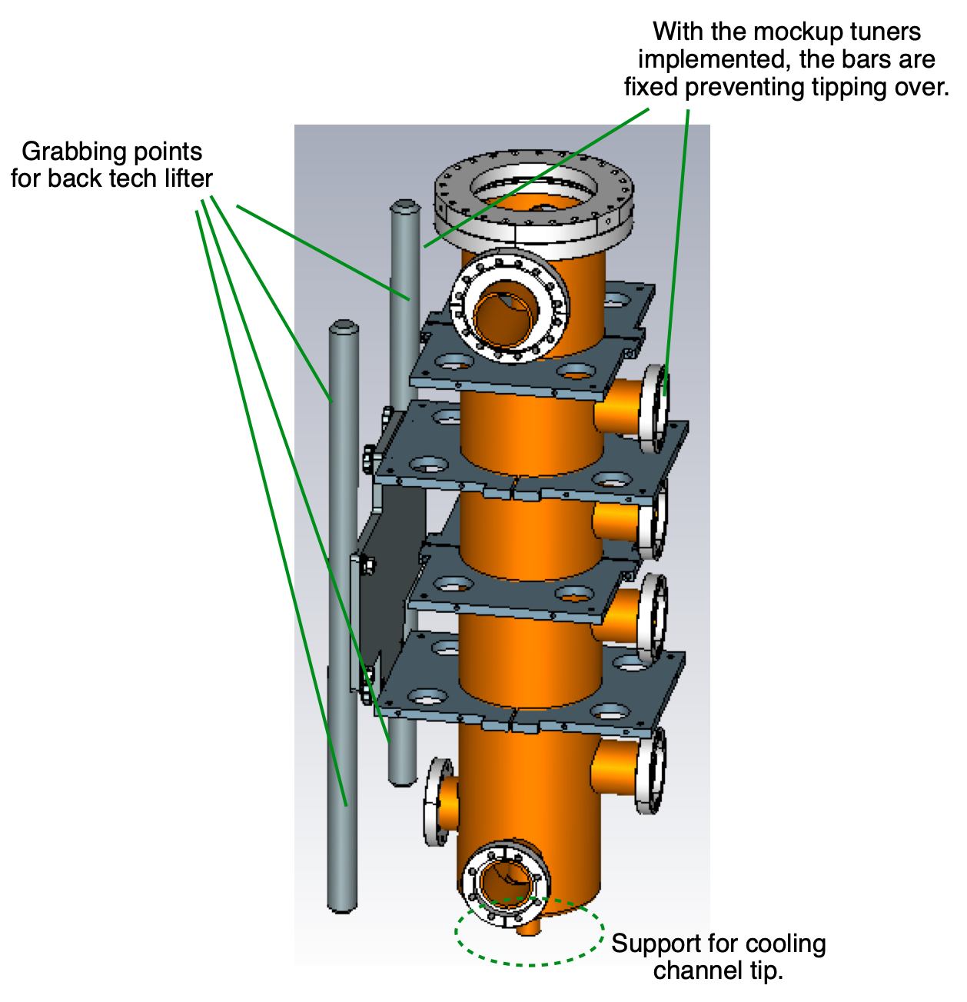
 | Place the CC on the bench ground. Let the backtech lifter grab the bar of the fixture to the OC and lift up by ~1m upside down. Align the two centers (of CC and OC) and slowly lower the outer conductor. Place the BC on top. The BC surface is set to be flush with the beam port ID using the copper gasket and shimming adjustment.  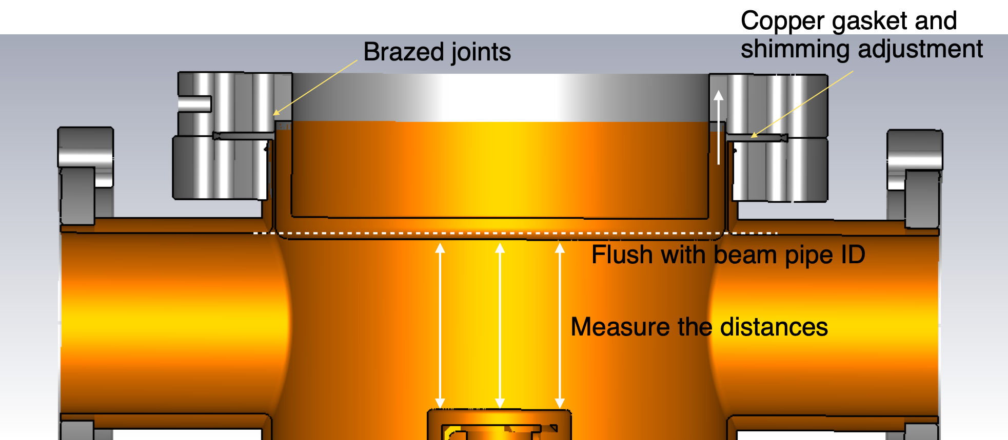  Measure the distances between the CC cap and the BC surface through open beam pipe ports in three places around the cap perimeter. The length for the first cut of the outer conductor should be distance with (distance with shimming-70)mm | Distance (reference): 72mm  Distance without shimming nor gasket  Distance 1:  Distance 2:  Distance 3:  Distances with shimming  Distance 1:  Distance 2:  Distance 3:
2 | Mount the mockup stubs on five tuner port blank flanges and obtain the insertion length of the stubs:  Measure the stub lengths from the top of stub to the flange flushing surface.  Write down the stub lengths, positions and install them by crashed copper gaskets and flange bolts.  Measure the MDC flange-to-flange distance on five stub tuner positions.  The inserted stub length should be calculated by:  Insertion length =stub length-(flange-to-flange)+rotatable flange thickness+blank flange thickness – port length (from rotatable flange surface to outer conductor ID position) = 15mm  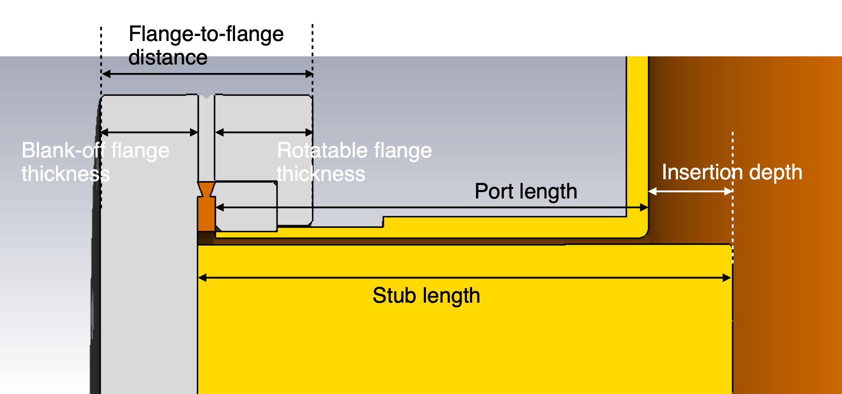  Install the mockup input coupler and pickup coupler. Connect the N-type RF cables to the VNA (Vector Network Analyzer) for S21 measurement | Stub length (reference): 95.5mm  Stub length  Flange-to-flange distance  Rotatable flange thickness  Blank-off flange thickness  Port length (reference):81.58mm  Port length  Insertion length
3 | Using the VNA, make the first measurement (frequencies of the lowest five resonant modes) roughly around 86.6MHz, 259.8MHz, 433MHz, 606.2MHz, and 779.4MHz: The S11 and S22 measurement should be done first to make sure that both coupling would be relative weak not affecting the cavity frequencies. FPC input beta1 should be <1 or ~1 and FP pickup beta2 should be <<1. | The lowest five resonant frequencies and coupling betas:  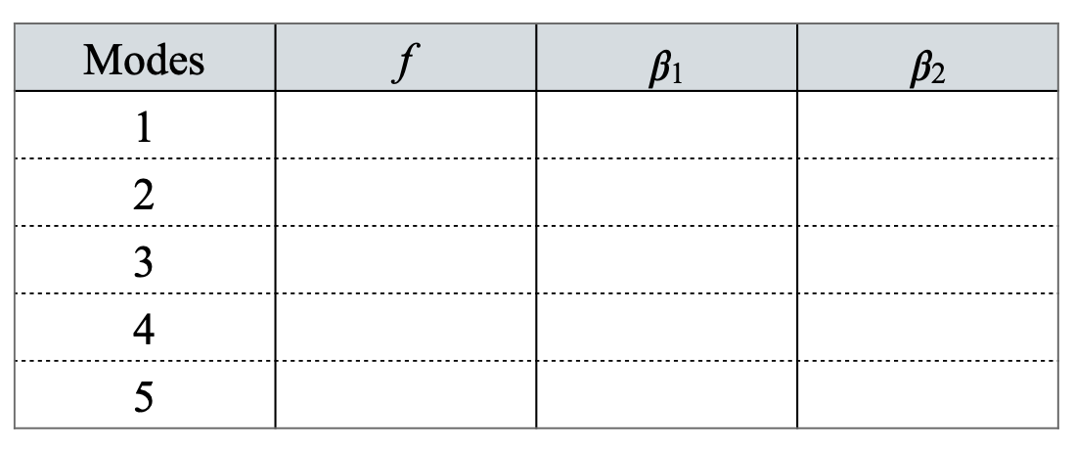
4 | Disassemble the assembly in opposite order of step 1. Deliver the outer conductor to the machine shop for the cut.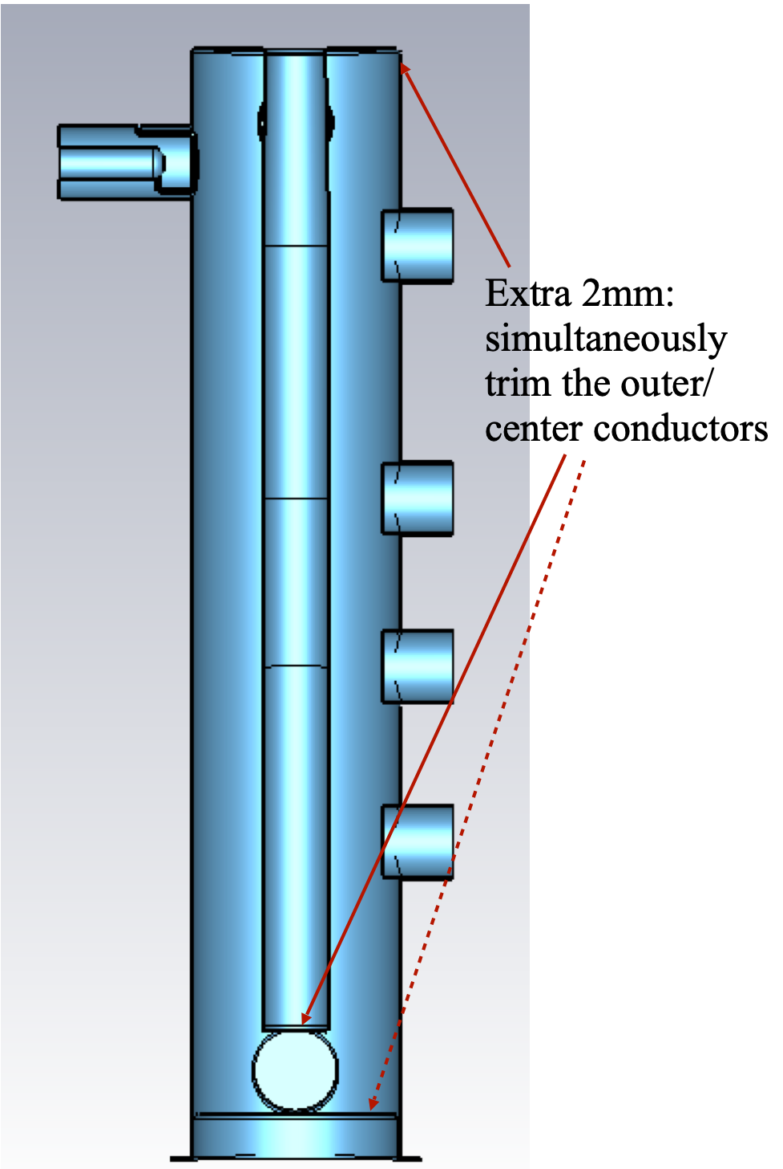 | Trimmed lengths:  OC
5 | The second RF measurement: repeat the steps 1-3. | The lowest five resonant frequencies. The coupling beta’s should not change much compared to the first RF measurement
6 | Deliver the outer conductor and the inner conductor to the machine shop for the second cut. | Trimmed lengths:  OC  CC
7 | The third RF measurement: repeat the steps 1-3. | The lowest five resonant frequencies. The coupling beta’s should not change much compared to the first RF measurement
8 | Establish a linear fit to frequency sensitivity. | The frequency sensitivity for five harmonic modes.
9 | Make a final cut for predicted target frequencies (cavity frequencies after final welding and in the room temperature air condition). The final trimming lengths before the final EBW are determined by the formula:  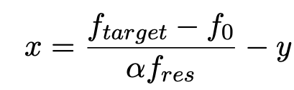,  where x=final trim length in [mm], y=welding shrinkage in [mm], f_{target}=target frequencies for the cavity in the room temperature air [MHz], f₀=freq. after step 5 in [MHz], αf_{res}>0=freq. sensitivity (freq. change per trimming by 1mm) in [MHz/mm] from step 6.  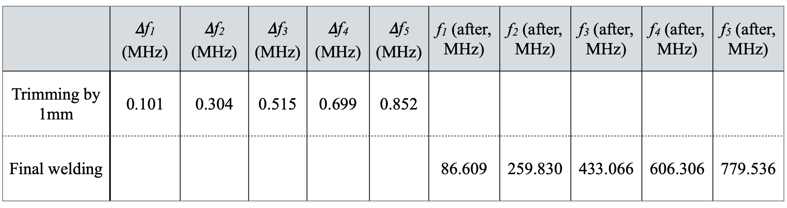 | Expected welding shrinkage (y).  Final cut length for the OC (x₁):  Final cut length for the CC (x₂):
10 | The forth RF measurement (after final cut): repeat the steps 1-3. | The lowest five resonant frequencies:
11 | Surface cleaning: ultrasonic cleansing
12 | Final Welding - on the outer conductor.
13 | The fifth RF measurement (after final welding): repeat the steps 1-3. If the frequencies reached target frequencies, trim the bottom cap by thickness of shimming material (~2mm).  If not, determine frequency sensitivity with respect to bottom cap insertion: Insert the cap 1mm further in by adjusting the shimming and bolting followed by the RF measurement. Establish the frequency sensitivity.  Determine the trimming length of the cap by the formula:  x’=2+(f_{target}-f₀’)/(α’f_{res}),  where x’=trim length of the cap in [mm], f₀’= freq. from the last step measurement in [MHz], α’f_{res}>0=freq. sensitivity (freq. change per trimming the cap by 1mm) in [MHz/mm].  Deliver the bottom gap flange to machine shop to trim the cap thickness.  Bolt the flange in nominal configuration. Additional RF measurement: repeat the steps 1-3. | The lowest five resonant frequencies before the trimming  The five resonant frequencies for frequency tuning sensitivities.  Trimming length of the BC:  The lowest five resonant target frequencies for final measurement.  Five measured frequencies after the final bottom cap thickness trimming.
12 | Leak check: Once the final EBW is finished, the center conductor support fixture is recommended to be installed all time for all in air and horizontal position handing. For the final leak check, do this procedure vertically. Rove the center conductor fixture. Blank the beam pipe ports by blankoff flange on one end, vacuum valve with zero-length reducer on the other end for vacuum pumping. Prepare the leak-tight N-type feedthroughs for FPC and pickup antenna and install them before the pump down. Make sure that vacuum type of feedthroughs are consistent to the bench RF measurement feedthroughs and make no change to the RF measurement accuracy.  Pump-down the kicker cavity and to do the leak checking, record the pumping down vacuum, pumping time and leak rate | Leak rate, vacuum and pumping-down time.
13 | Additional RF measurement: repeat the steps 2 to measure the frequency shifts after evacuation. Measure Q₀ and Q_{e} values.  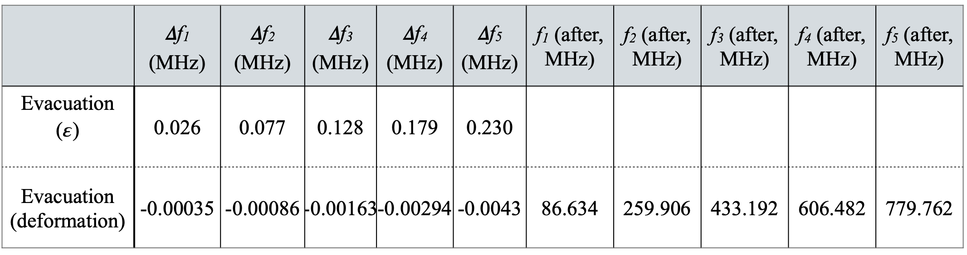  Vent the vacuum to observe the frequency changes and compare to the reference table from the simulation. | RF resonant frequencies, frequency change with evacuation, Q₀ values, Q_{e} values.

