|  |  |  |  |
| --- | --- | --- | --- |
| C75 Indium Pressing Procedure | | | |
| 1. **Document Number:** | 1. CP-C75-CPR-ASSY-INPP | 1. **Approval Date:** |  |
| 1. **Revision Number:** | 1. - | 1. **Periodic Review Date:** |  |
| 1. **Document Owner:** | 1. C. Dreyfuss |  |  |

## 

# Purpose and Scope

This procedure covers the preparation of indium formers and pressing indium seals for a C75 cavity pair components in preparation for assembly.

# References

[Indium Wire Cleaning Procedure](https://jlabdoc.jlab.org/docushare/dsweb/Get/Document-74893/IndiumWireCleaningProcedure.docx)

[C75 Ionized Nitrogen Cleaning Procedure](https://jlabdoc.jlab.org/docushare/dsweb/Get/Document-212167/CP-C75-CPR-CLN-ION-R1.pdf)

# Terms and Definitions

1. HOM- High Order Mode

2. FPC—Fundamental Power Coupler

3. FP---Field Probe

4. SS – Stainless Steel

# Process Details

**Materials Required:**

.025" Indium (Field probe)

.040" Indium (Top hat, HOM blanks, input probe adaptor)

.060" Indium ( End Dish, Inner Adapter)

Arbor press

Indium seal formers

Indium seal former backing plates

Scalpel

Cleanroom wipers

Acetone, Isopropyl alcohol

**Clean the Indium and the Indium forming table:**

* This procedure is done on the indium forming table in the production clean room.
* Wipe the indium forming table with isopropyl soaked clean room wipers until the wipers appear to be clean and the blow down with ionized nitrogen (no spec needed for this step).
* Inspect indium wire as it is removed from the spool for kinks or damage, do not use damaged wire. Never stretch or tear off the indium wire; always cut with a sharp scalpel.
* Use a clean, stainless steel scalpel to cut indium to the desired length.
* Lay the indium wire on the cleaned indium forming table. Squirt acetone over the indium allowing the indium to lie in a small puddle of acetone. Let the indium soak in the acetone while gently moving the indium around in the puddle. Allow the indium to soak for about 10 seconds.
* Soak a clean room wiper with acetone. With one hand pick-up the indium wire from one end and in the other hand grab the wiper. Gently wipe off the indium with the soaked wiper. Flip the indium wire end to end to ensure rubbing clean the entire length of wire.
* Wipe up the acetone puddle off the work station. ***Repeat the above steps with isopropyl alcohol***.
* **Indium wire is now clean and ready for use the clean indium must be pressed right after cleaning, do not let indium sit. If indium is not going to be pressed right away indium will have to be recleaned.**

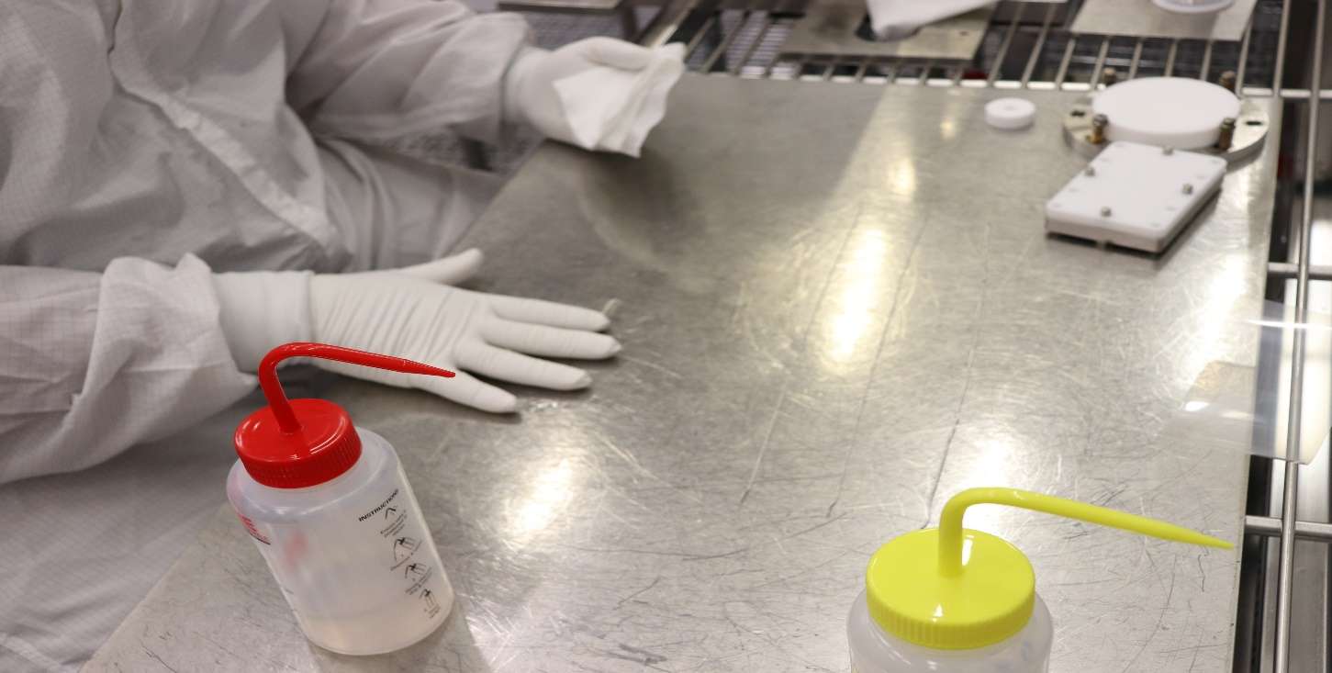

**Figure 1**: Indium cleaning.

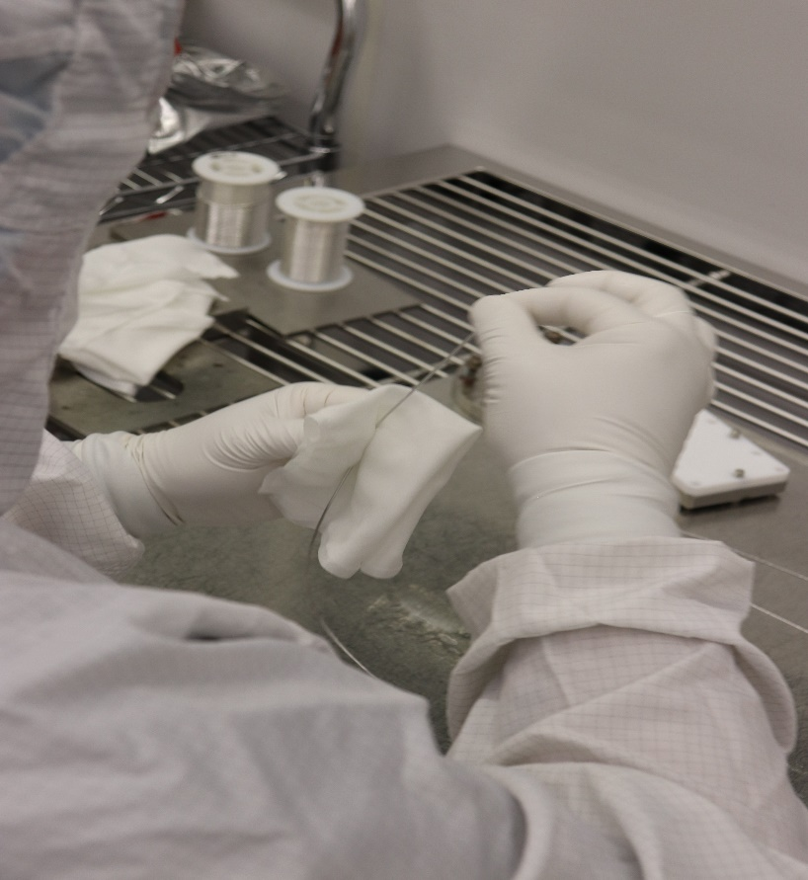

**Figure 2**: Indium wiping.

**Prepare to Press Indium to FPC Top hat, FPC Dog-leg Windows:**

* Clean a seventeen inch long piece of indium wire as per the [Indium Wire Cleaning procedure.](https://jlabdoc.jlab.org/docushare/dsweb/Get/Document-11341/Indium%20Cleaning%20Procedure.doc)
* Obtain the appropriate indium seal former.
* Wipe the Teflon seal former, including the seal groove, with Isopropyl alcohol and a clean wiper.
* Nitrogen clean indium former to spec 2 of the [C75 Ionized Nitrogen Cleaning Procedure](https://jlabdoc.jlab.org/docushare/dsweb/Get/Document-212167/CP-C75-CPR-CLN-ION-R1.pdf) Visually inspect seal paths on each flange. Clean the tophat/dog-leg window as per Spec 1 of the [C75 Ionized Nitrogen Cleaning Procedure](https://jlabdoc.jlab.org/docushare/dsweb/Get/Document-212167/CP-C75-CPR-CLN-ION-R1.pdf).
* Shape indium using grooved seal formers by laying the indium in the groove and gently pressing the indium, by hand, into groove.
* Hold as much of the indium as possible in place with fingertips. Start at one end and work indium around the entire groove. Overlap the ends of indium so that the ends are parallel and lay one atop the other. There should be approximately 1/16”- 1/8” overlap per joint. Using the end of the scalpel, flatten the overlap to join the two ends. Make one seal for each tophat/dog-leg window that is to be used. The seal will be pressed onto the flange that has 12 bolt holes.
* Place Teflon former with seal facing up, onto backing flange. The studs from backing flange must extend up through the seal former.
* Carefully place tophat/dog-leg window onto the seal former making sure the backing plate studs engage with the proper holes of the window/tophat**. *Use Extreme caution to not scratch or damage the seal path****.* Place flat washers and silicon bronze nuts onto the studs of the backing plate and evenly tighten. Evenly loosen and remove nuts and washers from backing plate studs. Be careful not to separate or move the seal former.
* Carefully and evenly lift the window/tophat from the seal former and backing plate. Inspect indium seal and ensure the seal is pressed firmly and uniformly to the flange. The indium should be uniform in the shape of a “V” and free of gaps, voids, and flat spots.
* Inspect seal for uniformity and adherence component is now ready for final assembly.

**Prepare to Press Indium to HOM Elbow:**

* Clean a twelve inch long piece of indium wire as per the [Indium Wire Cleaning Procedure](https://jlabdoc.jlab.org/docushare/dsweb/Get/Document-74893/IndiumWireCleaningProcedure.docx).
* Obtain the appropriate indium seal former. Wipe the Teflon seal former, including the seal groove, with Isopropyl alcohol and a clean wiper, nitrogen clean indium former to spec 2 of the [C75 Ionized Nitrogen Cleaning Procedure](https://jlabdoc.jlab.org/docushare/dsweb/Get/Document-212167/CP-C75-CPR-CLN-ION-R1.pdf)*.* Visually inspect seal paths on each flange.
* Clean the HOM elbow as per Spec 1 of the [C75 Ionized Nitrogen Cleaning Procedure](https://jlabdoc.jlab.org/docushare/dsweb/Get/Document-212167/CP-C75-CPR-CLN-ION-R1.pdf).
* Shape indium, using grooved seal formers by laying the indium in the groove and gently pressing the indium, by hand, into groove. Hold as much of the indium as possible in place with fingertips. Start at one end and work indium around the entire groove. Overlap the ends of indium so that the ends are parallel and lay one atop the other. There should be approximately 1/16”- 1/8” overlap per joint. Using the end of the scalpel, flatten the overlap to join the two ends
* Place backing flange on the indium forming table with pins facing up. Place the indium seal former, with the indium side up, on the backing flange. ***Use Extreme caution to not scratch or damage the seal path****.* Place the elbow flange (cavity end) on the assembly. Grasp elbow, backing plate, and seal former as an assembly. Carefully flip the assembly 180° and place into arbor press with the elbow flange facing down, contacting the press plate. Using the arbor press, press on the center of the seal former backing plate with an appropriate amount of force.
* Remove the elbow from the press and carefully remove theseal former and inspect seal for uniformity and adherence component(s) are now ready for final assembly. Repeat for the other elbow(s) if necessary.

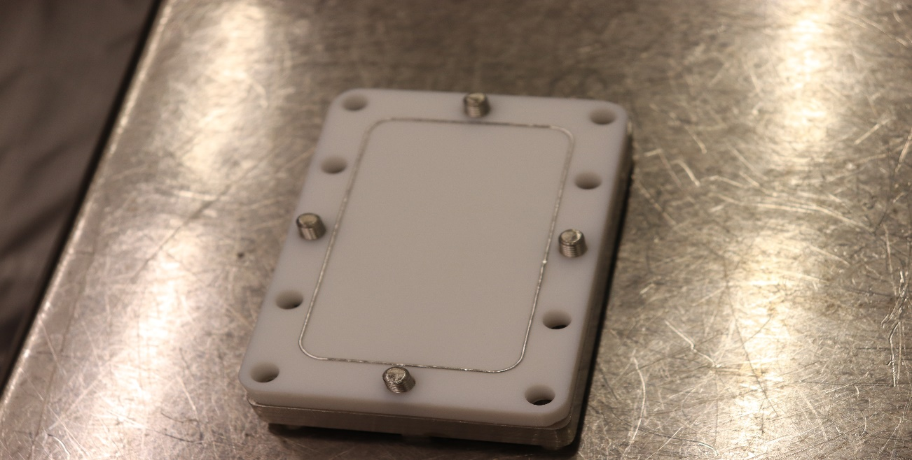

**Figure 3**: Indium wire, former and backing plate for HOM elbows.

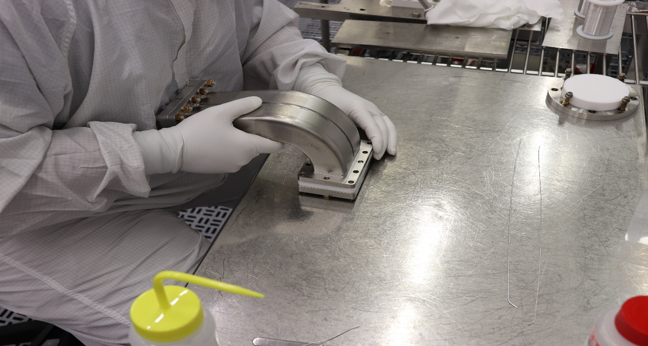

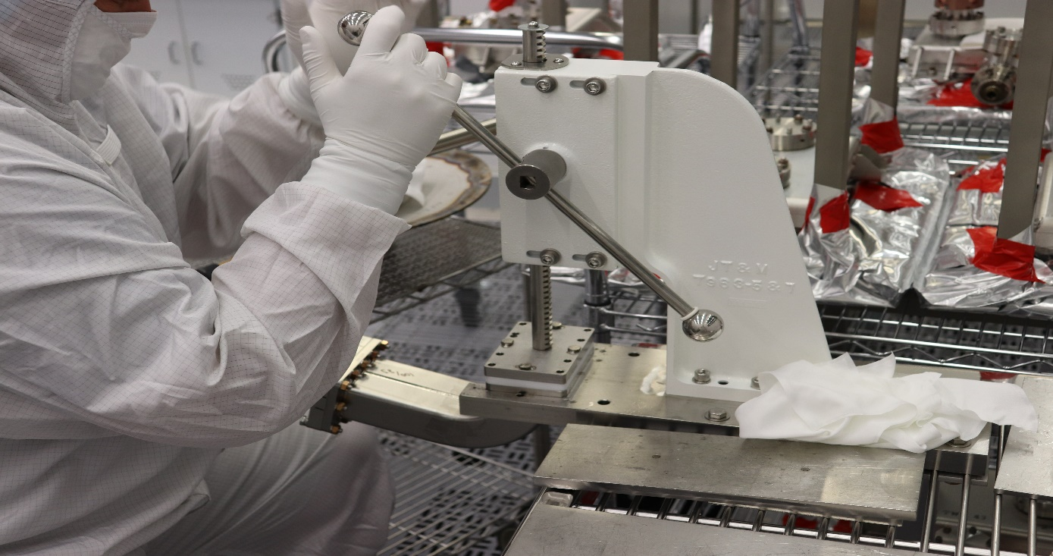

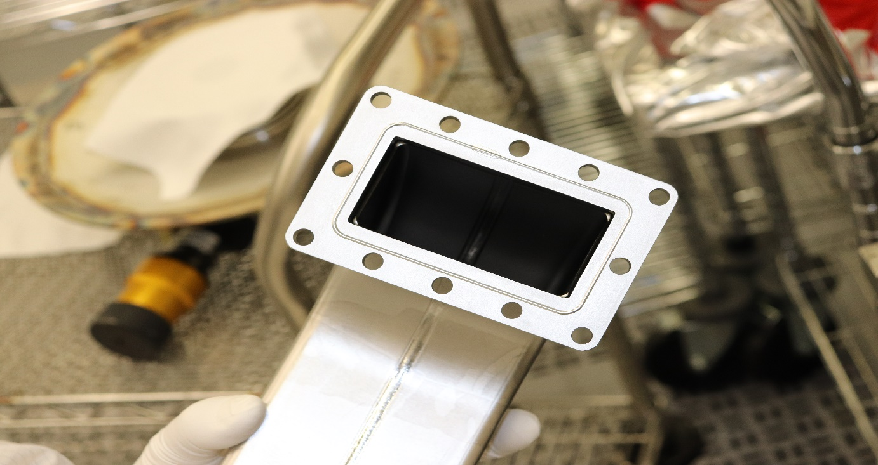

**Figure 4**: HOM elbow set on indium former (top); indium pressing (middle); indium pressed on flange of HOM elbows (bottom).

**Prepare to Press Indium to HOM Absorber:**

* Clean a twelve inch piece of indium wire as per the [Indium Wire Cleaning procedure.](https://jlabdoc.jlab.org/docushare/dsweb/Get/Document-11341/Indium%20Cleaning%20Procedure.doc)
* Obtain the appropriate indium seal former. Wipe the Teflon seal former, including the seal groove, with Isopropyl alcohol and a clean wiper, nitrogen clean indium former to spec 2 of the [C75 Ionized Nitrogen Cleaning Procedure](https://jlabdoc.jlab.org/docushare/dsweb/Get/Document-212167/CP-C75-CPR-CLN-ION-R1.pdf). Visually inspect seal path on the flange. Clean the HOM absorber as per Spec 1 of the [C75 Ionized Nitrogen Cleaning Procedure](https://jlabdoc.jlab.org/docushare/dsweb/Get/Document-212167/CP-C75-CPR-CLN-ION-R1.pdf).
* Shape indium using grooved seal formers by laying the indium in the groove and gently pressing the indium, by hand, into groove. Hold as much of the indium as possible in place with fingertips. Start at one end and work indium around the entire groove. Overlap the ends of indium so that the ends are parallel and lay one atop the other. There should be approximately 1/16”- 1/8” overlap per joint. Using the end of the scalpel, flatten the overlap to join the two ends.
* **Use extreme care when inserting the absorber into the seal former. The ceramic that makes up the absorber is very delicate and will chip or break easily. Contact the senior clean room technician if you have any questions regarding this step.** Carefully place HOM load onto seal former and engage the alignment pins. The ceramic portion of the load must go into the seal former housing. Grasp HOM load and seal former as an assembly. Carefully flip the assembly 180° and place into arbor press with the HOM load flange facing down, contacting the press plate. Using the arbor, press on the center of the seal former backing plate with an appropriate amount of force. Remove the HOM load from the press and carefully separate the former from the load and inspect seal for uniformity and adherence the component(s) are now ready for final assembly. Repeat for the other absorber(s).

**Prepare to Press Indium to Inner Adapter:**

* Clean a twelve inch long piece of indium wire as per the [Indium Wire Cleaning procedure.](https://jlabdoc.jlab.org/docushare/dsweb/Get/Document-11341/Indium%20Cleaning%20Procedure.doc) Obtain the appropriate indium seal former. Wipe the Teflon seal former, including the seal groove, with Isopropyl alcohol and a clean wiper nitrogen clean indium former to spec 2 of the [C75 Ionized Nitrogen Cleaning Procedure](https://jlabdoc.jlab.org/docushare/dsweb/Get/Document-212167/CP-C75-CPR-CLN-ION-R1.pdf). Visually inspect seal paths on each flange. Clean the inner adapter as per Spec 1 of the[C75 Ionized Nitrogen Cleaning Procedure](https://jlabdoc.jlab.org/docushare/dsweb/Get/Document-212167/CP-C75-CPR-CLN-ION-R1.pdf).
* Shape indium using grooved seal formers by laying the indium in the groove and gently pressing the indium, by hand, into groove. Hold as much of the indium as possible in place with fingertips. Start at one end and work indium around the entire groove. Overlap the ends of indium so that the ends are parallel and lay one atop the other. There should be approximately 1/16”- 1/8” overlap per joint. Using the end of the scalpel, flatten the overlap to join the two ends.
* Place seal former with indium into former backing-plate. Place inner adapter flange onto the seal former. ***Do not scratch or damage the seal path****.* Grasp inner adapter, backing plate, and seal former as an assembly. Carefully flip the assembly 180° and place into arbor press with the upper inner adapter flange contacting the press plate. Using the arbor press, press the backing plate in the middle of the plate. Remove the inner adapter from the press and seal former by slowly rotating Teflon former CW or CCW to free seal and then lift from flange face. Inspect seal for uniformity adherence then re-clean former and form a second piece of indium into the Teflon former and press indium onto the opposite side of the Inner Adapter. After pressing, remove from former and check indium for uniformity then put former back onto Inner adapter and let it sit on the former for protection.

**Prepare to Press Indium to End Dish Flanges:**

* Clean twelve inch long piece of indium wire as per the [Indium Wire Cleaning procedure.](https://jlabdoc.jlab.org/docushare/dsweb/Get/Document-11341/Indium%20Cleaning%20Procedure.doc)
* Obtain the appropriate indium seal former. Wipe the Teflon seal former, including the seal groove, with Isopropyl alcohol and a clean wiper nitrogen clean indium former to spec 2 of the [C75 Ionized Nitrogen Cleaning Procedure](https://jlabdoc.jlab.org/docushare/dsweb/Get/Document-212167/CP-C75-CPR-CLN-ION-R1.pdf)*.* Visually inspect seal paths on each flange. Clean the end dish flange as per Spec 1 of the [C75 Ionized Nitrogen Cleaning Procedure](https://jlabdoc.jlab.org/docushare/dsweb/Get/Document-212167/CP-C75-CPR-CLN-ION-R1.pdf)*.*
* Shape indium using grooved seal formers by laying the indium in the groove and gently pressing the indium, by hand, into groove. Hold as much of the indium as possible in place with fingertips. Start at one end and work indium around the entire groove. Overlap the ends of indium so that the ends are parallel and lay one atop the other. There should be approximately 1/16”- 1/8” overlap per joint. Using the end of the scalpel, flatten the overlap to join the two ends.
* Place the former with seal onto the edge of the indium forming table. Lower the end dish onto the indium seal. Carefully slide the end dish and backing plate to the edge of the table in a manner that you can securely grasp all parts together as an assembly. Flip the assembly 180° so that the end dish flange is facing up. Insert four (4) 5/16-24 x 1.5 lg. silver plated screws with one washer through the backing plate to secure it to the end dish flange. Evenly tighten the screws enough to form the indium seal.
* Remove screws and backing plate. Slowly rotate Teflon former to release seal and then remove Teflon former from flange face. Cover flange face by placing a fresh clean room wipe over the face with end dish pointing up. Repeat for the other end dish.

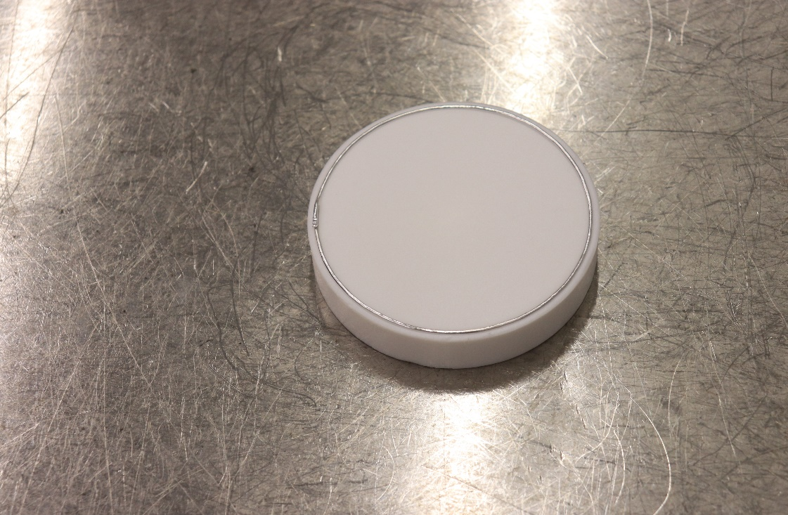

**Figure 5**: Indium wire on indium former used for both end-dishes and inner adapter.

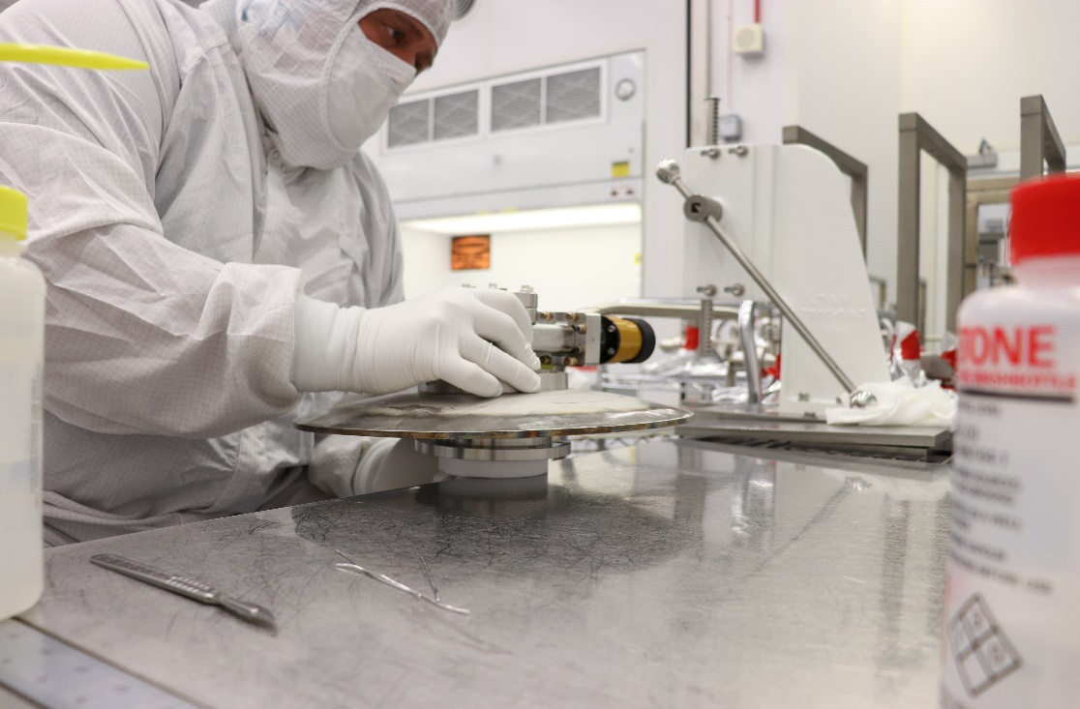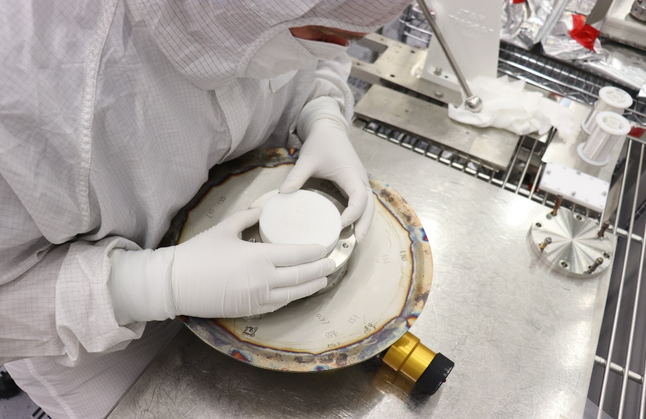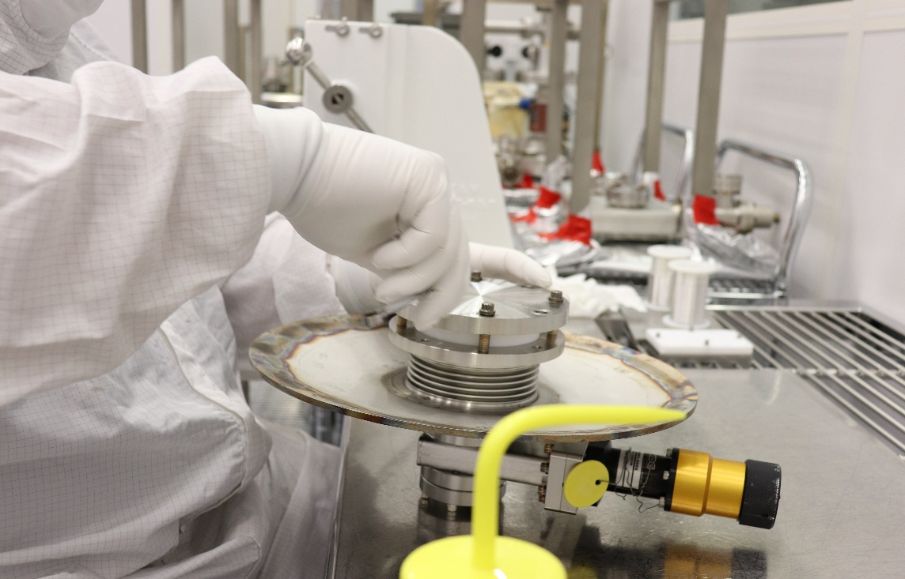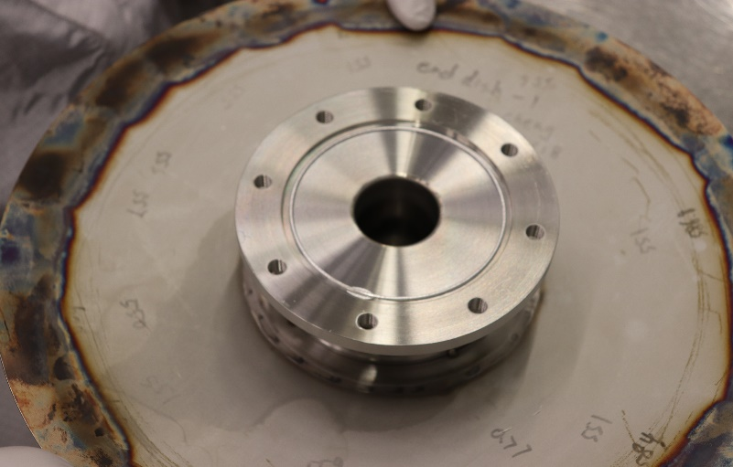

(a)

(b)

(c)

(d)

**Figure 6**: End-dish on top of indium former (a); centering of indium former (b); indium pressing (c); indium wire pressed on end dish flange.

**Prepare to Form Indium for Field Probe Feedthroughs:**

* Clean a three inch long piece of indium wire as per the [Indium Wire Cleaning procedure.](https://jlabdoc.jlab.org/docushare/dsweb/Get/Document-11341/Indium%20Cleaning%20Procedure.doc)
* Obtain the appropriate indium seal former. Wipe the Teflon seal former, including the seal groove, with Isopropyl alcohol and a clean wiper, then nitrogen clean indium former to spec 2 of the [C75 Ionized Nitrogen Cleaning Procedure](https://jlabdoc.jlab.org/docushare/dsweb/Get/Document-212167/CP-C75-CPR-CLN-ION-R1.pdf)*.*
* Visually inspect seal path of components. Shape indium using grooved seal formers by laying the indium in the groove and gently pressing the indium, by hand, into groove. Hold as much of the indium as possible in place with fingertips. Start at one end and work indium around the entire groove. Overlap the ends of indium so that the ends are parallel and lay one atop the other. There should be approximately 1/16”- 1/8” overlap per joint. Using the end of the scalpel, flatten the overlap to join the two ends.
* Remove formed indium from former and put onto a fresh clean room wipe, re-clean former and make a second indium seal for the second field probe. Transport both indium seals to assembly area for assembly to cavity.

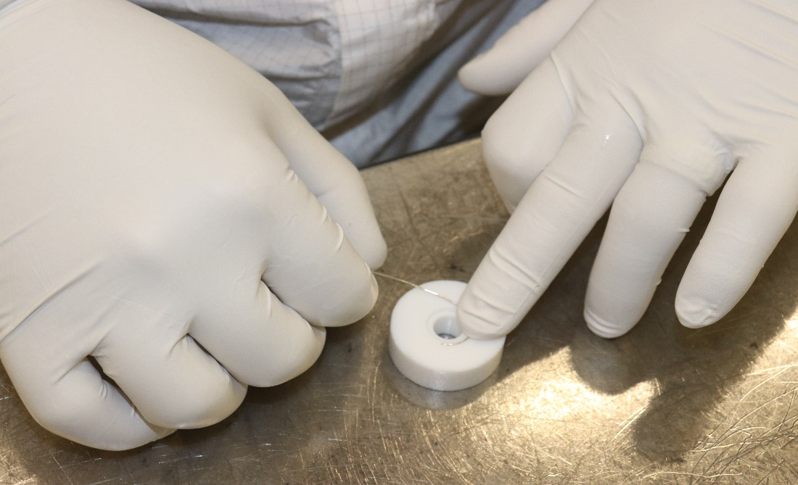

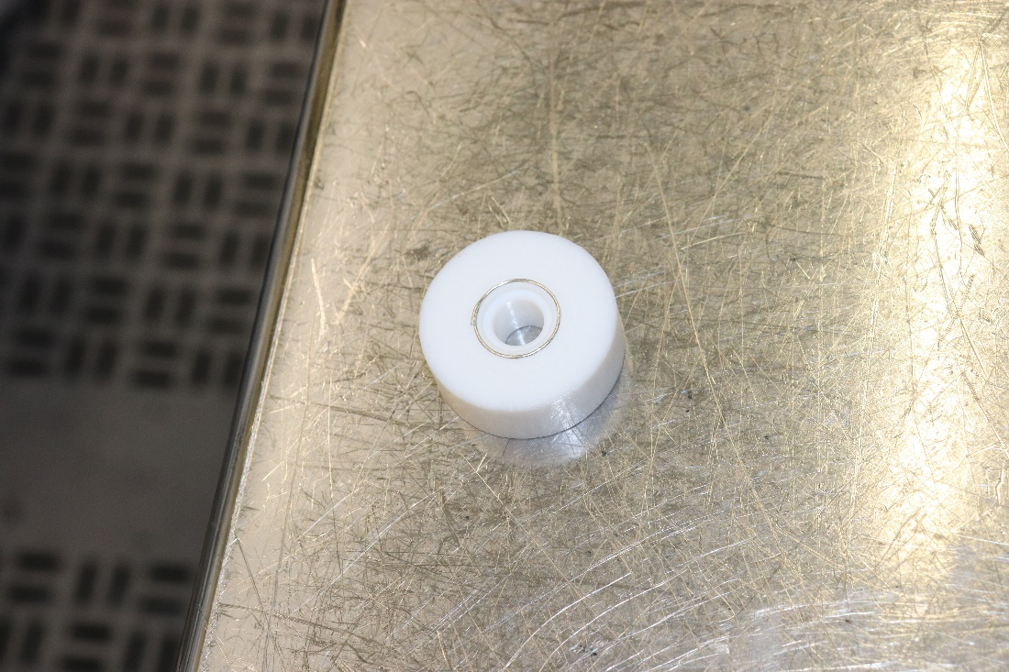

**Figure 7:** positioning of indium in the former for the field probe feedthrough.

# **5.0 Revision History**

|  |  |  |
| --- | --- | --- |
| Rev # | Revision or update: | Effective: |
| Release | Initial Release | 4/16/2010 |
| A | Changes made to procedure | 7/15/2011 |

# **6.0 Approvals**

|  |  |  |
| --- | --- | --- |
| Approved by: | Signature: | Date: |
| **Document Owner** | C. Dreyfuss |  |
| **Reviewer** | D. Forehand |  |
| **C75 Project SME** | G. Ciovati |  |
| **SRF Cavity Production Supervisor** | K. Davis |  |