Traveler Title | Brazement Adapter Assembly Receiving Inspection Traveler
Traveler Abstract | This is a receiving inspection traveler for RF window adapter assemblies involving visual, dimensional, RF, and leak test.
Traveler ID | P1-INSP-ADPT
Traveler Revision | R1
Traveler Author | S. Williams
Traveler Date | 06-Aug-2020
NCR Informative Emails | georged,forehand
NCR Dispositioners | scott,macha,edaly
D3 Emails | scott,georged,macha
Approval Names | S. Williams | K. Macha |  | - Reilly
Approval Signatures
Approval Dates
Approval Title | Author | Reviewer | Reviewer | Project Manager

References | List and Hyperlink all documents related to this traveler. This includes, but is not limited to: safety (THAs, SOPs, etc), drawings, procedures, and facility related documents.
 | CRM-120-7075-0024 B | Leak spec 11141S0029 | Drawing-window coating CRM-120-7075-0039

Revision Note
R1 | Initial release of this Traveler.

Step No. | Instructions | Data Input
1 | This is an ultra high vacuum component. Wear talc free latex gloves at all times when handling this part.  - Enter inspector name and date. | [[TechnicianName]] <<SRF>>  [[DateTime]] <<TIMESTAMP>>
2 | - Inspect shipping container and shipping documents.  - Is container damaged? If there is a sign of damage take pictures and upload file.  - Is shipping document matching with shipped parts (quantity, part number, etc)? If there is a discrepancy provide details in comment box. | [[ContainerDamaged]] <<YESNO>>  [[ContainerPics]] <<FILEUPLOAD>>  [[ShipDocOK]] <<YESNO>>  [[ShipDocDetail]] <<COMMENT>>
3 | Visual inspection  - Is the assembly free from the brazing residue?  - Is ceramic surface clean, free from scratches, cracks or stain?  - If it shows any defect provide pictures and comments. | [[WBASN]] <<WBASN>>  [[VisualClean]] <<YESNO>>  [[VisualCeramic]] <<YESNO>>  [[VisualPics]] <<FILEUPLOAD>>  [[VisualComment]]<<COMMENT>>

Step No | Instructions |  |  | Data Inputs
4 | Copper eyelet and Stainless steel adapter gap  Use the gap checking tool and sweep around the copper eyelet gap. If the brazing residue blocks the sweeping stop further inspection and generate NCR. |  |  | [[SweepPass]] <<YESNO>>
5 | Dimensional check (CMM)
 | Description | Specified Dimensions  Min/Max | Measured Dimensions |  | Pass/Fail
 | Envelope dimensions | Width  1.709/1.719 | [[Dim_width]] <<FLOAT>>  [[Dim_length]] <<FLOAT>>  [[Dim_thk]] <<FLOAT>>  [[Dim_radius1]] <<FLOAT>>  [[Dim_radius2]] <<FLOAT>>  [[Dim_radius3]] <<FLOAT>>  [[Dim_radius4]] <<FLOAT>> |  | [[Compare the measured value to the specified value and show pass or fail- if it’s outside of the range it fails]] <<NOTE>>  [[Dim_widthPassed]] <<YESNO>>  [[Dim_lengthPassed]] <<YESNO>>  [[Dim_thkPassed]] <<YESNO>>  [[Dim_radius1Passed]] <<YESNO>>  [[Dim_radius2Passed]] <<YESNO>>  [[Dim_radius3Passed]] <<YESNO>>  [[Dim_radius4Passed]] <<YESNO>>
Length
5.525/5.535
Thickness
.620/.630

Measure radii of all 4 corners
R.683/.693

 | Adapter opening  Measure 3 different locations as shown. | .981/.991 | [[Dim_opening_1]] <<FLOAT>>  [[Dim_opening_2]] <<FLOAT>>  [[Dim_opening_3]] <<FLOAT>> |  | [[Dim_opening_1Passed]] <<YESNO>>  [[Dim_opening_2Passed]] <<YESNO>>  [[Dim_opening_3Passed]] <<YESNO>>
 | Ceramic window thickness  Measure 3 different locations on centerline as indicated in the picture. | .0948/.0968 | [[Dim_CerThk_1]] <<FLOAT>>  [[Dim_CerThk_2]] <<FLOAT>>  [[Dim_CerThk_3]] <<FLOAT>> |  | [[Dim_CerThk_1Passed]] <<YESNO>>  [[Dim_CerThk_2Passed]] <<YESNO>>  [[Dim_Cer_Thk_2]] <<YESNO>>

Step No | Instructions | Data Inputs
6 | Initial leak test  Minimum Detectable Leak 1×10^-10 atm.cc/sec He | [[InitialLeakTechName]] <<SRF>>  [[InitialLeakPass]] <<YESNO>>  [[InitialLeakFile]] <<FILEUPLOAD>>
7 | RF Test  - Inspect the set-up and perform RF survey.  - Follow the F100 window power ramp up.  - Maintain the max power 12kW until the ceramic temperature has stabilized at its maximum (Temperature increase should be less than 1 degree C per hour).  - Observe and record the thermal activity at the window using IR camera.  - Record the window flange temperature using the thermocouple output signals.  - At the end of the test, turn off RF.  - Allow time for window and waveguide to cool before removing window from waveguide.  - If the RF test at this step is omitted provide the reason. | [[RF_TechName]] <<SRF>>  [[RF1_Time]] <<TIMESTAMP>>  [[UploadRF_File]] <<FILEUPLOAD>>  [[RF_TestComment]] <<COMMENT>>
8 | Final leak test  Minimum Detectable Leak 1×10^-10 atm.cc/sec He  - Enter technician name, test date and upload file. | [[FinalLeakTechName]] <<SRF>>  [[FinalLeakTime]] <<TIMESTAMP>>  [[FinalLeakPass]] <<YESNO>>  [[FinalLeakFile]] <<FILEUPLOAD>>
9 | - Package window adapter to ship to the ion implantation vendor, Cutting Edge Ions, LLC.  - Enter the technician name.  - Enter date of shipment. | [[ShipIonTechName]] <<SRF>>  [[ShipIonDate]] <<TIMESTAMP>>
10 | This traveler resumes when the adapter returns from the ion implantation vendor. Wear nitrile gloves at all times when handling this part.  - Enter technician name and date.  - Inspect the shipping container from the ion implantor. Is the container free from damage? | [[TiTechName]] <<SRF>>  [[TiDate]] <<TIMESTAMP>>  [[TiContainerOK]] <<YESNO>>
11 | - Has the ion implantation been performed on the brazement?  - Inspect if the correct side was ion implanted. Ion implanted surface shows yellow tint.  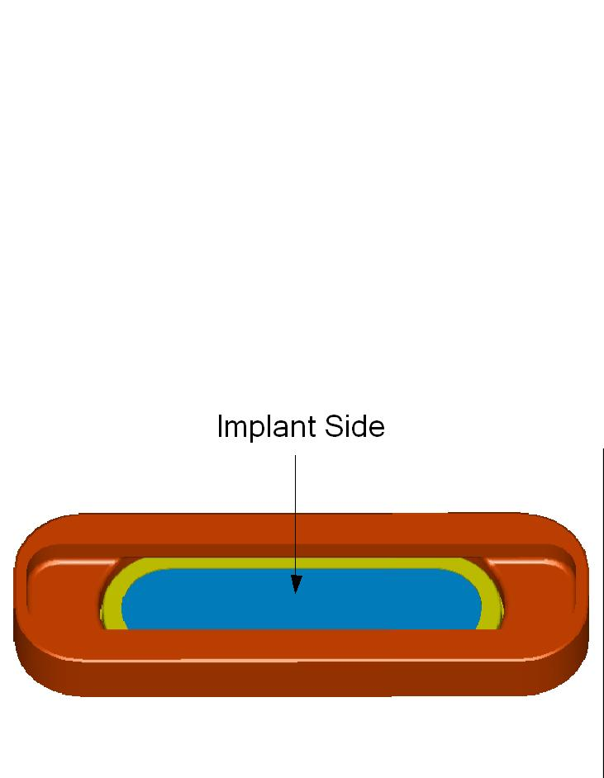  - Provide comment if the brazement shows any abnormality.  - Contact the responsible engineer for next step. | [[TiVisPass]] <<YESNO>>  [[TiComment]] <<COMMENT>>

Step No | Instructions | Data Inputs
12 | Is this brazement sampled for RF test?  - If yes, perform the initial leak check per spec 11141S0029. Minimum Detectable Leak 1×10^-10 atm.cc/sec He. If not, re-pack it for shipping to the anti-multipacting coating vendor and go to the step 4.  - Enter leak check technician name and time of the test. | [[Ti_RF_smpl]] <<YESNO>>  [[Ti_ILeak_Tech]] <<SRF>>  [[Ti_ILeak_Date]] <<TIMESTAMP>>
 | Did the brazement pass the leak check?  - If the brazement did not pass the leak check, generate NCR. Forward the passed brazement to the RF test personnel. | [[Ti_ILeak_Pass]] <<YESNO>>
 | Enter RF test technician name and the date of the test.  - Inspect the set-up and perform RF survey.  - Follow the F100 window power ramp up.  - Maintain the max power 12kW until the ceramic temperature has stabilized at its maximum (Temperature increase should be less than 1 degree C per hour).  - Observe and record the thermal activity at the window using IR camera.  - Record the window flange temperature using the thermocouple output signals.  - At the end of the test, turn off RF.  - Allow time for window and waveguide to cool before removing window from waveguide.  - Did the brazement pass the RF test?  - If the brazement did not pass the RF test, generate NCR. Forward the passed brazement to the leak check technician. | [[Ti_RF_Tech]] <<SRF>>  [[Ti_RF_Date]] <<TIMESTAMP>>  [[Ti_RF_file]] <<FILEUPLOAD>>  [[Ti_RF_Pass]] <<YESNO>>
 | Final leak check per spec 11141S0029.  - Enter leak check technician name and time of the test.  - Did the brazement pass the final leak check?  - Package the passed brazement for shipping to the anti-multipacting coating vendor.  - If it did not pass the leak check generate NCR. | [[Ti_FLeak_Tech]] <<SRF>>  [[Ti_FLeak_Date]] <<TIMESTAMP>>  [[Ti_FLeak_Pass]] <<YESNO>>

Step No | Instructions | Data Inputs
13 | Is the brazement shipped to the Anti-multipacting coating vendor, Thin Film Labs? | [[Ship_Anti]] <<YESNO>>  [[Ship_Anti_date]] <<TIMESTAMP>>
14 | Receiving inspection from anti-multipacting coating vendor  - This brazement is from the anti-multipacting (Titanium Dioxide) coating vendor. Make sure you opened the correct adapter ID.  - Enter technician name and date of the inspection.  - Inspect the shipping container. Is the container free from damage? | [[TiO2_Tech_Name]] <<SRF>>  [[TiO2_Date]] <<TIMESTAMP>>  [[TiO2_ContainerOK]] <<YESNO>>
15 | The existence of coating is hard to tell by visual inspection.  - Until the specific method is developed inspect ceramic surface for visual damages.  - Provide comment if the brazement shows any abnormality.  - Contact the responsible engineer for next step. | [[TiO2_VisPass]] <<YESNO>>  [[TiO2_Comment]] <<COMMENT>>
16 | Is this brazement sampled for RF test?  - If yes, perform the initial leak check per spec 11141S0029. Minimum Detectable Leak 1×10^-10 atm.cc/sec He. If not, repack, mark 'weld ready', and store in the designated area.  - Enter leak check technician name and time of the test.  - Did the brazement pass the leak check?  - If the brazement did not pass the leak check, generate NCR. Forward the passed brazement to the RF test personnel. | [[TiO2_RF_smpl]] <<YESNO>>  [[TiO2_ILeakTech]] <<SRF>>  [[TiO2_ILeakDate]] <<TIMESTAMP>>  [[TiO2_ILeakPass]] <<YESNO>>
 | - Enter RF test technician name and the date of the test.  - Inspect the set-up and perform RF survey.  - Follow the F100 window power ramp up.  - Maintain the max power 12kW until the ceramic temperature has stabilized at its maximum (Temperature increase should be less than 1 degree C per hour).  - Observe and record the thermal activity at the window using IR camera  - Record the window flange temperature using the thermocouple output signals.  - At the end of the test, turn off RF.  - Allow time for window and waveguide to cool before removing window from waveguide.  - Did the brazement pass the RF test?  - If the brazement did not pass the RF test, generate NCR. Forward the passed brazement to the leak check technician. | [[TiO2_RF_Tech]] <<SRF>>  [[TiO2_RF_Date]] <<TIMESTAMP>>  [[TiO2_RF_file]] <<FILEUPLOAD>>  [[TiO2_RF_Pass]] <<YESNO>>
 | - Final leak check per spec 11141S0029.  - Enter leak check technician name and time of the test.  - Did the brazement pass the final leak check? If it did not pass the leak check generate NCR. | [[TiO2_FLeakTech]] <<SRF>>  [[TiO2_FLeakDate]] <<TIMESTAMP>>  [[TiO2_FLeakPass]] <<YESNO>>  [[TiO2_FLeakFile]] <<FILEUPLOAD>>
 | - Is the part ready for weld?  - Send the passed adapter to the chem room to clean. Repack the cleaned part, mark 'weld ready', and store in the designated area.  - In inventory system, issue adapter to Ken Worland or his designate for welding. | [[Weld_ready]] <<YESNO>>

