Traveler Title | SNS PPU Cavity Helium Vessel FPC End Head Inspection Traveler
Traveler Abstract | Traveler defines inspection process for the FPC end head, one of three helium vessel components
Traveler ID | SNSPPU-CAV-INSP-HEHDF
Traveler Revision | R1
Traveler Author | K. M. Wilson
Traveler Date | 13-Jul-20
NCR Informative Emails | kwilson, edaly, areilly, macha, fischer
NCR Dispositioners | kwilson, edaly, macha
D3 Emails
Approval Names | K. M. Wilson | A. DeKerlegand | K. Macha | E. Daly
Approval Signatures
Approval Dates
Approval Title | Author | Reviewer | Reviewer | Project Manager

References | List and Hyperlink all documents related to this traveler. This includes, but is not limited to: safety (THAs, SOPs, etc), drawings, procedures, and facility related documents.
104211700-M8U-8200-A023-A FPC END HEAD WELDMENT | 104211700-M8U-8200-A006 FPC END DISHED HEAD | 104211700-M8U-8200-A026 HELIUM VESSEL ASSEMBLY

Revision Note
R1 | Initial release of this Traveler.

Step No. | Instructions | Data Input
1 | Initial Inspection
 | Technician Name  Date of Inspection  Serial Number of part | [[TechName]] <<SRF>>  [[InspectionDate]] <<TIMESTAMP>>  [[HESSN]] <<HESSN>>
 | Is head generally free from excessive dirt or other contaminants? (Head is not expected to be clean to UHV standards.) | [[PartCleanOk]] <<YESNO>>
 | Visually inspect the rest of the head. There should be no dents (minor surface dings can be disregarded), or gouges (other than minor surface defects), or other damage. | [[VisualOk]]<<YESNO>>
 | Look at all welds and verify they are smooth and flush, with no crevices, cracks or protrusions. This is not intended to be a formal weld inspection, but to very that welds generally appear as expected and no damage has occurred in transit. | [[WeldsOk]] <<YESNO>>
 | There should be no unusual discoloration to the titanium, especially around the welds. | [[ColorationOk]] <<YESNO>>
 | Verify weld chamfer as shown on Section A-A of 104211700-M8U-8200-A006. Exact dimensions are not critical but should be approximately 0.25 x 45 degrees. | [[ProperWeldChamfer]] <<YESNO>>
 | Comments  Upload photos of any damage. | [[VisualInspComment]] <<COMMENT>>  [[VisualInspPhoto]] <<FILEUPLOAD>>

Step No | Instructions |  |  | Data Inputs
3 | Dimensional check. One FPC end head from every shipment should be checked dimensionally. All dimensions are from drawing 104211700-M8U-8200-A023-A FPC END HEAD WELDMENT unless 104211700-M8U-8200-A006 FPC END DISHED HEAD is noted.
 | Dimension | Nominal | Tolerance
 | Length of upper tube | 11.37 | ± 0.06 | [[Dimension1Ok]] <<YESNO>>
 | Length of lower tube | 9.16 | ± 0.06 | [[Dimension2Ok]] <<YESNO>>
 | Inner diameter (-A006) | 23.50 | ± 0.01 | [[Dimension3Ok]] <<YESNO>>
 | Head curvature (-A006) | 24.25 | ± 0.01 | [[Dimension4Ok]] <<YESNO>>
 | Axial length (-A006) | 4.77 | ± 0.01 | [[Dimension5Ok]] <<YESNO>>
 | Restraint block - axial | 0.50 | ± 0.01 | [[Dimension6Ok]] <<YESNO>>
 | Restraint block - horizontal | 0.00 (centered) | ± 0.01 | [[Dimension7Ok]] <<YESNO>>
 | Tube 1 horizontal (see picture below) | 6.72 | ± 0.04 | [[Dimension8Ok]] <<YESNO>>
 | Tube 1 vertical | 6.72 | ± 0.04 | [[Dimension9Ok]] <<YESNO>>
 | Tube 1 hole angle | 15.6 deg | ± 0.5 deg | [[Dimension10Ok]] <<YESNO>>
 | Tube 2 horizontal | 6.72 | ± 0.04 | [[Dimension11Ok]] <<YESNO>>
 | Tube 2 vertical | 6.72 | ± 0.04 | [[Dimension12Ok]] <<YESNO>>
 | Tube 2 hole angle | 15.6 deg | ± 0.5 deg | [[Dimension13Ok]] <<YESNO>>
 | Tube 3 horizontal | 6.72 | ± 0.04 | [[Dimension14Ok]] <<YESNO>>
 | Tube 3 vertical | 6.72 | ± 0.04 | [[Dimension15Ok]] <<YESNO>>
 | Tube 3 hole angle | 15.6 deg | ± 0.5 deg | [[Dimension16Ok]] <<YESNO>>
 | Tube 4 horizontal | 6.72 | ± 0.04 | [[Dimension17Ok]] <<YESNO>>
 | Tube 4 vertical | 6.72 | ± 0.04 | [[Dimension18Ok]] <<YESNO>>
 | Tube 4 hole angle | 15.6 deg | ± 0.5 deg | [[Dimension19Ok]] <<YESNO>>
 | 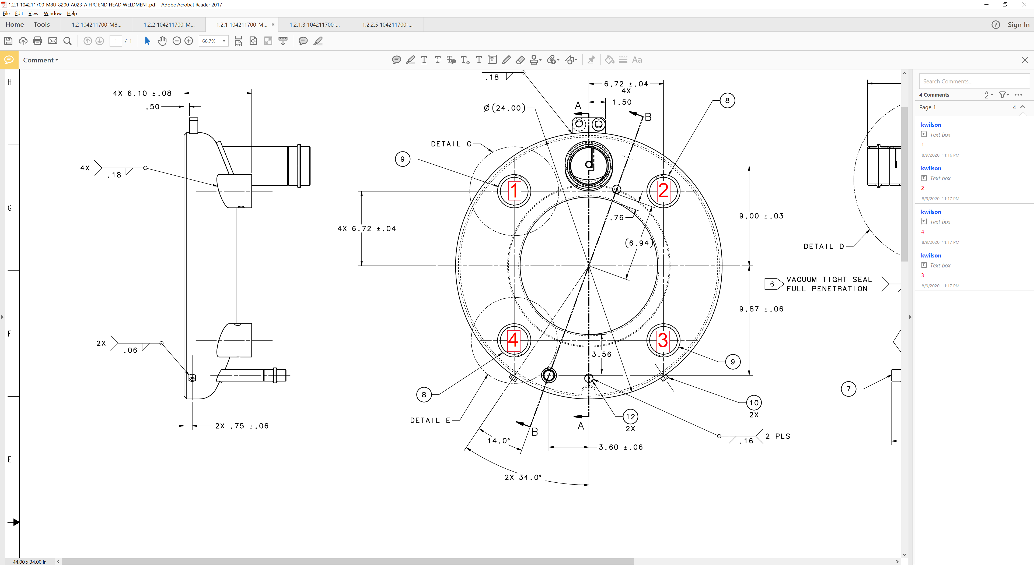
 | Comments |  |  | [[DimensionComment]] <<COMMENT>>
4 | Storage
 | The helium vessel head should be stored in a way that protects it from damage. |  |  | [[StorageTech]] <<SRF>>  [[StorageDate]] <<TIMESTAMP>>

