|  |  |  |  |
| --- | --- | --- | --- |
| RF testing of C75 cavities in the VTA | | | |
| **Document Number:** | CP-C75-CPR-VTRF | **Approval Date:** | 20-Aug-2020 |
| **Revision Number:** | - | **Periodic Review Date:** | 14-Jul-2023 |
| **Document Owner:** | G. Ciovati |  |  |

## 

# Purpose and Scope

This procedure describes how to perform the cryogenic RF testing of C75 cavities in the VTA. The same procedure applies to whether the cavity is part of a cavity-pair or it is tested as a single cavity.

# References

[VTA OSP folder](https://jlabdoc.jlab.org/docushare/dsweb/View/Collection-27272) - Link to folder in Docushare with VTA Operational Safety Procedure.

# Terms and Definitions

1. **VTA** – Vertical Test Area.
2. **HOM** – High-Order Modes.
3. **VNA** – Vector Network Analyzer
4. **CCG** – Cold Cathode Gauge
5. **PLC** – Programmable Logic Controller
6. **FCC** – Field Control Chassis

# Process Details

The requirements for being allowed to perform the cryogenic RF test of a C75 cavities in the VTA are as follows:

* Radiation Worker 1
* Read and signed the VTA Operational Safety Procedure
* Trained on and signed the VTA Radiological Work Permit
* Approval as a “Qualified RF Operator” by the VTA Facility Manager

The cryogenic RF test of C75 cavities in the VTA involves the following steps:

1. Setup and cables calibration
2. Low-field measurements
3. High-power measurements
4. HOM survey (cavity pair only)

Each of these steps is described in the following sections.

The following information should be recorded in the VTA RF Test Logbook:

* Operator name and date
* Dewar number and top plate ID number
* Cavity vacuum pressure measured by the CCG on the top plate, in mbar.
* He pressure in Torr as indicated on the VAT Controller indicator.
* He liquid level in centimeters (see Allen-Bradley PLC screen of the dewar)
* Dewar temperature in Kelvin (convert using table below), the reference temperature for the high-power cavity RF test is 2.07 K.

|  |  |
| --- | --- |
| **Dewar Helium Pressure (Torr)** | **Dewar Temperature (K)** |
| 23.08 | 1.99 |
| 23.77 | 2.00 |
| 24.47 | 2.01 |
| 25.19 | 2.02 |
| 25.92 | 2.03 |
| 26.66 | 2.04 |
| 27.42 | 2.052 |
| 28.20 | 2.06 |
| 28.98 | 2.07 |
| 29.78 | 2.08 |
| 30.60 | 2.09 |
| 31.43 | 2.10 |
| 32.27 | 2.11 |
| 33.13 | 2.12 |
| 34.00 | 2.13 |
| 34.88 | 2.14 |
| 35.78 | 2.15 |
| 36.69 | 2.16 |
| 37.61 | 2.17 |
| 38.55 | 2.18 |
| 39.50 | 2.19 |
| 40.46 | 2.2 |

1. **Setup and cables calibration**
   1. **Finding the frequencies of the TM010 passband with a VNA**
2. Connect the cable from Port 1 and Port 2 of the VNA to the input power feedthrough and the transmitted power (also called “field probe”) feedthrough on the dewar top plate, respectively.
3. Measure S21 on the VNA and set the output power to the maximum level (typically 0-13 dBm).
4. Set the IF bandwidth to 300 Hz
5. Set the number of points to a minimum of 1601
6. Set the Span to 2 MHz
7. Set the center frequency to 1497.300 MHz. A sharp peak corresponding to the p-mode resonant frequency should be visible on the screen. If not, increase the span.
8. Set Marker Function -> Marker Search -> Max; Tracking -> On
9. Take note of the marker frequency
10. Repeat steps 6-8 for the following center frequency values corresponding to the 5 passband resonant modes:

-mode 1497.300 MHz

4/5 mode 1492.270 MHz

3/5 mode 1480.140 MHz

2/5 mode 1465.700 MHz

/5 mode 1454.425 MHz

* 1. **Cables calibration**
  2. At the patch panel in the VTA control room, connect the RF cables for the RF system being used to the dewar with the cavity to be tested: Forward Power -> A; Transmitted Power -> B; Incident Power -> C; Reflected Power -> D
  3. Verify the RF ENABLE ON/OFF switch of the RF system is OFF.
  4. Run the LabVIEW program named **VTA_main.vi**.
  5. A window will appear as shown in figure 1:

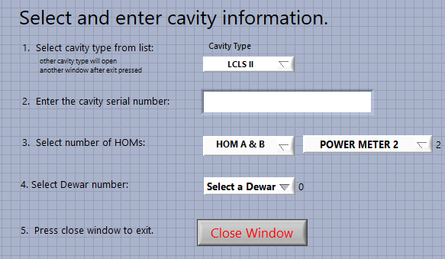

**Figure 1:**

* Select the cavity type from the list matches and displays the square root (R/Q)/L of the cavity under test.
* The cavity serial number can be determined from the white board just outside the VTA. The data file name will be determined by the cavity serial number. If more than one test has been conducted, the data file name will be the cavity serial number with an uppercase letter appended to the end of it.
* When all the information is filled in, press the CLOSE button to continue to the main RF testing screen.
  1. Zero the power meters by clicking the red button labeled Zero Pwr Meters.
  2. Verify RF off cavity resonance before continuing.
  3. Run the cable calibration program by clicking the red button labeled Calibrate Cables.
  4. Refer to Appendix A for complete cable calibration instruction.

1. **Low-field measurements**

The measurements described in this section should be performed prior to the high-power RF test or for measuring the Q0 as a function of the He bath temperature at low field, Eacc = 2 – 4 MV/m

* 1. **Preparation for RF testing**

With reference to figure 2, follow steps 1 – 3.

1. Assure the flexible tubing is plugged into the pressurized He port at the dewar. Assure valve V3 is closed
2. Open valve V1, then open valve V2. This will purge air out of the small tubing section. After ~15 sec close valve V2
3. Open valve V3 such that the pressure measured by gauge G1 is above zero but the poppet relief valve RV is not triggered. This allows He gas purging the input power RF cable and preventing a discharge when high-power RF flows through the cable.

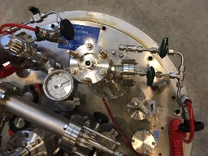

Tube connected to pressurized He gas supply

V1

V2

V3

G1

RV

**Figure 2.** Hardware for He purging of the input power RF cavity on the C75 cavity pair test stand.

1. Close the dewar shield.
2. Notify personnel working in test area that a high power RF test is about to begin. Verify they are wearing a dosimeter and ask if they are authorized to be in the VTA during high-power RF testing.
3. In the VTA Operational Safety Log Book enter: date, cavity name, operator name and dewar number.
4. Post VTA as a Radiation Area per instructions in RWP.
5. At the PSS system panel, move the key from disable to enable position and press dewar under test square grey icon so it is red.
6. Turn on high power amplifier located in test area.
7. In the software, set the Attn slide switch to 40 dB.
8. Turn high power RF on by moving the RF switch on the RF Monitor chassis from OFF to ON.
9. Verify the cavity is not locked, by check transmitted power meter is reading ~0 W.
   1. **Cable calibration check**

The steps described in this subsection can be applied anytime during the high-power RF test to check the consistency of the cable calibration at different power levels.

* 1. In software, set Qext2 > 100. (There are two modes for measuring Qext2: CW mode is selected whenever the entered value for Qext2 > 100; decay mode is selected whenever the entered value for Qext2 <= 100)
  2. Set the attenuation slider switch such that the cavity incident power level is ~1-3 W.
  3. Click ‘Measure and Log’ button in the software.
  4. Verify the Ploss/Pincident ratio is less than 0.003. If it is not, redo the Forward Power Into

Detuned Cavity Step in the cable calibration routine, using the high power amplifier set

between ~1-3 W. Repeat the cable calibration check. If the ratio is not less than 0.003,turn high power off. Check that cable connections at the dewar are tight and repeat steps 2 – 4.

Note that changing cables or tightening connectors may require at least a partial cable calibration.

* 1. Once Ploss/Pincident ratio is less than 0.003, the cable calibration check is complete.
  2. **Initial Cavity Tuning**

1. Set the frequency of the signal generator to the value f=1800 MHz + f0 where f0 is the resonant frequency of the -mode of the cavity
2. Set the center frequency of the spectrum analyzer to f0 with a span of 4 MHz
3. Connect the transmitted power crystal signal, reflected power crystal signal and phase error signal to the oscilloscope.
4. Set the SEL Loop to CLOSED.
5. In the software, switch to the ‘live numbers’ read back tab. The software will report the most recent power levels.
6. Increase incident power to ~ 1-3 W. This is done in the software by slowly reducing the attenuator slider switch.
7. Once incident power is ~ 1-3 W, click on the software button labeled ‘Set Mixer Level’.
8. Set Mixer Level adjusts the variable attenuator control voltage so the transmitted power crystal detector voltage is within the crystal voltage range of 10 V. A simple way to check this is to set the Channel Scale to 1 V/div, set the zero-level to the bottom line of the oscilloscope screen. When the trace goes beyond the screen vertical scale, the signal is greater than 10 V.
9. Using the phase knob on the LabView screen, tune the cavity to the center frequency.
10. Press Optimize Phase button to get finer phasing using the FCC.
11. Write the cavity frequency and the dewar pressure as indicated on the VAT Controller in the log book.
12. Adjust the frequency of the signal generator so that DISC LARGE in the LLRF dF cluster of the RF Test VI is between 5-15 kHz.
    1. **Measure cavity coupling**
13. In software, set Qext2 <= 100. (CW mode : Qext2 > 100; Decay mode: Qext2 <= 100)
14. On the scope, decrease the volts/division for the reflected power signal until the trace reads above zero.
15. Set the horizontal time scale for 2 seconds.
16. Tune the cavity and set attenuator slide switch to provide enough power to measure transmitted power on the crystal detector connected to the oscilloscope. Power level should be less than 10 W.
17. Using the RF ON/OFF switch on the chassis, turn RF OFF and watch the Pt power decay on the scope. When it is decayed, turn RF ON. The scope will display a decay shape on reflected power, press the stop/run button on the scope to stop scrolling and freeze the screen.
18. The shape of the reflected power signal during the decay indicates the cavity coupling. An example of the overcoupled, undercoupled and critically coupled cavity pulse shape is shown in figure 3. Note the relative amplitude of reflected power peaks when RF power on vs. RF power off.

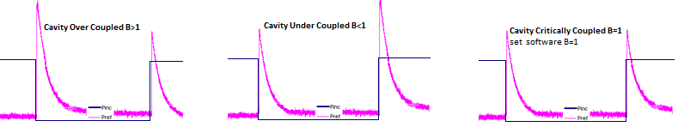

**Figure 3**. Examples of oscilloscope traces for overcoupled, undercoupled and critically coupled cavities. Note the relative amplitude of reflected power peaks when RF power on vs. RF power off.

1. Write down the coupling in the log book.
2. In software, set B switch to B > 1 or B < 1 based on the results of this measurement.
3. Press the stop/run button on the scope to resume scrolling.
   1. **Qext2 measurement and low-field Q0 measurement**

Note: If field emission is greater than 0.01 mR/hr, do not measure Qext2. It will not be accurate.

1. In software, set B switch to B > 1 or B < 1 based on the results of subsection 2.4.
2. Adjust the power attenuation slider so that Eacc is between 3-5 MV/m
3. In software, click the button labeled Set Mixer Level and then Optimize Phase.
4. In software, set Qext2 <= 100. The ‘Measure and Log’ button label will change to ‘Decay 100% to 95%’.
5. Press ‘Decay 100% to 95%’. The RF system will perform a decay measurement.
6. A window will appear which displays the decay curve. Close the window to return to the main VI.
7. Perform at least three decay measurements or more if necessary to have at least three sets of decay measurements that have similar values, within the Eacc range 3-5 MV/m.
8. Press the button labeled Click to Update Qext2. Scroll through the decay measurements and select the one which represents the average values measured. This is the Qext2 that will be used in the main VI to calculate gradient.
9. In the logbook, write down in table format:

Eacc, Q0, Qext1, Qext2, Qext2 % error, Tau and radiation.

Steps 1-6 should be followed in order to measure the low-field Q0 as a function of the He bath temperature.

1. **High-power RF measurements**

The test will capture data for Q0 versus Eacc, Radiation versus Eacc and frequency versus Eacc^2 curves.

1. Starting at 1.5 MV/m, press the button labeled Optimize Phase.
2. Press the button labeled Click to Update Lorentz on the main VI.
3. In the left tab labeled Autostep, press the button labeled Click to Run Auto Step.
4. The Autostep algorithm will decrement the attenuation slider control such that gradient changes by the value entered in the Step Size control.
5. Check the following conditions:
   * 1. the CW measurement of incident power is below 100 W to avoid overheating cables
     2. the CW measurement of dewar radiation is below 0.5 mR/hr
     3. the cavity is not quenching
6. Turn off high power using the manual switch and turn off Autostep if any of the above conditions are not met.
7. Record gradient when onset of field emission occurs.
8. If there is field emission due to multipacting, RF processing can be attempted by pulsing the RF power as follows:
   1. **Slow Pulse Method**

Used for low radiation multipacting barriers and other RF processing

* + 1. In the left tab, select Pulse Slow tab.
    2. Set the pulse width.
    3. Set the Period.
    4. Turn the Pulse switch ON to begin pulsing.
    5. Turn the Pulse switch OFF to return to CW operations.
  1. **Fast Pulse Method**

Used for high radiation multipacting barriers and other RF processing that requires higher speed and more control over pulse shape and pulse amplitude.

* + 1. In tab next to RF Control, select Pulse tab.
    2. Set High Value and Low Value attenuation.
    3. Set the pulse On Time and Off Time.
    4. The button On/Off or two Values pressed in sets the pulse on equal to the High Value power setting and sets the pulse off to full attenuation.
    5. The button On/Off or two Values depressed sets the pulse on equal to the High Value power setting and sets the pulse off equal to the Low Value power setting.
    6. Press the Enable Pulser button to start pulsing. Depress to return to CW operations.

1. The test is completed when the cavity reaches a limit, and RF processing is ineffective. Limits include: quench, radiation, multipacting.

**NOTE 1:** Experimentally, it was found that C75 cavities have a “soft” multipacting barrier between 12 – 15 MV/m, which is processed in < 2 min and a “hard” multipacting barrier between 18 – 25 MV/m. The hard barrier causes quenching of the cavity and often little to no radiation is produced. The RF operator should be very careful if the cavity quenches between 18 – 25 MV/m to look for any sign of possible multipacting, such as any detectable radiation or the transmitted power signal on the oscilloscope not reaching the same exact level when self-pulsing due to quenching or during RF processing.

**NOTE 2**: The RF operator must check the value of the Lorentz force coefficient, KL, upon completion of the RF test. If the value of KL is not within the range -3.7 to -4.2 Hz/(MV/m)2 it is very likely that there is an error in the cable calibration. The cable calibration should be repeated as well as the RF test.

1. If required, perform Q0 versus Eacc in all other modes or temperatures. When measuring Q0(Eacc) for other passband modes, repeat the Qext2 measurement (Sec. 2.5) to determine the correct Qext2 for each mode.
2. When the cavity performance measurements are complete:
   * 1. In the control room, turn off high power RF.
     2. In the high bay turn off the high power amplifier.
3. In the software, press ‘backup files’. A copy of the log file will be placed on the network at:

O:\srfee\LabVIEWData\VTACavityTest.

1. The subfolder is dependent on the frequency of the cavity.
2. At the PSS System panel. Press the red icon for the dewar used in the test so it turns grey.
3. If no other dewar is being used for high power testing, switch the PSS system to the disabled state with the key.
4. Open the dewar shield.
5. If no other testing is taking place, unpost the radiation area as per RWP.
6. Stop purging of the input power cable with Helium gas as follows: (**ATTENTION**: if the steps are not followed in the prescribed order, several hundred liters of liquid helium can be contaminated with air!)
   1. with reference to Fig. 2, close valve V3
   2. unplug the flexible tubing from the pressurized He gas port at the dewar.
7. Fill out the cavity performance traveler.
8. **HOM survey**

This section details the use of the VTA HOM survey LabView program. It reflects mainly the preparation of an Excel file to be used by Mathematica to extract loaded-Q values. The HOM survey is done only on cavities which are part of a cavity pair.

* 1. **Connect the network analyzer to the cavity and laptop**
     + 1. Connect a E5071C network analyzer as follows

1. Port 1 connected to the FPC adapter
2. Port 2 connected to FP adapter (field probe), it may be useful to attach port 2 to the output of a RF preamp
   * + 1. Connect the network analyzer to the srfvtalap laptop using the GPIB – USB adapter.
   1. **Use LabVIEW program for HOM survey data acquisition**
      * 1. Login to VTA laptop as srs-ee (use the PASSWORD).
        2. Open the LabVIEW shortcut on the desktop called “VTA HOM Survey.vi”.
        3. Under the ‘README’ tab, a short description of the program’s function as well as the options available to the user are listed.
        4. Under the ‘Setup Inst’, fill in the information about the test: Tester’s Name, Dewar #, etc.
        5. Make sure to select the VISA instrument as connected
        6. Run the program by clicking the white arrow. (Fig. 4)
        7. A popup window will appear asking where to save the collected data, and important information about the cavity. (Fig. 5)
        8. Fill in the information and click ‘Done’.

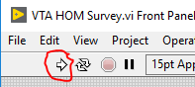

**Figure 4.** Run button

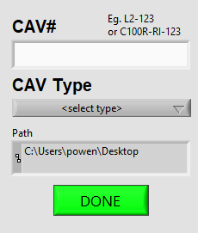

**Figure 5.** Cavity information popup menu

**Appendix A: detailed cables calibration steps**

**NOTE 3:** The C75 cavities do not have HOM cables.

**Step 1. Reflected Power from VTA**

A. Verify RF Power off in control room.

B. Measure network analyzer power out (cable GH) using power meter.

(for S21 configuration measure network analyzer power out at port 1)

Write down the measured network analyzer power out in logbook.

C. At dewar, connect cable GH to cable AB as shown in figure A1.

D. In cable calibration VI, click button labeled 'Reflected Power From VTA'

E. A pop-up will appear, enter the network power out (from Step 1.B, above) in the yellow highlighted field. Click Done button when finished.

F. Disconnect cable GH from cable AB.

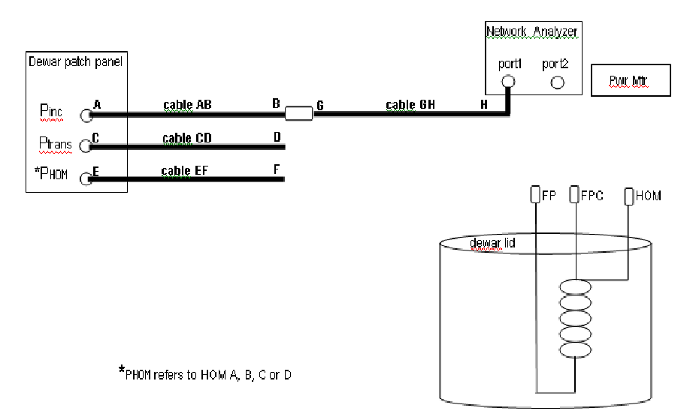

**Figure A1.** Connect cable AB to cable GH to measure the reflected power from VTA.

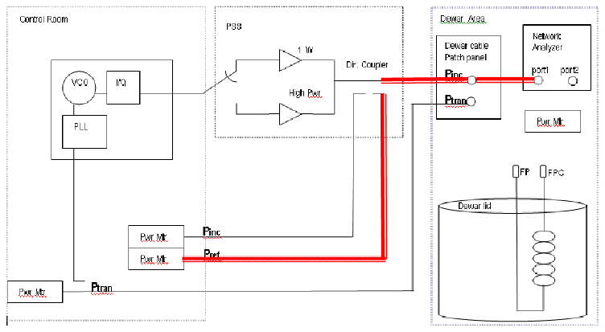

**Figure A2.** Block diagram representation of ‘reflected power from VTA’ cable calibration step.

**Step 2. Incident power measured at dewar**

A. Connect cable AB to power meter cable as shown in Figure A3.

B. Turn low power RF on in control room.

C. In cable calibration VI, set Atten to 20 dB using slide control.

D. Set frequency of the signal generator so that the frequency measured by the frequency counter is = Pi mode frequency + 50 kHz.

D. At dewar, write down measured power on cable AB.

E. In cable calibration VI, click button labeled 'Pi @ dewar'.

F. A pop-up screen will appear, enter the Pi measured at the dewar from Step 2D, above. Click Done button when finished.

G. Turn RF Power off in control room.

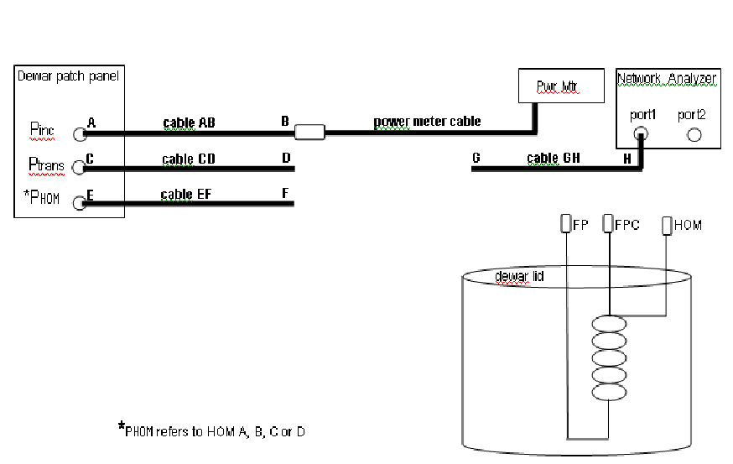

**Figure A3.** Connect cable AB to cable GH to measure the reflected power from VTA.

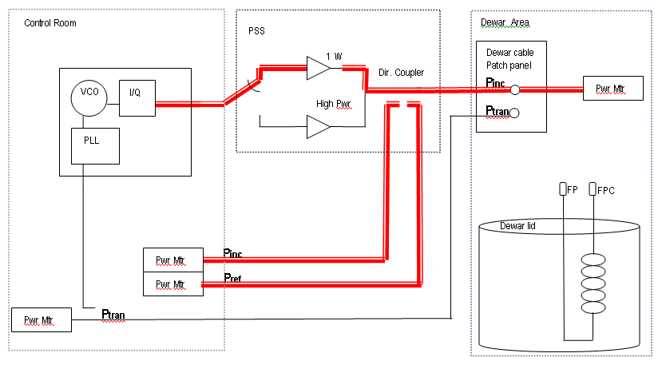

**Figure A4.** Block diagram representation of ‘incidentpower measured at dewar’ cable calibration step.

**Step 3. Ptrans to control room**

A. At dewar, connect cable CD to cable GH as shown in Figure A5.

B. In cable calibration VI, click button labeled 'Transmitted Power Into Control Room.

C. A pop-up screen will appear, enter the network analyzer power out measured in step 1B. Click Done button when finished.

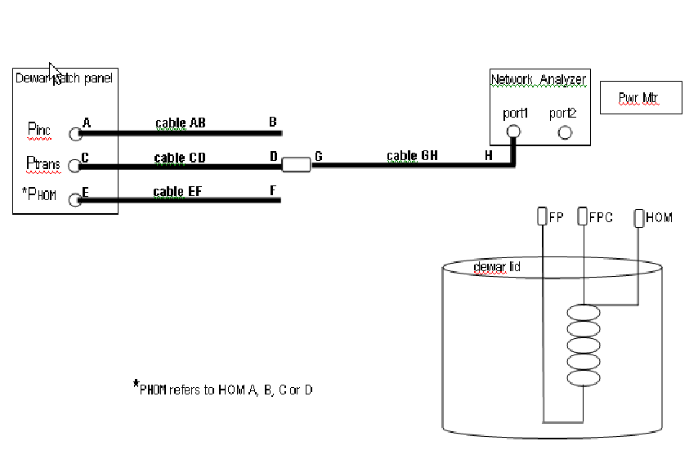

**Figure A5.** Connect cable CD to cable GH to measure the transmitted power to control room.

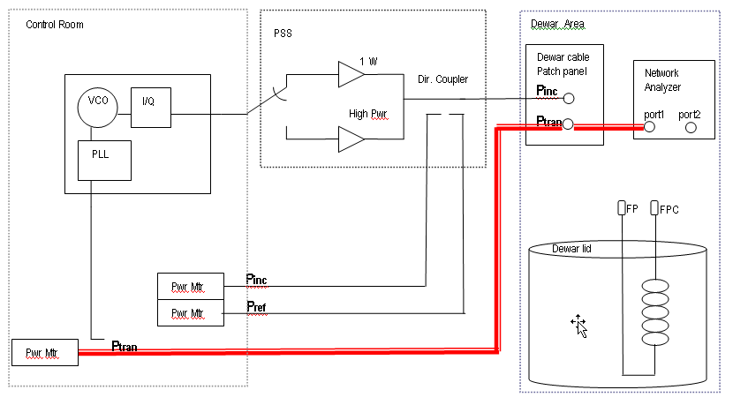

**Figure A6.** Block diagram representation of ‘transmitted power to control room’ cable calibration step.

**Step 5. Transmitted Cable Return Loss**

A. At dewar, connect circulator ports 1, 2, and 3 as shown in figure A7:

1 - Cable GH

2 - Calibrated open connector.

3 - Power meter sensor.

B. Write down the measured power in the logbook.

C At dewar, connect circulator ports 1, 2, and 3 as shown in figure A8:

1 - Cable GH

2 - Cavity field probe (FP) connector

3 - Power meter sensor.

D. Write down the measured power in the logbook.

E. In cable calibration VI, click button labeled 'Transmitted Cable Return Loss'.

F. A pop-up screen will appear, enter the open (Step 5B) and field probe (Step 5D) power measurements. Click Done button when finished.

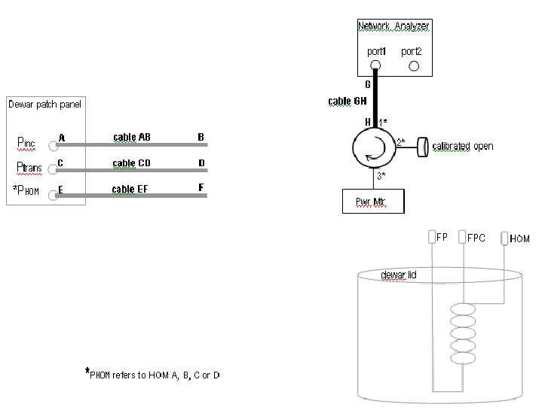

**Figure A7.** Cable GH, calibrated open and power meter connected to circulator for ‘Transmitted Cable Return Loss’ open measurement.

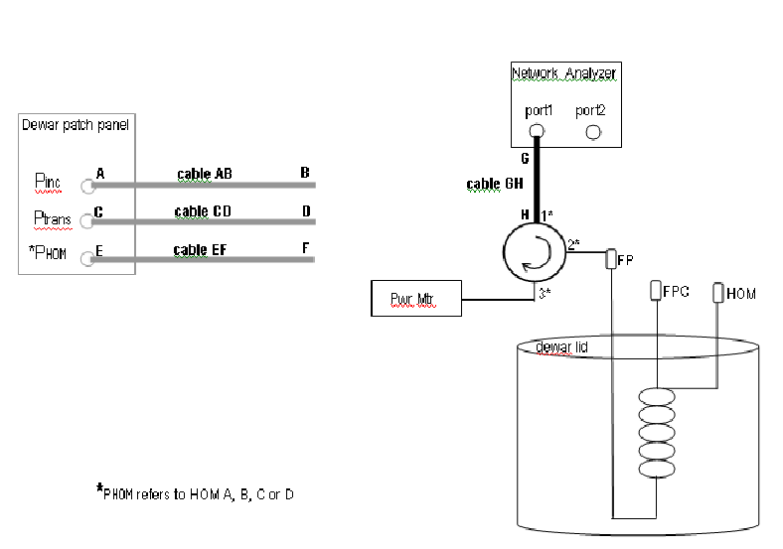

**Figure A8.** Cable GH, cavity field probe (FP) and power meter connected to circulator for ‘Transmitted Cable Return Loss ’ field probe measurement.

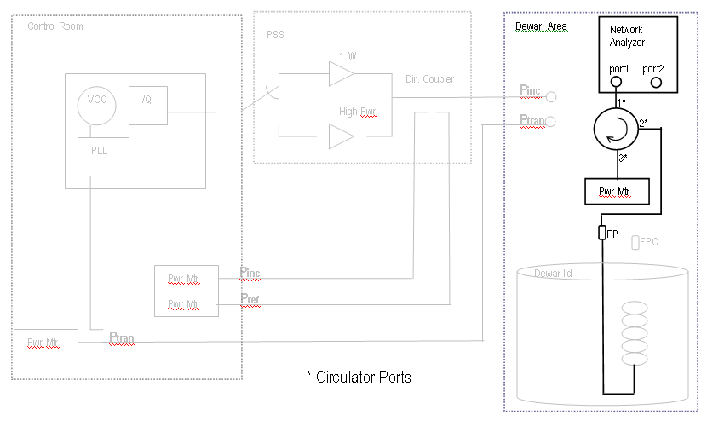

**Figure A9.** Block diagram representation of ‘transmitted cable return loss’ field probe cable calibration step.

**Step 6. Fwd Pwr to detuned cavity**

1. Connect all cables from dewar patch panel to dewar as shown in figure A10:

- cable AB to Fundamental Power Coupler [FPC] port

- cable CD to Field Probe [FP] port

- cable EF to each HOM X port

1. Clear area and close dewar lid.
2. Turn low power RF on. In cable calibration VI, set Atten to 20 dB using slide control.
3. Verify Pt power meter reads ~ 0 W.
4. In cable calibration VI, click button labeled 'Foward Power into Detuned Cavity'.
5. A pop-up screen will appear and quickly disappear without any operator interaction.
6. Turn RF power off.
7. Upon completing the cable calibration, click the button labeled ‘DONE’ in the cable calibration VI.

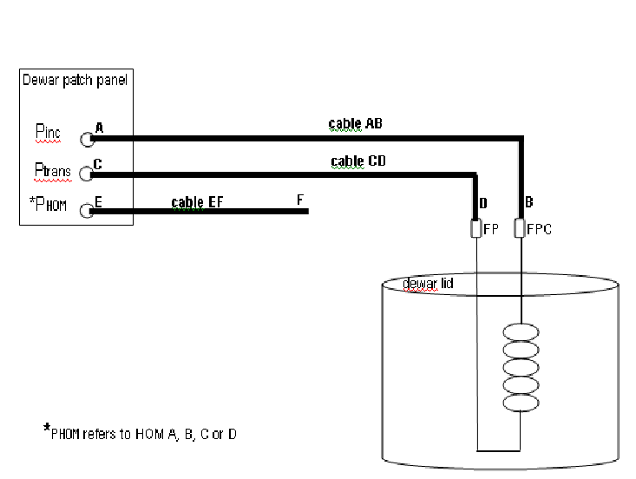

**Figure A10.** Cable AB to Fundamental Power Coupler (FPC) port and Cable CD to Field Probe (FP) port for ‘forward power to detuned cavity’ cable calibration step.

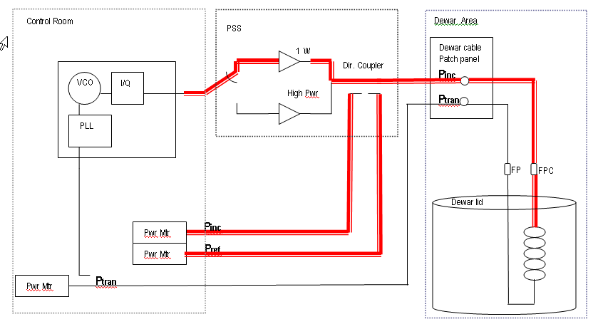

**Figure A11.** Block diagram representation of ‘Forward Power to detuned cavity’ cable calibration step.

1. A window will open to display the difference between the current calibration and the last calibration performed in the dewar. Percent difference = (10^(difference/10) – 1)*100

|  |  |
| --- | --- |
| Difference (dB) | Percent Difference |
| 0.01 | 0.23 % |
| 0.03 | 0.69 % |
| 0.05 | 1.16 % |
| 0.07 | 1.62 % |
| 0.10 | 2.33 % |
| 0.30 | 7.15 % |
| 0.50 | 12.2 % |
| 0.70 | 17.5 % |
| 1.00 | 25.9 % |
| 2.00 | 58.5 % |

Good calibrations will have a difference of 0.05 dB or less, provided that no cables have been replaced.

1. Click on the button labeled ‘done’ to exit the calibration comparison window.
2. A window will appear requesting the operator to replace or cancel overwriting the cable calibration file. Select replace to write the new calibration data to the calibration file. Partial calibration values can be written to the file without overwriting existing calibration data. Select cancel to skip writing the new calibration data to the calibration file.
3. The main VI will be displayed. The calibration is finished.
4. Write down the power meter correction factors from the 6_VTA_main.vi screen. They are displayed in the *PM corr fac* cluster as **Ci, Cr** and **Ct**.

# **Revision History**

|  |  |  |
| --- | --- | --- |
| Rev # | Revision or update: | Effective: |
| Release | Initial Release | 08/20/2020 |
|  |  |  |

# **Approvals**

|  |  |  |
| --- | --- | --- |
| Approved by: | Signature: | Date: |
| **Document Owner** | G. Ciovati |  |
| **SRF Cavity Production Group Leader** | K. Davis |  |
| C75 Project Manager | K. Macha |  |