Traveler Title | SNSPPU Cavity Receiving Inspection
Traveler Abstract | Incoming inspection of SNSPPU production cavites
Traveler ID | SNSPPU-CAV-INSP
Traveler Revision | R1
Traveler Author | p. Dhakal
Traveler Date | 25-Apr-20
NCR Informative Emails | edaly
NCR Dispositioners | Kwilson,kdavis,Dhakal
D3 Emails | Edaly,kwilson,kdavis,Dhakal
Approval Names | P. Dhakal | K. Macha | K. Wilson | E. Daly
Approval Signatures
Approval Dates
Approval Title | Author | Reviewer | Reviewer | Project Manager

References | List and Hyperlink all documents related to this traveler. This includes, but is not limited to: safety (THAs, SOPs, etc), drawings, procedures, and facility related documents.

Revision Note
R1 | Initial release of this Traveler.

Receiving Inspection Goals:
This traveler covers all steps required to visually and dimensionally (CMM measurements) accept incoming cavities.
Careful handling of the cavity is mandatory at all times. This includes transferring the cavity to another work station during or after the inspections. The goals of this inspection covers:
- Visual inspections of the SNSPPU cavity (some checks require torque wrench and caliper)
- CMM Inspections )restricted to accessible components on the exterior)
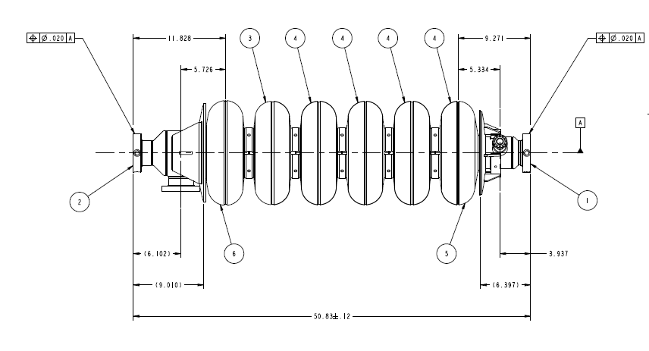
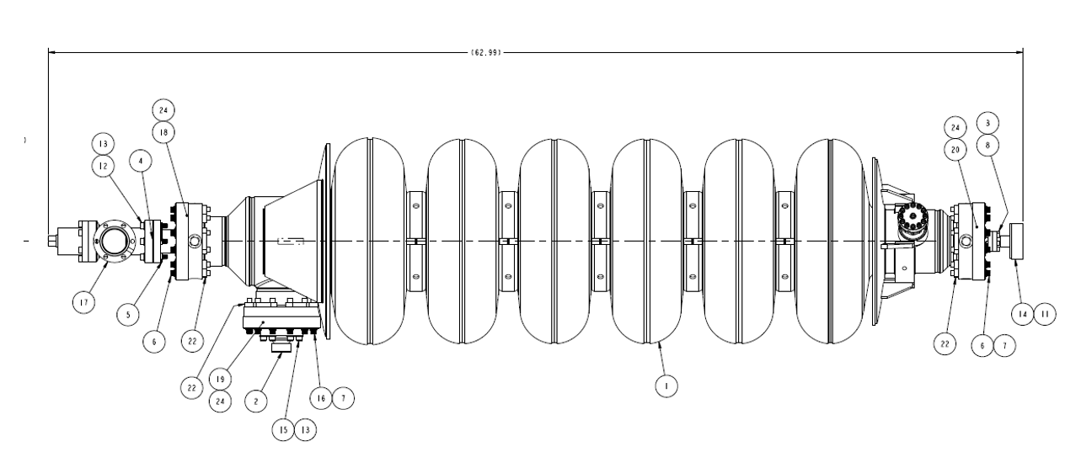
SNS PPU cavites are produced and delivered by RI Research Instruments, GmbH (short: RI). Each SNSPPU production cavity is delivered without a helium vessel under vacuum and at this point has passed 3 acceptance levels (hold points) at the vendor site permitting shipment to JLab. At JLab the cavity must have passed receipt inspection and RF inspection to allow visual and CMM inspection. Vendor drawings of the cavity assembly reflecting the condition at delivery are shown below

To be added some picture of shiping
Step No. | Instructions | Data Input
1 | Record serial numbers  Inspector Name  Cavity Serial Number  Date of Inspection | [[InspTech]] <<SRFCVP>>  [[InspDateTime]] <<TIMESTAMP>>  [[SerialNumComment]] <<COMMENT>>  [[SNfileupload]] <<FILEUPLOAD>>
 | Cavity | [[CAVSN]] <<CAVSN>>
 | Valve | [[AV15SN]] <<AV15SN>>
 | Beam tube flange adapter – short | [[FlangeShortSN]] <<SN>>
 | Beam tube flange adapter - long | [[FlangeLongSN]] <<SN>>
 | Burst Disk | [[PBDSN]] <<PBDSN>>
 | Field Probe | [[FPFTSN]] <<FPFTSN>>
 | Input Coupler | [[NTFTSN]] <<NTFTSN>>
2 | Configuration Check. Are the following components installed? | [[CMMTechInstall]] <<SRFCVP>>  [[CMMDateTimeInstall]] <<TIMESTAMP>>  [[CMMCommentInstall]] <<COMMENT>>  [[CMMUploadInstall]] <<FILEUPLOAD>>
 | Support blocks (4) | [[SupportBlocks]] <<YESNO>>
 | Right Angle Valve in closed position, exposed stem length is approximately 8mm. Measure and record length. | [[RightAngleValve]] <<YESNO>>  [[ValveBoltLength]] <<FLOAT>>
3 | Damage Check. Are the following components damaged? | [[CMMTechDammage]] <<SRFCVP>>  [[CMMDateTimeDammage]] <<TIMESTAMP>>  [[CMMCommentDammage]] <<COMMENT>>  [[CMMUploadDammage]] <<FILEUPLOAD>>
 | Field Probe Pin | [[FieldProbePin]] <<YESNO>>
 | Burst Disc | [[BurstDisc]] <<YESNO>>
 | Any other damage | [[OtherDamages]] <<YESNO>>

Step No | Instructions |  |  | Data Inputs
4 | CMM Inspections  Perform dimensional inspections on CMM. Fill out NCR for any out of tolerance measurements. |  |  | [[CMMTech]] <<SRFCVP>>  [[CMMDateTime]] <<TIMESTAMP>>  [[CMMComment]] <<COMMENT>>
 | Drawing number | Description | Drawing Value (mm or as noted) |  | Measured Value | Within Tolerance
 | XXXXXX | What needed to CMM? | xxxxx |  | [[DIM1]] <<FLOAT>> | [[DIMTOL1]] <<YESNO>>
 | XXXXXX | What needed to CMM? | xxxxx |  | [[DIM2]] <<FLOAT>> | [[DIMTOL2]] <<YESNO>>
 | XXXXXX | What needed to CMM? | xxxxx |  | [[DIM3]] <<FLOAT>> | [[DIMTOL3]] <<YESNO>>
 | XXXXXX | What needed to CMM? | xxxxx |  | [[DIM4]] <<FLOAT>> | [[DIMTOL4]] <<YESNO>>

