Traveler Title | SNS PPU Cavity Helium Vessel Probe End Head Inspection Traveler
Traveler Abstract | Traveler defines inspection process for the probe end head, one of three helium vessel components
Traveler ID | SNSPPU-CAV-INSP-HEHDP
Traveler Revision | R1
Traveler Author | K. M. Wilson
Traveler Date | 13-Jul-20
NCR Informative Emails | kwilson, edaly, areilly, macha, fischer
NCR Dispositioners | kwilson, edaly, macha
D3 Emails
Approval Names | K. M. Wilson | A. DeKerlegand | K. Macha | E. Daly
Approval Signatures
Approval Dates
Approval Title | Author | Reviewer | Reviewer | Project Manager

References | List and Hyperlink all documents related to this traveler. This includes, but is not limited to: safety (THAs, SOPs, etc), drawings, procedures, and facility related documents.
104211700-M8U-8200-A025 PROBE END HEAD WELDMENT | 104211700-M8U-8200-A019 PROBE END DISHED HEAD | 104211700-M8U-8200-A026 HELIUM VESSEL ASSEMBLY | SNSPPU-CAV-ASSY-HELV

Revision Note
R1 | Initial release of this Traveler.

Step No. | Instructions | Data Input
1 | Initial Inspection
 | Technician Name  Date of Inspection  Serial Number of part | [[TechName]] <<SRF>>  [[InspectionDate]] <<TIMESTAMP>>  [[HESSN]] <<HESSN>>
 | Is head generally free from excessive dirt or other contaminants? (Head is not expected to be clean to UHV standards.) | [[PartCleanOk]] <<YESNO>>
 | Carefully visually inspect the bellows, inside and outside. There should be no dents or gouges or other damage. | [[BellowsOk]]<<YESNO>>
 | Visually inspect the rest of the head. There should be no dents (minor surface dings can be disregarded), or gouges (other than minor surface defects), or other damage. | [[VisualOk]]<<YESNO>>
 | Look at all welds and verify they are smooth and flush, with no crevices, cracks or protrusions. This is not intended to be a formal weld inspection, but to verify that welds generally appear as expected and no damage has occurred in transit. | [[WeldsOk]] <<YESNO>>
 | There should be no unusual discoloration to the titanium, especially around the welds. | [[ColorationOk]] <<YESNO>>
 | Verify weld chamfer as shown on Section A-A of 104211700-M8U-8200-A019. Exact dimensions are not critical but should be approximately 0.25 x 45 degrees. | [[ProperWeldChamfer]] <<YESNO>>
 | Comments  Upload photos of any damage. | [[VisualInspComment]] <<COMMENT>>  [[VisualInspPhoto]] <<FILEUPLOAD>>
2 | Three of item 14 (0.500-13 threaded rod) are welded to the head. Verify rods are threaded correctly by ensuring a nut threads freely onto them. | [[ThreadsOk]] <<YESNO>>  [[ThreadsComment]] <<COMMENT>>

Step No | Instructions |  |  | Data Inputs
3 | Dimensional check. One Probe End Head from every shipment should be checked dimensionally. All dimensions are from drawing 104211700-M8U-8200-A025 PROBE END HEAD WELDMENT unless104211700-M8U-8200-A019 PROBE END DISHED HEAD is noted. Please reference dimensions to datum A, shown here:  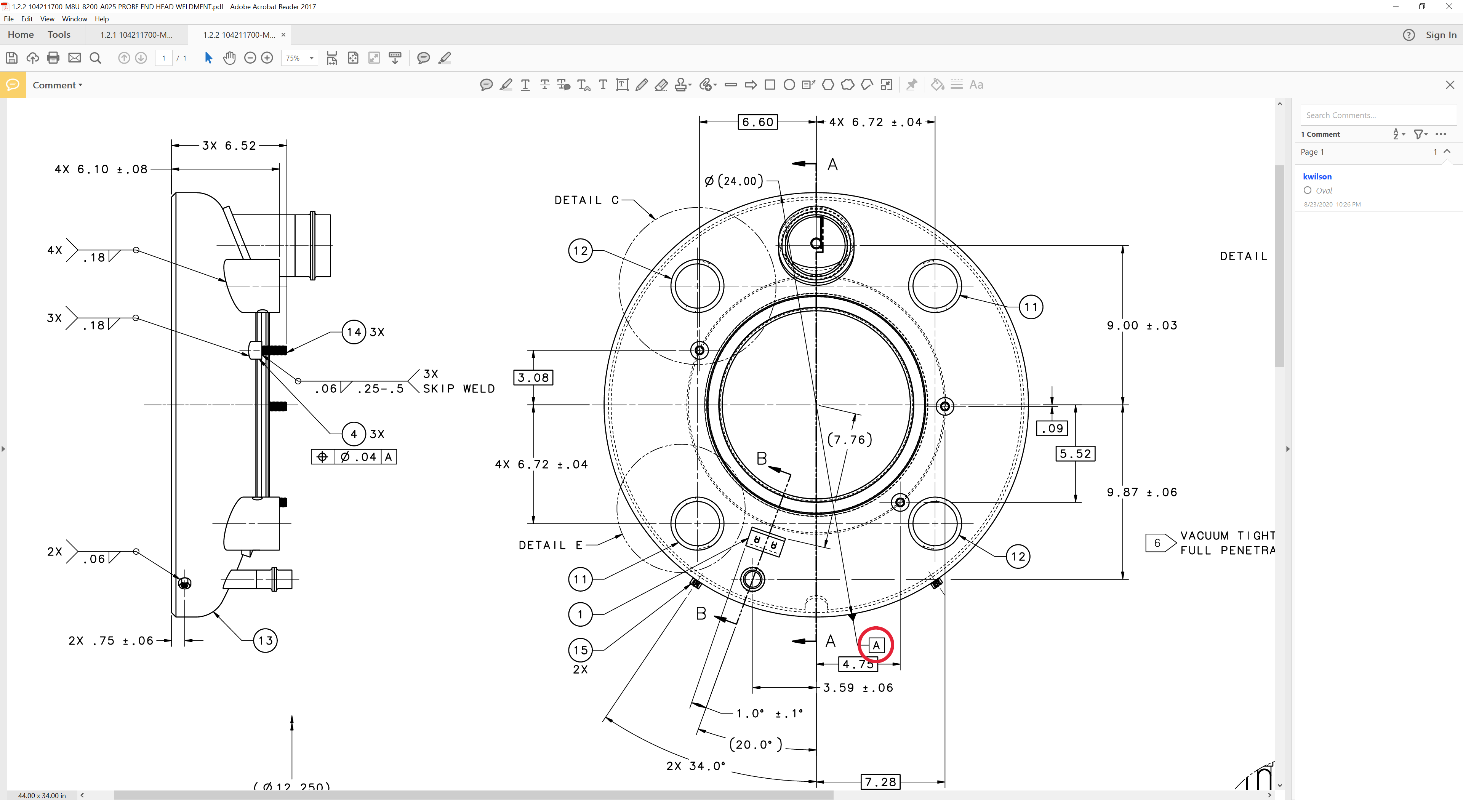
 | Dimension | Nominal | Tolerance
 | Length of upper tube | 8.99 | ± 0.06 | [[Dimension1Ok]] <<YESNO>>
 | Length of lower tube | 6.81 | ± 0.06 | [[Dimension2Ok]] <<YESNO>>
 | Inner diameter (-A019) | 23.50 | ± 0.01 | [[Dimension3Ok]] <<YESNO>>
 | Head curvature (-A019) | 24.25 | ± 0.01 | [[Dimension4Ok]] <<YESNO>>
 | Axial length (-A019) | 4.77 | ± 0.01 | [[Dimension5Ok]] <<YESNO>>
 | Tube 1 horizontal | 6.72 | ± 0.04 | [[Dimension6Ok]] <<YESNO>>
 | Tube 1 vertical | 6.72 | ± 0.04 | [[Dimension7Ok]] <<YESNO>>
 | Tube 1 hole angle | 15.6 deg | ± 0.5 deg | [[Dimension8Ok]] <<YESNO>>
 | Tube 2 horizontal | 6.72 | ± 0.04 | [[Dimension9Ok]] <<YESNO>>
 | Tube 2 vertical | 6.72 | ± 0.04 | [[Dimension10Ok]] <<YESNO>>
 | Tube 2 hole angle | 15.6 deg | ± 0.5 deg | [[Dimension11Ok]] <<YESNO>>
 | Tube 3 horizontal | 6.72 | ± 0.04 | [[Dimension12Ok]] <<YESNO>>
 | Tube 3 vertical | 6.72 | ± 0.04 | [[Dimension13Ok]] <<YESNO>>
 | Tube 3 hole angle | 15.6 deg | ± 0.5 deg | [[Dimension14Ok]] <<YESNO>>
 | Tube 4 horizontal | 6.72 | ± 0.04 | [[Dimension15Ok]] <<YESNO>>
 | Tube 4 vertical | 6.72 | ± 0.04 | [[Dimension16Ok]] <<YESNO>>
 | Tube 4 hole angle | 15.6 deg | ± 0.5 deg | [[Dimension17Ok]] <<YESNO>>
 | Threaded rod 1 horizontal | 6.60 | ± 0.01 | [[Dimension18Ok]] <<YESNO>>
 | Threaded rod 1 vertical | 3.08 | ± 0.01 | [[Dimension19Ok]] <<YESNO>>
 | Threaded rod 1 length | 6.52 | ± 0.01 | [[Dimension20Ok]] <<YESNO>>
 | Threaded rod 2 horizontal | 7.28 | ± 0.01 | [[Dimension21Ok]] <<YESNO>>
 | Threaded rod 2 vertical | 0.09 | ± 0.01 | [[Dimension22Ok]] <<YESNO>>
 | Threaded rod 2 length | 6.52 | ± 0.01 | [[Dimension23Ok]] <<YESNO>>
 | Threaded rod 3 horizontal | 4.75 | ± 0.01 | [[Dimension24Ok]] <<YESNO>>
 | Threaded rod 3 vertical | 5.52 | ± 0.01 | [[Dimension25Ok]] <<YESNO>>
 | Threaded rod 3 length | 6.52 | ± 0.01 | [[Dimension26Ok]] <<YESNO>>
 | 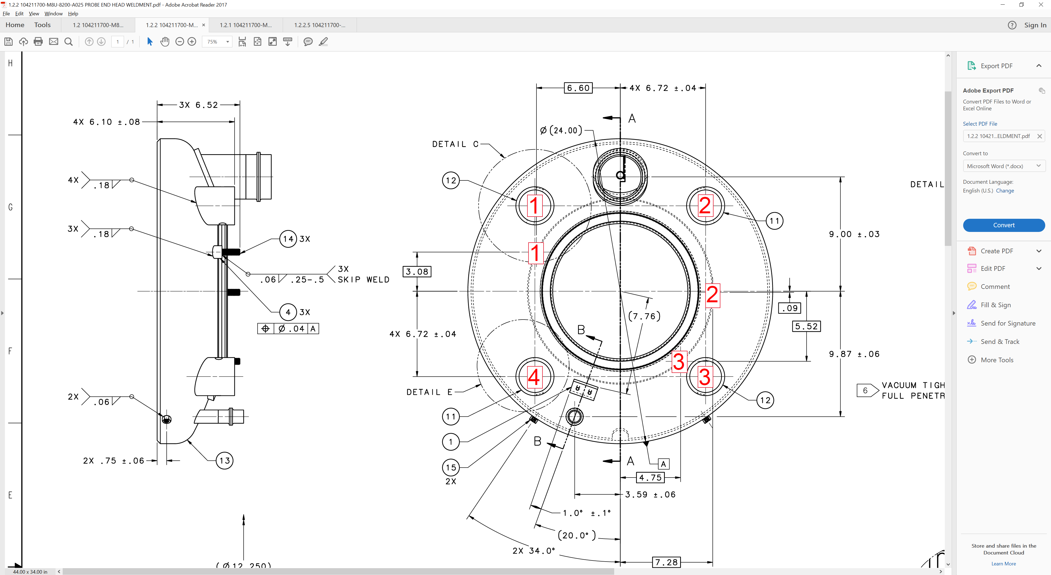
 | Comments |  |  | [[DimensionComment]] <<COMMENT>>
4 | Storage
 | The helium vessel head should be stored in a way that protects it from damage. |  |  | [[StorageTech]] <<SRF>>  [[StorageDate]] <<TIMESTAMP>>

