Traveler Title | SNS PPU Cavity Helium Vessel FPC End Head Inspection Traveler
Traveler Abstract | Traveler defines inspection process for the FPC end head, one of three helium vessel components
Traveler ID | SNSPPU-CAV-INSP-HEHDF
Traveler Revision | R1
Traveler Author | K. M. Wilson
Traveler Date | 13-Jul-20
NCR Informative Emails | kwilson, edaly, areilly, macha, fischer
NCR Dispositioners | kwilson, edaly, macha
D3 Emails
Approval Names | K. M. Wilson | A. DeKerlegand | K. Macha | E. Daly
Approval Signatures
Approval Dates
Approval Title | Author | Reviewer | Reviewer | Project Manager

References | List and Hyperlink all documents related to this traveler. This includes, but is not limited to: safety (THAs, SOPs, etc), drawings, procedures, and facility related documents.
104211700-M8U-8200-A023-A FPC END HEAD WELDMENT | 104211700-M8U-8200-A006 FPC END DISHED HEAD | 104211700-M8U-8200-A026 HELIUM VESSEL ASSEMBLY | SNSPPU-CAV-ASSY-HELV

Revision Note
R1 | Initial release of this Traveler.

Step No. | Instructions | Data Input
1 | Initial Inspection
 | Technician Name  Date of Inspection  Serial Number of part | [[TechName]] <<SRF>>  [[InspectionDate]] <<TIMESTAMP>>  [[HEHDFSN]] <<HEHDFSN>>
 | Is head generally free from excessive dirt or other contaminants? (Head is not expected to be clean to UHV standards.) | [[PartCleanOk]] <<YESNO>>
 | Visually inspect the rest of the head. There should be no dents (minor surface dings can be disregarded), or gouges (other than minor surface defects), or other damage. | [[VisualOk]]<<YESNO>>
 | Look at all welds and verify they are smooth and flush, with no crevices, cracks or protrusions. This is not intended to be a formal weld inspection, but to verify that welds generally appear as expected and no damage has occurred in transit. | [[WeldsOk]] <<YESNO>>
 | There should be no unusual discoloration to the titanium, especially around the welds. | [[ColorationOk]] <<YESNO>>
 | Verify weld chamfer as shown on Section A-A of 104211700-M8U-8200-A006. Exact dimensions are not critical but should be approximately 0.25 x 45 degrees. | [[ProperWeldChamfer]] <<YESNO>>
 | Comments  Upload photos of any damage. | [[VisualInspComment]] <<COMMENT>>  [[VisualInspPhoto]] <<FILEUPLOAD>>

Step No. | Instructions | Data Input
2 | Verify head length for calculating shell trimming
 | Technician Name  Date of Inspection | [[TechName]] <<SRF>>  [[InspectionDate]] <<TIMESTAMP>>
 | Please measure the dimension indicated by the red arrow below, from the tip of the chamfer to the inside of the countersink. Please record the dimension. This should be approximately 4.56 in. Please measure in several locations and record the average if there are slight variations. | [[TrimmingDim]] <<DIM>>
 | 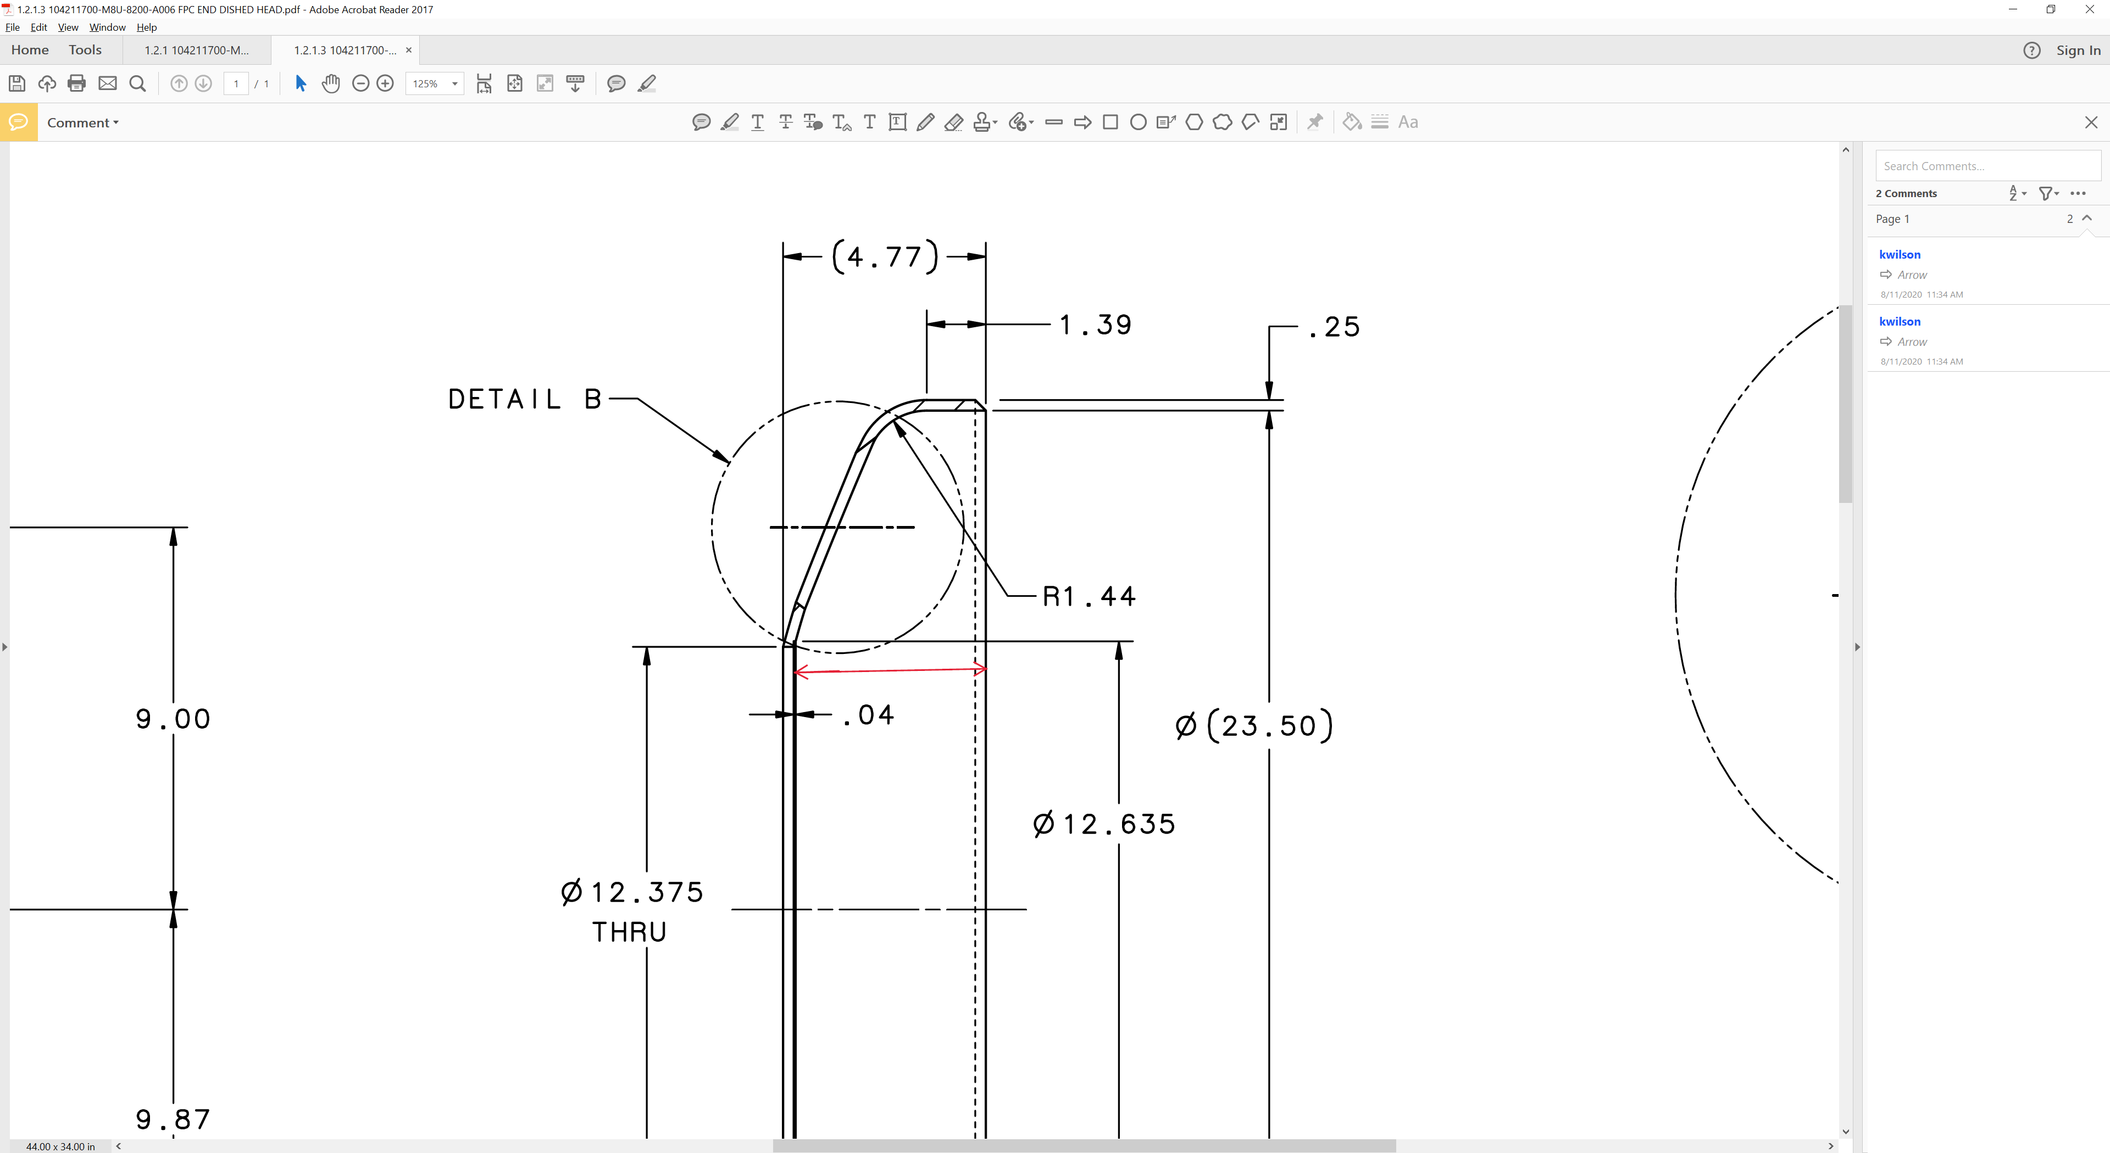

Step No | Instructions |  |  |  | Data Inputs
3 | Dimensional check. One FPC end head from every shipment should be checked dimensionally. All dimensions are from drawing 104211700-M8U-8200-A023-A FPC END HEAD WELDMENT unless 104211700-M8U-8200-A006 FPC END DISHED HEAD is noted. Please reference dimensions to datum A, shown here:  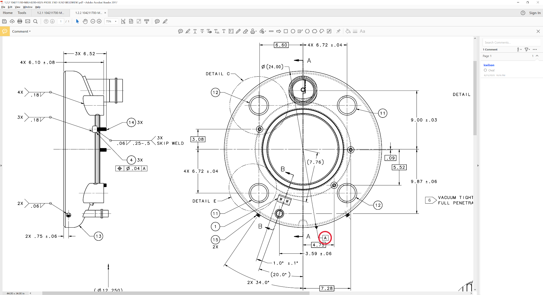
 | Technician Name  Date of Inspection |  |  |  | [[TechName]] <<SRF>>  [[InspectionDate]] <<TIMESTAMP>>
 | Dimension | Nominal | Tolerance | Measured Value | Dimension Within Tolerance?
 | Length of upper tube | 11.37 | ± 0.06 | [[Dimension1]] <<DIM>> | [[Dimension1Ok]] <<YESNO>>
 | Length of lower tube | 9.16 | ± 0.06 | [[Dimension2]] <<DIM>> | [[Dimension2Ok]] <<YESNO>>
 | Inner diameter (-A006) | 23.50 | ± 0.01 | [[Dimension3]] <<DIM>> | [[Dimension3Ok]] <<YESNO>>
 | Head curvature (-A006) | 24.25 | ± 0.01 | [[Dimension4]] <<DIM>> | [[Dimension4Ok]] <<YESNO>>
 | Axial length (-A006) | 4.77 | ± 0.01 | [[Dimension5]] <<DIM>> | [[Dimension5Ok]] <<YESNO>>
 | Restraint block - axial | 0.50 | ± 0.01 | [[Dimension6]] <<DIM>> | [[Dimension6Ok]] <<YESNO>>
 | Restraint block - horizontal | 0.00 (centered) | ± 0.01 | [[Dimension7]] <<DIM>> | [[Dimension7Ok]] <<YESNO>>
 | Tube 1 horizontal (see picture below) | 6.72 | ± 0.04 | [[Dimension8]] <<DIM>> | [[Dimension8Ok]] <<YESNO>>
 | Tube 1 vertical | 6.72 | ± 0.04 | [[Dimension9]] <<DIM>> | [[Dimension9Ok]] <<YESNO>>
 | Tube 1 hole angle | 15.6 deg | ± 0.5 deg | [[Dimension10]] <<DIM>> | [[Dimension10Ok]] <<YESNO>>
 | Tube 2 horizontal | 6.72 | ± 0.04 | [[Dimension11]] <<DIM>> | [[Dimension11Ok]] <<YESNO>>
 | Tube 2 vertical | 6.72 | ± 0.04 | [[Dimension12]] <<DIM>> | [[Dimension12Ok]] <<YESNO>>
 | Tube 2 hole angle | 15.6 deg | ± 0.5 deg | [[Dimension13]] <<DIM>> | [[Dimension13Ok]] <<YESNO>>
 | Tube 3 horizontal | 6.72 | ± 0.04 | [[Dimension14]] <<DIM>> | [[Dimension14Ok]] <<YESNO>>
 | Tube 3 vertical | 6.72 | ± 0.04 | [[Dimension15]] <<DIM>> | [[Dimension15Ok]] <<YESNO>>
 | Tube 3 hole angle | 15.6 deg | ± 0.5 deg | [[Dimension16]] <<DIM>> | [[Dimension16Ok]] <<YESNO>>
 | Tube 4 horizontal | 6.72 | ± 0.04 | [[Dimension17]] <<DIM>> | [[Dimension17Ok]] <<YESNO>>
 | Tube 4 vertical | 6.72 | ± 0.04 | [[Dimension18]] <<DIM>> | [[Dimension18Ok]] <<YESNO>>
 | Tube 4 hole angle | 15.6 deg | ± 0.5 deg | [[Dimension19]] <<DIM>> | [[Dimension19Ok]] <<YESNO>>
 | 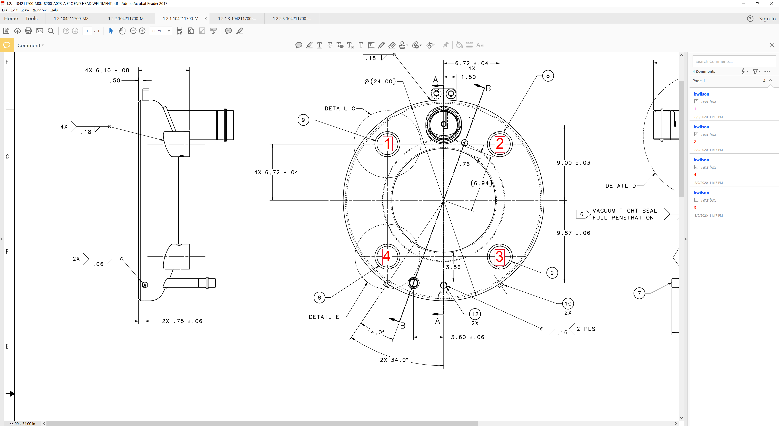
 | Comments |  |  |  | [[DimensionComment]] <<COMMENT>>
4 | Storage
 | The helium vessel head should be stored in a way that protects it from damage. |  |  |  | [[StorageTech]] <<SRF>>  [[StorageDate]] <<TIMESTAMP>>

