Traveler Title | LCLS-II HE Field Probe Feedthru Receiving Inspection
Traveler Abstract | LCLS-II HE Field Probe feedthru receiving inspection traveler, this is for the work center QA.
Traveler ID | L2HE-CAV-INSP-FPFT-S1
Traveler Revision | R1
Traveler Author | HyeKyoung Park
Traveler Date | 26-Mar-2020
NCR Emails | hkpark
Approval Names | HyeKyoung Park | George DeKerlegand | Katherine Wilson
Approval Signatures
Approval Dates
Approval Title | Author | Work Center Reviewer | Project Manager

References | List and Hyperlink all documents related to this traveler. This includes, but is not limited to: safety (THAs, SOPs, etc), drawings, procedures, and facility related documents.
 | Drawing GMM-9434A

Revision Note
R1 | Initial release of this Traveler.

Step No. | Instructions |  | Data Input
 | Pick up feedthrough (field probe) is an ultra high vacuum component. Wear talc free latex or Nitrile gloves at all times when handling this component.
 | CMM Room Inspections
1 | Visual inspection [CMM Room]  - Select a serial number from the dropdown menu.  - Enter inspector name and date.  - Is part clean, free from dust, oil, finger prints, or brazing residue?  - Gasket sealing surface: smooth, free from burrs or nicks?  - Sapphire: free from cracks? Is thereexcess of braze material on the surface of spphire?  - Surface of probe: free from scratches or stain?  The part passed the visual inspection?  Provide comments and pictures if any. If the part does not pass visual inspection, generate NCR. |  | [[FPFTSN]] <<FPFTSN>>  [[Insp_NAME_SRF]] <<SRF>>  [[Insp_Date]] <<TIMESTAMP>>  [[Vis_Pass]] <<YESNO>>  [[Vis_Comment]] <<COMMENT>>  [[Vis_Pics]] <<FILEUPLOAD>>
2 | Connector and pin checks [CMM Room]  - Check thread fit with a standard SMA type connector.  - Check the pin’s braze integrity with a tweezer. There should be no rotation or axial movement but lateral flexibility is acceptable.  Provide comments if any abnormality is observed. |  | [[Thread_fit_pass]] <<YESNO>>  [[Pin_braze_pass]] <<YESNO>>  [[Conn_pin_comment]] <<COMMENT>>
3 | Dimensional checks [CMM Room]  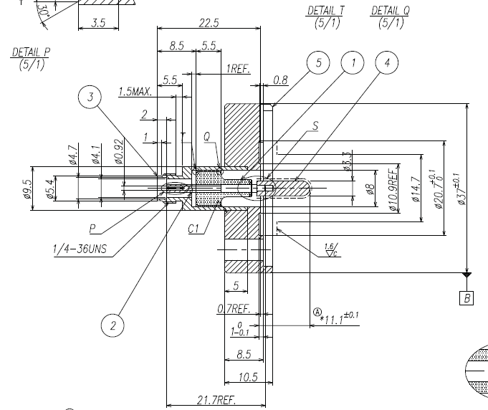
 | Description | Specified Dimensions: unit in mm (Min/Max)
 | Flange seal surface to probe tip | 11.0/11.2 | [[Dim_seal_to_tip]] <<FLOAT>>
 | Probe tip diameter | 3.2/3.4 | [[Dim_probe_dia]] <<FLOAT>>

Step No. | Instructions |  | Data Input
 |  | QC Review
4 |  | This final inspection is visual and the purpose is to make sure there is no damage during cold cycle and leak check. Inspect for bent or broken connect pin and probe.  Enter name and date of the final inspection.  Review the cold cycle and leak check travelers.  If all NCRs are closed and the feedthrough passes the final inspection, select YES for production relaease. Otherwise generate NCR.  Deliver the feedthrough to the storage area. | [[Final_Insp_Name]] <<SRF>>  [[Final_Insp_Date]] <<TIMESTAMP>>  [[Production_realease]] <<YESNO>>

