Traveler Title | C75 Supply End Can Beam Pipe Assembly Traveler
Traveler Abstract | This Traveler is for the assembly of the supply end can beam pipe for a C75 Cryomodule. This is a two part assembly. This part will be installed onto the supply end can while the Cryomodule is on the assembly rail. This work is to be done by trained and authorized personel only.  ** Radiation surveys shall be performed and information recorded at traveler hold points or comment boxes.**  ** Radiological controls are a critical component of the cryomodule rework disassembly and assembly process. Dose rate, as well as contamination surveys (where indium gaskets or seals are present) shall be performed and analyzed, with information communicated to all involved personnel. Results will be recorded at traveler hold points or comment boxes. RW-II training will be required where contamination is identified**
Traveler ID | C75R-CST-ASSY-BPIP
Traveler Revision | R1
Traveler Author | Chris Wilcox
Traveler Date | 9-July-2020
NCR Emails | macha,fischer,areilly
Approval Names | Chris Wilcox | John Fischer | Kurt Macha | Ken Worland
Approval Signatures
Approval Dates
Approval Title | Author: | Reviewer: | Project Manager: | Secondary Reviewer

References | List and Hyperlink all documents related to this traveler. This includes, but is not limited to: safety (THAs, SOPs, etc.), drawings, procedures, and facility related documents.
C75 SEC Beam Pipe Assy Dwg | C75 Beam Pipe View First Stage | C75 Beam Pipe View Front | Ionized nitrogen cleaning procedure

Revision Note
R1 | Initial release of this Traveler.

Step No. | Instructions | Data Input
1 | Contact RADCON to survey the refurbished parts and inform them on the process flow. In this case, the Chemistry areas, Clean Room, and storage until use. | [[CMATech]] <<SRFCMP>>  [[Date]] <<TIMESTAMP>>  [[Comment]] <<COMMENT>>
2 | Disassemble Supply End Can Beam Pipe  Disassemble the Supply End Can Beam Pipe and discard the used hardware, and used gaskets into the RADCON WASTE BIN.  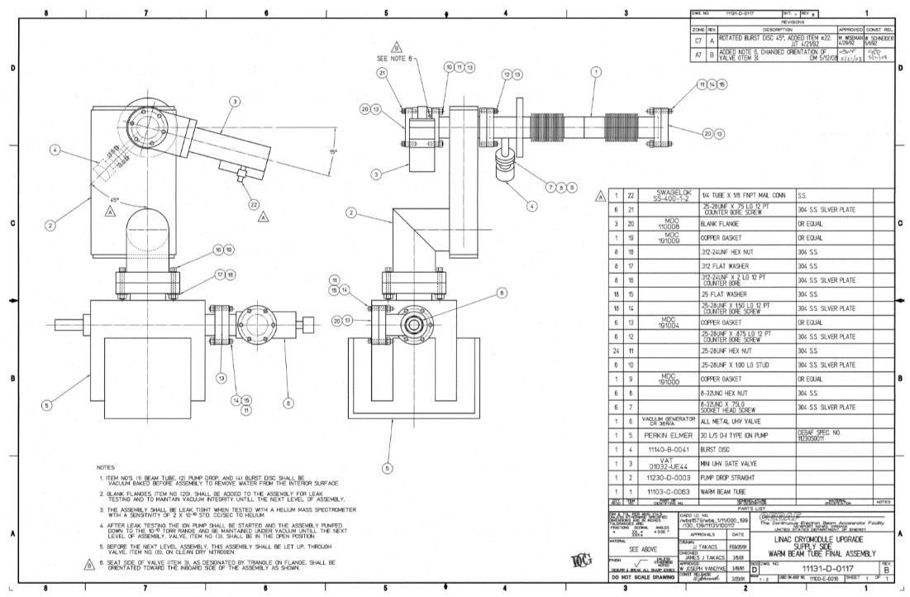 | [[CMETech2]] <<SRFCMP>>  [[Date2]] <<TIMESTAMP>>  [[Comment2]] <<COMMENT>>  [[RAMTag1]] <<FILEUPLOAD>>  [[RAMTag2]] <<FILEUPLOAD>>  [[RAMTag3]] <<FILEUPLOAD>>
3 | Send all parts and new hardware in for cleaning:  Include any appropriate RAM tags  Send all Supply End Can beam pipe components and new hardware in for standard UHV cleaning and vacuum baking.  Items are then to be placed in the passthru for reception into the Clean Room along with RAM tags. | [[CMATech3]] <<SRFCMP>>  [[Date3]] <<TIMESTAMP>>  [[Comment3]] <<COMMENT>>
4 | Preparation of Hardware and Components:  Enter the Clean Room, donning new garments as per protocol. Receive all cleaned hardware and components from the passthru into the Clean Room.  Clean the handles and upper shelf of a cleanroom cart with an isopropyl soaked wipe. Blow the cart with ionized nitrogen.  Individually remove each vacuum component from its bag and clean with ionized nitrogen as per the Ionized nitrogen cleaning procedure.  Note: When blowing valves, (including the 01 VAT valve) cycle them as you are blowing the internals to eliminate the possibility of trapped particles. | [[CMATech4]] <<SRFCMP>>  [[Date4]] <<TIMESTAMP>>  [[Comment4]] <<COMMENT>>
5 | Assemble Supply End Can Beam Pipe:  The bellows can be easily damaged, protect it during the assembly process, movement, and storage.  Assemble the beam pipe using the appropriate drawings and standard clean assembly practices. Install Conflat Blanks on each end of the assembly with three bolts to function as a dust seal. Install Conflat Blank with all eight bolts at the bottom of the vacuum box and tighten to a uniform seal.  After the blanks are installed on each end, install the bellows stiffening cage and protection for transport and storage.  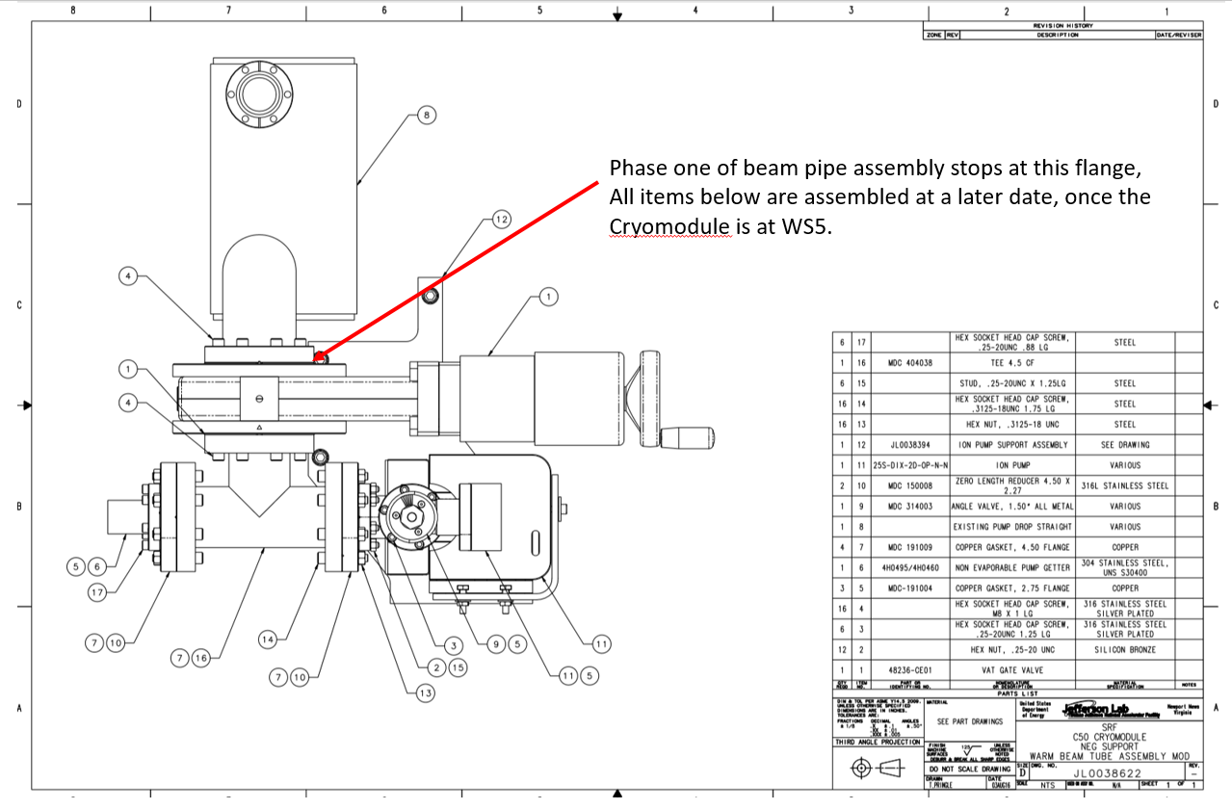  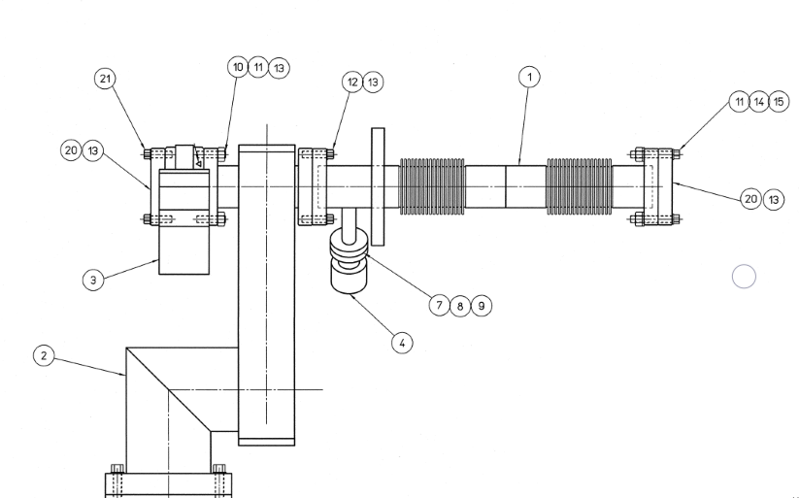  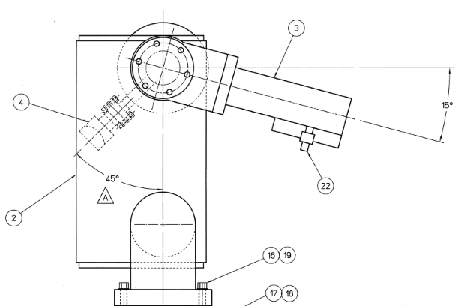 | [[CMATech5]] <<SRFCMP>>  [[Date5]] <<TIMESTAMP>>  [[Comment5]] <<COMMENT>>
6 | Once the assembly is completed, CALL RADCON before you place parts and RAM tag in the pass thru to be removed from the Clean Room. | [[CMATech6]] <<SRFCMP>>  [[Date6]] <<TIMESTAMP>>  [[Comment6]] <<COMMENT>>
7 | Have parts and assemblies prepared for storage outside the clean room:  After RADCON has been notified, place completed assemblies in the clean room pass thru. Call the chem room supervisor and have the assemblies double bagged in N2. Exit the clean room as per protocol immediately to receive parts | [[CMATech7]] <<SRFCMP>>  [[Date7]] <<TIMESTAMP>>  [[Comment7]] <<COMMENT>>
8 | Transport:  Assemblies are ready to be store in a RADCON posted area (if required) until installation on a cryomodule. | [[CMATech8]] <<SRFCMP>>  [[Date8]] <<TIMESTAMP>>  [[Comment8]] <<COMMENT>>  [[SECBeamPipeSN]] <<SN>>

