|  |  |  |  |
| --- | --- | --- | --- |
| 5 Cell Single Cavity Assembly | | | |
| **Document Number:** | CP-C75-CAV-ASSY | **Approval Date:** |  |
| **Revision Number:** | - | **Periodic Review Date:** |  |
| **Document Owner:** | C. Dreyfuss |  |  |

## 

# Purpose and Scope

The following procedure is to define the steps for the assembly of a single CEBAF 5-cell cavity that will be used for cavity qualification testing. Before initiating this procedure, the cavity must have been high pressure rinsed as per the appropriate procedure.

# References

[Indium Pressing Procedure](https://jlabdoc.jlab.org/docushare/dsweb/Get/Document-74894/IndiumPressingProcedure.docx)

[Indium Wire Cleaning Procedure](https://jlabdoc.jlab.org/docushare/dsweb/Get/Document-74893/IndiumWireCleaningProcedure.docx)

[Ionized Nitrogen Cleaning with Particle Counter Procedure](https://jlabdoc.jlab.org/docushare/dsweb/Get/Document-74896/IonizedNitrogenCleaningParticleCounterProcedure.docx)

# Terms and Definitions

1. **HOM- High Order Mode**
2. **FPC—Fundamental Power Coupler**
3. **FP---Field Probe**

# Process Details

**Preparation for Assembly Steps:**

**All fasteners, HOM blanks, field probe, beamline blanks, and feedthroughs have been cleaned and are available for use. The following list of components shall be gathered from the cleaned hardware set for a single five cell cavity assembly:**

45 pcs. 1/4-20 SiBr nut

180 pcs. 1/4" SS 316L Belleville washers

45 pcs. 1/4-20 x 1.5" lg. 316L SS hex head CS

45 pcs. 1/4" 316L SS flat washer

1 pc. 1/4-20 x 1.25" lg. 316L SS hex head CS

1 pc. Field probe feed through

1 set Field probe with jamb nut

1 pc. 316 SS Probe clamp ring

2 pcs. 316 SS field probe feed through split flange ring (clear holes)

2 pcs. 316 SS field probe feed through split flange ring (tapped holes)

6 pcs. 6-32 x .875" lg. 316 SS SHCS with dicronite coating 30 pcs. #6 SS belleville washer

2 pcs. Beamline flange cover

2 pcs. HOM cover

1 pc. FPC flange cover

1 pc. Field probe flange cover

4 pcs. Split flange (tapped holes)

4 pcs. Split flange (clear holes)

16 pcs. 5/16-24 x 1 1/2 lg. 316L SS hex head CS

64 pcs. 5/16 SS 316L Belleville washers

1. Clean the handles and upper shelf of a cleanroom cart with an isopropyl soaked wipe. Clean the cart with ionized nitrogen.
2. Visually inspect each indium seal path of the blanks and the cavity they should be smooth and free of scratches, dings, residual indium and stains. Contact the supervisor if there are any discrepancies. Carefully place each component onto the clean room table by the N2 gun. Individually clean the HOM blanks and FPC blank and beamline blanks as per the [*Ionized* *Nitrogen Cleaning with Particle Counter Procedure*](https://jlabdoc.jlab.org/docushare/dsweb/Get/Document-11342/) and inspect indium seals after nitrogen cleaning is complete Press indium seals onto the HOM blank and FPC blank as per the [*Indium Pressing Procedure*](https://jlabdoc.jlab.org/docushare/dsweb/Get/Document-11340/)*.*
3. Preassemble feedthrough onto the top beamline blank with probe tip attached, then preassemble bottom beamline blank (pump out port) with feedthrough on it with no probe tip attached. Then press indium onto the two beamline blanks as per the [*Indium Pressing Procedure*](https://jlabdoc.jlab.org/docushare/dsweb/Get/Document-11340/). After indium is pressed onto the bottom beamline blank you can attach the probe tip.
4. Organize hardware by placing four Belleville washers on six bolts. Gather six flat washers and six SiBr nuts. Clean the hardware as per the [*Ionized Nitrogen Cleaning with Particle Counter Procedure*](https://jlabdoc.jlab.org/docushare/dsweb/Get/Document-11342/)*.*
5. Place the hardware on the top shelf of the cleanroom cart, next to the HOM, FPC, and beamline blanks.
6. The cavity will already be in the assembly area with all flanges uncovered and FPC flange should be up to accommodate drying. Gather a set of cavity flange covers, Gore-Tex gaskets and spring clamps. Clean required cavity flange covers, gaskets and clamps with clean ionized nitrogen in front of the particlecounter as per the [*Ionized Nitrogen Cleaning with Particle* *Counter Procedure*](https://jlabdoc.jlab.org/docushare/dsweb/Get/Document-11342/). Carefully place the flange covers, gaskets, and spring clamps onto the top shelf of the cleanroom cart.
7. **Before covering the cavity flange--consider the following**:

* Attach flange covers with one motion as to not rotate or vibrate flanges once together
* Never position your body or clothing over an opening
* Replace gloves and spray with ionized N2 any time a glove is damaged during an operation.
* Only one person should be near the cavity during this blanking operation
* Inspect cavity sealing surfaces of cavity flanges as covers are installed.

1. Starting at the bottom, cover the beam-line flange and clamp in place.
2. Cover each HOM cavity flange and clamp in place.
3. Cover the Field probe flange and clamp in place.
4. Cover the FPC flange and clamp in place.
5. Cover the top beam-line flange and clamp in place.
6. Assemble the bottom beamline/pump-out port flange to the cavity. With two people install with one motion as to not rotate or vibrate flanges once together. Never position your body or clothing over an opening, inspect the indium seal surface on the cavity. It should be smooth and free of scratches, stains, and residual indium. Contact the supervisor if there are any discrepancies. One person will hold the flange up to the cavity flange the other person will install the split flanges and the hardware the second person does not move towards the cavity until first person has the flange onto the cavity. The split in the split flanges will be offset from each other. After all fasteners are installed into split flanges in a star pattern snug the bolts so the indium on the flange starts it crush then person holding the blank can let go of the blank, cavity is now able to rotate for rest of assembly.
7. The field probe used for this assembly is for a blank purpose it is not being used to test this is why the probe tip for the field probe does not need to be installed. Install field probe with one motion as to not rotate or vibrate flanges once together. Never position your body or clothing over an opening. Using the back tech lifting fixture rotate the cavity so that the field probe flange is horizontal, with the flange sealing surface pointing towards the floor. Inspect the field probe seal surface on the cavity. It should be smooth and free of scratches, stains, and residual indium.Contact the supervisor if there are any discrepancies. Install the field probe assembly:Using clean tweezers carefully remove indium from former and place it onto the stainless steel field probe flange. *Make sure you do not scratch the sealing surface or distort the shape of the seal.* Install the field probe with indium and hold in place. While holding the probe, slide the round clamp ring over the feed through. Install the thru hole split flange plates. Install the tapped hole split flange rings and align bolt patterns. Ensure the 'splits' of each set of flanges are not aligned with each other. Install all hardware and snug down so field probe does not move when rotating cavity.
8. Attach HOM blank with one motion as to not rotate or vibrate flanges once together. Never position your body or clothing over an opening. Carefully remove HOM flange cover, insert two opposite screws with appropriate hardware into the HOM blank flange. Bring HOM blank up to cavity, making sure the flanges are perfectly aligned. Thread nuts onto bolts and slightly tighten to ensure cleanliness while installing other HOM blank. Repeat for the other HOM blank and install remaining hardware and snug down so blank does not move when cavity is rotated.
9. Rotate cavity so FPC flange is pointed down so the FPC blank can be installed.

Carefully remove FPC flange cover, insert two opposite screws with appropriate hardware into the FPC blank flange. Bring FPC blank up to cavity, making sure the flanges are perfectly aligned. Thread nuts onto bolts and slightly tighten to ensure cleanliness while installing other FPC blank. Repeat for the other FPC blank and install remaining hardware and snug down so blank does not move when cavity is rotated.

1. . Rotate cavity so the top beamline flange is pointed down so the top beamline blank can be installed. With two people install with one motion as to not rotate or vibrate flanges once together. Never position your body or clothing over an opening, inspect the indium seal surface on the cavity. It should be smooth and free of scratches, stains, and residual indium. Contact the supervisor if there are any discrepancies. Assemble the top beamline flange to the cavity. One person will hold the flange up to the cavity flange the other person will install the split flanges and the hardware. The split in the split flanges will be offset from each other. After all fasteners are installed into split flanges in a star pattern snug the bolts so the indium on the flange starts it crush then person holding the blank can let go of the blank, cavity is now able to rotate to finish cavity assembly and torqueing.
2. Torque HOM and FPC flange fasteners using the following torque specs and torque pattern for each flange. 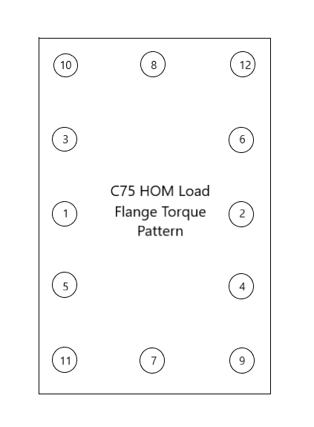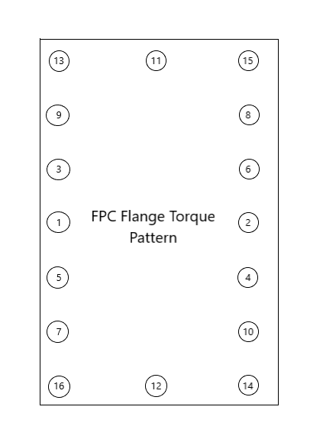Evenly torque all bolts, except corners, incrementally to 30, 40, and then 55 in. lbs. Torque corner bolts to 40 in. lbs.

1. Torque the field probe flange to 15 in/lbs using a standard torque pattern
2. Torque the beam-line flanges, incrementally, to 70, 90 and 125 in/lbs, using a standard torque pattern
3. Re-check torque of all fasteners.
4. Cavity is now ready to move into the VAA to attach to test stand and slow pump down the cavity.

# **Revision History**

|  |  |  |
| --- | --- | --- |
| Rev # | Revision or update: | Effective: |
| Release | Initial Release | 5/1/2020 |
|  |  |  |

# **Approvals**

|  |  |  |
| --- | --- | --- |
| Approved by: | Signature: | Date: |
| **Document Owner** |  |  |
| **Document Reviewer** |  |  |
| **SRF Cavity Production Manager** |  |  |
| **C75 Project SME** |  |  |
| **SRF Operations Department Head** |  |  |