Traveler Title | Pair Assembly-Cavity Evacuation and Leak Test
Traveler Abstract | This procedure is for guiding you through the steps of evacuating a cavity pair and leak testing it prior to RF testing.
Traveler ID | C75-CPR-ASSY-EVAC
Traveler Revision | R1
Traveler Author | K. Macha
Traveler Date | 16-Feb-2018,
NCR Emails | forehand
Approval Names | D. Forehand | S. Castagnola | K. Macha
Approval Signatures
Approval Dates
Approval Title | Reviewer | Reviewer | Project Manager

References | List and Hyperlink all documents related to this traveler. This includes, but is not limited to: safety (THAs, SOPs, etc), drawings, procedures, and facility related documents.
 | CP-STP-CAV-EVAC  ..\OneDrive - Jefferson Lab\Clean Room Production Pump System Operation.docx | Ionized Nitrogen Cleaning Procedure

Revision Note
R1 | Initial release of this Traveler.

Step No. | Instructions | Data Input
1 | Record Cavity Pair ID #::  Operators login :  Record upper cavity serial #:  Record lower cavity serial #: | [[CPRSN]] <<CPRSN>>  [[Operator1]] <<SRF>>  [[Operator2]] <<SRF>>  [[Timestamp1]] <<TIMESTAMP>>  [[UpperCAVSN]]<<CAVSN>>  [[LowerCAVSN]]<<CAVSN>>
2 | Requirements for performing this procedure:  Tall SS table and handi lift cart  4 pcs. Aluminum standoff cylinders  Ultra high vacuum pump.  Dual -Ion gauge and controller.  RGA and system software operational on a computer.  Tools in clean room for standard vacuum hardware. | [[Complete2]] <<SRF>>  [[Comment2]] <<COMMENT>>
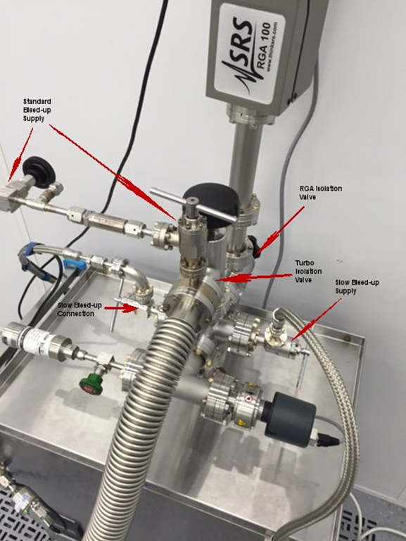
The turbo cart in now located inside the clean room for easy access to the operator. The scroll pump is located outside the clean room. Valve 3 has been omitted.

Step No. | Instructions | Data Input
3 | Transfer Cavity Pair to Tall SS Table:  Position the cavity in the center of the strong-back rails and lock it in place with the clamping blocks.  Using the Handi Lift cart, position it in the center of the cavity rails. Lift the cavity above the v-blocks and roll the assembly back far enough to get the SS table under the cavity.  Raise the cavity above the table height and roll the table under the cavity.  Install the four standoff blocks under the strong-back and bolt in place.  Lower the cavity pair onto the table and remove the lift cart. | [[Complete3]] <<SRF>>
4 | Ensure the turbo pump station is turned off and vented:  If the turbo pump is running:  Open the nitrogen inlet valve enough to hear the pop-off relief vibrate. Turn the pump control main power switch to the off position, wait 5 minutes. Slowly open the nitrogen line mini valve and watch the ion gauge pressure raise. Wait until the cold cathode gauge pressure reads saturation, should be between 900-1000 mbar. | [[Complete4]] <<SRF>>  [[Comment4]] <<COMMENT>>
5 | Properly positions cavity valves:  The lower cavity valve is to be closed.  The upper cavity valve is to be open. | [[LowerValveClosed]] <<CHECKBOX>>  [[UpperValveClosed]] <<CHECKBOX>>  [[Complete5]] <<SRF>>  [[Timestamp5]]<<TIMESTAMP>>
6 | Connect the cavity to the vacuum pump:  Record the pump serial #.  Change and wash gloves before proceeding  Position the cavity table so the pump hose can be connected easily to the lower cavity valve. A fit-up test should be performed to locate the cavity so the line bellows 2 ¾ conflat connection has low tension when positioned where it will be assembled.  Carefully loosen and remove the 2 ¾ conflat hardware on the end of the vacuum line and remove CF blank and used gasket.  Carefully loosen and remove the 2 ¾ conflat hardware on the end of the cavity valve.  Inspect conflat knife edges for dings or scratches, repair if needed.  Assemble the pump-down line to the cavity valve with a clean CF gasket and tighten hardware.  Notify Pump Operator that cavity is ready for pump down. | [[PumpStationNo]] <<TEXT>>  [[Complete6]] <<SRF>>  [[Timestamp6]]<<TIMESTAMP>>  [[Comment6]] <<COMMENT>>

Step No. | Instructions | Data Input
7 | Prepare the turbo station for pump down:  Close the two for-line valves. (KF-40 o-ring seal valve and the needle valve bypass valve. | [[Complete7]] <<SRF>>  [[Comment7]] <<COMMENT>>
8 | Evacuate the Cavity:  Verify the valves between the cavity and the pump are open.  Open the calibrated leak rate.  Pump the cavity as per the slow pump-down cavity evacuation procedure.  CP-STD-CAV-EVAC  Record the start time of the cavity evacuation. | Start of pumping:  [[Timestep8]] <<TIMESTAMP>>  [[Complete8]] <<SRF>>  [[Comment8]] <<COMMENT>>
9 | Cavity safely on the turbo:  Record the time when the cavity is safely on the turbo. When the pressure reaches 1e-4 torr.  Allow the cavity to pump overnight for leak test the following morning. | [[Complete9]] <<SRF>>  [[Timestep9]] <<TIMESTAMP>>  [[Comment9]] <<COMMENT>>
10 | Record cavity pressure:  Check and record pressure the following day.  Cavity is now ready for leak test. | [[Timestep10]] <<TIMESTAMP>>  [[PumpPressure10]] <<SCINOT>>  [[Complete10]] <<SRF>>  [[Comment10]] <<COMMENT>>

Step No. | Instructions | Data Input
11 | Preparation for leak test:  Verify the leak rate is open:  If it was not opened open it in the following way.  Close valve #4  Open the valve to the calibrated helium gas leak rate on the pump station  Ensure the turbo station pressure is below 1e-7 mbar  Open valve #4  Turn on the RGA:  Turn on the power to the RGA  Connect the serial cable from the RGA to the computer.  Turn on the RGA filament and setup the helium trace. Turn on the multiplier and start the helium trace when total pressure on RGA is less than 2e-6 mbar. | [[Complete11]] <<SRF>>  [[Comment11]] <<COMMENT>>
12 | Preparation for leak test: (Continued)  Verify that the line on the leak test scan has stabilized and is flat.  Close the valve to the calibrated helium leak rate on the pump station. Watch the scan for a noticeable drop when the valve is closed. If a partial pressure difference can be seen, continue to the next step. Allow the scan to run for at least 10 more minutes. The line needs to be flat to continue. If the line is not flat or no drop is seen from the calibrated leak, stop and inform the supervisor. | [[Complete12]] <<SRF>>  [[Comment12]] <<COMMENT>>
13 | Perform leak test:  Spray all connections associated with the cavity and related hardware with a helium spray wand. If a rise of the partial pressure occurs, notify a supervisor. If not, re-torque fasteners at all indium sealing joints. Bag the entire cavity pair and fill with helium. Allow the bag to stand with helium for 10 minutes. Save the RGA leak test scan. Record standard leak size and time for helium spray. Stop the leak test scan and start an analog scan with AMU set to 1-100. Save the scan. Upload the appropriate documents to record the leak test and RGA analog scan. | [[Complete13]] <<SRF>>  [[CavityLeakTight]] <<CHECKBOX>>  [[UploadWordFile]] <<FILEUPLOAD>>  [[RGALeakTestScan]] <<FILEUPLOAD>>  [[RGAAnalogScan]] <<FILEUPLOAD>>  [[Comment13]] <<COMMENT>>
14 | Traveler is complete:  The cavity pair is ready for top-hats and transfer to the RF test stand. | [[Complete14]] <<SRF>>  [[Timestamp14]]<<TIMESTAMP>>  [[Comment14]] <<COMMENT>>

