Traveler Title | P100 Cavity Assembly
Traveler Abstract | The following traveler documents the steps for cavity assemblies for VTA qualification of P100 cavities.
Traveler ID | P100-CLNRM-CAV-ASSY
Traveler Revision | R1
Traveler Author | Chris Dreyfuss
Traveler Date | 1-Sept-2020
NCR Emails | T. Ganey
Approval Names | Chris Dreyfuss | Kurt Macha | Tiffany Ganey
Approval Signatures
Approval Date | 1-Sept-2020 | 1-Sep-2020 | 1-Sept-2020
Approval Title | Author | Reviewer | Project Manager

References | List and Hyperlink all documents related to this traveler. This includes, but is not limited to: safety (THAs, SOPs, etc), drawings, procedures, and facility related documents.
P100 cavity assembly procedure for VTA qualification.

Revision Note
R1 | Initial release of this Traveler.

Step No. | Instructions | Data Input
1 | Cavity:  - Record Cavity Serial Number  - Use the D3 button at the top of the page to record a discrepancy or deviation that occurred before, during, or after the assembly.  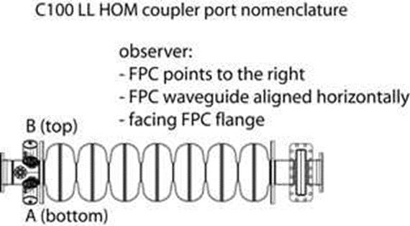 | [[CAVSN]] <<CAVSN>>  [[AssemblyTech1]] <<SRFCVP>>  [[AssemblyTech2]] <<SRFCVP>>  [[RecordDate]] <<TIMESTAMP>>  [[FieldName]] <<COMMENT>>
2 | Cavity Assembly:  - Cavity flanges Checked for stains and Scratches.  - Record cavity serial number.  - Record HOM and Field Probe serial numbers.  - Perform cavity assembly as per the P100 cavity assembly procedure for VTA qualification.  - Use the comment box at the right to record notes, etc., regarding this assembly.  - Torque for the beam-line flanges which is 125 inch lbs. The FPC flange is 55 inch lbs on the straights and 40 inch lbs on the corners. And the HOM and Field Probe are 40 inch lbs.  - Cavity is now ready to move to the VAA and install in the test stand and pumpdown. | [[Assembly_Tech1]] <<SRFCVP>>  [[Assembly_Tech2]] <<SRFCVP>>  [[FieldProbe]] <<FPFTSN>>  [[FieldProbeLength]] <<NOTE>>  [[HOM A]] <<HMFTSN>>  [[HOM A Length]] <<NOTE>>  [[HOM B]] <<HMFTSN>>  [[HOM B Length]] <<NOTE>>  [[AssyComments]] <<COMMENT>>  [[CavityTorqued]] <<YESNO>>

