|  |  |  |  |
| --- | --- | --- | --- |
| C75 End Dish Acid Etching | | | |
| **Document Number:** | CP-C75-CHEM-ENDD | **Approval Date:** | 05- June-2020 |
| **Revision Number:** | Rev. 2 | **Periodic Review Date:** | 05-June-2022 |
| **Document Owner:** | Gregory Grose |  |  |

## 

# Purpose and Scope

The purpose of this document is to clearly define the procedure for acid etching and removing all impurities from the indium sealing surface of C75 End Dish Beamline Flange for use in cavity pair assemblies.

# References

[SRF-19-83800-OSP](https://mis.jlab.org/mis/apps/mis_forms/operational_safety_procedure_form.cfm?entry_id=83800) - OSP for Safe Operations in the Production Chemistry Room

[CP-STP-CAV-CHEM-ACID](https://jlabdoc.jlab.org/docushare/dsweb/Get/Document-141848/CP-STP-CAV-CHEM-ACID-R1.pdf) – Standard Acid Etching at the Chemical Fume Hood Procedure

[CP-STP-CAV-CHEM-DEGR](https://jlabdoc.jlab.org/docushare/dsweb/Get/Document-132364/CP-STP-CAV-CHEM-DEGR-R3.pdf) - Standard Cavity, Components, or Parts Degreasing Procedure

[Alconox User’s Manual](https://jlabdoc.jlab.org/docushare/dsweb/Get/Document-73545/Alconox-UserManual.pdf)- User’s manual for Alconox detergents

# Terms and Definitions

* **DI/UPW**: Deionized (DI) and Ultra-Pure Water (UPW) are used interchangeably in this procedure.
* **Ultrasonic, USC, and sonic:** are used interchangeably in this procedure. The container or tank may also be referred to as a bath.
* **N2 / Nitrogen:** filtered nitrogen is most commonly used.
* **Quick Dump Rinser (QDR):** A sink that fills and empties water to rinse components several times.
* **PI/PM/SOTR:** Principal Investigator, Project Manager, Subcontracting Officer Technical Representative. Someone otherwise in charge of the project or item in question. A supervisor may also be utilized if needed.

|  |  |  |  |
| --- | --- | --- | --- |
| * **Items used in this procedure:** | | | |
| **Chemicals** | **Detergents:** | **Solvents:** | **Wipers:** |
| Stainless Steel Etch | Micro90 | Acetone, Clean Room Quality Isopropyl (Isopropanol) | TX1009B Alpha Wipes, TX2009 Beta Wipes |

# Process Details

**SAFETY:**

Individuals must keep safety as the first priority in the process; before beginning any job, the user must assure they have the correct PPE for the individual job. Maintaining the level of safety and secure nature of the work area is paramount. Assure personal safety by using caution in movement and taking necessary steps to avoid unnecessary personnel in the immediate area.

Refer to the work-center OSP for specifics.

**NOTE**: The drying oven can accommodate two end dishes at a time, this procedure allows for the cleaning of one or two end dishes as necessary. No more than two end dishes should be cleaned in a day. Plan work accordingly to allow for room in the oven.

## Pre-Cleaning

1. Ensure the workspace is clean and tidy.
2. To prevent excessive exposure to particulate in air, the user is to perform all actions within the laminar flow hood (when possible).
3. Don appropriate PPE.
   1. Gloves should be worn whenever handling items and changed after cleaning and as needed to maintain cleanliness.
4. Inspect End Dish for excessive damage (chips/scratches).
   1. If part has pre-existing impairment notify PI/PM.
   2. Do not clean verified through written acknowledgement of previous damage presence.
5. Use only pre-approved detergents and solvents.
6. Wipe all oil and marker off with acetone.
7. Measure a small amount of Micro90 into a small container (~4 oz.).
8. Use a TX 1009B Alpha Wipe to apply detergent directly to the component’s exterior and/or interior.

NOTE: take care not to scratch the sealing surfaces.

* 1. Additional wipers, brushes or other means may be necessary to pre-clean heavily soiled components.
  2. Use soft bristled brush saturated in mixture to gently clean the bellows.

1. Use a Texwipe clean room foam tip swab to clean the inside of the bolt holes.
   1. Do NOT use a cotton tip swab as these leave fibers.
2. Thoroughly rinse component with DI water.
3. Repeat until heavy soil, oil, etc. has been removed.

## Acid Etching

1. Refer to the acid etching procedure [CP-STP-CAV-CHEM-ACID](https://jlabdoc.jlab.org/docushare/dsweb/Get/Document-141848/CP-STP-CAV-CHEM-ACID-R1.pdf) for guidance on mixing and acid etching with Stainless Steel (SS) Etch.
2. Refer to the Chem Room OSP for guidance on PPE and a pre-acid work and inspection checklist.
3. Prepare the workspace:
   1. Using a rubber stopper completely wrapped in Teflon tape (Fig. 1), plug the beamline via the smaller flange to prevent acid leakage.
   2. Place the end dish on an empty HDPE container, making sure the larger flange is face up (Fig. 1).

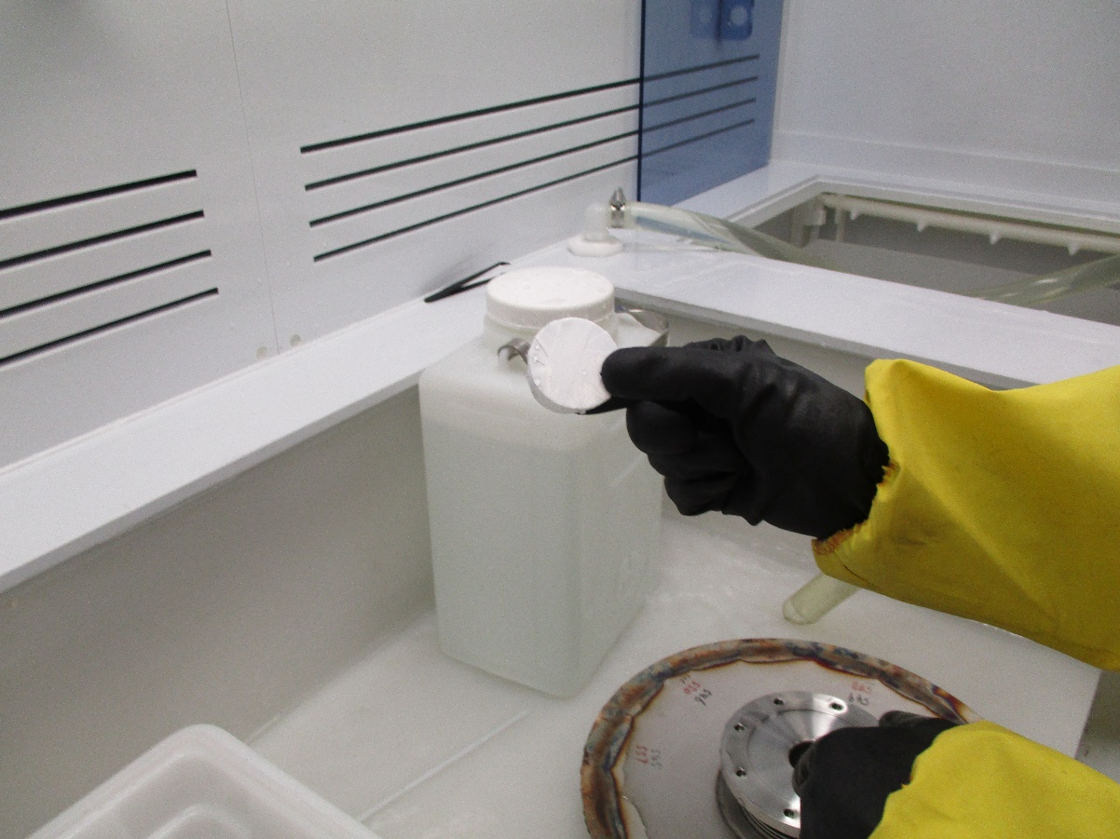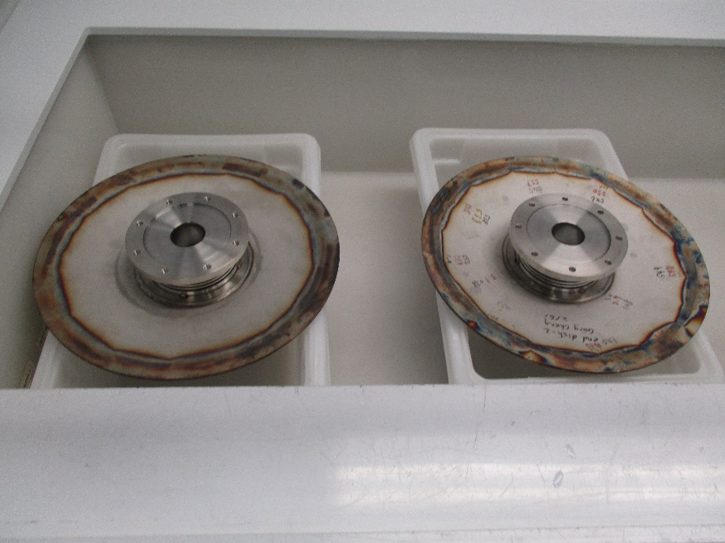

**Figure 1**: rubber stopper for the beamline (left), end-dishes set for SS etch (right).

1. SS etch the indium sealing surface of the end dish:
   1. Carefully fill the recessed sealing surface area with SS Etch
      1. DO NOT allow the SS Etch to flow through the bolt holes or onto the bellows.
   2. Allow SS Etch to soak on the sealing surface for 60 minutes.
2. After 60 minutes of etching, carefully remove the rubber stopper allowing the acid to drain into container below it.
3. Rinse thoroughly with DI water.
4. Cleanup workspace and return acid hood to prior use condition.
5. Remove PPE, replace with fresh pair of nitrile gloves.
6. Inspect and dry sealing surfaces with N2 to insure no stains or blemishes remain, if necessary repeat any of the procedure to attain desired level of surface perfection.

## Post-etching cleaning

1. Measure a small amount of Micro90 into a small container (~4 oz.).
2. Use soft bristled brush saturated in detergent to gently clean the bellows. Use TX 1009B Alpha Wipe to clean the other surfaces. Use a Texwipe clean room foam tip swab to clean the inside of the bolt holes (Do NOT use a cotton tip swab as these leave fibers), see Fig. 2.
3. Thoroughly rinse component with DI water.
4. Bake the end dish in the N2 drying oven according to CP-STP-CAV-CHEM-BAKE.
   1. This is typically set for ~10+ hours at 100°C in the nitrogen oven.
   2. The nitrogen flow should be set to 50 PSI and 50 CFM.
5. Once end dishes are completely dry, they will need to be bagged:
   1. Bag dishes separately.
   2. Seal opposite end of bag with sealing machine.
   3. Repeat process until all hardware is bagged.
   4. Transport bagged components to the next work center.

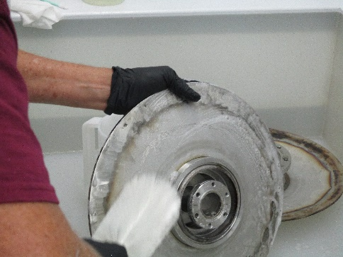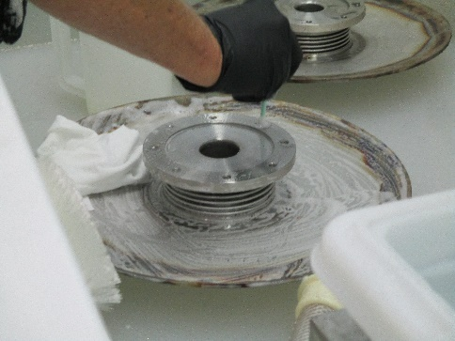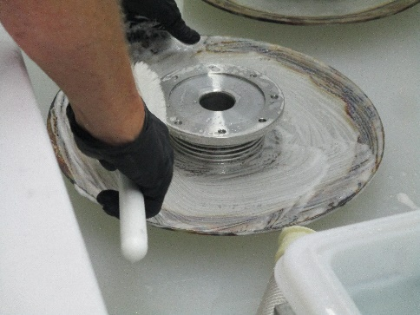

**Figure 2**: Post-etching cleaning.

# **Revision History**

|  |  |  |
| --- | --- | --- |
| Rev # | Revision or update: | Effective: |
| Release | Initial Release | 02-June-2020 |
| 2 | Added pictures and post-etching steps. |  |

# **Approvals**

|  |  |  |
| --- | --- | --- |
| Approved by: | Signature: | Date: |
| **Document Owner** | Gregory Grose |  |
| **Reviewer** | Ashley Mitchell |  |
| Scientific Lead | Gianluigi Ciovati |  |
| Project Lead | Kurt Macha |  |