Remote desktop from off site or if you are using a computer on site that is on the wireless network

17 March 2020

First you need to download and install putty for Windows 10 by going to:

<https://www.chiark.greenend.org.uk/~sgtatham/putty/latest.html>

As of March 17, 2020 below is a direct link to the 64 bit version.

[putty-64bit-0.73-installer.msi](https://the.earth.li/~sgtatham/putty/latest/w64/putty-64bit-0.73-installer.msi)

Next you need the IP address for the windows machine that you want to tunnel into. The best way is to go to the computer center’s power management web page at:

<https://cc.jlab.org/wakeonlan/>

You have to login to the CC webpage using your CUE account before it will show you a list of the computers in your name along with their assigned IP addresses. If the computer is not in your name you can put in part of a computer name and get a list of matches.

Some handy IP addresses are the terminal servers owned by the computer center. You can find a list of their ip address by searching for JLABTS Currently the addresses are:

JLABTS.jlab.org 129.57.87.20

Next configure Putty.

You will start out with a window like this

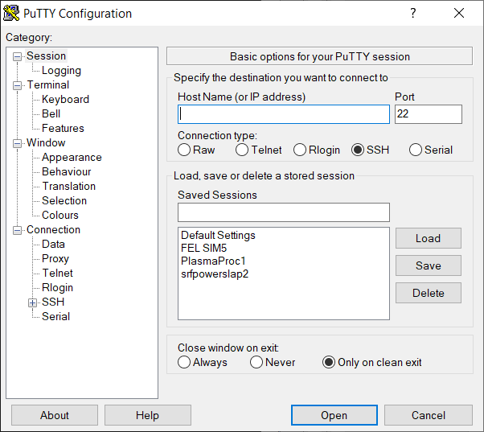

Type in the name you want to assign to the computer. The vertical line at the end of the name happens to be the curser.

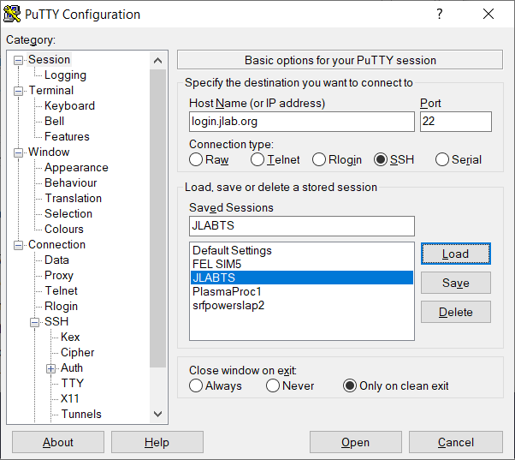

Next click the + button next to SSH and click on tunnels and enter the source port and destination. I have had times when the source port was already in used by something else in my computer and have also used 3390. The text for the IP address

120.57.87.20:3389

Do not forget the colon.

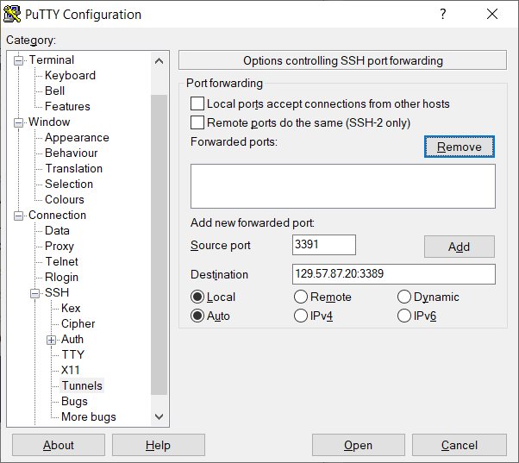

Click Add and it should look like this:

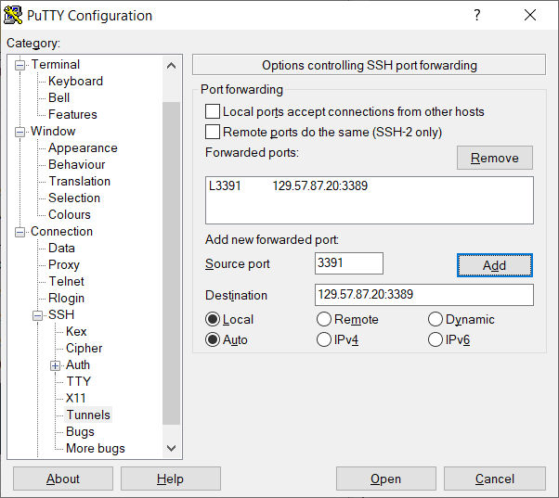

When you come back to the window the places where you entered numbers will be blank.

Next click on X11 and check the boxes as shown.

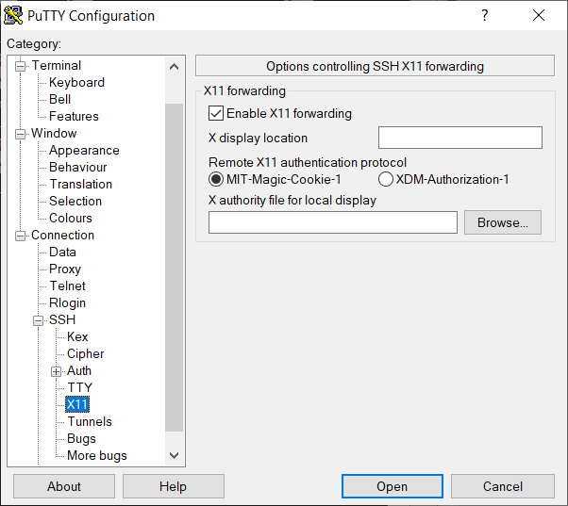

Next click on Session and click SAVE. The session should be added to your list.

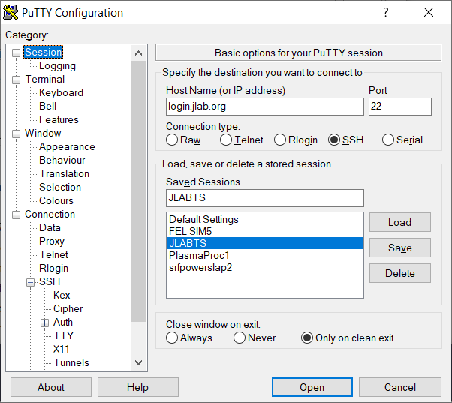

At the end of this document I will add all of the options in the event that someone has trouble and wants to verify the settings. The next time you open putty you can click on a session name and click Load. Next click OPEN you will get a standard window with “Login as:” with a prompt.

Login with your Cue user account and password.

DO NOT CLOSE this window just minimize it.

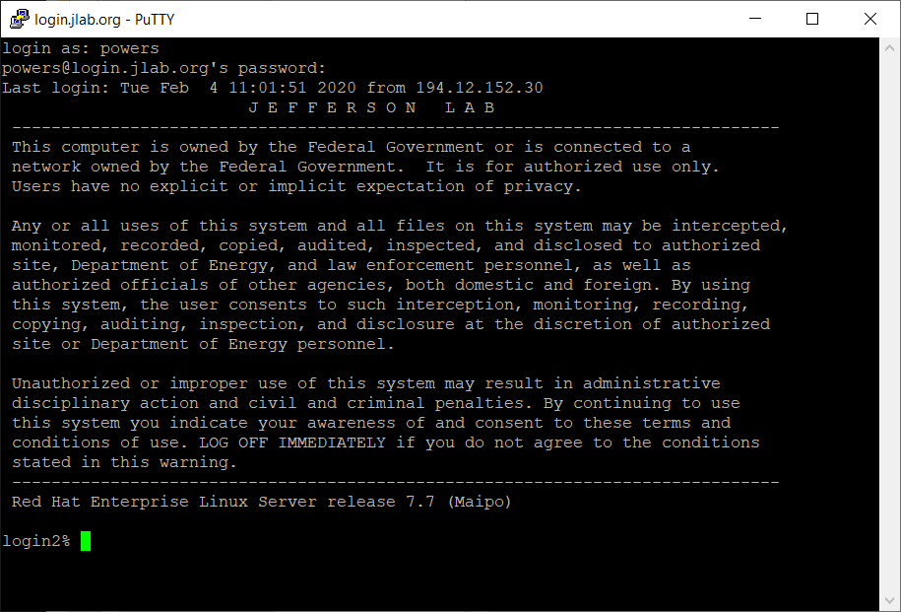

Now go to windows remote desktop and use the computer name localhost:3391 or what ever number you used when you set up the tunnel. Plug you smart card in before you start will make it work easier but you will need it. This MIGHT work if you do not have a smart card and are logging into a machine using an account that does not require one.

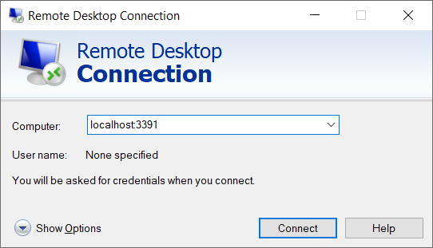

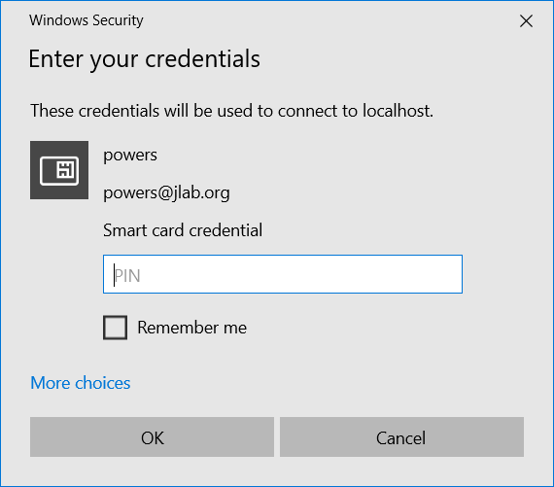

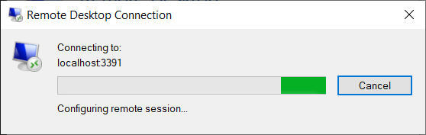

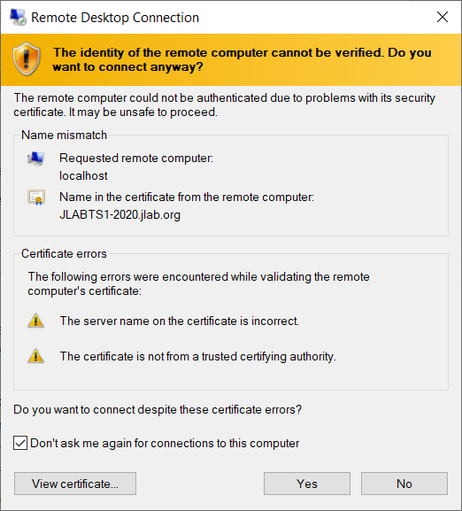

Check the “Don’t ask me again” then the “Yes” button and you should be in with access to the M: drive.

To add more computers to the list start with one that works and go to the tunnel option highlight the line with the IP address and click remove. This will transfer the numbers to the source and destination boxes. Adjust the IP address; click Add; then go to Session, change the name in the saved sessions box and click save.

