Traveler Title | P1 Cavity Flange Lapping
Traveler Abstract | The following traveler records lapping data for cavity flanges.
Traveler ID | P1-CAV-CHEM-LAP
Traveler Revision | R1
Traveler Author | Alex Wildeson
Traveler Date | 23-Sept-2020
NCR Informative Emails | areilly,forehand,ganey
NCR Dispositioners | ashleya,kdavis
D3 Emails | ashelya,ganey,kdavis,forehand
Approval Names | Alex Wildeson | Ashley Mitchell | Kirk Davis
Approval Signatures
Approval Date
Approval Title | Author | Reviewer | Project Manager

References | List and Hyperlink all documents related to this traveler. This includes, but is not limited to: safety (THAs, SOPs, etc), drawings, procedures, and facility related documents.
F100 Cavity Flange Repair Procedure

Revision Note
R1 | Initial release of this Traveler.

Step No. | Instructions | Data Input
A | Input Cavity SN: | [[CAVSN]] <<CAVSN>>  [[DateTime]] <<TIMESTAMP>>  [[LapCommentA]] <<COMMENT>>
1 | Lap cavity FPC flange groove using F100 Cavity Flange Repair Procedure if required. | [[FPC_ScotchBriteMethod]] <<YESNO>>  [[TimeStep1]] <<TIMESTAMP>>  [[Tech]] <<SRFCVP>>  [[VisualOK_FPC]] <<YESNO>>  [[VisualTech1]] <<SRFCVP>>  [[LapComment1]] <<COMMENT>>
2 | Lap cavity FPC Beam line flange groove using F100 Cavity Flange Repair Procedure if required. | [[BL_FPC_ScotchBriteMethod]] <<YESNO>>  [[TimeStep2]] <<TIMESTAMP>>  [[Tech2]] <<SRFCVP>>  [[VisualOK_BL_FPC]] <<YESNO>>  [[VisualTech2]] <<SRFCVP>>  [[LapComment2]] <<COMMENT>>

Step No. | Instructions | Data Input
3 | Lap cavity HOM Beamline flange groove using F100 Cavity Flange Repair Procedure if required. | [[BL_HOM_ScotchBriteMethod]] <<YESNO>>  [[TimeStep3]] <<TIMESTAMP>>  [[Tech3]] <<SRFCVP>>  [[VisualOK_BL_HOM]] <<YESNO>>  [[VisualTech3]] <<SRFCVP>>  [[LapComment3]] <<COMMENT>>
4 | Lap cavity HOM-1 flange groove using F100 Cavity Flange Repair Procedure if required. HOM-1 is to the right of the Beam Tube as shown.  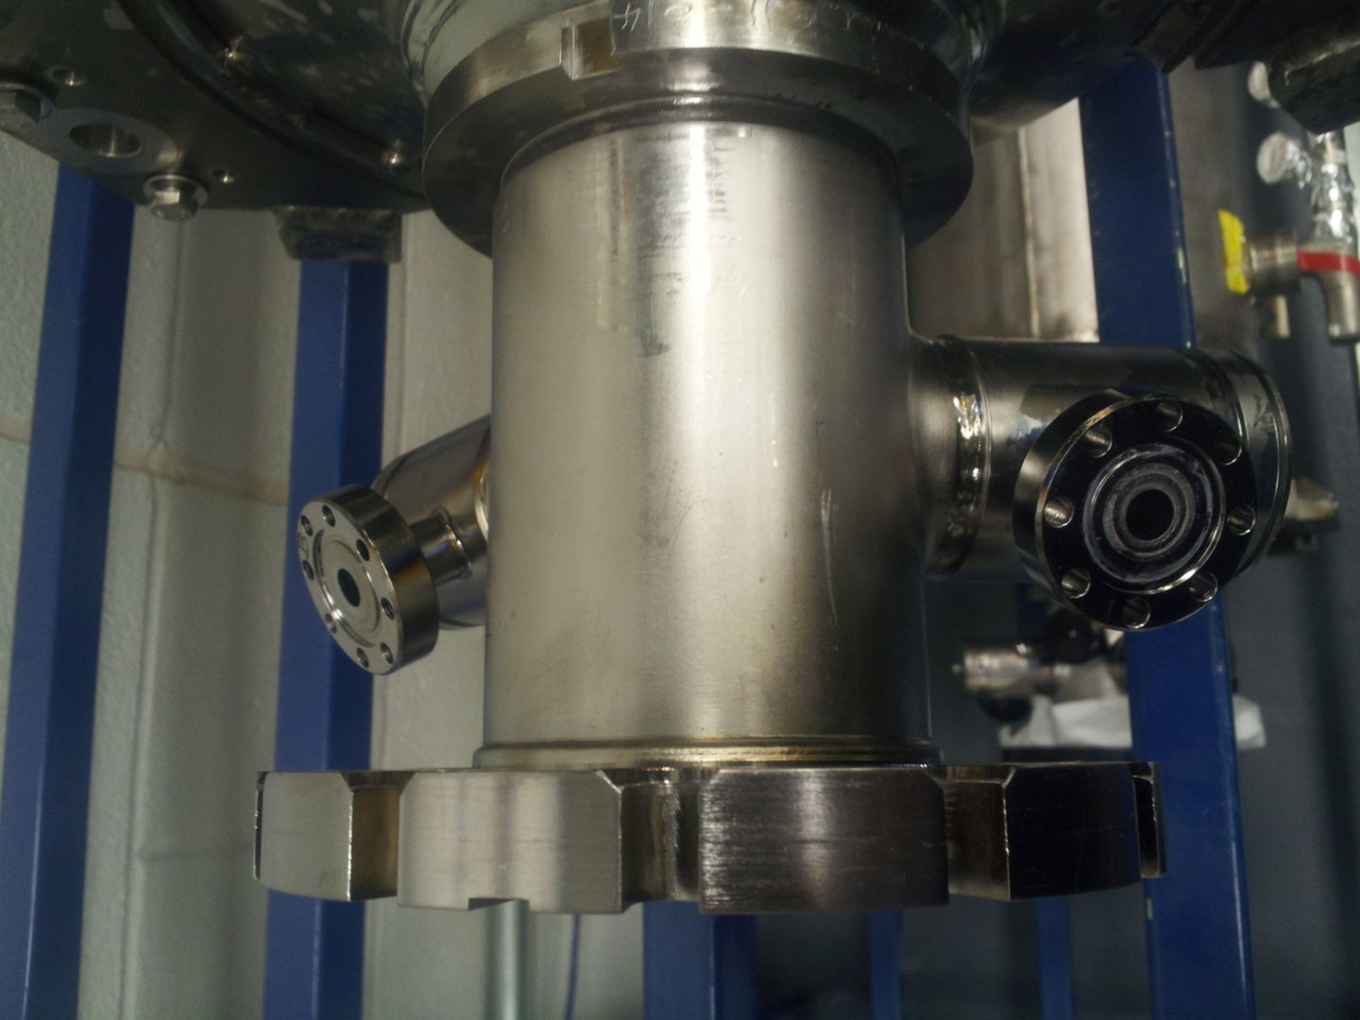 | [[HOM1_ScotchBriteMethod]] <<YESNO>>  [[TimeStep4]] <<TIMESTAMP>>  [[Tech4]] <<SRFCVP>>  [[VisualOK_HOM1]] <<YESNO>>  [[VisualTech4]] <<SRFCVP>>  [[LapComment4]] <<COMMENT>>
5 | Lap cavity HOM-2 flange groove using F100 Cavity Flange Repair Procedure if required. HOM-2 is to the left of the Beam Tube as shown.  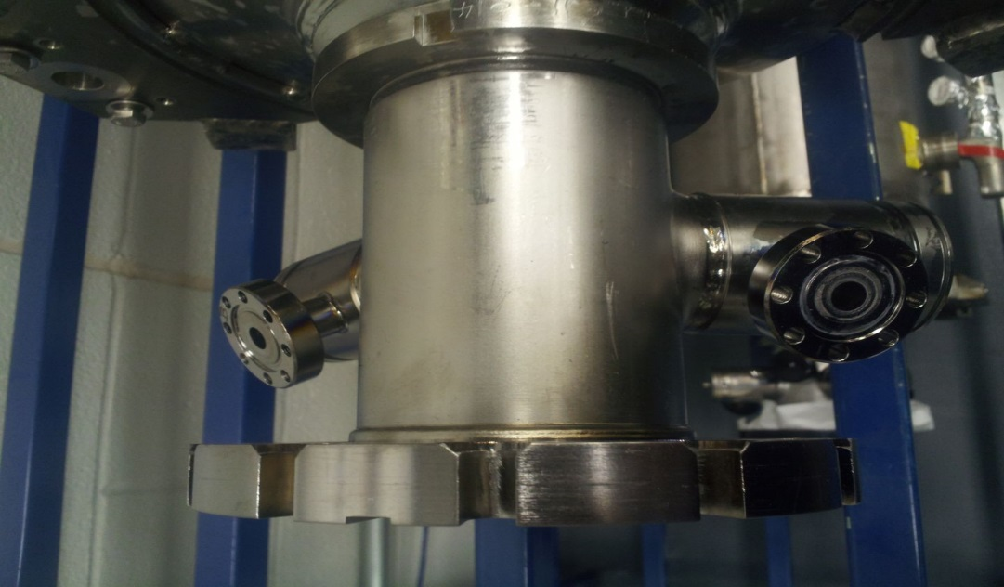 | [[HOM2_ScotchBriteMethod]] <<YESNO>>  [[TimeStep5]] <<TIMESTAMP>>  [[Tech5]] <<SRFCVP>>  [[VisualOK_HOM2]] <<YESNO>>  [[VisualTech5]] <<SRFCVP>>  [[LapComment5]] <<COMMENT>>

Step No. | Instructions | Data Input
6 | Lap cavity field probe flange groove using F100 Cavity Flange Repair Procedure if required. | [[FP_ScotchBriteMethod]] <<YESNO>> [[TimeStep6]] <<TIMESTAMP>>  [[Tech6]] <<SRFCVP>>  [[VisualOK_FP]] <<YESNO>>  [[VisualTech6]] <<SRFCVP>>  [[LapComment6]] <<COMMENT>>

