Traveler Title | C100R Double Sided Rectangular Flange Receiving Inspection Traveler
Traveler Abstract | This is receiving inspection traveler for C100 RF window double sided rectangular flange.
Traveler ID | C100R-CAV-INSP-FLNG
Traveler Revision | R1
Traveler Author | HyeKyoung Park
Traveler Date | 30-Sep-20
NCR Informative Emails
NCR Dispositioners
D3 Emails
Approval Names | HyeKyoung Park | Mark Wiseman | John Hogan
Approval Signatures
Approval Dates
Approval Title | Author | Reviewer | Project Manager

References | List and Hyperlink all documents related to this traveler. This includes, but is not limited to: safety (THAs, SOPs, etc), drawings, procedures, and facility related documents.
CRM-120-7075-0037 A

Revision Note
R1 | Initial release of this Traveler.

Step No. | Instructions | Data Input
1 | This is an ultra high vacuum component. Wear talc free latex gloves at all times when handling this part.  Enter inspector name and date. | [[TechnicianName]] <<SRF>>  [[DateTime]] <<TIMESTAMP>>
2 | Inspect shipping container and shipping documents.  Is container damaged? If there is a sign of damage take pictures and upload file.  Is shipping document matching with shipped parts (quantity, part number, etc)? If there is a discrepancy provide detail in comment box.  Enter the serial number. | [[ContainerDamaged]] <<YESNO>>  [[ContainerPics]] <<FILEUPLOAD>>  [[ShipDocOK]] <<YESNO>>  [[ShipDocDetail]] <<COMMENT>>  [[DSRFSN]] <<DSRFSN>>
3 | Visual inspection  Is flange free from damage?  Is knife edge free from burrs and nicks?  If it shows any defect provide pictures and comments.  Use the adapter measured close to the nominal, place in the flange pocket and check the fit. | [[VisualClean]] <<YESNO>>  [[VisualKnife]] <<YESNO>>  [[VisualPics]] <<FILEUPLOAD>>  [[VisualComment]] <<COMMENT>>  [[Adpater_fit]] <<YESNO>>

Step No. |  | Instructions | Data Input
4 | Dimensional check (CMM)  During the measurement be careful not to damage the knife edge.
 | Dimensions |  | Specified Nominal | Measured Dimensions | Pass/Fail
 | 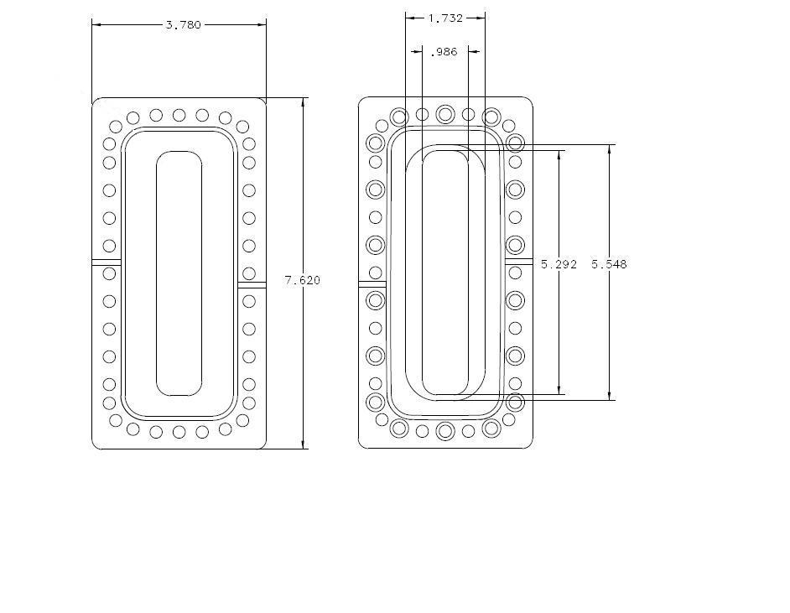  Establish the datum axes, determine the coordinates of the radius start and end location. Measure all locations.  If the center of the flange is selected as an origin and the locations are (-2.083, -0.175), (-2.083, 0.175), (2.083, -0.175), and (2.083, 0.175). use the standard tolerance +/-0.005.  Measure all four radii where the adapter has to fit it.  Radii locations  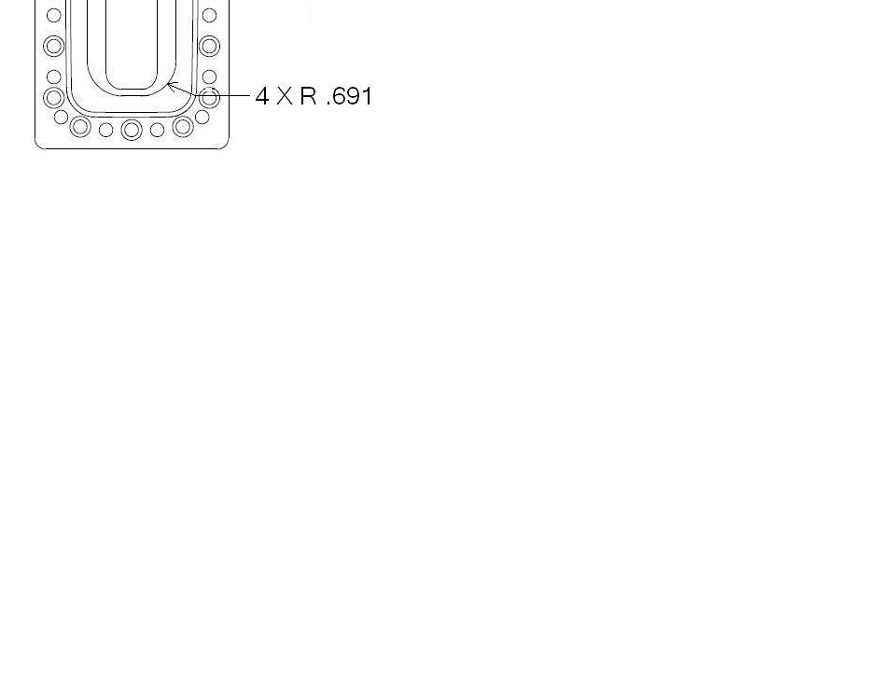  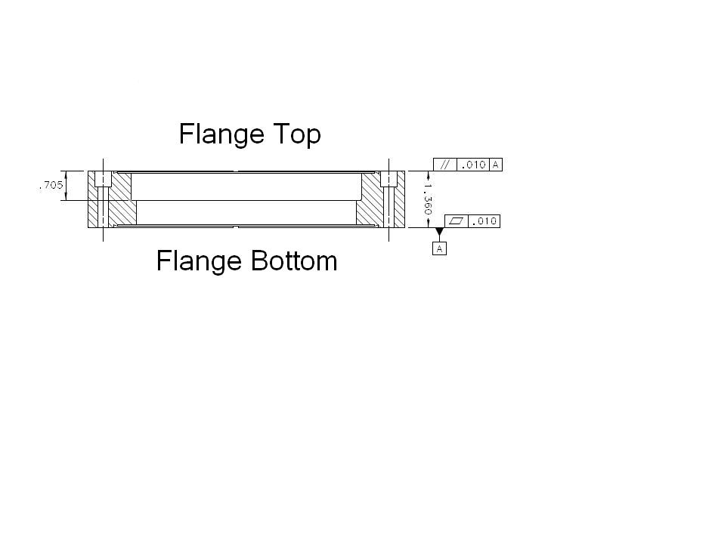  Establish the flange surface and measure the depth of knife edge. Measure at 4 corners and at each midpoint of 4 sides. Select 'yes' when all dimensions are within tolerance.  The A,B, and C are information gathering purpose only.  Save the CMM data separately when it was measured.  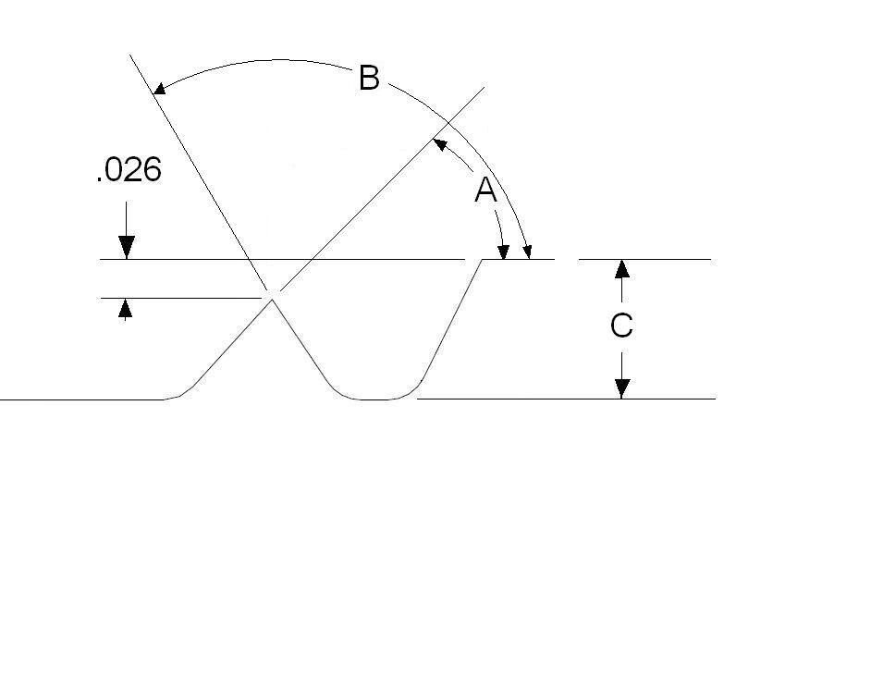 |  | Flange length  7.620 | [[Len_7620]] <<FLOAT>> | [[Compare the measured value to the specified value and show pass or fail automatically- if it’s outside of the +/-.005 it fails]] <<NOTE>>  [[Len7620]] <<YESNO>>
 |  |  | Flange width  3.780 | [[Wid_3780]] <<FLOAT>> | [[Wid3780]] <<YESNO>>
 |  |  | Bore length_1  5.548 | [[Len_5548]] <<FLOAT>> | [[Len5548Pass]] <<YESNO>>
 |  |  | Bore width_1  1.732 | [[Wid_1732]] <<FLOAT>> | [[Wid1732Pass]] <<YESNO>>
 |  |  | Bore length_2  5.292 | [[Len_5292]] <<FLOAT>> | [[Len5292Pass]] <<YESNO>>
 |  |  | Radius location  Radius  4X.691 | [[Radius_location_pass]] <<YESNO>>  [[Radius1]] <<FLOAT>>  [[Radius2]] <<FLOAT>>  [[Radius3]] <<FLOAT>>  [[Radius4]] <<FLOAT>> | [[If all radii are within nominal +/- .005 show yes, if any one of them fails show no]] <<NOTE >>  [[RadiiPassFail]] <<YESNO>>
 |  |  | Bore width_2  .986 | [[Wid_986]] <<FLOAT>> | [[Wid986Pass]] <<YESNO>>
 |  |  | Flange thickness  1.360 | [[Thk_1360]] <<FLOAT>> | [[Thk1360Pass]] <<YESNO>>
 |  |  | Bore step  .705 | [[Bore_step]] <<FLOAT>> | [[BoreStepPass]] <<YESNO>>
 |  |  | Flatness  .010 | [[Flatness]] <<FLOAT>> | [[FlatnessPass]] <<YESNO>>
 |  |  | Parallelism  .010 | [[Parallelism]] <<FLOAT>> | [[ParallelismPass]] <<YESNO>>
 |  |  | Knife edge depth  .026+/-.005 | [[Knife_dep_top]] <<YESNO>> | [[ParallelismPass]] <<YESNO>>

Step No. | Instructions | Data Input
 | 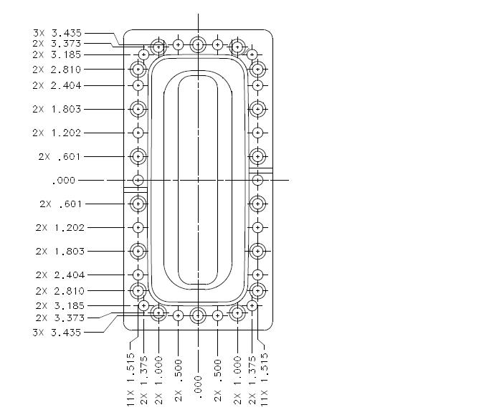  Bolt hole positions  Establish center lines and measure all hole positions.  When all hole positions are correct select 'yes'. | [[BoltholePos]] <<YESNO>>
5 | Wrap flanges individually with aluminum foil and store in the designated area.

