Traveler Title | SNSPPU Cavity Receiving Inspection
Traveler Abstract | Incoming Inspection of SNSPPU Production Cavities.
Traveler ID | SNSPPU-CAV-INSP-CAV
Traveler Revision | R2
Traveler Author | Pashupati Dhakal
Traveler Date | 6-Oct-20
NCR Informative Emails | kwilson, edaly, dhakal, macha
NCR Dispositioners | kwilson, edaly, dhakal, macha
D3 Emails | kwilson, edaly, dhakal, macha
Approval Names | Pashupati Dhakal | Kurt Macha | G. Dekerlegand | Ed Daly
Approval Signatures
Approval Dates
Approval Title | Author | Reviewer | Reviewer | Project Manager

References | List and Hyperlink all documents related to this traveler. This includes, but is not limited to: safety (THAs, SOPs, etc), drawings, procedures, and facility related documents.
104211800-M8U-8200-A001 Cavity Assembly | 104211800-M8U-8200-A002 Probe End Sub-Assy | 104211800-M8U-8200-A002 FPC End Sub-Assy | Cavity in Shipping Crate | 104211800-M8U-8200-A017 FPC Flange Detail
104211800-M8U-8200-A016 FPC End Flange Detail | 104211800-M8U-8200-A011 Probe End Flange Detail

Revision Note
R1 | Initial release of this Traveler.
R2 | First Revision after the first cavity Inspection

Step No. | Instructions | Data Input
1 | Enter the cavity serial number ID that is going to be inspected. The SN should be ingraved on end dish. It not contact cavity SOTR. | [[CAVSN]] <<CAVSN>>  [[Inspector1]] <<SRF>>
3 | Cell Serialization ( FPC-FP, Cell 1-6)  Each cell has two SN for each half record both. The numers are alpha numeric. | [[Cell 1]] <<FLOAT>>  [[Cell 2]] <<FLOAT>>  [[Cell 3]] <<FLOAT>>  [[Cell 4]] <<FLOAT>>  [[Cell 5]] <<FLOAT>>  [[Cell 6]] <<FLOAT>>
4 | Ensure the right Angle Valve is in the closed position. | [[RightAngleValve Clsoed]] <<YESNO>>  [[ValveComments]] <<Comments>>
5 | Torque Value Check. A286 8/32 – 40 in-lb. A286 5/16 – 30 ft-lb  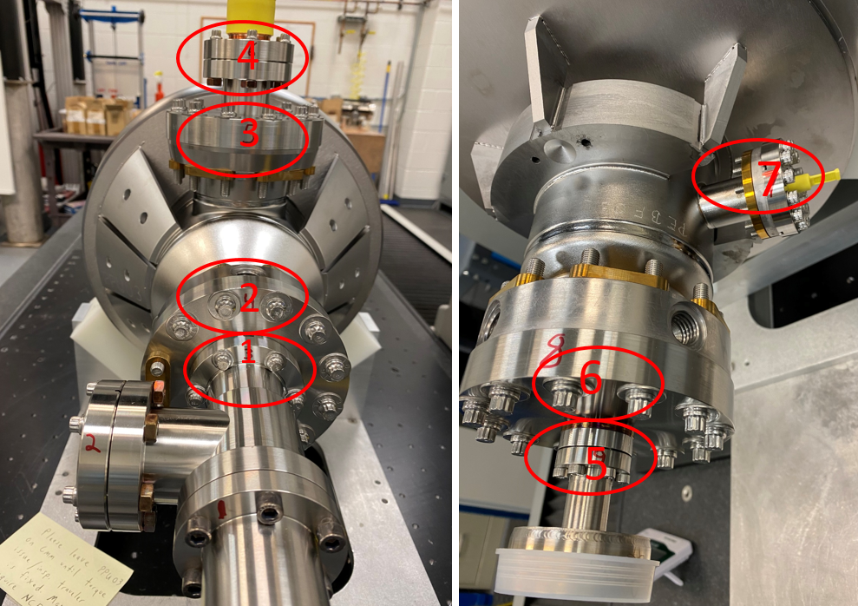  Joints are numbered 1 to 7. NOTE - Starting location is at valve end of cavity | [[Are torque values correct]] << YES NO>>  [[Torque]] <Comments>>
 | 1. Valve screws ~30 ft-lb | [[DIMTOL25]] <<YESNO>>  [[TorqComment1]] <<COMMENT>>
 | 2. Beamline flange FPC End ~ 30 ft-lb | [[DIMTOL26]] <<YESNO>>  [[TorqComment2]] <<COMMENT>>
 | 3. FPC Flange ~ 30 ft-lb | [[DIMTOL27]] <<YESNO>>  [[TorqComment3]] <<COMMENT>>
 | 4. FPC coupler ~ 30 ft-lb | [[DIMTOL28]] <<YESNO>>  [[TorqComment4]] <<COMMENT>>
 | 5. Burst disk joint ~ 40 in-lb | [[DIMTOL29]] <<YESNO>>  [[TorqComment5]] <<COMMENT>>
 | 6. Beamline flange Field Probe end ~30 ft-lb | [[DIMTOL30]] <<YESNO>>  [[TorqComment6]] <<COMMENT>>
 | 7. Field probe ~ 30 ft-lb | [[DIMTOL31]] <<YESNO>>  [[TorqComment7]] <<COMMENT>>
6 | CMM Inspections  Perform dimensional inspections on CMM. Fill out NCR for any out of tolerance measurements.  104211800-M8U-8200-A001 Cavity Assembly  104211800-M8U-8200-A002 Probe End Sub-Assy  104211800-M8U-8200-A003 FPC End Sub-Assy  104211800-M8U-8200-A017 FPC Flange Detail  104211800-M8U-8200-A011 Probe End Flange Detail  104211800-M8U-8200-A016 FPC End Flange Detail | [[Inspector3]] <<SRF>>  [[CmmComments]] <<COMMENT>>  [[AdditionalFile2]] <<FILEUPLOAD>>

Drawing number | Description | Drawing Value (inch) | Measured Value | Within Tolerance
104211800-M8U-8200-A001 | Distance between end dishes. Measure from machined step to machined step. | 35.423 | [[DIM1]] <<FLOAT>> | Reference Dimension N/A
104211800-M8U-8200-A003 | Coupler flange perpendicularity. | .005 | [[DIM2]] <<FLOAT>> | [[DIMTOL2]] <<YESNO>>
104211800-M8U-8200-A017 | Coupler flange perpendicularity OD | 4.889 | [[DIM3]] <<FLOAT>> | [[DIMTOL3]] <<YESNO>>
104211800-M8U-8200-A016 | Beamline Flange OD- FPC side | 4.889 | [[DIM4]] <<FLOAT>> | [[DIMTOL4]] <<YESNO>>
104211800-M8U-8200-A011 | Beamline Flange OD – FP side | 4.889 | [[DIM5]] <<FLOAT>> | [[DIMTOL5]] <<YESNO>>
104211800-M8U-8200-A002 | End Flange to Dish ( FP side) | 6.397 | [[DIM6]] <<FLOAT>> | Reference Dimension N/A
104211800-M8U-8200-A003 | End Flange to Dish ( FPC Side) | 9.01 | [[DIM7]] <<FLOAT>> | Reference Dimension N/A
104211800-M8U-8200-A003 | Perpendicularity of FPC end dish to beam center | .005 | [[DIM8]] <<FLOAT>> | N/A
104211800-M8U-8200-A002 | Perpendicularity of FP end dish to beam center | .005 | [[DIM9]] <<FLOAT>> | N/A
104211800-M8U-8200-A002 | Tuner 120 Deg. C-Bore location | 2.559  5.118 | [[DIM10]] <<FLOAT>>  [[DIM11]] <<FLOAT>> | [[DIMTOL10]] <<YESNO>>  [[DIMTOL11]] <<YESNO>>
104211800-M8U-8200-A002 | Tuner tapped hole locations.  Verify 10-32 Thread inserts are installed and test thread. | .590  1.180  2.559  5.118 | [[DIM12]] <<FLOAT>>  [[DIM13]] <<FLOAT>>  [[DIM14]] <<FLOAT>>  [[DIM15]] <<FLOAT>> | [[DIMTOL12]] <<YESNO>>  [[DIMTOL13]] <<YESNO>>  [[DIMTOL14]] <<YESNO>>  [[DIMTOL15]] <<YESNO>>  [[ThreadCheck1]] <<YESNO>>
104211800-M8U-8200-A002  104211800-M8U-8200-A001 | Lollipop tapped hole C-Bore face. Side of flange at FP side.  Flange rotation, Lollipop tapped hole 0 Deg. To FPC flange.  Verify 5/8-11 threads with thread gauge. | 2.351  0 Deg. | [[DIM16]] <<FLOAT>>  [[DIM17]] <<FLOAT>> | [[DIMTOL16]] <<YESNO>>  [[DIMTOL17]] <<YESNO>>  [[ThreadCheck2]] <<YESNO>>
104211800-M8U-8200-A002 | Alignment tool tapped hole C-Bore face. Side of flange at FP side.  Hole location 90 deg from FPC face  Verify 5/8-11 threads with thread gauge. | 2.351  2.351  90 Deg | [[DIM18]] <<FLOAT>>  [[DIM19]] <<FLOAT>>  [[DIM20]] <<FLOAT>> | [[DIMTOL18]] <<YESNO>>  [[DIMTOL19]] <<YESNO>>  [[DIMTOL20]] <<YESNO>>  [[ThreadCheck3]] <<YESNO>>
104211800-M8U-8200-A003  104211800-M8U-8200-A001 | Lollipop tapped hole C-Bore face. Side of flange at FPC side.  Flange rotation, Lollipop tapped hole 0 Deg. To FPC flange.  Verify 5/8-11 threads with thread gauge. | 2.351  0 Deg. | [[DIM21]] <<FLOAT>>  [[DIM22]] <<FLOAT>> | [[DIMTOL21]] <<YESNO>>  [[DIMTOL22]] <<YESNO>>  [[ThreadCheck4]] <<YESNO>>
104211800-M8U-8200-A002  104211800-M8U-8200-A001 | Alignment tool tapped hole C-Bore face. Side of flange at FPC side.  Hole location 90 deg from FPC face  Verify 5/8-11 threads with thread gauge.  Are the threads okay? | 2.351  2.351  90 Deg | [[DIM23]] <<FLOAT>>  [[DIM24]] <<FLOAT>> | [[DIMTOL23]] <<YESNO>>  [[DIMTOL24]] <<YESNO>>  [[ThreadCheck5]] <<YESNO>>

