proposed quality Updates

# TPQM input upgrades

1. Initial import from Excel spreadsheet
2. Format an Excel spreadsheet template for projects
3. Editable grid with security
4. Auto fill grid with completion dates from trav_config
5. Auto email reminders to authors

# tpqm output upgrades

1. Reformat the grid
2. Upgrade graphing?
3. Statistics?

# Acronym configuration

1. Upgrade acronym table (format?)
2. Utilize table to ensure proper acronyms are used (travelerization)
3. Give complete definitions
4. Create a user interface to locate acronyms

# Quality metrics

1. Request requirements from Quality Board / Steering Committee
   1. What metrics should be monitored
      1. Projects – travelers, NCRs, D3s
      2. Production – throughput time of Work Centers
      3. Vendor quality based on INSP NCRs
      4. SOTR responsiveness to NCRs
      5. VTA and CMTF data
   2. How often to be reported
   3. Monthly comparison
   4. What reports are needed for Quality Board
   5. What statistics should be calculated
2. Database upgrade
   1. Create new tables to hold quality metrics (monthly / weekly)

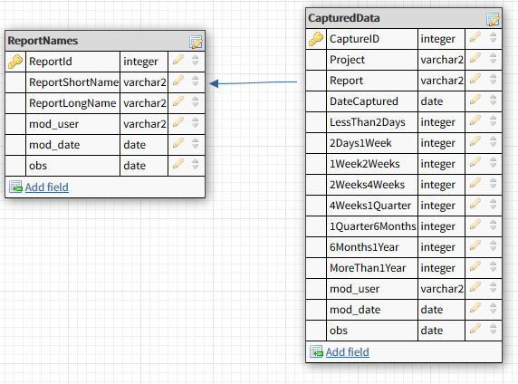

1. Create automatic collection functions for metrics

|  |  |  |
| --- | --- | --- |
| Instantiation to First Response | Closure Periods | Open NCR Age |
| Less than 2 Days | Less than 2 Weeks | Less than 2 Weeks |
| 2 Days - 1 Week | 2 Weeks - 4 Weeks | 2 Weeks - 4 Weeks |
| 1 Week - 2 Weeks | 4 Weeks - 1 Quarter | 4 Weeks - 1 Quarter |
| 2 Weeks - 4 Weeks | 1 Quarter - 6 Months | 1 Quarter - 6 Months |
| 4 Weeks - 1 Quarter | 6 Months - 1 Year | 6 Months - 1 Year |
| 6 Months - 1 Year | More than 1 Year | More than 1 Year |