C75 Dogleg Chemistry & Degreasing
Document Number: | CP-C75-CPR-CHEM-DGLG | Approval Date: | 15- Sept-2020
Revision Number: | 1 | Periodic Review Date: | 15-Sept-2022
Document Owner: | Ashley Mitchell

Purpose and Scope

PURPOSE: To remove all impurities from surface of dogleg (interior and exterior). This procedure will be utilized several times throughout the processing of doglegs in preparation for pair assembly. Each section of the procedure may be used individually depending on the process needed.

SAFETY:
Individuals must keep safety as the first priority in the process; before beginning any job, the user must assure they have the correct PPE for the individual job. Maintaining the level of safety and secure nature of the work area is paramount. Assure personal safety by using caution in movement and taking necessary steps to avoid unnecessary personnel in the immediate area.
Refer to the work-center OSP for specifics.

References

SRF-20-102692-OSP - OSP for Safe Operations in the Production Chemistry Room
CP-STP-CAV-CHEM-ACID – Standard Acid Etching at the Chemical Fume Hood Procedure
CP-STP-CAV-CHEM-DEGR - Standard Cavity, Components, or Parts Degreasing Procedure
Alconox User’s Manual - User’s manual for Alconox detergents
CP-C75-CAV-BCP-ER-R1 – BCP etch rate measurement procedure

Terms and Definitions

- DI/UPW: Deionized (DI) and Ultra-Pure Water (UPW) are used interchangeably in this procedure and may also be referred to as simply water.
- Ultrasonic, USC, and sonic: are used interchangeably in this procedure. The container or tank may also be referred to as a bath.
- N2 / Nitrogen: filtered nitrogen is most commonly used.
- Quick Dump Rinser (QDR): Also called the triple rinser. A sink that fills and empties water to rinse components several times.
- PI/PM/SOTR: Principal Investigator, Project Manager, Subcontracting Officer Technical Representative. Someone otherwise in charge of the project or item in question. A supervisor may also be utilized if needed.

- Items used in this procedure:
Chemicals | Detergents: | Solvents: | Wipers:
BCP 1:1:1 | Micro90 | Acetone, Clean Room Quality Isopropyl (Isopropanol) | TX1009B Alpha Wipes, TX2009 Beta Wipes

Process Details

NOTE: Dogleg flanges are easily damaged and care should be taken throughout this procedure to ensure the flanges are not marred. This is especially important after the thread inserts have been installed into the large flange to prevent re-work and lost time.

Pre-Cleaning
- Ensure the workspace is clean and tidy.
- Don appropriate PPE.
  - Gloves should be worn whenever handling items and changed after cleaning and as needed to maintain cleanliness.
- Inspect dogleg for excessive damage (chips/scratches).
  - If part has pre-existing impairment notify PI/PM.
  - Do not clean verified through written acknowledgement of previous damage presence.
- Use only pre-approved detergents and solvents.
- When using the smaller sonics in the hoods in 1043, the water must be filled to a minimum of 5 inches to prevent the motors from overheating. Failure to do so can cause permanent damage to the USC.
- The item(s) must be completely submerged for proper ultrasonic cleaning action. Ensure there are no trapped air pockets under or within the item in the USC.
- To prevent excessive exposure to particulate in air, the technician is to perform all actions within the laminar flow hood (when possible).
- If the dogleg appears excessively soiled or greasy, or has recently been lapped, perform the following:
  - Wipe all oil and marker off with acetone.
  - Measure a small amount of Micro90 into a small container (~4 oz.).
  - Use a TX 1009B Alpha Wipe to apply detergent directly to the component’s exterior and/or interior.
    - NOTE: take care not to scratch the interior.
    - Additional wipes, brushes or other means may be necessary to pre-clean heavily soiled components.
    - Use slim brush saturated in mixture to gently clean interior.
  - Use a Texwipe clean room foam tip swab to clean the inside of the bolt holes.
    - Do NOT use a cotton tip swab as these leave fibers.
  - Thoroughly rinse component with DI water.
  - Repeat until heavy soil, oil, etc. has been removed.

Ultrasonic Cleaning
- Close drain system of USC.
- Fill USC with at least 5” or enough DI water to completely submerge the dogleg (part needs to be completely submerged for USC cleaning to successfully be performed).
- Place a USC compatible plastic sheet or similar item on the floor of the sonic to protect the dogleg.
- Place dogleg in ultrasonic.
  - Avoid putting more than one dogleg in each USC.
    - If necessary, user can put two doglegs per basin if the appropriate room and measures can be taken to insure proper cleaning perimeters are met AND that doglegs are not damaged.
  - Set dogleg on an angle to ensure the particulate shaken loose by the USC will not settle on the interior. Use dogleg stands if necessary.
  - Tilt the dogleg several directions underwater to remove any trapped air.
- Add 1-2% Micro90 detergent to the USC tank.
  - About 300 ml (small USC) or 600 ml (large USC).
  - Micro90 or a basic pH detergent must be used after acid etching to ensure any residual acid is completely neutralized.
- Turn on USC and allow the component(s) to clean for 50 minutes.
  - This time may be adjusted if the water was preheated.
  - The UPW/detergent temperature shall be at least 130°F (54°C) for a minimum of 15 minutes.
- Prepare a HDPE (or solvent compatible) container large enough to comfortably fit a dogleg and fill it with enough isopropyl to cover at least half a dogleg.
  - Usually 1-2 bottles.
  - See Chem Room OSP for additional PPE requirements.
- Turn off the USC and heater.
- After USC cleaning, the dogleg needs to be rinsed thoroughly and then dried.
NOTE: Doglegs are a special case in which each one needs to be addressed individually. Do not begin rinsing/drying one dogleg until the previous one is completely finished with BOTH processes:
  - Rinse each dogleg individually by:
    - Transferring it to the “rinse only” wet bench.
    - Thoroughly rinse both the interior and exterior with DI water hose.
      - A large container may be used to submerge the dogleg and run water continuously over the dogleg.
    - Use the DI Water squirt bottle to rinse each bolt hole on the large flange surface.
      - Do not touch the flange surface as this may result in damage.
    - Agitate in first rinse basin 3 times.
    - Agitate in second rinse basin 3 times.
    - Agitate in third rinse basin 3 times.
    - Rinse again with DI water hose.
    - Tilt dogleg to remove any trapped water.
  - Dry each dogleg individually IMMEDIATELY after rinsing it:
    - Place the dogleg in the container of isopropyl.
      - Agitate or use a small container to pour isopropyl over the dogleg to ensure all areas are covered in isopropyl.
      - Allow the dogleg to soak in the isopropyl if necessary to thoroughly penetrate the blind holes.
      - Use the isopropyl squirt bottle to rinse each bolt hole on the large flange surface.
    - Carefully remove the dogleg from the container and transfer to a cart near a filtered nitrogen (N₂) gun.
      - Place a wipe or other barrier on the cart to prevent metal to metal contact.
    - Dry the dogleg using the nitrogen (N₂) gun.
NOTE: Hearing protection must be worn as the noise can be excessive.
    - Make sure to dry all orifices out completely. Change the dogleg’s position as necessary to reach all interior/exterior areas where moisture may remain.
    - Examine each part (focusing on the flanges) for water spots or other blemishes.
    - If water spots are found remove them with a few drops of DI water and isopropyl on a TX 1009 AlphaWipe, then proceed with the drying process.
    - Painstakingly inspect dogleg for any water, stains, or damage prior to moving onto the next dogleg for rinsing/drying.
- Place the dogleg on a wipe in the laminar flow hood to continue drying.
- Bag the dogleg once all processes are complete, and the dogleg is assuredly clean and dry.
  - Only bag if the dogleg is COMPLETELY dry and no stains appear on surface.
  - Place the dogleg in its own bag.
  - Seal opposite end of bag with sealing machine.
  - Cover both flange faces with the appropriately sized protective cover
  - Alternatively, if bagging is not necessary, cover flanges with Alpha Wipes and protective covers.
- Proceed to the next work center or step.
  - Doglegs may be placed in an appropriately sized container to protect the flanges in transport.

Acid Etching
Refer to the acid etching procedure CP-STP-CAV-CHEM-ACID for guidance on mixing and acid etching with BCP.
Refer to the Chem Room OSP for guidance on PPE and a pre-acid work and inspection checklist.

Doglegs may be etched in the following ways depending on their stage of fabrication:
- If the ceramic window has not been brazed to the large flange yet, the entire dogleg can be immersed in the acid for etching.
- If the ceramic window has been brazed but there are no threaded inserts in the flange, the flange can be immersed in the acid for etching
- If the ceramic window has been brazed and threaded inserts have been installed in the holes in the flange with the window, the flange should NOT be immersed in the acid and only Q-tip etching is allowed.
- Prepare the workspace.
  - Ensure the hood is clean and all systems are functional per the Chem Room OSP.
  - Prepare one HDPE container large enough to hold the Dogleg, full with DI water
  - Prepare two HDPE containers, an inner one and the outer one. The inner one will be filled with acid and should be large enough to fit the Dogleg flange or the entire Dogleg, depending on the stage of fabrication. The outer one will contain iced water used to control the acid temperature throughout the etching.
  - If Q-tipping, a small container for acid and a container with either Micro90 or sodium bicarbonate to neutralize the acid and acid compatible Q-tips.
  - Prepare a USC bath for post-acid cleaning.

Etching of flanges only
- Don appropriate PPE.
- Chill the large container where the acid is stored in a bucket with iced water to cool the acid to < 15 °C (59 °F). (see Fig. 1)

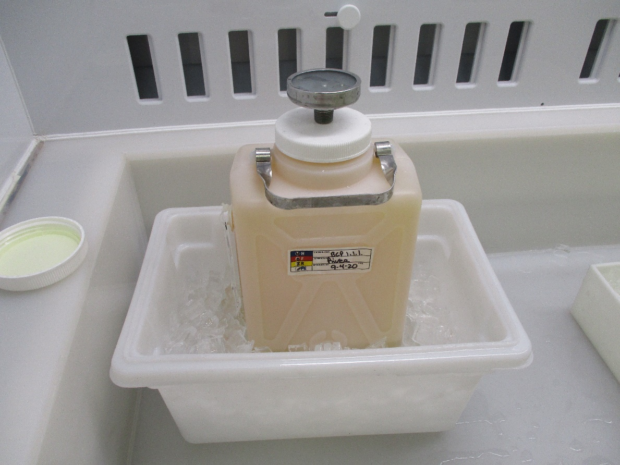
Figure 1: Acid container being chilled before use.

- Pour enough BCP 1:1:1 into the inner acid container, then put water and ice in the outer container. Make sure there is enough acid such that the container does not float.
- Perform the etch rate measurement as described in the procedure CP-C75-CAV-BCP-ER-R1 and calculate the etching time T to remove 25 microns as T (min) = 25 micron/etch rate (microns/min)
- Set the timer to time = T
- Immerse the Dogleg flange in the inner acid container just enough to cover the surface of the flange, start the timer and slowly agitate it in the acid solution for time T (see Fig. 2).

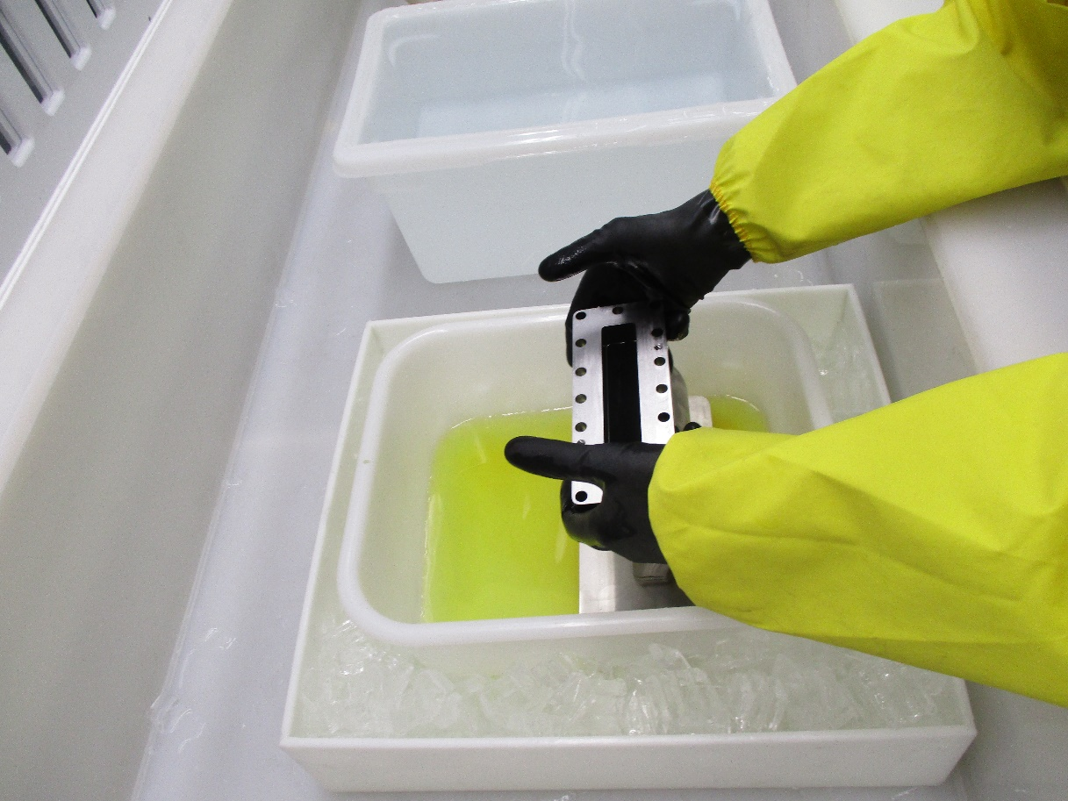
Figure 2: Dogleg flange being etched in BCP kept cold by chilled water bath.

- Quickly move the Dogleg into the container with DI water and move it in the water for at least 20 sec.
- Remove the Dogleg from the container with DI water, let drip any excess water, then rotate it to etch the other flange.
- Check the temperature of the inner acid container. Add ice to the outer container if necessary to keep the acid temperature within 15-17 °C (59-63 °F).
- Repeat steps 6-8 to etch the second flange.
- Rinse Dogleg with the DI water hose or dunk the dogleg in a water bath.
  - Use the DI water squirt bottle on the blind holes on the large flange.
  - Dry holes with N₂ gun to ensure no acid remains in holes, optional if doing so take heed to use proper ear PPE as the noise can be excessive.
- Repeat Step 11 three times.
- Place into the Quick Dump Rinser tank in the acid hood and allow to run for at least 10 minutes to ensure any trapped acid is diluted.
- Return acid hood and PPE to prior use condition.
- Follow Sec. 4.2 for post-acid etch cleaning.

Etching of entire dogleg
Follow Steps 1-7 and 11-15 above, taking into account that the inner acid container should be large enough to be able to fully immerse the dogleg in acid. Do a test using water to make sure a properly sized container has been chosen and no liquid is spilled when immersing the Dogleg in it. When etching an entire Dogleg the required material removal may vary depending on the stage of fabrication. Please confirm the amount of etching with the PI.

Flange Q-tip BCP
- Follow Steps 1-3 above.
- Dip the Q-tip in BCP and carefully cover the flange around the bolt holes with acid.
  - If the acid starts smoking excessively, rinse with water and restart where you left off.
  - Do not allow acid into the threaded bolt holes.
- Place used Q-tips in the neutralization container.
- Follow Steps 11-15 above.

Revision History

Rev # | Revision or update: | Effective:
Release | Initial Release | 9/15/2020

Approvals

Approved by: | Signature: | Date:
Document Owner | Ashley Mitchell
Reviewer | Teena Harris
C75 Project Manager | Kurt Macha
C75 Scientific Lead | Gianluigi Ciovati

