Traveler Title | P1 Helium Vessel Modification Traveler
Traveler Abstract | The traveler is intended to document the rework of the SL21 helium vessels to increase the He riser size and eliminate the gaseous choke.  The helium vessels were surveyed and tagged by RADCON during the SL21 Cryomodule disassembly effort and shall be handled as required. RADCON is to be notified prior to the assemblies being move.
Traveler ID | P1-CMA-HELV-REWRK
Traveler Revision | R1
Traveler Author | John Fischer
Traveler Date | 12-Oct-20
NCR Informative Emails | areilly,kdavis,fischer
NCR Dispositioners | kdavis,fischer,forehand,jjcamp
D3 Emails | kdavis,fischer,forehand,jjcamp,areilly
Approval Names | John Fischer | Kirk Davis | Tony Reilly | Jeff Campbell
Approval Signatures
Approval Dates
Approval Title | Author/CMA Lead | CAG Lead | Project Manager | Technical Reviewer

References | List and Hyperlink all documents related to this traveler. This includes, but is not limited to: safety (THAs, SOPs, etc), drawings, procedures, and facility related documents.
P1 HV Machining Procedure | P1 Helium Vessel Modification Dwg | P1 Helium Vessel Welding Procedure

Revision Note
R1 | Initial release of this Traveler.

Step No. | Instructions | Data Input
1 | Identify and record the Cavity/Helium Vessel S/N to be machined | [[Technician]] <<SRF>>  [[Date]] <<TIMESTAMP>>  [[Comment]] <<COMMENT>>  [[HVSN]] <<SN>>
2 | Measure RF Passbands and record if deemed necessary. | [[Technician2]] <<SRF>>  [[Date2]] <<TIMESTAMP>>  [[Comment2]] <<COMMENT>>  [[PreRFData]] <<FILEUPLOAD>>
3 | Deliver the assembly to the Machine Shop.  Coordinate with RADCON and the Machine Shop Supervisor prior. Items are tagged and require tracking. | [[Technician3]] <<SRF>>  [[Date3]] <<TIMESTAMP>>  [[Comment3]] <<COMMENT>>
4 | Following the “P1 HV Machining Procedure”, enlarge the helium vessel return header diameter. Record comments.  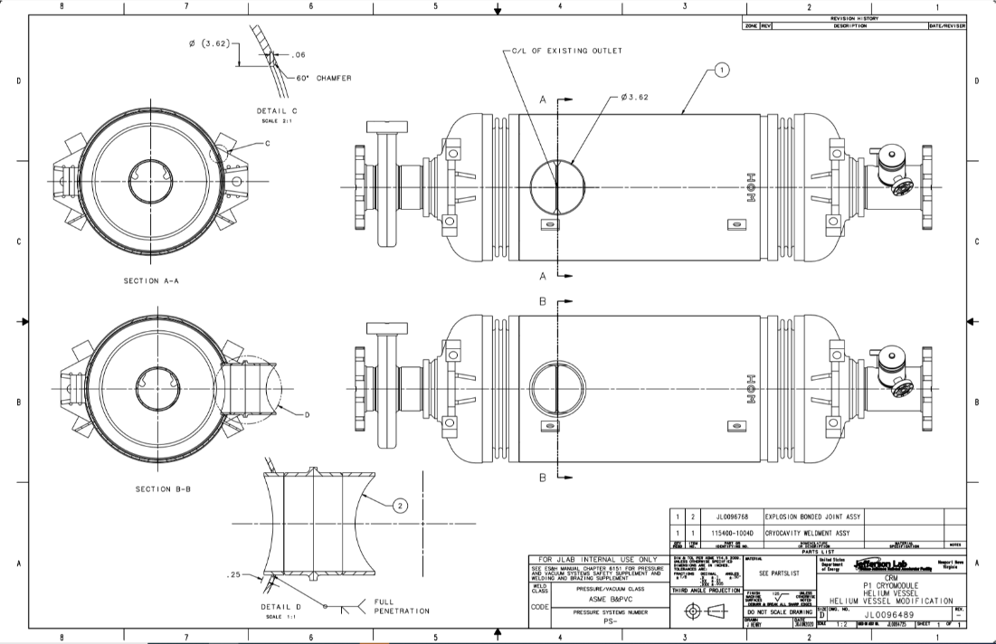 | [[Technician4]] <<SRF>>  [[Date4]] <<TIMESTAMP>>  [[Comment4]] <<COMMENT>>
5 | Transport the assembly back to the Test Lab  Coordinate with RADCON and the Machine Shop Supervisor prior. Items are tagged and require tracking. | [[Technician5]] <<SRF>>  [[Date5]] <<TIMESTAMP>>  [[Comment5]] <<COMMENT>>
6 | Measure RF Passbands post machining and record if deemed necessary. | [[Technician6]] <<SRF>>  [[Date6]] <<TIMESTAMP>>  [[Comment6]] <<COMMENT>>  [[PostRFData]] <<FILEUPLOAD>>
7 | Prepare and weld the new riser assembly to the Helium Vessel. Shown on the drawing above. Use the Welding Procedure to execute this work. P1 Helium Vessel Welding Procedure | [[Technician7]] <<SRF>>  [[Date7]] <<TIMESTAMP>>  [[Comment7]] <<COMMENT>>
8 | Complete and the upload weld maps | [[WeldInspector]] <<SRF>>  [[Date8]] <<TIMESTAMP>>  [[Comment8]] <<COMMENT>>  [[WeldMaps]] <<FILEUPLOAD>>
9 | Leak check the Helium Vessel assembly. Record findings. | [[Technician9]] <<SRF>>  [[Date9]] <<TIMESTAMP>>  [[Comment9]] <<COMMENT>>  [[LeakCheckData2]] <<FILEUPLOAD>>
10 | Measure RF Passbands post welding and record if deemed necessary. | [[Technician10]] <<SRF>>  [[Date10]] <<TIMESTAMP>>  [[Comment10]] <<COMMENT>>  [[PostRFData2]] <<FILEUPLOAD>>
11 | Verfiy this Traveler is complete. Turn over completed assembly to the CAG. | [[Technician11]] <<SRF>>  [[Date11]] <<TIMESTAMP>>  [[Comment11]] <<COMMENT>>

