Traveler Author Checklist

# Authoring

Front Page

* Is the Traveler ID in the correct format?
  + In Pansophy, navigate to TRAVELERS > AUTHORIZED USERS > TP ACRONYMS to verify
    - <https://pansophy.jlab.org/pansophy/Admin/TPAcronyms2020.cfm>
  + If you have further questions, contact the Pansophy Team for help
* Are you in the current traveler template?
  + The current (Oct. 2020) traveler template includes the NCR Informative Emails, NCR Dispositioners and D3 Emails fields on the first page
  + If you do not have the current format, please open a new document with the current template
    - Instructions on this can be found here <https://pansophy.jlab.org/pansophy/Documents/TravelerAuthorship2020.ppsx>
* Did you add NCR Disopositioners and NCR Informative emails?
  + What is the difference between the two?
    - **NCR Dispositioners**: someone who is able to assign an initial and final disposition to the NCR
    - **NCR Informative Emails:** someone who receives an email to inform them that an NCR has been instantiated. They **cannot** disposition the NCR and the email is for informative purposes
  + These fields should be the username, separated by a comma with no spaces
    - Ex: megan,bookwalt,mdickey
  + A username is not in both the dispositioner and informative email line
    -  
    - 
* Did you add D3 emails?
  + What are D3 emails?
    - **D3 Emails:** Similar to the NCR Informative emails, these emails go to the specified users to inform them that a D3 has been instantiated for a specific traveler
  + These fields should be the username, separated by a comma with no spaces
* Have you attached the appropriate reference files?
  + You can upload your drawing or excel sheets to **Traveler Included Files** in the appropriate project folder in DocuShare and link it to the traveler from there
* Are you revising an already existing traveler?
  + Please use the word document located in the **Approved Travelers** folder in DocuShare for editing
    - Sometimes a traveler has behind the scenes errors that the Pansophy Team corrects. The word document in the **Approved Travelers** folder will contain any necessary corrections made by the Pansophy Team
  + Ensure that you update the **Traveler Revision** and the **Revision Note**

Traveler Instructions and Data collection

* Is there a serial number on the first page?
  + A traveler requirement is that there is an SN on the first page. If you are unaware of the acronym, please navigate to TRAVELERS > AUTHORIZED USERS > TP ACRONYMS in Pansophy and select **Component** in the **Listing For** dropdown
    - <https://pansophy.jlab.org/pansophy/Admin/TPAcronyms2020.cfm>
* Are the fieldnames descriptive to the step being performed?
  + 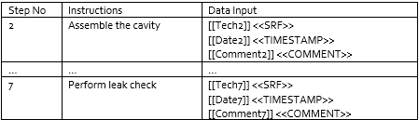
    - These fieldnames are not descriptive to the step being performed
  + 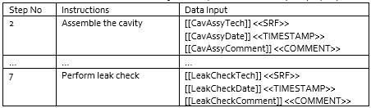
    - These fieldnames are descriptive of the step being performed which will aide in future datamining (Example: User Defined Query)
* Are the fieldnames unique (no duplicates)?
  + Example: if a leak check is performed more than once in a traveler, do not name the fields the same
    - 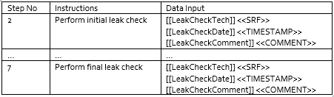
    - 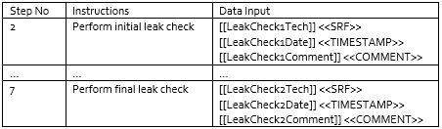
    - 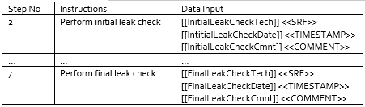
    - The above are just examples of different ways to properly name fieldnames
* Did you use the proper data types?
  + The description of each data type can be found in <https://pansophy.jlab.org/pansophy/Documents/TravelerAuthorship2020.ppsx>

# Review

Uploading to DRaft Travelers

1. When you feel your traveler is ready for review, you may upload it to the **Draft Travelers** folder for the appropriate project area in DocuShare
   1. <https://jlabdoc.jlab.org/docushare/dsweb/View/Collection-16191>
2. Make the fellow reviewers aware that the document is there
3. Reviewers can review and make changes as they feel appropriate from this folder
4. Reviewers will inform author if/when they make changes and feel that the document is ready for approvals

Ready for Approvals

* When reviewers have notified the author that they are done reviewing, the author can prepare to upload the traveler to the new **Ready for Approvals** folder in DocuShare
  + Authors, before uploading, please ensure that the traveler still follows the traveler author rules and that all reviewer comments and change tracking has been deleted
* When the traveler has been uploaded to the new **Ready for Approvals** folder, send an email to [pansophy@jlab.org](mailto:pansophy@jlab.org) with the traveler title to inform the Pansophy Team that it is ready
* The Pansophy Team will then move the document to the approvals folder to route it for signatures/approvals
* Great job! Once the traveler has been approved by all reviewers, your work for the authoring of that traveler is complete!

# Closing Remarks from the Pansophy Team

* Please refrain from emailing the traveler to the **Pansophy Team**
  + We have been very busy with the influx of travelers and the document can often get lost in our inboxes
* If you need assistance in traveler authorship, please email [pansophy@jlab.org](mailto:pansophy@jlab.org)
* We understand that it is sometimes hard to break old habits but these changes will ensure that all travelers:
  + Will follow a better process flow and , in turn, can be uploaded for approvals and to Pansophy in a more timely manner
  + Will require little to no editing from the Pansophy Team