Traveler Author Checklist

Authoring
Front Page
- Is the Traveler ID in the correct format?
  - In Pansophy, navigate to TRAVELERS > AUTHORIZED USERS > TP ACRONYMS to verify
    - https://pansophy.jlab.org/pansophy/Admin/TPAcronyms2020.cfm
  - If you have further questions, contact the Pansophy Team for help
- Are you in the current traveler template?
  - The current (Oct. 2020) traveler template includes the NCR Informative Emails, NCR Dispositioners and D3 Emails fields on the first page
  - If you do not have the current format, please open a new document with the current template
    - Instructions on this can be found here https://pansophy.jlab.org/pansophy/Documents/TravelerAuthorship2020.ppsx
- Did you add NCR Disopositioners and NCR Informative emails?
  - What is the difference between the two?
    - NCR Dispositioners: someone who is able to assign an initial and final disposition to the NCR
    - NCR Informative Emails: someone who receives an email to inform them that an NCR has been instantiated. They cannot disposition the NCR and the email is for informative purposes
  - These fields should be the username, separated by a comma with no spaces
    - Ex: megan,bookwalt,mdickey
  - A username is not in both the dispositioner and informative email line
    - 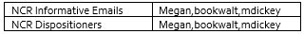
    - 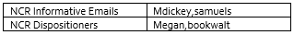
- Did you add D3 emails?
  - What are D3 emails?
    - D3 Emails: Similar to the NCR Informative emails, these emails go to the specified users to inform them that a D3 has been instantiated for a specific traveler
  - These fields should be the username, separated by a comma with no spaces
- Have you attached the appropriate reference files?
  - You can upload your drawing or excel sheets to Traveler Included Files in the appropriate project folder in DocuShare and link it to the traveler from there
- Are you revising an already existing traveler?
  - Please use the word document located in the Approved Travelers folder in DocuShare for editing
    - Sometimes a traveler has behind the scenes errors that the Pansophy Team corrects. The word document in the Approved Travelers folder will contain any necessary corrections made by the Pansophy Team
  - Ensure that you update the Traveler Revision and the Revision Note
Traveler Instructions and Data collection
- Is there a serial number on the first page?
  - A traveler requirement is that there is an SN on the first page. If you are unaware of the acronym, please navigate to TRAVELERS > AUTHORIZED USERS > TP ACRONYMS in Pansophy and select Component in the Listing For dropdown
    - https://pansophy.jlab.org/pansophy/Admin/TPAcronyms2020.cfm
- Are the fieldnames descriptive to the step being performed?
  - 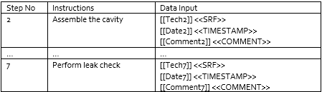
    - These fieldnames are not descriptive to the step being performed
  - 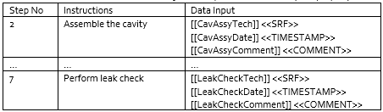
    - These fieldnames are descriptive of the step being performed which will aide in future datamining (Example: User Defined Query)
- Are the fieldnames unique (no duplicates)?
  - Example: if a leak check is performed more than once in a traveler, do not name the fields the same
    - 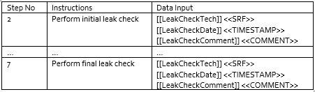
    - 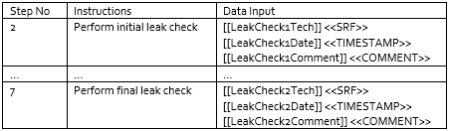
    - 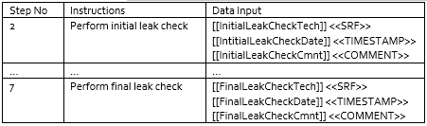
    - The above are just examples of different ways to properly name fieldnames
- Have you verified that there are no special characters in your field names?
  - The only special character allowed is an underscore ( _ )
  - No spaces allowed
    - Click this button to show paragraph marks. This assists in seeing spaces in field names 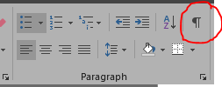
- Did you use the proper data types?
  - The description of each data type can be found in https://pansophy.jlab.org/pansophy/Documents/TravelerAuthorship2020.ppsx

Review
Uploading to DRaft Travelers
- When you feel your traveler is ready for review, you may upload it to the Draft Travelers folder for the appropriate project area in DocuShare
  - https://jlabdoc.jlab.org/docushare/dsweb/View/Collection-16191
- Make the fellow reviewers aware that the document is there
- Reviewers can review and make changes as they feel appropriate from this folder
- Reviewers will inform author if/when they make changes and feel that the document is ready for approvals
Ready for Approvals
- When reviewers have notified the author that they are done reviewing, the author can prepare to upload the traveler to the new Ready for Approvals folder in DocuShare
  - Authors, before uploading, please ensure that the traveler still follows the traveler author rules and that all reviewer comments and change tracking has been deleted
- When the traveler has been uploaded to the new Ready for Approvals folder, send an email to pansophy@jlab.org with the traveler title to inform the Pansophy Team that it is ready
- The Pansophy Team will then move the document to the approvals folder to route it for signatures/approvals
- Great job! Once the traveler has been approved by all reviewers, your work for the authoring of that traveler is complete!

Closing Remarks from the Pansophy Team
- Please refrain from emailing the traveler to the Pansophy Team
  - We have been very busy with the influx of travelers and the document can often get lost in our inboxes
- If you need assistance in traveler authorship, please email pansophy@jlab.org
- We understand that it is sometimes hard to break old habits but these changes will ensure that all travelers:
  - Will follow a better process flow and , in turn, can be uploaded for approvals and to Pansophy in a more timely manner
  - Will require little to no editing from the Pansophy Team

