Traveler Title | SNSPPU Cavity Receiving Inspection
Traveler Abstract | Incoming Inspection of SNSPPU Production Cavities.
Traveler ID | SNSPPU-INSP-CAV
Traveler Revision | R2
Traveler Author | Pashupati Dhakal
Traveler Date | 9-Oct-20
NCR Informative Emails | Edaly
NCR Dispositioners | kwilson,dhakal,macha
D3 Emails | kwilson,edaly,dhakal,macha
Approval Names | Pashupati Dhakal | Kurt Macha | Earl Mosby | Ed Daly
Approval Signatures
Approval Dates
Approval Title | Author | Reviewer | Reviewer | Project Manager

References | List and Hyperlink all documents related to this traveler. This includes, but is not limited to: safety (THAs, SOPs, etc), drawings, procedures, and facility related documents.
104211800-M8U-8200-A001 Cavity Assembly | 104211800-M8U-8200-A002 Probe End Sub-Assy | 104211800-M8U-8200-A002 FPC End Sub-Assy | Cavity in Shipping Crate | 104211800-M8U-8200-A017 FPC Flange Detail
104211800-M8U-8200-A016 FPC End Flange Detail | 104211800-M8U-8200-A011 Probe End Flange Detail

Revision Note
R1 | Initial release of this Traveler.
R2 | First revision.

Step No. | Instructions | Data Input
1 | Un-crate the cavity from the shipping box and enter the cavity serial number ID that is going to be inspected.  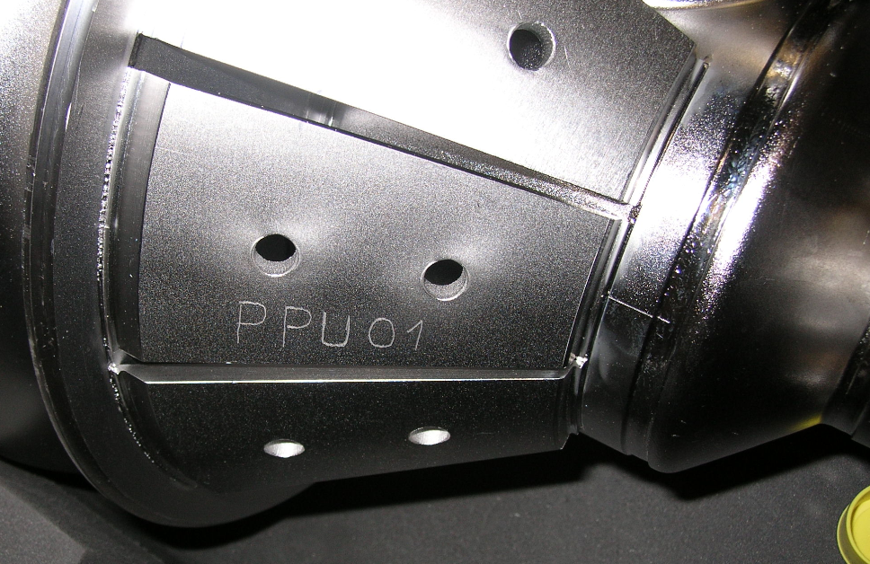 | [[CAVSN]] <<CAVSN>>  [[Inspector1]] <<SRF>>  [[TestDate]] <<TIMESTAMP>>
2 | Inspect for any visual damage. Record the component serial numbers, if any.  Visual inspection should be looking for any obvious damage to the cavity as well as damage to the input and FPC connectors. Pay special attention the the feedthrough pins. Inspect the busrt disk to ensure it is not dented or broken.  Field Probe SN  Input Probe SN  End Group FPC side SN  End Group FP side SN  Flange FPC side SN  Flange FPC side SN  Burst Disc SN  Cavity in Shipping Crate | [[FPFTSN]] <<SN>>  [[INTFTSN]] <<SN>>  [[PBDSN1]] <<SN>>  [[PBDSN2]] <<SN>>  [[EndGroup]] <<SN>>  “Need 7 input SN”  [[PassVisualInspectionOK]] <<YESNO>>  [[VisualInspectComments]] <<COMMENT>>  [[Inspector2]] <<SRF>>  [[AdditionalFile1]] <<FILEUPLOAD>>
3 | Ensure the right Angle Valve is in the closed position. | [[RightAngleValveClosed]] <<YESNO>>  [[ValveComments]] <<COMMENT>>

Step No. | Instructions | Data Input
4 | Are cell Serialized? Record ( FPC to FP, Cell 1-6). Each cell has two SN for each half record both. The numers are alpha numeric.  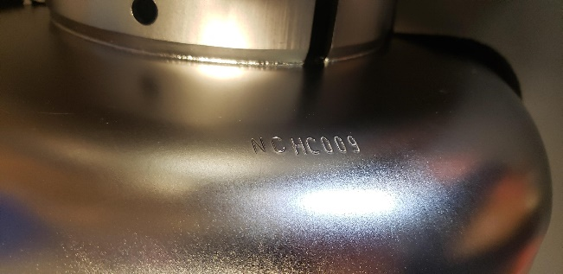 | [[Cell1]] <<SN>>  [[Cell2]] <<SN>>  [[Cell3]] <<SN>>  [[Cell4]] <<SN>>  [[Cell5]] <<SN>>  [[Cell6]] <<SN>>
5 | Check Torque Value on Screws  Joints are numbered 1 to 7. NOTE - Starting location is at valve end of cavity  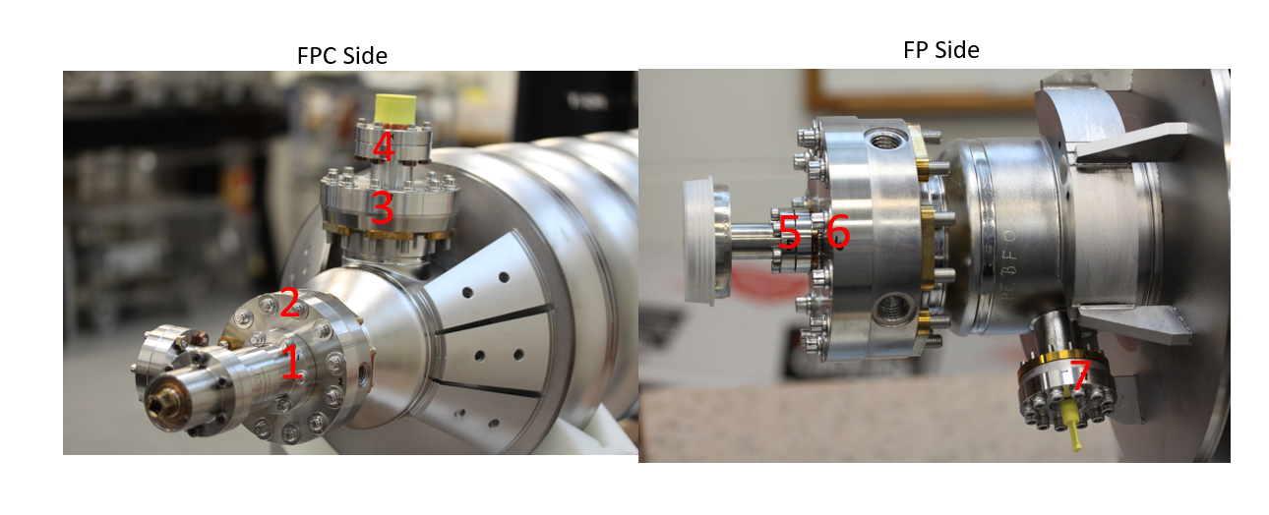  A286 5/16 ~ 30 ft-lb (Locations 2, 3 and 6)  A286 8-32 ~ 40 in-lb (Location 7)  Valve flange snd Input flance (2 ¾ ) > 11 ft-lb (Locations 1,4 and 5) | [[Location 1]] <<YESNO>>  [[TorqComment1]] <<COMMENT>>  [[Location 2]] <<YESNO>>  [[TorqComment2]] <<COMMENT>>  [[Location 3]] <<YESNO>>  [[TorqComment3]] <<COMMENT>>  [[Location 4]] <<YESNO>>  [[TorqComment4]] <<COMMENT>>  [[Location 5]] <<YESNO>>  [[TorqComment5]] <<COMMENT>>  [[Location 6]] <<YESNO>>  [[TorqComment6]] <<COMMENT>>  [[Location 7]] <<YESNO>>  [[TorqComment7]] <<COMMENT>>  [[Are torque values correct]] << YES NO>>  [[Torque]] <Comments>>
6 | CMM Inspections  Perform dimensional inspections on CMM. Fill out NCR for any out of tolerance measurements.  104211800-M8U-8200-A001 Cavity Assembly  104211800-M8U-8200-A002 Probe End Sub-Assy  104211800-M8U-8200-A003 FPC End Sub-Assy  104211800-M8U-8200-A017 FPC Flange Detail  104211800-M8U-8200-A011 Probe End Flange Detail  104211800-M8U-8200-A016 FPC End Flange Detail | [[Inspector3]] <<SRF>>  [[CmmComments]] <<COMMENT>>  [[AdditionalFile2]] <<FILEUPLOAD>>  [[TestDate]] <<TIMESTAMP>>

Drawing number | Description | Drawing Value (inch) | Measured Value | Within Tolerance
104211800-M8U-8200-A001 | Distance between end dishes. Measure from machined step to machined step. | 35.423 | [[DIM1]] <<FLOAT>> | Reference Dimension N/A
104211800-M8U-8200-A003 | Coupler flange perpendicularity. | .005 | [[DIM2]] <<FLOAT>> | [[DIMTOL2]] <<YESNO>>
104211800-M8U-8200-A017 | Coupler flange perpendicularity OD | 4.889 | [[DIM3]] <<FLOAT>> | [[DIMTOL3]] <<YESNO>>
104211800-M8U-8200-A016 | Beamline Flange OD- FPC side | 4.889 | [[DIM4]] <<FLOAT>> | [[DIMTOL4]] <<YESNO>>
104211800-M8U-8200-A011 | Beamline Flange OD – FP side | 4.889 | [[DIM5]] <<FLOAT>> | [[DIMTOL5]] <<YESNO>>
104211800-M8U-8200-A002 | End Flange to Dish ( FP side) | 6.397 | [[DIM6]] <<FLOAT>> | Reference Dimension N/A
104211800-M8U-8200-A003 | End Flange to Dish ( FPC Side) | 9.01 | [[DIM7]] <<FLOAT>> | Reference Dimension N/A
104211800-M8U-8200-A003 | Perpendicularity of FPC end dish to beam center | .005 | [[DIM8]] <<FLOAT>> | N/A
104211800-M8U-8200-A002 | Perpendicularity of FP end dish to beam center | .005 | [[DIM9]] <<FLOAT>> | N/A
104211800-M8U-8200-A002 | Tuner 120 Deg. C-Bore location | 2.559  5.118 | [[DIM10]] <<FLOAT>>  [[DIM11]] <<FLOAT>> | [[DIMTOL10]] <<YESNO>>  [[DIMTOL11]] <<YESNO>>
104211800-M8U-8200-A002 | Tuner tapped hole locations.  Verify 10-32 Thread inserts are installed and test thread. | .590  1.180  2.559  5.118 | [[DIM12]] <<FLOAT>>  [[DIM13]] <<FLOAT>>  [[DIM14]] <<FLOAT>>  [[DIM15]] <<FLOAT>> | [[DIMTOL12]] <<YESNO>>  [[DIMTOL13]] <<YESNO>>  [[DIMTOL14]] <<YESNO>>  [[DIMTOL15]] <<YESNO>>  [[ThreadCheck1]] <<YESNO>>
104211800-M8U-8200-A002  104211800-M8U-8200-A001 | Lollipop tapped hole C-Bore face. Side of flange at FP side.  Flange rotation, Lollipop tapped hole 0 Deg. To FPC flange.  Verify 5/8-11 threads with thread gauge. | 2.351  0 Deg. | [[DIM16]] <<FLOAT>>  [[DIM17]] <<FLOAT>> | [[DIMTOL16]] <<YESNO>>  [[DIMTOL17]] <<YESNO>>  [[ThreadCheck2]] <<YESNO>>
104211800-M8U-8200-A002 | Alignment tool tapped hole C-Bore face. Side of flange at FP side.  Hole location 90 deg from FPC face  Verify 5/8-11 threads with thread gauge. | 2.351  2.351  90 Deg | [[DIM18]] <<FLOAT>>  [[DIM19]] <<FLOAT>>  [[DIM20]] <<FLOAT>> | [[DIMTOL18]] <<YESNO>>  [[DIMTOL19]] <<YESNO>>  [[DIMTOL20]] <<YESNO>>  [[ThreadCheck3]] <<YESNO>>
104211800-M8U-8200-A003  104211800-M8U-8200-A001 | Lollipop tapped hole C-Bore face. Side of flange at FPC side.  Flange rotation, Lollipop tapped hole 0 Deg. To FPC flange.  Verify 5/8-11 threads with thread gauge. | 2.351  0 Deg. | [[DIM21]] <<FLOAT>>  [[DIM22]] <<FLOAT>> | [[DIMTOL21]] <<YESNO>>  [[DIMTOL22]] <<YESNO>>  [[ThreadCheck4]] <<YESNO>>
104211800-M8U-8200-A002  104211800-M8U-8200-A001 | Alignment tool tapped hole C-Bore face. Side of flange at FPC side.  Hole location 90 deg from FPC face  Verify 5/8-11 threads with thread gauge.  Are the threads okay? | 2.351  2.351  90 Deg | [[DIM23]] <<FLOAT>>  [[DIM24]] <<FLOAT>> | [[DIMTOL23]] <<YESNO>>  [[DIMTOL24]] <<YESNO>>  [[ThreadCheck5]] <<YESNO>>

