Creating Folders in Outlook for NCRs

# In the Outlook 2016 App

1. Navigate to the folder Tab. Ensure that you are able to easily navigate to the folder you just created.
2. Click “New Folder” and name it what you like. I am going to create one for SNSPPU NCRs where I am a dispositioner. I will call it “SNSPPU NCRs Disp”
3. Once the folder is created, navigate to the Home tab.
4. Click on the “Rules” drop down, to the right of “Quick Steps”, and click “Manage Rules & Alerts”
5. Click on “New Rule”
6. Since I am setting one up for NCRs I can disposition, so I selected “Apply rule on messages I receive” the click “Next”
7. Select “with specific words in the subject” and “with specific words in the body” 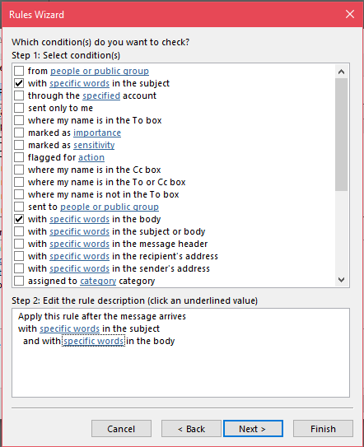
   1. * If you are creating a folder for all NCRs, not just ones you can or cannot disposition, just select “with specific words in the subject”*
8. Click the underlined words in the bottom boxed area.
   1. Subject word selection – “SNSPPU”  
      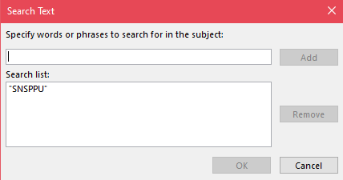
   2. Body word Selection – “You have been listed as an engineer with dispositioning capabailities of a Non-Conformance Report”  
      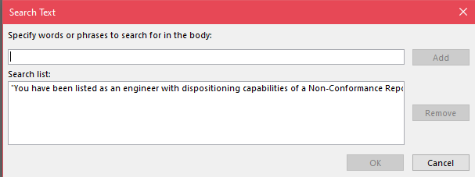
9. Click “Next” then select the top checkbox that says “Move it to the specified folder” and click the underlined words, “Specified Folder” in the bottom box and select your newly created folder 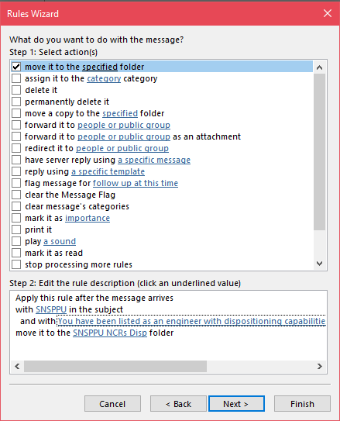
10. Click “Finish” then “Apply” then “OK”

# On the Outlook Web Page

1. On the web page, right click in the left pane “Create New Folder”. I am going to create one for SNSPPU NCRs where I am listed for informative emails. I will call it “SNSPPU NCRs Inform”. Ensure that you are able to easily navigate to your new folder.
2. Click the settings icon in the upper right corner and then click “View all Outlook settings” on the bottom right pane.
3. Under the mail tab, click “Rules” and click “Add new rule”
4. Choose a title, I chose SNSPPU Inform and choose your conditions. I set mine as “Subject Includes”: “SNSPPU” then click “Add another condition” AND “Message body includes”: “You have been listed as a person to be informed of a Non-Conformance Report”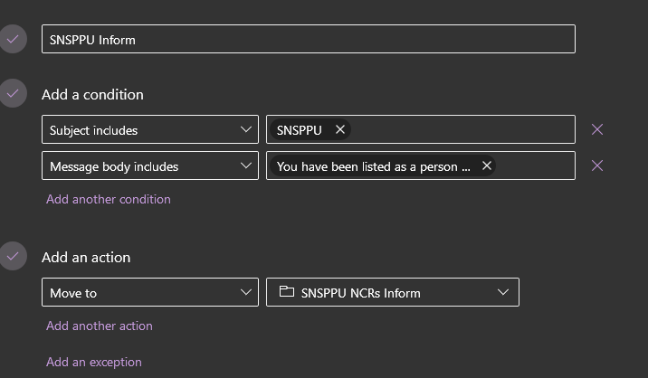
5. Click “Save”