|  |  |  |  |
| --- | --- | --- | --- |
| C75 cavity tuning and HOM measurements | | | |
| **Document Number:** | CP-C75-CAV-TUNE | **Approval Date:** |  |
| **Revision Number:** | - | **Periodic Review Date:** |  |
| **Document Owner:** | R. Overton |  |  |

## 

# Purpose and Scope

This procedure describes the steps to measure the frequency, field-flatness and Qext of the FPC, field probe and coupling antennae for C75 cavities, as well as measuring the HOM spectrum and the field profile of HOMs.

# References

[Coupling-cal](https://jlabdoc.jlab.org/docushare/dsweb/Get/Document-231010/Coupling-cal%20a.xls) - Spreadsheet to calculate Qext

[Flatness Calculation](https://jlabdoc.jlab.org/docushare/dsweb/Get/Document-231011/Flatness%20Calculation.xls) - Spreadsheet to calculate Field Flatness

# Terms and Definitions

1. **VNA** – Vector Network Analyzer.
2. **HOM** – High Order Mode.
3. **FPC** – Fundamental Power Coupler

# Process Details

**Cavity Setup:**

1. Cavity will be placed on tuning bench by hand with FPC end towards the fishing reel and flange 90 degrees to bench.
2. Cavity will be supported by the equator of the 2 end cells in the tuning bench (Fig. 1)
3. Temporary blanks, feed-throughs and antennas will supply RF power to the cavity while tuning and measuring takes place (Fig.2)



FIG. 1. C75 cavity setup on the tuning bench.



FIG. 2. Beamline blanks with RF feedthrough and center holes.

1. The threaded holes for the feed-throughs are slightly off center so the bead-pull string can be run through a hole in the center of the blank. The metallic bead needs to be pulled through the cavity on beam center.
2. The temporary antenna will be cut to a length that will ensure that it is under coupled and not affecting the field in the cavity (approximately one inch back, on the beam tube side, from the iris of the first cavity cell). The recommended lengths from the tip of the antenna to the inner surface of the blank are 3.563” if inserted in the beamline on the HOM side and 3.125” if inserted on the beamline on the FPC side.
3. Blanks and antennas will be clamped to the beam-line flanges of both ends of the cavity.
4. The FPC flange can be open or have a tapered waveguide attached. Either configuration is acceptable for the bead-pull measurements (will not change field profile). The cavity is now ready to have the bead-pull string set up using the “no touch” string insertion method.

**“No Touch” Bead-Pull Setup:**

The goal of the no touch insertion method is to have the nylon fishing string sent through the cavity without anything touching the inside surfaces of the cavity. The string shall remain tight throughout the tuning process to prevent touching of the inside surface of the cavity.

1. Technician shall wear rubber gloves while setting up the string for the bead-pull measurements.
2. Remove the ½” Titanium tube from the plastic sleeve and wipe with clean room cloth soaked in alcohol.
3. Slide the tube through the two guide holes on the HOM side of the tuning bench and continue until pointed plastic guide slides through plastic sleeve in the center of the temporary blank (Fig. 3).

NOTE: After the pipe is fully inserted through the first blank, the sliding motion must be slowed down considerably. This is done as a precautionary method of decreasing any surface damage to the cavity if the guides fail to keep the rod in the center of the cavity.

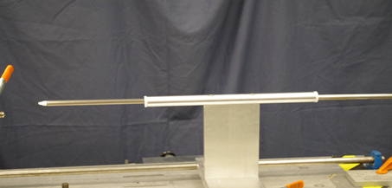

FIG. 3. Ti rod sliding through the guide.

1. Slide the rod through the entire cavity until it protrudes through the blank on the FPC end of the cavity
2. Remove the plastic tips from both ends of the Titanium rod. Slide the plastic wire through the inside of the rod. Tape the nylon fishing line to the end of the plastic wire (Fig. 4)

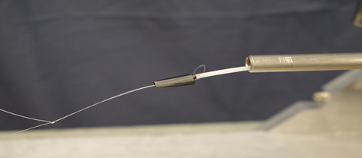

FIG. 4. Fishing line attached to thick plastic wire.

1. Pull the plastic wire (with bead) all the way through the Ti rod.
2. While holding the string snugly (to prevent any sway in the string), carefully remove the Titanium rod from the cavity and guide holes.

NOTE: After the rod is all the way through the cavity and the string is exposed, grab the string and clamp it to the flange. This will keep the string tight inside the cavity and not touching any interior surfaces.

1. Run the string around the two pulleys and the weight with pulleys. Hang the loop in the end of the string on the hook near the top pulley (Fig. 5). Check that the wire goes through the center of the guide and of the cavity.
2. The string runs from the fishing reel around a height adjusting wheel and through the cavity. The electric motor connected to the fishing reel will run the string in and out of the cavity as needed. The cavity is now ready for RF measurements and tuning.

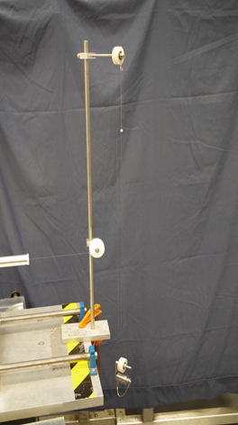

FIG. 5. Fishing wire going on pulleys and maintained in tension by the weight at the bottom.

**RF Measurements:**

1. Connect Port 1 of the VNA to the beamline RF connector on FPC side of the cavity and Port 2 of the VNA to the beamline RF connector on the opposite side of the cavity. Set the VNA for an S21 measurement, Format = Log Mag, Number of points = 1600, IF Bandwidth = 1 kHz.
2. Set the Start Frequency to 1450 MHz and Stop Frequency to 1496 MHz. There should be 5 peaks displayed corresponding to each mode of the TM010 passband. Record the frequency of each mode.
3. Set the Center Frequency to the frequency of the -mode (the mode of the TM010 passband with the highest frequency) and the Span to 5 MHz and record the frequency.
4. Change the Format to Phase and set the Trigger to Single. Set Sweep Type = CW Frequency and enter the frequency of the -mode.
5. Set the Sweep Time to an appropriate time that will match the length of time the bead takes to pull through the cavity. Generally, the bead is set up so it takes approximately 30-45 seconds to complete the measurement. Start a single sweep with the analyzer at the same time the bead is started. The result will be similar to the plot in Fig. 6.

NOTE: The amplitude of each cell shall be no more than ten degrees or the bead will have to be shortened.

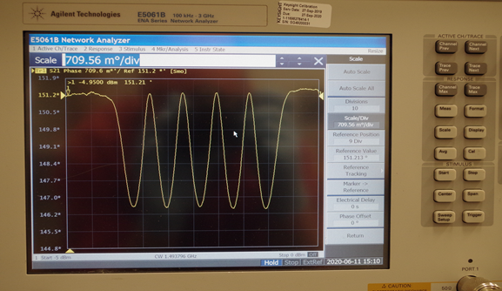

FIG. 6. Result from a beadpull on the -mode of the C75 cavity.

1. The Field Flatness, FF, can be computed as:

FF(%) = {1-[sqrt(Max)-sqrt(Min)]/sqrt(Avg)}*100

where Max, Min, and Avg. are the maximum, minimum and average amplitudes of the peaks shown in Fig. 6. A spreadsheet “Flatness Calculation” is available to automatically calculate the field flatness after entering the amplitudes of each peak measured on the VNA.

1. Set the Sweep Time to an appropriate time that will match the length of time the bead takes to pull through the cavity. Generally, the bead is set up so it takes approximately 30-45 seconds to complete the measurement. Start a single sweep with the analyzer at the same time the bead is started. The result will be similar to the plot in Fig. 6.

**Cavity Tuning:**

The technician will look at the data in the bead-pull and the frequency of the cavity. This information will help determine how to move forward in tuning the cavity. The field profile combined with the need to lower or raise the frequency overall will help the technician decide which cell needs to be tuned and whether it needs to be squeezed or stretched. The technician will determine the frequency change to make on each of the individual cells in the cavity based on the amplitudes of the signal. The target frequency and field flatness are specified in the Traveler associated with this Procedure.

Squeezing an individual cell will do two things: the resonant frequency of the cavity will go down and the stored energy in that individual cell will be reduced. The opposite will occur when stretching an individual cell.

Perform a bead-pull after manipulating each cell to verify the field profile has changed similarly to what was expected. Each new bead-pull will help determine which cell to tune next.

Numerous bead-pulls and cell manipulations are required to get the cavities tuned to frequency and field flatness specifications at the same time. This can be a very intuitive process that requires a little bit of training and quite a bit of experience. Often times an individual cell may need to be tuned opposite of what may seem needed for target frequency specifications. This may be necessary in order to obtain the desired field flatness at the end of the process.

After cavity is tuned to desired Frequency and field flatness remove fishing line and bead with ”No Touch” Bead-Pull procedure:

1. Remove the ½” Titanium rod from the plastic sleeve and wipe with clean room cloth soaked in alcohol
2. Remove the plastic tips from both ends of the Titanium rod. Slide plastic wire through the inside of the rod, Tape the nylon fishing line to the end of the plastic wire.
3. Pull the plastic wire (with bead) all the way through the Ti rod. Slide the rod through the entire cavity until it protrudes through the blank on the FPC end, keeping the fishing line tight
4. With the Ti rod all the way through cavity you can now wind the fishing line around fixture for the fishing reel.
5. When the fishing line is out remove the Ti rod from the cavity.

**FPC Qext measurement and tuning:**

1. Setup the VNA as follows:

Measure: S21

Trigger: Continuous

Format: Log Mag

Span: 1 MHz

Number of Points: 1601

IF BW: 300 Hz

Set the Center Frequency to be the frequency of the -mode.

NOTE:

1. Calibrate the VNA: connect the cables to the Keysight N4431B electronic calibration module. Select Cal, E-CAL.
2. Verify the calibration using an S21 measurement with the cables connected together: the attenuation should be ≤ ±0.01dB when measuring calibrated cables.
3. The inner adapter (fig. 7a) shall be clamped on FPC end beam-line flange when calibrating the Qext of the FPC body. It is not necessary to blank the open end of the inner adapter. Use the waveguide taper with attached tophat for proper FPC body calibration. The waveguide shall be clamped to FPC flange and supported to minimize weight load on cavity (see fig. 7b). Connect Port 2 of the VNA to the feedthrough on the tophat



a)

b)

FIG. 7. Inner adapter (a) and waveguide taper with top-hat clamped to FPC port of the cavity (b).

1. A launching antenna should be inserted in a feedthrough installed on HOM end beam-line blank. Connect Port 1 of the VNA to the feedthrough. The length of the antenna should result in under-coupling.
2. Set the VNA to Measure S11, Format: Polar, to check the input antenna for coupling and reflection coefficient. The VNA screen should be similar to the one shown in Fig. 8a: the signal will not include the origin if the antenna is properly under-coupled. Too short of an antenna will result in noisy signal.
3. Set marker to search for minimum. Using the Scale: Phase Offset button, roll the signal around until the point of the marker is on the positive x-axis.
4. Change the Format to Real, use the Reference Value button to roll the “off-resonance” (detuned) signal to the reference line (Fig. 8b). Record the values of “S11_Detuned” and “S11_Resonant” in mU by placing the marker off resonance and on resonance (Use the Mrk Search: Min function), respectively. The length of the launching antenna should be such that S11_Resonant is ~ 0.8-0.9 mU.

The reflection coefficient can be calculated as:  = S11_Resonant/S11_Detuned.

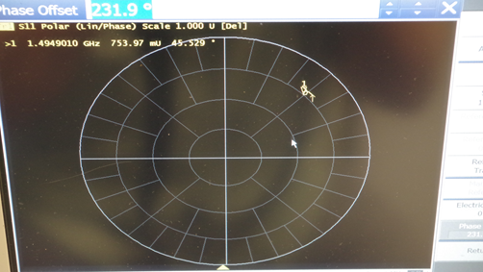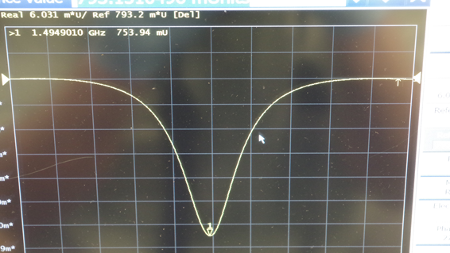

a)

b)

FIG. 8. VNA screenshots to check the coupling (a) and measure the reflection coefficient of the launching antenna (b).

1. Change the measurement to S21, Format: Log Mag. Set Mrk Search to Max, Tracking: On, set Width: On (default setting for marker widths is -3 dB), as shown in Fig. 9. Record the values of “QL” and “loss” displayed on the screen. The Qext can be calculated as:



$Qext= \frac{4β}{1+β}QL{∙10}^{{\left|loss\right|}/{10}}$

The measured quantities can be typed in the Qext calculation spreadsheet to automatically calculate the Qext. The Qext of the FPC needs to be set at 2.0E7 ± 15% (1.7E7 - 2.3E7). If the Qext is out of tolerance, tuning will be required.

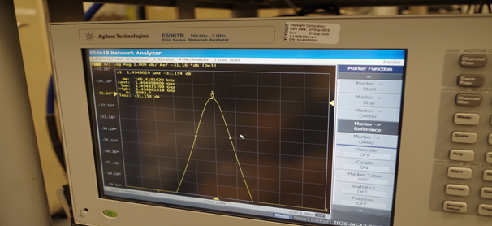

FIG. 9. VNA screenshot of the FPC insertion loss measurement.

1. Attenuation can be increased, causing the Qext to also increase, by squeezing the FPC body. Install the FPC tuning tools to the ribs on the FPC body. FPC body is to be plastically deformed by spreading the tuning tools with threaded rod installed through the top of the tool (see Fig. 10).

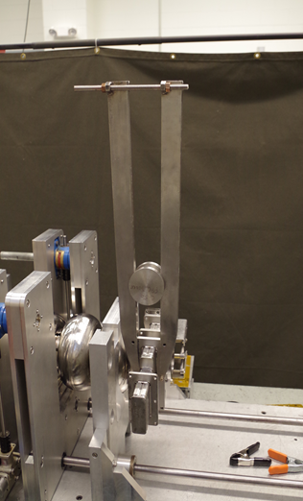

FIG. 10. FPC tuning fork.

1. Repeat step 10 to measure the Qext after tuning, until the value is within the specified range.

**Field Probe Qext calibration:**

In preparation to build a cavity-pair, the length of the field probe antenna has to be adjusted to result in a Qext of 8E11 ± 50% (4E11 – 1.6E12). The measurement method involves the same steps listed in the “FPC Qext measurement and tuning” Section, except that:

* instead of connecting Port 2 of the VNA to the tophat, it is connected to the field probe feedthrough on one of the HOM waveguides. For this measurement, it is not necessary to have the inner adapter of the waveguide with tophat assembly clamped to the beamline flange and FPC flange, respectively.
* The launching antenna is inserted on a feedthrough on the beamline blank on the FPC-side of the cavity.

**Qext calibration for input and pick-up antennae for single-cavity test:**

If the C75 cavity is going to be tested as a single cavity in the VTA, the forward power is coupled into the cavity through an input antenna on the beamline and a sample of the stored energy is transmitted through a pick-up antenna on the beamline on the opposite side of the cavity.

The measurement method involves the same steps listed in the “FPC Qext measurement and tuning” Section, except that the Port 2 of the VNA is connected to the feedthrough holding the antenna to be calibrated.

The input copper antenna is screwed onto a feedthrough mounted on a stainless steel beamline blank with a pump-out port. The beamline blank with the input antenna is clamped to the HOM side of the cavity and the launching antenna is on a beamline blank on the opposite side. The length of the antenna should be set to result in a QextInput = 5E9 – 8E9.

The pick-up copper antenna is screwed onto a feedthrough mounted on a niobium beamline blank, clamped to the FPC side of the cavity. It is important that the blank is made of Nb, otherwise the RF losses on the blank will be too high. The launching antenna is on a beamline blank on the opposite side. The length of the antenna should be set to result in a QextFP= 1E12 – 5E12.

All other ports (rectangular HOM and FPC ports) will be closed by niobium blank flanges, in preparation for a single-cavity test.

**HOM measurements:**

1. Follow the steps listed in the “Cavity Setup” and “No Touch Bead-Pull Setup” to prepare the cavity for measuring the frequency and field profile of the HOMs.
2. Clamp the waveguide adapter with tophat to the FPC flange and terminate the feedthrough onto a 50  load.
3. The metallic bead used to measure the field profile of the TM010 modes has to be replaced by a nylon spherical bead. Keeping the string tight, slide the metallic bead closer to the reel (you can let out more string while you hold the bead, then reel the string back in), the idea is for the metallic bead to end up on the reel so it doesn’t enter the cavity during HOM beadpulls. You can now use a squeeze clamp to hold the string tight. Cut the end of the string with the loop and add the nylon spherical bead (Fig. 11). Tie a new loop and slide the bead closer to the cavity to begin the HOM beadpulls.

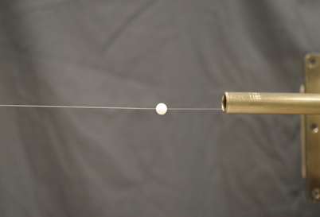

FIG. 11. Nylon spherical bead used for measurements of the HOMs field profile.

1. Record frequencies of all HOMs up to 2050 MHz (this is the HOM waveguide cutoff frequency) utilizing S21 transmission spectrum from beamline antenna to beamline antenna. This covers nominally 4 mode pairs. First frequency is around 1750 MHz. Modes have various polarizations. To best separate neighboring modes, rotate coupling antenna in beam tubes to improve transmission signal for mode under investigation.

NOTE: Leave the HOM waveguides “open ended” above 1900 MHz.

1. Store two S21 transmission spectra (in dB) in a single Excel spreadsheet (use max. number of points, IFBW=300 Hz) with beamline antennae either both in vertical or horizontal direction, respectively (two Excel worksheets, name: S21_H and S21_V).
2. In order to measure the modes you may have to try several different setups (Open FPC, Blanked FPC, Tophat on FPC). You may also have to rotate the temporary antennae on the beamline flange. When you find the peak, you will adjust the setup to split the peak to find both modes (Fig. 12). (This can be time consuming and frustrating). After you separate the two modes, center one and change span to zoom in, do a beadpull and record the data. Now open the span up and find the other mode (you may have to adjust the setup) and zoom in and do a beadpull and record the data.

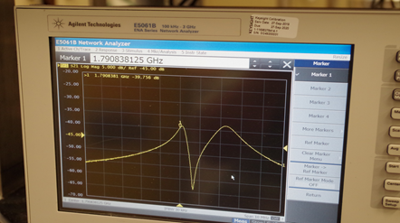

FIG. 12. VNA screenshot showing the two peaks from a dipole TE111 mode.

1. Some example's of set up for each mode are as follows looking at the cavity from FPC end:

1749.315 MHz: tophat with taper and load on FPC, antennae at 9 o’clock on beamline

1750.136 MHz: tophat with taper and load on FPC, antennae at 6 o’clock on beamline

1791.245 MHz: tophat with taper on FPC, antennae at 9 o’clock on beamline

1793.782 MHz: tophat with taper and load on FPC, antennae at 6 o’clock on beamline

1859.465 MHz: tophat with taper and load on FPC, antennae at 3 o’clock on beamline

1860.025 MHz: tophat with taper on FPC, antennae at 6 o’clock on beamline

1926.883 MHz: blanks on FPC and HOM ports, antennae at 9 o’clock

1928.283 MHz: tophat with taper and load, HOM ports blanked, antennae at 12 o’clock

1994.505 MHz: blank on FPC, antennae at 9 o’clock

1996.709 MHz: tophat and taper on FPC, HOM ports blanked, antennae at 6 o’clock

2036.098 MHz: tophat and taper on FPC, HOM ports blanked, antennae at 3 o’clock

2038.097 MHz: FPC and HOM ports open, antennae at 6 o’clock

1. Perform a beadpull measurement at each resonant HOM frequency. Save the raw data and result graph for each HOM to an Excel spreadsheet in new worksheet (name sheets: HOM_#, # is integer in sequence of increasing HOM frequency). Always use a pull direction from the HOM waveguide endgroup to the FPC waveguide endgroup.
2. When all beadpulls are done:

* clamp the string to the cavity flange and remove the nylon sphere, retie a loop on the end.
* Clean the Ti tube for “No Touch” beadpull setup and slide it through the alignment fixture on the tuning bench.
* Remove the plastic tips and slide the plastic wire through the Ti tube.
* Attach the beadpull string to the plastic wire with tape. Pull the wire and string through the Ti tube. Keeping the string tight remove the clamp holding the string from the cavity flange and slide the Ti tube through the cavity.
* When the Ti tube is passed the flange on the opposite side of the cavity, you can wind the string on the beadpull fixture. When the string is out, remove the Ti tube.

# **Revision History**

|  |  |  |
| --- | --- | --- |
| Rev # | Revision or update: | Effective: |
| Release | Initial Release | 4/16/2010 |

# **Approvals**

|  |  |  |
| --- | --- | --- |
| Approved by: | Signature: | Date: |
| **Document Owner** | R. Overton |  |
| **Reviewer** | G. Ciovati |  |
| Project Manager | K. Macha |  |