|  |  |  |  |
| --- | --- | --- | --- |
| **Renormalization to local atmospheric pressure when a cart is already attached, and monitoring the pressure of a closed volume** | | | |
| **Document Number:** | <QPR-xxx> | **Approval Date:** | Mmm DD, YYYY |
| **Revision Number:** | <1, 2, 3> | **Periodic Review Date:** | Mmm DD, YYYY |
| **Process Owner:** | Ari Palczewski | **Department Owner:** | SRF Ops |

# Purpose

The purpose of this document is to slowly return a closed volume such as a girder, cryomodule, or CEBAF LINAC section to absolute atmospheric pressure for disconnects. This procedure should be used whenever the pressure of a closed volume shifts because of local barometric pressure or temperature. This procedure can also be used in case when the closed volume changes for another reason and the pressure level is between 1Torr and ATM. This procedure only applies if a pressure monitoring slow pump/vent vacuum cart is already installed and monitoring the pressure of the closed volume.

This procedure supports the Quality Management System as described in the Quality Manual QML-001.

# Scope

This procedure applies to cryomodule, girder, or beamline section in CEBAF that requires particle free vacuum work. The procedure is laid out in a three step process; evaluate the pressure compared to absolute ATM, pressurized the close volume slightly above ATM is necessary, and slowly depressurize the volume through a filtered ATM bypass to the absolute barometric pressure.

This procedure does not apply to CM, Girder or closed volumes where the pressure is not known, or under vacuum.

# Terms and Definitions

The following terms have specific meanings within this procedure.

|  |  |
| --- | --- |
| **Term** | **Definition** |
| Verify use | If an instruction specifies to “verify” and the item is not true, stop and seek help unless instructed otherwise in the specific line. |
| Slow vent/pump cart | Particle free vacuum cart with automatic controls for controlling particle movement by keeping the gas flow below a certain rate. |
|  |  |

Equipment

1. Clean slow vent/pump cart previously attached under a cleanroom tent and attached to a closed volume. The pressure of the closed volume must be above 1 Torr (most likely with 10 Torr and 780) to use this procedure.
2. Pressure logging computer attached to cart, software running and display attached for operator feedback.  (remote desktop on a secondary computer is allowed).
3. 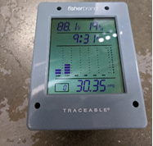Local barometric pressure read-back device, Fisherbrand™ Traceable™ Digital Barometer.

A list of general terms and definitions can be found in the Quality Manual QML-001.

# Roles and Responsibilities

The following roles have responsibilities described in this document.

|  |  |
| --- | --- |
| **Role** | **Responsibility** |
| Technician | Person performing the work outlined with this manual. |
|  |  |
|  |  |
|  |  |

# Procedure

Setup

1. Verify that the turbo cart isolation valve is open
2. Verify turbo pump has been off for 20 minute.

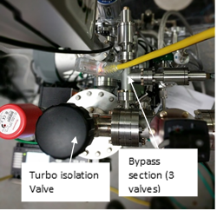

1. Verify all valves by the turbo isolation valve are closed (cart bypass section).
2. Verify the pressure tracking software is running and a local display is available for operator feedback.
3. Verify the pressure tracking software is running at 1 reading/second.
4. Verify the controller reads **closed** on the B1 readback (FC line).
5. Check to see if the girder or CM is above or below ATM by using the local ATM pressure mounting boxes (small gray box).  If within 2 Torr of the ATM reading - assume it is under ATM and raise the pressure 2 Torr above the barometric pressure.  The conversion from inHg is shown on the monitoring software.
6. If the box reads 30.01inhg (762.3Torr) the pressure in the closed volume must be above 764.3 Torr or greater.
7. Verify the N2 line is connected to the gas inlet for the mass slow controller.  If any of the items below are not true the cart is in an error state – see appendix A.
8. Verify the inlet isolation valve is open.
9. Verify the regulator is open to 10 PSI.
10. Verify the N2 line is connected and the isolation valve open on the house N2.

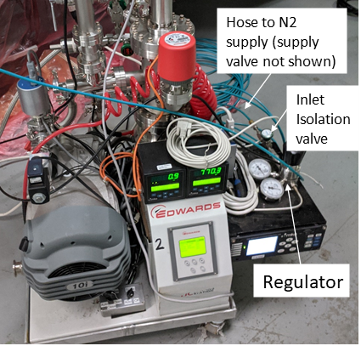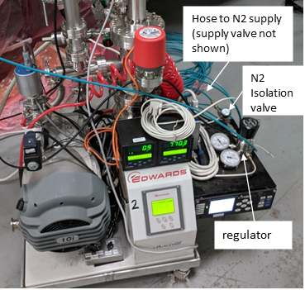

If the pressure of the isolated volume is below ATM use the mass flow controller to raise the pressure of the cart/girder/CM.

Depending on the size of the isolated volume the pressure change below can be rather quick.  If you do not understand how fast the pressure will rise seek help before performing the controller operation below.

1. On the 946 controller home screen.  Set to channel B1 using the up or down arrow on the home screen. The controller is now set to the mass flow controller.

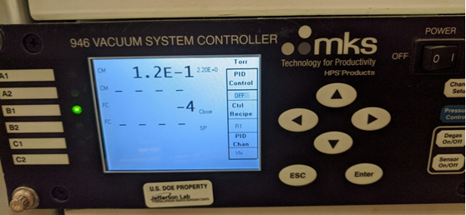

1. Press the **Setpoint** button and verify that the B1 FC line flashed SP/3.0e+2. (**NEVER**use the **Open** button)

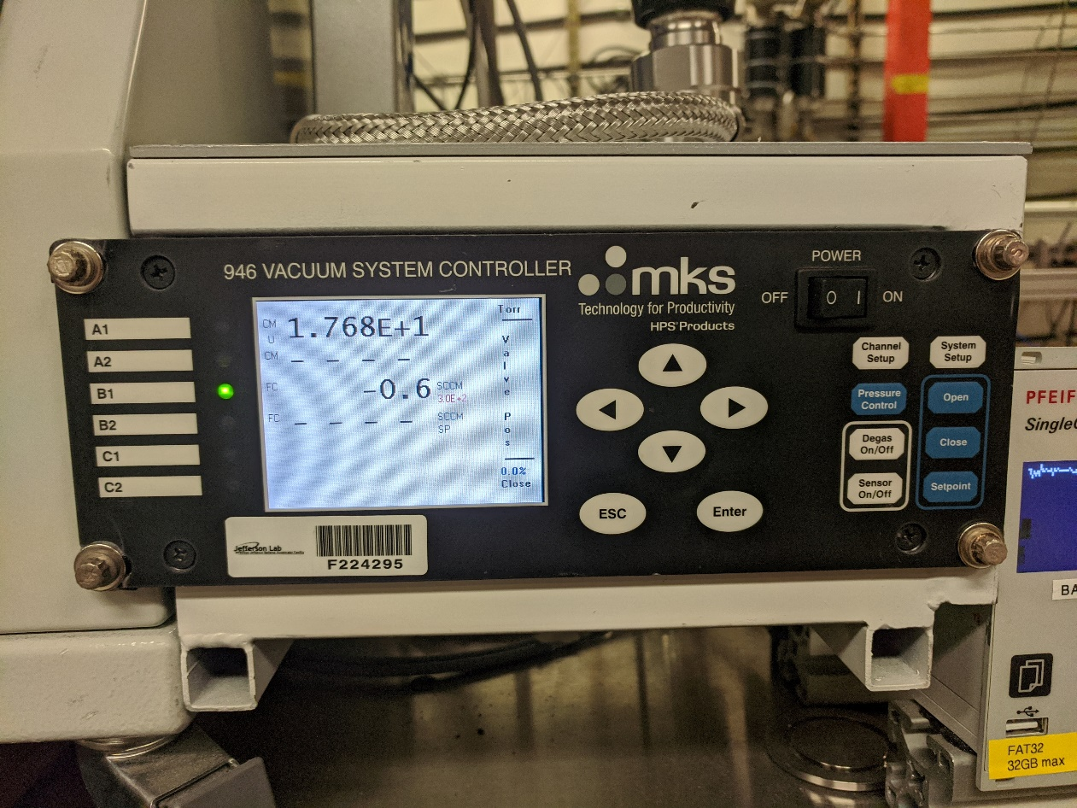

1. Press **enter** to return the cart/volume to at least 2 Torr above ATM**.**
2. Press **close**
3. Press **Enter**.
4. Wait 5 minute to verify the pressure is stable.

**Once the pressure is above ATM, either in the “as found” state or after using the section above.**

1. Open the ¼ turn isolation valve on the pressure normalization bypass.
2. Open the bypass regulating needle valve 1/8 turn and wait for the pressure to stop dropping faster than one of the rates below (volume dependent), wait a minimum of 2 minutes for each change below
3. For a large volume like the NL entire beamline (0.2 Torr/min)
4. For a single CM (2 Torr/min)
5. For a single girder (10 Torr/min)
6. Open the regulating valve 1/8 turn and wait
7. Open the regulating valve 1/4 turn and wait
8. Open the regulating valve 1/4 turn and wait
9. Open the regulating valve 1/4 turn and wait
10. Open the regulating valve 1/4 turn and wait
11. Open the regulating valve 1 turn and wait
12. Open the regulating valve 100%
13. Verify the needle and ¼ turn valves on the ATM bypass is 100% **OPEN**.
14. Make an elog entry that the bypass at the location and the closed volume is now at ATM.

**Appendix A**

If the N2 gas line is not installed and all N2 manual valves open, this section will walk you through the steps to install the line and minimize accidental flow past the mass flow controller.

For all operation below, data logging is required and for every valve move, a technician monitoring the mass flow readout is required (B1 FC line on the 946 controller).  If at any time, the mass flow goes above 50 sccm or the mass flow shows anything above 5 sccm for more than 5 seconds, stop and seek help.

This operation must be competed within 10 minutes.

1. If the cart is connected to any volume such as a girder/CM or LINAC section, isolate the cart from the volume and record the time and pressure. Because of the small volume of the cart, the pressure will change up to 0.3 Torr during the valve closure.

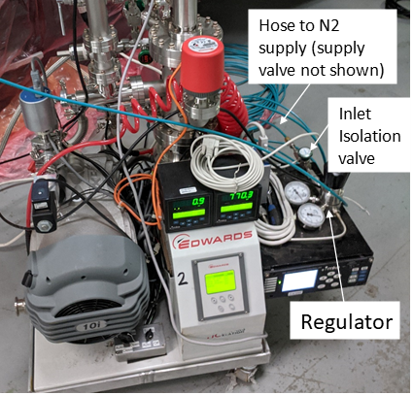

1. Verify that the N2 line is closed on the N2 supply.
2. Verify that the isolation valve at the controller inlet is closed.
3. Verify that the regulator is closed and that the pressure reads zero.
4. Verify the N2 line is connected to the isolation cart’s N2 nitrogen inlet
5. If the line is not connected, purge the line with low flow for a minimum of 30 seconds and continue the flow while connecting to the N2 inlet.
6. Turn on the N2 supply, if not on, from the connection.
7. Open the isolation valve slowly and monitor that the pressure does not go up in the regulator.
8. Open the regulator slowly until the pressure is 10 psi.
9. Verify that the cart pressure did not change from the logged pressure in step 1
10. Verify that the mass flow reads zero or negative at the B1 read-back.
11. The cart is now ready for use.
12. Open the volume isolation valve and verify the pressure return to the logged beginning pressure.

Process Workflow

Increase pressure in closed volume

Isolated closed system with pressure monitoring

Perform pre-checks and status of the system

Verify stability of the system

Pressure above ATM

See Appendix A

Enter eLog the system is ready. Maintain data logging

Identify if the pressure of the volume is above or below absolute barometric pressure

NO

Yes

Pressurize closed volume using mass flow controller

No

Yes

Preform pressure reduction though needle valve assembly

Check N2 line section is ready for slow flow pressurization

# References

|  |  |
| --- | --- |
| **Document No.** | **Title** |
| QML-001 | SRF Ops Quality Manual |
| <QPR-###> | <Document Title> |
|  |  |

# Release and Revision History

|  |  |  |
| --- | --- | --- |
| **Rev #** | **Major Changes** | **Approval Date:** |
| 1 | Initial version | Mmm DD, YYYY |
| 2 | <brief description of major changes> | Mmm DD, YYYY |
|  |  |  |
|  |  |  |

# Approvals

|  |  |  |  |
| --- | --- | --- | --- |
| **Approved by:** | **Name:** | **Signature:** | **Date:** |
| Process Owner | Ari Palczewski | DocuShare E-sign | Mmm DD, YYYY |
| Quality Engineer | Jacob Harris | DocuShare E-sign | Mmm DD, YYYY |
| Department Head | Tony Reilly | DocuShare E-sign | Mmm DD, YYYY |