|  |  |  |  |
| --- | --- | --- | --- |
| **SRF Vacuum Monitoring Software Setup and Operation** | | | |
| **Document Number:** | <QPR-ID10t> | **Approval Date:** | Mmm DD, YYYY |
| **Revision Number:** | 1 | **Periodic Review Date:** | Mmm DD, YYYY |
| **Process Owner:** | Natalie Brock | **Department Owner:** | SRF Ops |

# Purpose

The purpose of this document is to outline the setup and use of vacuum monitoring software commonly utilized in SRF operations.

This procedure supports the Quality Management System as described in the Quality Manual QML-001.

# Scope

This procedure applies to Labview software used to record vacuum data from a variety of controllers.

# Terms and Definitions

None

A list of general terms and definitions can be found in the Quality Manual QML-001.

# Roles and Responsibilities

The following roles have responsibilities described in this document.

|  |  |
| --- | --- |
| **Role** | **Responsibility** |
| Technician | Perform hardware connection and software setup. Run software and verify operation. |

# Procedure

**Setup and Operation**

## Hardware Setup

* 1. Connect a straight through 9 pin serial cable from the Communications port on the back of the PDR900 controller to a 9 pin serial-to-usb adapter.
  2. Open the Device Manager on the data logging pc (right click on the Windows logo and select Device Manager).
  3. Plug the serial-to-usb adapter into any available usb port on the pc and watch the Device Manager window as the adapter is recognized and assigned a COM port Number.
  4. Record the COM port number and associated controller. Technicians not familiar with windows operating environment COM port assigning may require extra training at this step.
  5. 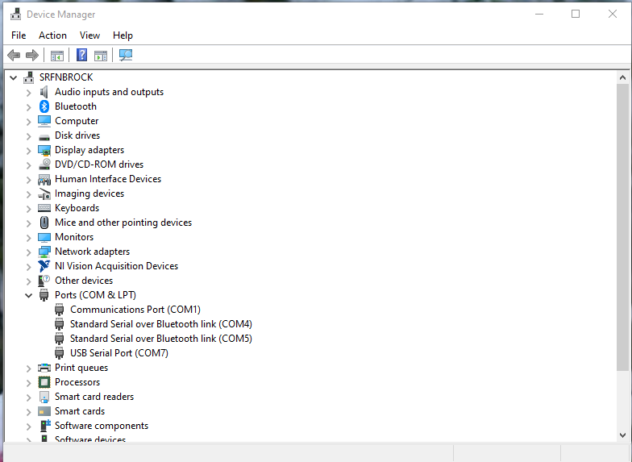Repeat steps 5.1.a through 5.1.d for each addition controller.
  6. 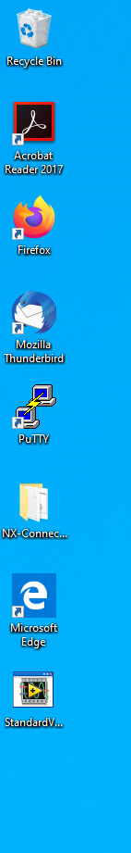Open StandardVacuumCart.exe and select the Setup Parameters tab. (the icon is located on the desktop.
  7. Using the dropdown menus, select the appropriate COM port for each of the controllers being used. (these were recorded in steps 5.1.a to 5.1.d )
  8. Make sure the controllers being used are switched on, and any other controllers listed on the Setup Parameters tab are switched off.

## Software setup

1. In the Setup Parameters tab, set the File Name Prefix to match the zone, cavity, string etc. being monitored
2. Make sure the Data Directory Path is set to C:\LabView Data\.
3. Set the Wait Between Samples time. The default value is 1 second. This wait time can be changed while the software is running but for general operation should be left at 1sec.

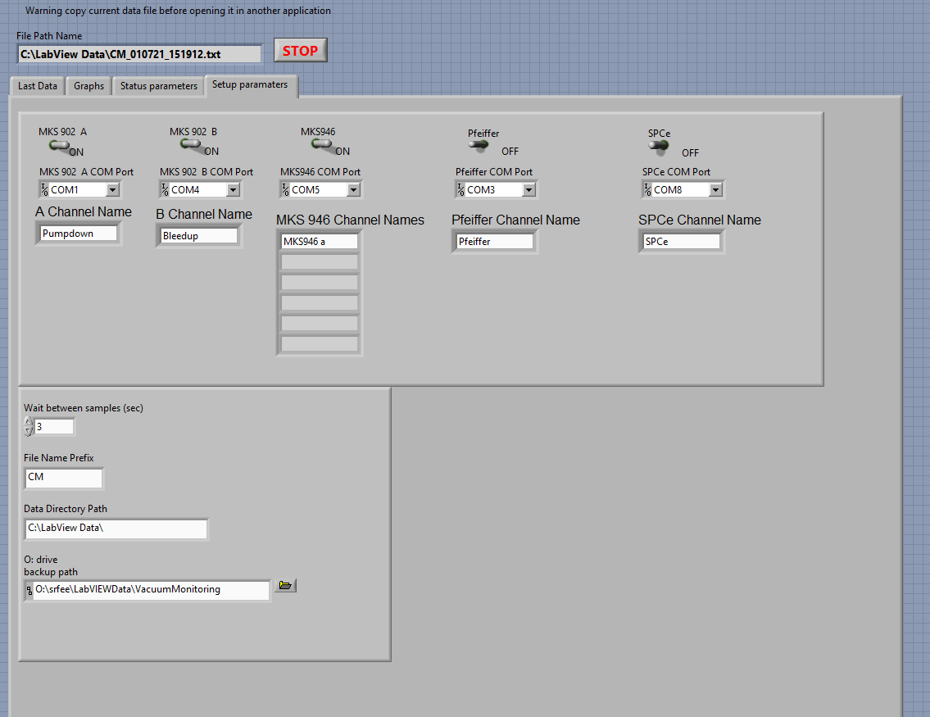

## Software Operation

#### Click the white arrow to run the program.

1. Select the Last Data tab to view the pressure reading(s).
2. Verify that the file name at the top of the screen is correct.
3. Open Windows Explorer and navigate to C:\LabView Data.
4. Verify that a log file matching the file name has been created. If you need to read the file while the vacuum monitor is running, create a copy of the log file and open the copy.

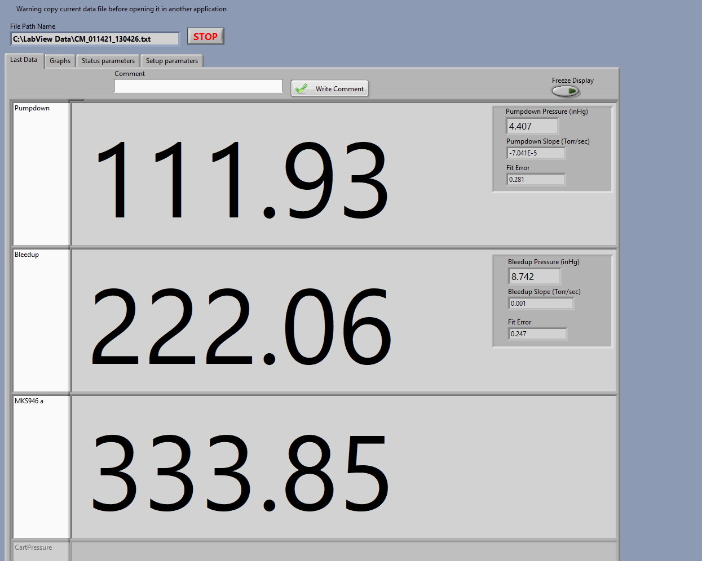

# Process Workflow

Vacuum Cart and PC running, not connected

Record the COM number assigned to the controller

Select controller Com port

Setup file parameters

Add another controller?

Switch controller to ON

Vacuum data is being logged

Connect the controller on the vacuum cart to the pc with a serial to usb cable

YES

NO

Open StandardVacuumCart.exe

Add another controller?

YES

NO

Run the software

Verify log file

# References

|  |  |
| --- | --- |
| **Document No.** | **Title** |
| QML-001 | SRF Ops Quality Manual |

# Release and Revision History

|  |  |  |
| --- | --- | --- |
| **Rev #** | **Major Changes** | **Approval Date:** |
| 1 | Initial version | Mmm DD, YYYY |

# Approvals

|  |  |  |  |
| --- | --- | --- | --- |
| **Approved by:** | **Name:** | **Signature:** | **Date:** |
| Process Owner | Natalie Brock | DocuShare E-sign | Mmm DD, YYYY |
| Engineer | Ari Palczewski | DocuShare E-sign | Mmm DD, YYYY |
| Group lead | Mike Drury | DocuShare E-sign | Mmm DD, YYYY |
| Group lead | Anthony DiPette | DocuShare E-sign | Mmm DD, YYYY |
| Department Head | Tony Reilly | DocuShare E-sign | Mmm DD, YYYY |