BPM Chamber Cleaning Procedure
Document Number: | CP-STP-CAV-CHEM-BPM | Approval Date: | 10-SEP-2020
Revision Number: | Initial Release | Periodic Review Date: | 10-SEP-2022
Document Owner: | Anne-Marie Valente-Feliciano

Purpose and Scope

This procedure covers the cleaning of a BPM chamber.
The tasks take place in the SRF Production Chemistry Room.
Parts will be received from SRF personnel after particulate sampling and disassembly from a girder, in the SRF main cleanroom.

STP- Standard Traveler/Procedure:
This Standard Procedure is intended to be generalized such that it could apply to most cavity types at JLab. The PI/PM is encouraged to provide project specific instructions to supplement this procedure, which are to be attached to the applicable Traveler.
If at any time the project specific instructions change or modify the content of this procedure, then a new procedure will be required, to be approved through the normal processes at SRF and JLab.

SAFETY:
Individuals must keep safety as the first priority in the process; before beginning any job, the user must assure they have the correct PPE for the individual job. Maintaining the level of safety and secure nature of the work area is paramount. Assure personal safety by using caution in movement and taking necessary steps to avoid unnecessary personnel in the immediate area.
Refer to the work-center OSP for specifics.

References

Chemistry Cleaning Procedures
Alconox User’s Manual - User’s manual for Alconox detergents
SRF-19-83800-OSP - OSP for Safe Operations in the Production Chemistry Room
BPM Cavity Acceptance Test (EES-PR-02-002/ Pete Francis).

Terms and Definitions

- DI/UPW: Deionized (DI) and Ultra-Pure Water (UPW) are used interchangeably in this procedure and may be referred to as simply water.
- N₂ / Nitrogen: filtered nitrogen.
- PI/PM/SOTR: Principal Investigator, Project Manager, Subcontracting Officer Technical Representative. Someone otherwise in charge of the project or item in question. A supervisor may also be referred to if needed.

- Items used in this procedure:
Detergents/Solvents: | Wipers:
Liquinox, Clean Room Quality Isopropyl (Isopropanol) | TX1009B Alpha Wipes, TX2009 Beta Wipes

Process Details

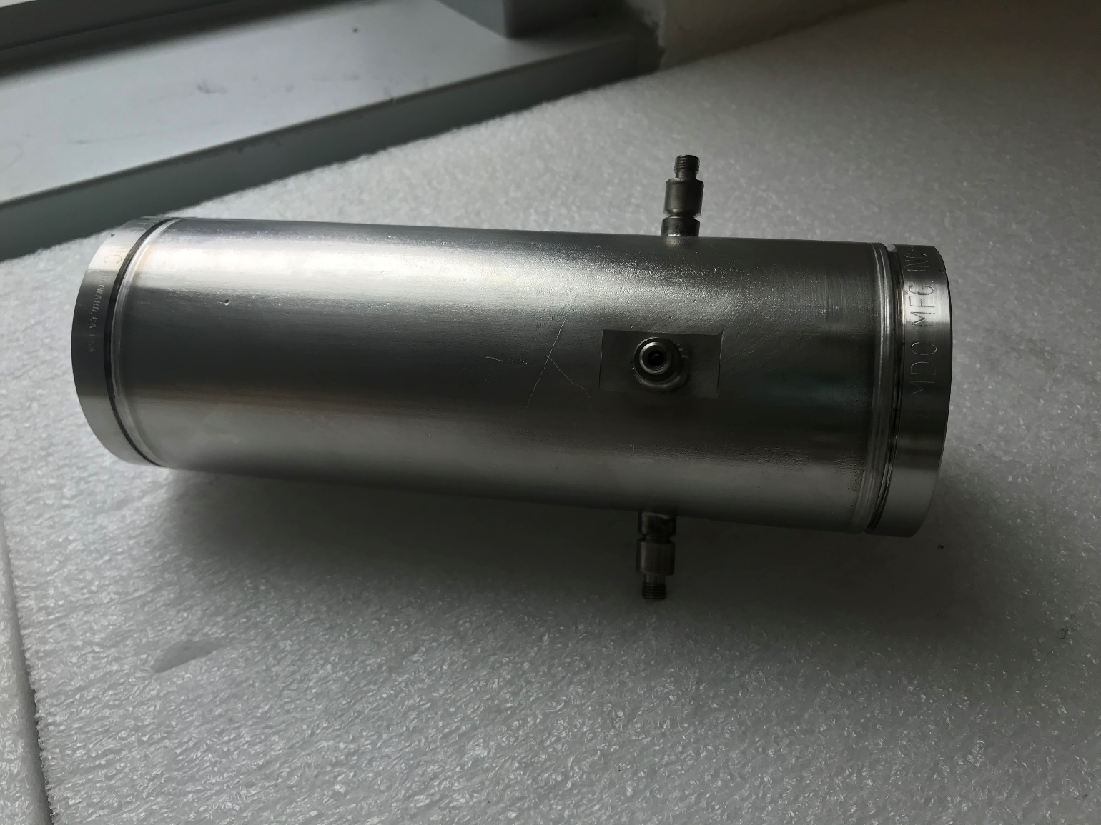

Figure 1: BPM

Prior to Cleaning
- Ensure the workspace is clean and tidy.
- Don appropriate PPE.
- Gloves should be worn whenever handling items and changed after cleaning and as needed to maintain cleanliness. Inspect item(s) for damage (dents, scratches, dings, etc).
  - If an item has pre-existing impairment, notify the PI/PM or a supervisor.
  - Do not proceed until written acknowledgement of previous damage presence has been received.
- Use only pre-approved detergents and solvents.
- The item(s) must be completely submerged for proper ultrasonic cleaning action. Ensure there are no trapped air pockets under or within the item in the USC. This will require rocking the BPM in the vertical orientation after is fully submerged.
- Verify the availability 4 new and cleaned SMA covers.

BPM Chamber Cleaning
- Don new gloves.
- Before cleaning the BPM chamber, ensure that color code is engraved next to the feedthrough.
  - R=Red=Y+
  - G=Green=X+
  - Y=Yellow=Y-
  - B=Blue=X-
- Pre-clean each blind whole with 10% Liquinox solution and Q-tip or stainless steel wire brush to visually clean. This may require multiple passes to remove the old embedded silver plating.
- Rise each hole and body to remove detergent for final inspection.
- Ultrasonically clean the BPM chamber with 1% Liquinox in DI water in the ultrasonic bath at 50°C (120°F) for 15 minutes in the vertical position.
  - Flip the chamber under water halfway though the cleaning to remove particles from the blind holes.
  - DO NOT USE Micro-90 as it can oxidize the feedthroughs.
- Thoroughly triple rinse with DI water, rinsing station is preferred.
- Perform a final rinse with cleanroom ultra-pure isopropyl from a spray bottle.
- Dry with filtered nitrogen using the low flow nitrogen inside the chemistry room hoods or 50% reduced flow (~30°) filtered nitrogen by the particle counter (verify flow reduction by spraying glove during the pressure turndown).
  - DO NOT USE the high flow nitrogen at the water station or particle counter.
  - Only spray nitrogen in the direction of the antennas, never towards the tips. See Figure 2.
  - The nitrogen gun may never be closer than 6 inches from the opening of the BMP, or the tips may be damaged from the high velocity spray.
- Allow 1 hour final drying in the hood, or dry in the nitrogen oven as an alternate method to nitrogen spraying and hood drying.
  - Nitrogen oven is typically set for 10 hours at 100°C.
  - See CP-STP-CAV-CHEM-BAKE for procedure on using the nitrogen drying oven.
- Contact the personnel identified to perform the BPMs check. – see section 4.3
- Transfer to the ISO-5 Path-through – see section 4.4.
Figure 2: BPM internal images
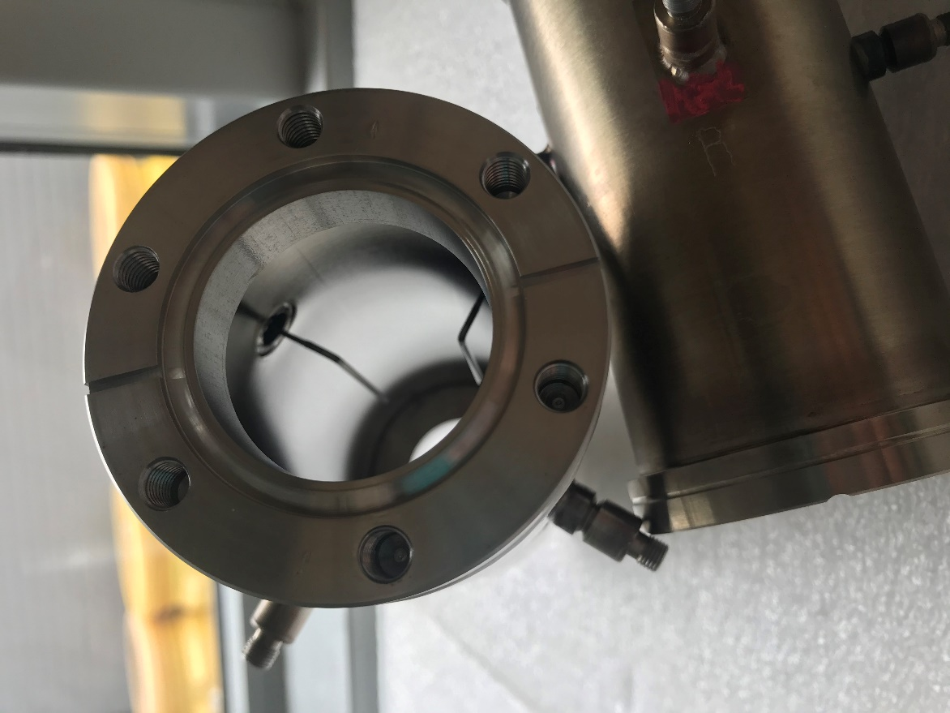 | Nitrogen spray should be used from this direction so as not to damage the internal antennas.
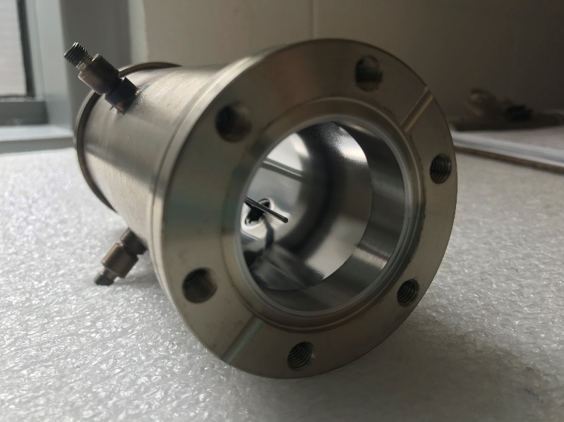 | Nitrogen spray should NOT be used on this side of the BPM as it may cause damage to the internal antennas.

BPMs check
This task needs to be performed by the personnel identified by the project. It refers to the initial check test performed in the tunnel or in the cleanroom before the girder disassembly.

- Check the BPMs with the network analyzer following “BPM antennas following the BPM Cavity Acceptance Test” (EES-PR-02-002).
- At no time will the BPM be touched other than the small SMA connector during the procedure to maintain cleanliness.
- Use only pre-cleaned cables used for this procedure that are stored in the chemistry room.
- Don new gloves.
- Connect the cables to the BPM first and then the network analyzer.
- If there is no change compare to the measurement performed before girder disassembly, proceed to the next step.
- If there is a change and the BPMs are outside specifications (ie if the difference between Y+ and Y- or X+ and X- is more than 0.25dB), call Pete Francis (x7528). The BPMs have to be reset.
- Don a new set of clean gloves.
- Remove cable from BPM.
- Remove the pre-cleaned SMS cap from the supplied clean bag.
- Install the connector on each feedthrough.
- Return the BPM to clean area for entry into the cleanroom.

Transfer to Clean Room
- Turn down the nitrogen gun to 50% flow, ~30 degrees on the nitrogen isolation valve. Verify flow reduction by spraying glove during the pressure turndown.
- Blow off the chamber with filtered N₂ and verify no more than 1µm count in 10 seconds is present over any location on the part.
  - Only spray nitrogen in the direction of the antennas, never towards the tips.
  - The nitrogen gun may never be closer than 6 inches from the opening of the BMP, or the tips may be damaged from the high velocity spray.
- Bag the BPM Chamber.
- Don cleanroom hair net, face mask, overcoat, and then new gloves.
- Transfer the item to the ISO-5 pass-through for assembly.

Revision History

Rev # | Revision or update: | Effective:
Release | Initial Release | 9/10/20

Approvals

Approved by: | Signature: | Date:
Document Owner
SRF Operations Department Head
SRF R&D Department Head

