Traveler Title | LCLS-II-HE FPC Waveguide Kit Inspection Traveler
Traveler Abstract | This traveler covers the inspection of FPC waveguide kits at WS5. The inspections are conducted while parts are removed from kits during installation
Traveler ID | L2HE-INSP-FPCWG
Traveler Revision | R1
Traveler Author | huque
Traveler Date | 27-Jan-21
NCR Informative Emails | kwilson
NCR Dispositioners | Huque, fischer, stribet
D3 Emails | Huque, fischer
Approval Names | Naeem Huque | Mircea Stirbet | John Fischer | Katherine Wilson
Approval Signatures
Approval Dates
Approval Title | Author | Reviewer | Reviewer | Project Manager

References | List and Hyperlink all documents related to this traveler. This includes, but is not limited to: safety (THAs, SOPs, etc), drawings, procedures, and facility related documents.
SA-375-600-90-SOW | PF-375-600-92 | PF-375-600-93 | PF-375-602-38 | PF-490-703-62
PF-375-602-44 | PF-375-602-45 | PF-490-703-61 | SA-375-600-90 | SA-375-602-49
PF-375-600-92_CMM | PF-375-600-93_CMM | PF-375-602-38_CMM | PF-375-602-45_CMM | PF-490-703-61_CMM
PF-490-703-62_CMM | SA-375-600-90_CMM

Revision Note
R1 | Initial release of this Traveler.

Step No. | Instructions | Data Input
1 | Waveguide Kit Serial Number  Cryomodule on which the kit will be installed | [[FPCWGSN]] <<FPCWGSN>>  [[CMSN]] <<CMSN>>
2 | Is CMM inspection done on this kit?  CMM Tech  CMM Date  Measure dimensions marked in the following files. Upload report for each part separately. Write NCRs for each part separately.  PF-375-600-92_CMM  PF-375-600-93_CMM  PF-375-602-38_CMM  PF-375-602-45_CMM  PF-490-703-61_CMM  PF-490-703-62_CMM  SA-375-600-90_CMM | [[CMMYesNo]] <<YESNO>>  [[CMMTechName]] <<SRF>>  [[CMMDate]] << TIMESTAMP >>  [[92CMMFile]] <<FILEUPLOAD>>  [[92CMMComment]] <<COMMENT>>  [[93CMMFile]] <<FILEUPLOAD>>  [[93CMMComment]] <<COMMENT>>  [[38CMMFile]] <<FILEUPLOAD>>  [[38CMMComment]] <<COMMENT>>  [[45CMMFile]] <<FILEUPLOAD>>  [[45CMMComment]] <<COMMENT>>  [[61CMMFile]] <<FILEUPLOAD>>  [[61CMMComment]] <<COMMENT>>  [[62CMMFile]] <<FILEUPLOAD>>  [[62CMMComment]] <<COMMENT>>  [[90CMMFile]] <<FILEUPLOAD>>  [[90CMMComment]] <<COMMENT>>
3 | Technician Name  Inspection Time  Are all components in the table below present in the kit box?  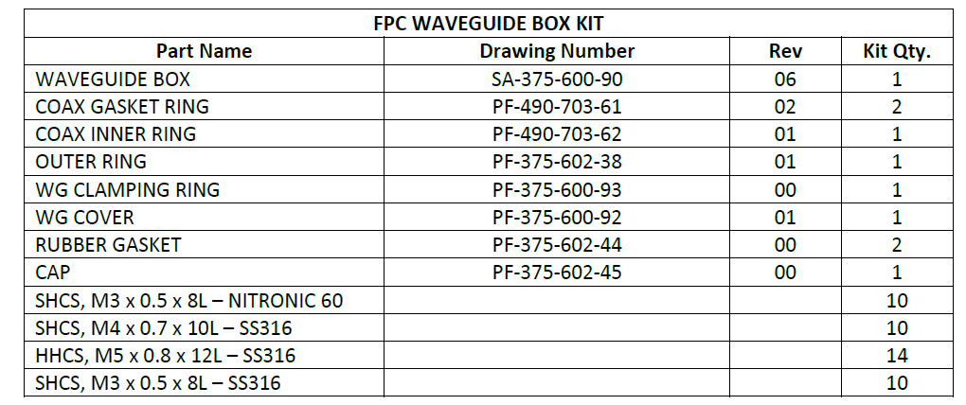  If parts are missing, note in an NCR and replace the kit box. | [[TechName]] <<SRF>>  [[InspTime]] <<TIMESTAMP>>  [[BOMCheck]] <<YESNO>>  [[BOMComment]] <<COMMENT>>
4 | Check for signs of damage on any components. If found, write an NCR and upload photos | [[DamageCheck]] <<YESNO>>  [[DamageComment]] <<COMMENT>>  [[DamagePhoto]] <<FILEUPLOAD>>
5 | Check for scratches on all sealing surfaces and (in particular) the RF contact areas on the waveguides (see red arrows below). If found, write an NCR and upload photos for scratches, gouges deeper that 1/16” should be reported in an NCR.  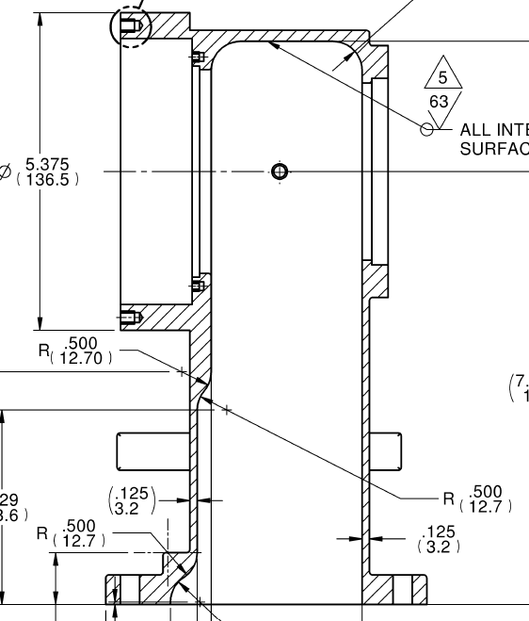 | [[ContCheck]] <<YESNO>>  [[ContComment]] <<COMMENT>>  [[ContPhoto]] <<FILEUPLOAD>>
6 | Check the coating on the waveguide box (SA-375-600-90) for any large scratches or regions of missing coating; upload images if found. Write NCRs for any scratches/gouges over 1.0” in length (with substrate visible) or regions of no coating greater than 0.25” in diameter. | [[CoatCheck]] <<YESNO>>  [[CoatComment]] <<COMMENT>>  [[CoatPhoto]] <<FILEUPLOAD>>

