|  |  |  |  |
| --- | --- | --- | --- |
| Quench Detection with OST | | | |
| **Document Number:** | CP-STP-CAV-VTRF-OST | **Approval Date:** | 22- Feb-2018 |
| **Revision Number:** | - | **Periodic Review Date:** | 18-Feb-2022 |
| **Document Owner:** | G. Ciovati |  |  |

## 

# Purpose and Scope

This procedure describes the installation of OST sensors, the data acquisition and the triangulation used to detect the quench location during a cryogenic RF cavity test in the VTA

# References

[OST for quench detection_LINAC'08](http://accelconf.web.cern.ch/LINAC08/papers/thp036.pdf#search=%20domain%3Daccelconf%2Eweb%2Ecern%2Ech%20%20%2Btitle%3A%22oscillating%22%20%20%2Bauthor%3A%22conway%22%20%20FileExtension%3Dpdf%20%2Durl%3Aabstract%20%2Durl%3Aaccelconf%2Fjacow)

[Oscilloscope TDS2024B User Manual](https://jlabdoc.jlab.org/docushare/dsweb/Get/Document-218807/TDS2024B%20User%20Manual.pdf)

# Terms and Definitions

1. **OST** – Oscillating Superleak Transducer.
2. **VSA** – Vertical Support Area.
3. **VTA** – Vertical Test Area

# Process Details

1. **Prerequisites**

The person doing the data acquisition with the OST sensors must be a qualified VTA RF Operator and should have a basic knowledge about using a digital oscilloscope.

1. **OST sensors installation**

The OST sensors and the readout electronic box are located on a shelf between the VSA and the VTA dewar area. There are two 8-channel readout boxes, one that requires two 9 V batteries to operate and one that can be plugged into a 120 V AC outlet. A minimum of 3 OST sensors is required to detect a quench in a single-cell cavity. A minimum of 5 sensors is recommended to detect a quench in a multi-cell cavity.

A preliminary check of the operability of an OST sensor can be done by connecting the sensor to one of the INPUT channels of the readout box and looking for a movement of the membrane when the readout box is switched ON.

* 1. The OST sensors should be mounted on the Ti cage that holds the cavity in a test stand and they should be distributed over the cavity length and around the cavity to allow for a second sound wave originating from a quench spot anywhere on the cavity surface to be detected by more than one OST sensor. Figures 1 and 2 shows OST sensors mounted on the cage with a C75 5-cell cavity in it.
  2. Connect an SMA cable to each OST sensor.

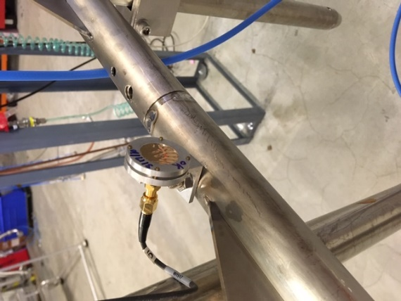

**Figure 1**. OST sensor mounted on the cavity cage.

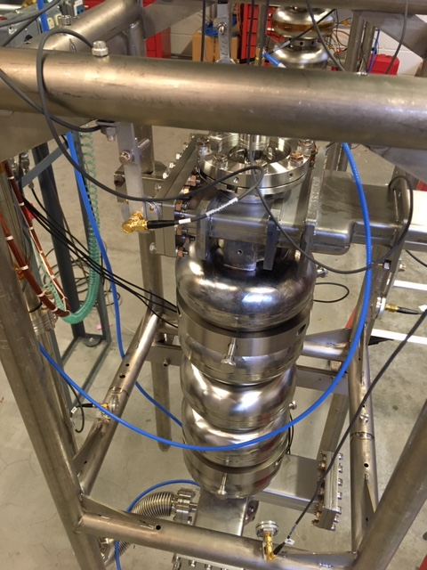

**Figure 2**. Four OST sensors mounted on the cage with a C75 5-cell cavity on the vertical test stand. Two additional sensors are on the back side and not visible in the picture.

1. **Data acquisition**
   1. Set the readout box on the dewar top plate and connect the cables from the SMA feedthrough on the top plate (Fig. 3) to the INPUT BNCs of the readout box. Connect the OUTPUT BNCs to one end of cables that go underneath the dewar shield and the other end of those cables to the channels of two Tektronix oscilloscopes (Figs. 3 and 4). Be careful and consistent with following the cables’ labels. Output 1 on the readout box amplifies the signal coming from Input 1 and so forth.

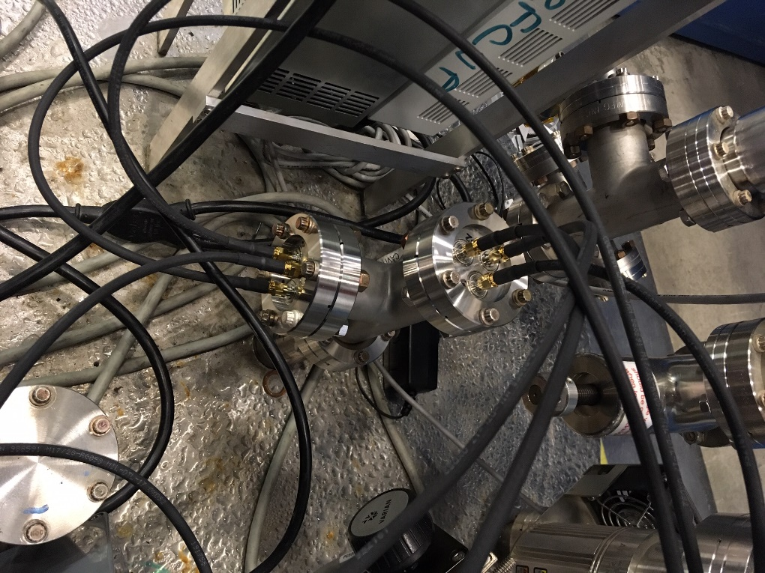

**Figure 3**. Six SMA feedthroughs on two 2.75” Conflat flange on the top plate, connecting the OST cables inside the dewar to cables connected to the INPUT of the readout box.

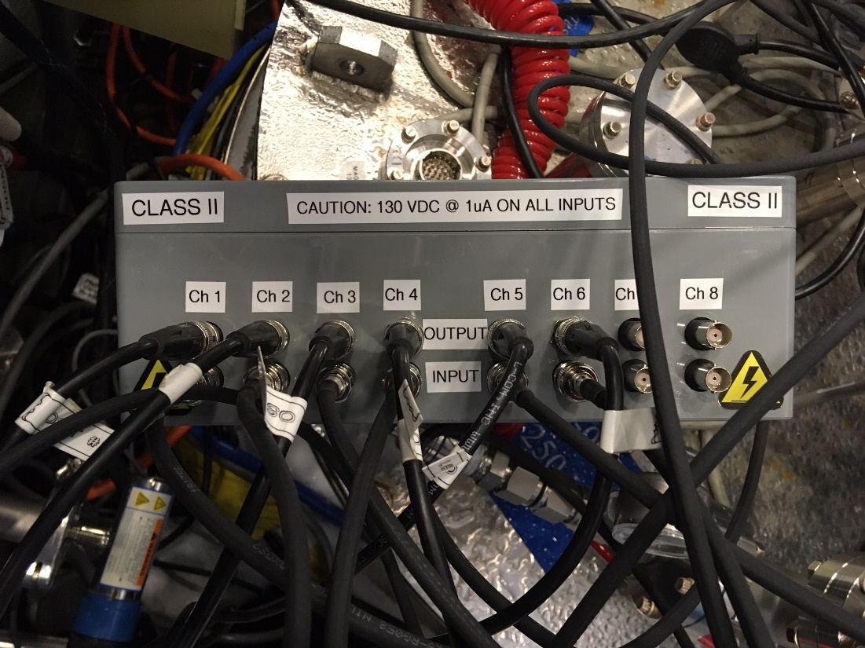

**Figure 4**. Plug-in readout box with 6 OST signals connected to the INPUTs. The OUTPUTs are connected to two digital oscilloscopes.

* 1. If using the battery-powered readout box, open the case and insert two 9 V batteries. Switch the readout box ON (there is a switch on the side for the plug-in readout box, as shown in Fig. 5. There is a switch on the front for the battery-powered readout box).

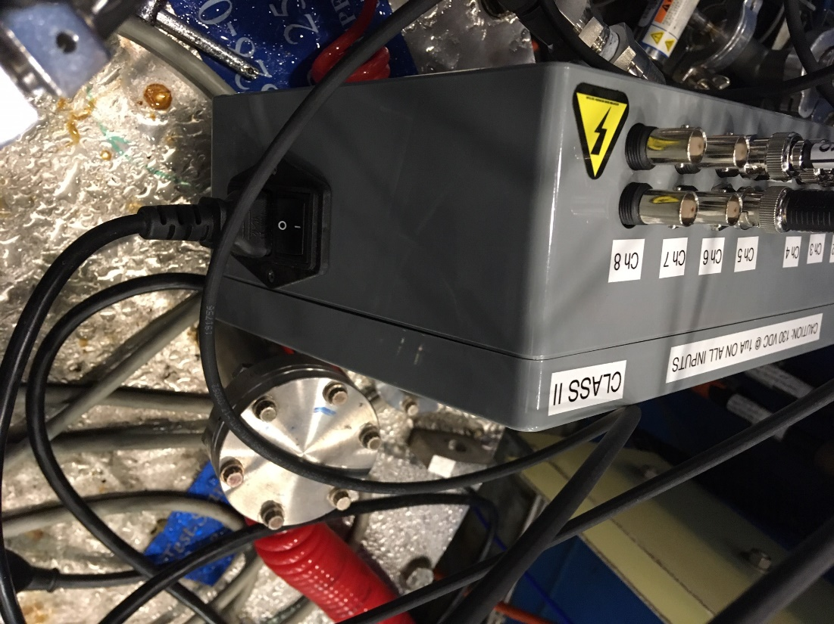

**Figure 5.** ON/OFF switch on the side of the plug-in readout box.

* 1. A signal corresponding to the transmitted power from the cavity, Pt, must connected to one channel of each oscilloscope, as it provides the trigger signal to acquire the data when Pt drops to zero while quenching. There is currently no dedicated cable installed between the low-level RF systems in the VTA control room and patch panels at each of the dewars for this purpose. Some thinking is required to bring the Pt signal to the cart with the oscilloscopes, located in the dewar area.

As an example, Figs. 6 and 7 show the routing of the Pt signal from the oscilloscope of Production 1 RF System to a patch panel in the amplifier rack in the VTA area and then to one of the channels of two oscilloscopes next to the dewar, used for measuring the OSTs signals (Fig. 7). As an alternative, one could connect a 3 dB splitter to the “Probe” feedthrough on the dewar top plate and send half of the cavity probe RF signal rectified by a crystal detector and a 50  load to one of the channels of the OST oscilloscopes.

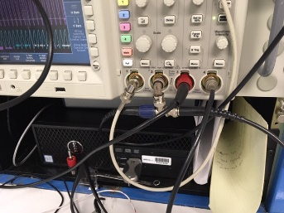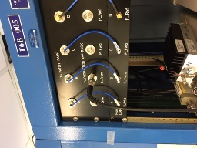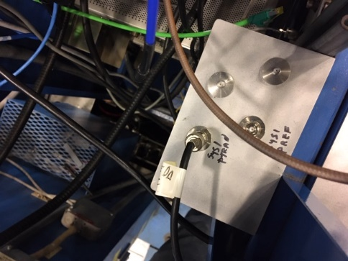

Pt signal

Pt signal

Pt signal from control room

Pt signal to oscilloscopes with OST signals

a)

b)

c)

**Figure 6**. a) Pt signal going from the LL RF chassis of Production System 1 to “P_Trans” port on patch panel “to PRODUCTION AMP RACK” of Production System 1 (b), which brings the signal to the port marked “SYS 1 PTRAN” on a patch panel in the amplifier rack (c). A cable from this port brings the signal to one of the channels of the oscilloscopes used to detect the OST signals.

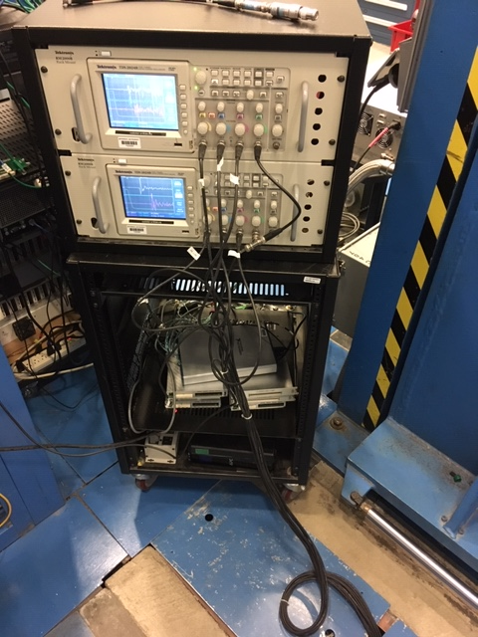

6 cables from OUTPUT of readout box under the dewar lid

**Figure 7**. Cart with two digital oscilloscopes: the signals from the OUTPUT of the OST readout box are connected to channels 1 to 3 of each oscilloscope through cables going in the trench under the dewar shield. The Pt signal coming from the control room is connected to both Ch. 4 of the oscilloscopes.

* 1. Quench detection with OSTs shall be done at a temperature of **1.8 K** (12.5 Torr) as the speed of the second sound wave is fairly constant at this temperature. Increase the RF field in the cavity until repetitive quenching is achieved, as shown by the Pt signal on the oscilloscope associated with the low-level RF system in the control room.
  2. The trigger of the OSTs oscilloscopes should be set to be the falling edge of the channel to which the Pt signal is connected to. Set the signal acquisition to “single measurement” and adjust the time (x) and y-scales of the channels to maximize the resolution. Select to acquire 16 averages.

The signals should look similar to the ones shown in Fig. 8, in which Ch. 4 is Pt, and Ch. 1 to 3 is from the OST readout box. The time when the large spike in the OST signal is observed is the time of arrival of the second sound wave originated from the quench spot.

Refer to the TDS2024B User Manual for details about triggering and data acquisition.

Save each waveform as .CSV data file on a USB memory stick plugged in each oscilloscope. Refer to the TDS2024B User Manual for details saving data from the oscilloscope.

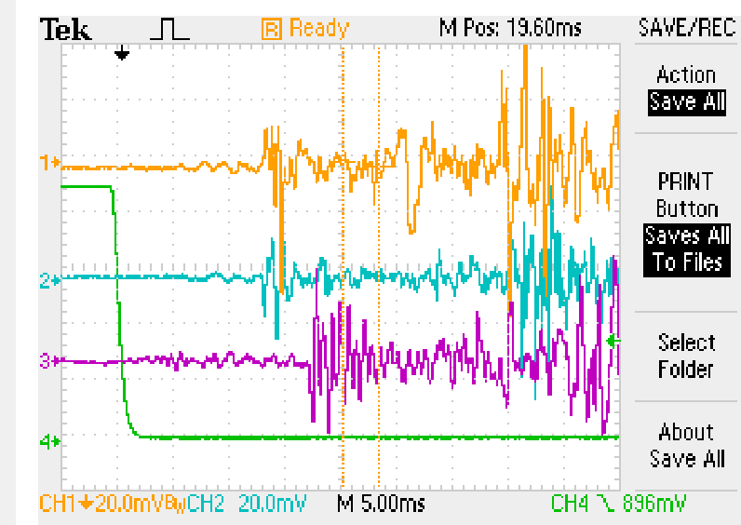

tCh1

**Figure 8**. Typical signals from one of the OSTs oscilloscopes: channels 1-3 are from the OSTs, Ch. 4 is the Pt signal. Also shown is the travel time of the second sound to the OST connected to Ch. 1.

* 1. Import the .CSV data files and plot Pt and each of the OST signals. For each OST signal, determine the time between the onset of quench (start of drop in Pt signal) and the arrival of the second sound wave signal to the OST (start of “spikes” in OST signal, which may be a negative or positive excursion). With reference to Fig. 8, this time will be “tCh1” for the OST connected to Ch. 1. Convert time to distance as dCh1 = vss*tCh1, where **vss = 22 m/s** is the speed of the second sound wave.

**NOTE:** Keep an accurate bookkeeping of which channel on the oscilloscopes correspond to which OST sensor inside the dewar!

1. **Triangulation of OST data**
   1. Once the cavity has been warmed up and moved back to the VSA, prepare a wire of length = dChx + 0.5” where dChx is the distance calculated at step 3.6 for each OST sensor, “Chx” is the channel number.
   2. Tape each wire to the side of the corresponding OST sensor and extend each wire to be straight and in a direction such as to have a common point of interception on the cavity surface. This point is the quench location and should be clearly marked with a pen marker. Typically the interception “point” turns out to be an area ~0.5” x 0.5”.
   3. The OST sensors can then be removed from the cavity cage and placed back in the plastic container on the shelf in the dewar area.

# **Revision History**

|  |  |  |
| --- | --- | --- |
| Rev # | Revision or update: | Effective: |
| Release | Initial Release | 4/16/2010 |
| A | Changes made to procedure | 7/15/2011 |

# **Approvals**

|  |  |  |
| --- | --- | --- |
| Approved by: | Signature: | Date: |
| **Document Owner** | G. Ciovati |  |
| **Test and Measurement Group Head** | K. Davis |  |
| SRF R&D Department Head | R. Rimmer |  |