Traveler Title | SNS-PPU FPC Installation Prep Traveler
Traveler Abstract | This traveler contains step by step instructions to be followed for preparing SNS-PPU FPCs for installation on the cavity string. Incoming inspection of the FPCs is carried out at ORNL.
Traveler ID | SNSPPU-CAV-INSP-FPC
Traveler Revision | R1
Traveler Author | M. Stirbet
Traveler Date | 28-Jan-21
NCR Informative Emails | [[FieldName]] {{edaly}} <<EMAIL>>  [[FieldName]] {{SUBJ LINE}} <<EMAILSUBJ>>
NCR Dispositioners | [[FieldName]] {{stirbet,forehand,kdavis, huque}} <<EMAIL>>  [[FieldName]] {{SUBJ LINE}} <<EMAILSUBJ>>
D3 Emails | [[FieldName]] {{stirbet,forehand,kdavis,edaly, huque }} <<EMAIL>>  [[FieldName]] {{SUBJ LINE}} <<EMAILSUBJ>>
Approval Names | Mircea Stirbet | D. Forehand | K. Davis | N. Huque | E. Daly
Approval Signatures
Approval Dates
Approval Title | Author | Reviewer | Reviewer | Reviewer | Project Manager

References | List and Hyperlink all documents related to this traveler. This includes, but is not limited to: safety (THAs, SOPs, etc), drawings, procedures, and facility related documents.
ES&H Manual 6106 Appendix T3 Risk Assessment and Safety Controls for Safe Lifting
https://www.jlab.org/ehs/ehsmanual/6106T3.htm
SNSPPU-cold FPCs on cart Drawings-links
SNS cold FPC drawing

Revision Note
R1 | Initial release of this Traveler.

Step No. | Instructions | Data Input
1 | The cold part of the FPCs will be delivered in pairs, assembled on a test waveguide, under Nitrogen over pressure.
 | - Record FPC prep date | [[FPCInspDate]] <<TIMESTAMP>>
 | - Record FPC serial number (see image for location)  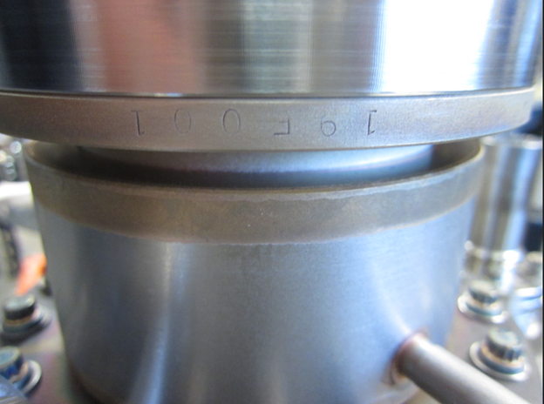 | [[FPCSN]] <<SN>>
 | - Record technician names | [[FPCOper1]] <<USERNAME>>  [[FPCOper2]] <<USERNAME>>
2 | Perform particulate counts: using a particulate counter Solaire and dry, filtered nitrogen supply, check particulate counts on the external and internal surfaces of each FPC. If needed scrubb with filtered nitrogen to have at least 100 counts on the external surfaces and less than 10 counts on all internal surfaces.
 | 2.1. Perform and record particulate counts on external FPC surfaces. Select YES, if external particulate cocunts are less than values specified in procedure (less than 100 counts 0.3 um particulates), describe findings in comment box and upload graph with particulate counts for FPC. If counts are higher, scubb with filtered nitrogen until they are below 100. Generate NCR only if external particulate counts cannot be brought below 100. | [[FPCpartiExternalOK]] <<YESNO>>  [[FPCpartiExternal]] <<FILEUPLOAD>>  [[FPCpartiExternalComm]] <<COMMENT>>
3 | Remove Silver plated bolts from the FPC cavity flange, then:
 | 3.1. Using filtered nitrogen, scrubb the FPC cavity flange area until particulates are less than 10 counts. Remove Silver plated bolts from the FPC cavity flange, then: | [[FPCpartiExternalOK]] <<YESNO>>  [[FPCpartiExternal]] <<FILEUPLOAD>>  [[FPCpartiExternalComm]] <<COMMENT>>
 | 3.2. Attach clean room lifting tooling to the outer conductor and gently lift the cold coupler from the test waveguide. After that, two activities are to be done just prior to coupler assembly on the cavity: internal particulate counts and internal visual inspection. These could be done at the same time.
 | 3.2.1. Perform and record particulate counts on internal FPC surfaces. Select YES, if external particulate cocunts are less than 10 counts 0.3 um particulates. Describe particulate counts data in the comment box if initial counts are higher than 100, and upload graph with particulate counts. Generate NCR if internal particular counts are in excess of 1000 counts. | [[FPCpartiInternalOK]] <<YESNO>>  [[FPCpartiInternal]] <<FILEUPLOAD>>  [[FPCpartiInternalComm]] <<COMMENT>>
 | 3.2.2. FPC cavity flange sealing surface (should be smooth, without scratches, dents or AlMg left over). Select YES, if sealing surface looks OK, Select NOT, document (with photos), document findings and generate NCR if the sealing surface has any issues. | [[FPCcavFlangeSurfaceOK]] <<YESNO>>  [[FPCcavFlangePhoto]] <<FILEUPLOAD>>  [[FPCcavFlangeSurface]] <<COMMENT>>
 | 3.2.3. FPC antenna surface (should be free of scratches, dents, eventual RF arcing marks generated during RF qualification tests ). Document any defects with comments and photos. Do not write an NCR for these issues. | [[FPCantennaPhoto]] <<FILEUPLOAD>>  [[FPCantennaComm]] <<COMMENT>>
 | 3.2.4. Outer conductor copper plating (should be free of blisters, scratches, flaking copper, outer conductor SS surface without coupler plating, eventual arcing marks generated during RF qualifications tests ). Record any significant defects with comments and photos. Generate an NCR only for flaking copper; otherwise, mark YES in the OK field. | [[FPCouterCuPlatingOK]] <<YESNO>>  [[FPCouterCuPlatingPhoto]] <<FILEUPLOAD>>  [[FPCouterCuPlatingComm]] <<COMMENT>>
4 | Check and select Yes if all NCRs related with FPC prep have been addressed (closed), then close traveler. | [FPCNCRsClosed]] <<YESNO>>

