Slow Pump Down using dual assembly with bypass Tee allowing slow pumping or slow venting

Document Number: | CP-WMGRDR-VAC-PMPDWN | Approval Date: | Feb 4, 2021
Revision Number: | 1 | Periodic Review Date: | Feb 4, 2023
Process Owner: | Ari Palczewski | Department Owner: | SRF Ops

Purpose

When a CM/girder requires an installation or modification, the slow-pump/slow-vent assembly is connected with a bypass Tee. In this case, special care must be taken as a vacuum accident is more likely in this configuration compared to a single connection.

Scope
This procedure applies to cryomodule, girder, or cold beamline section in CEBAF that requires particle free pumpdown after a repair or modification. Given the critical nature of every pumpdown, this procedure instructs the operator to perform a complete pumpdown and backfill of the system with verification of the flow rates and logging. This is followed by valving into the girder or CM and performing the procedure again. Between the test operation and the actual pumpdown, the pump cart power cannot be cycled or the test operation must be redone. The full system test can’t be skipped for any reason.

Terms and Definitions

The following terms have specific meanings within this procedure.

Term | Definition
Verify use | If an instruction specifies to “verify” and the item is not true stop and seek help; Unless instructed otherwise in the specific line.
Slow vent/pump cart | Particle free vacuum cart with automatic controls for controlling particle movement by keeping the gas flow below a certain rate.
Equipment:
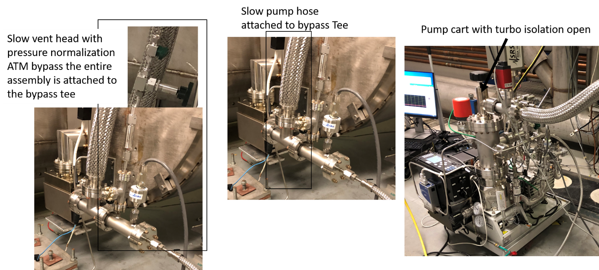
¼ - Turn isolation valve
Regulating Valve

A list of general terms and definitions can be found in the Quality Manual QML-001.

Roles and Responsibilities

The following roles have responsibilities described in this document.

Role | Responsibility
Technician | Trained vacuum personal performing the work outlined with this manual. The person must have training in particle free vacuum operations and familiar with the particle free vacuum cart and controllers.

Procedure

- Verify the pressure logging software is running and the technician can see the software readback while operating the vacuum cart.
- Close the isolation valve to girder/cryomodule. If the valve is already closed, seek help from Ari Palczewski as the system is in an error state. Comment in the logging software the valve closure – P1 girder#L## or CM#L## closed, see software screen shot below. Where P1 is the pressure before closing.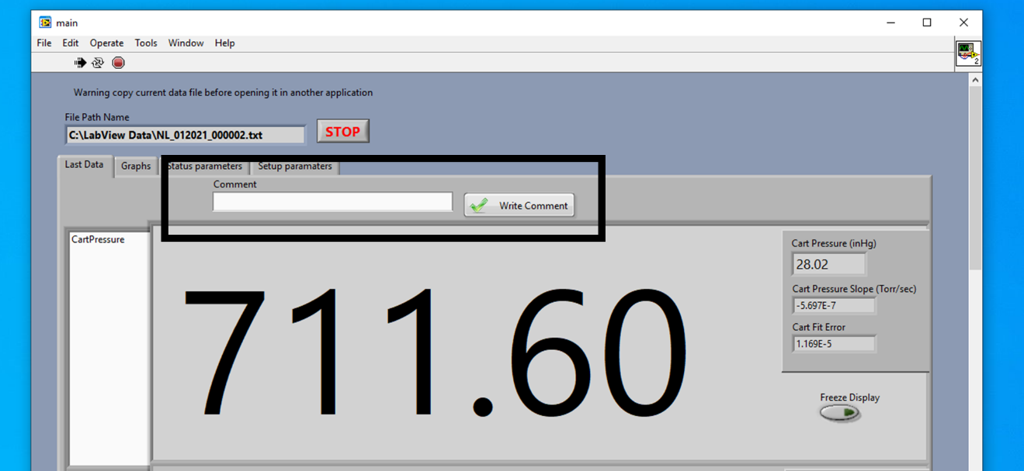
- Verify the turbo cart isolation valve is open. This valve should never be closed with the pump cart attached through a bypass tee allowing slow-pumping or slow-venting at any time. 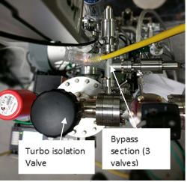
- Verify all valves below the turbo isolation valve are closed (cart bypass section).
- Verify the needle and ¼ turn valves on the ATM bypass are closed.
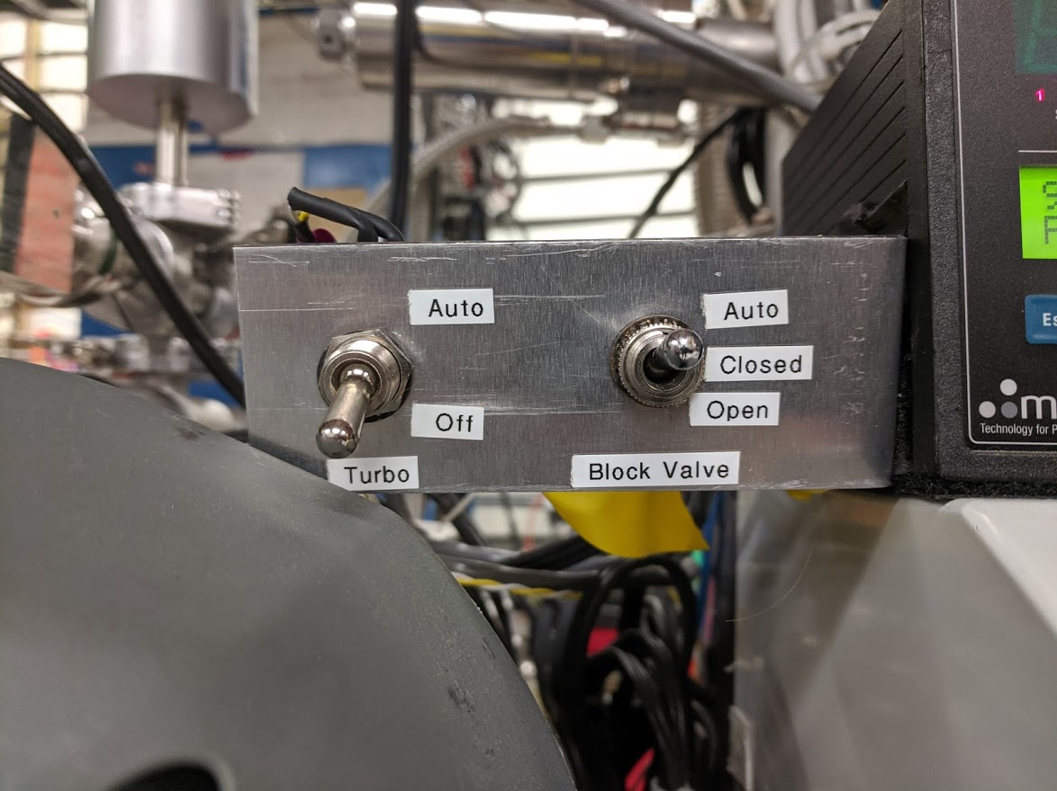
- Verify both Turbo switch is in the Off position and the Block Valve is in the Auto position (image below).
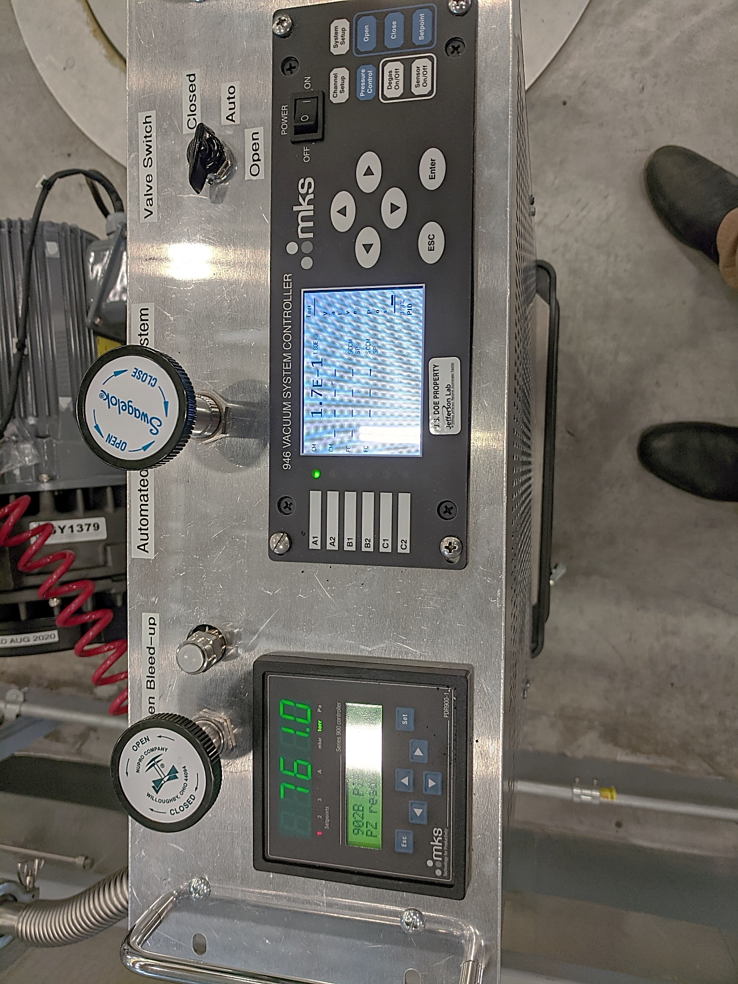
- On the 946 controller. Set to channel A1 using the up or down arrow on the home screen. The controller is now set to the metering valve.

- Press Pressure Control button 1x. Verify the readback shows preset under Op Mode.
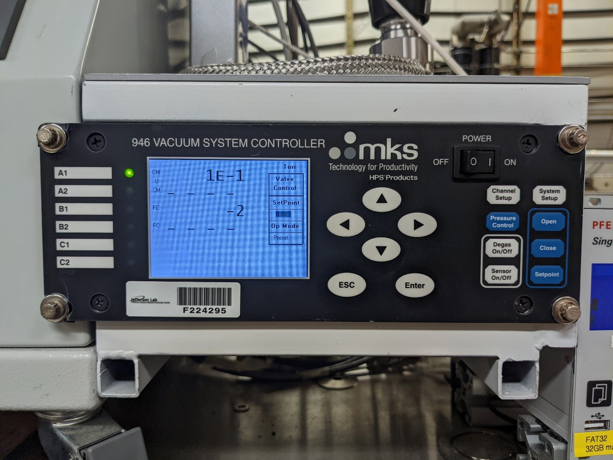
- Press Pressure Control button 1x. PID control should be in the off position. To change PID control to the ON position highlight (OFF) press enter. Using up/down arrow key change PID from OFF to ON then press enter to accept change. – do not touch anything on the other two screens under Pressure Control.
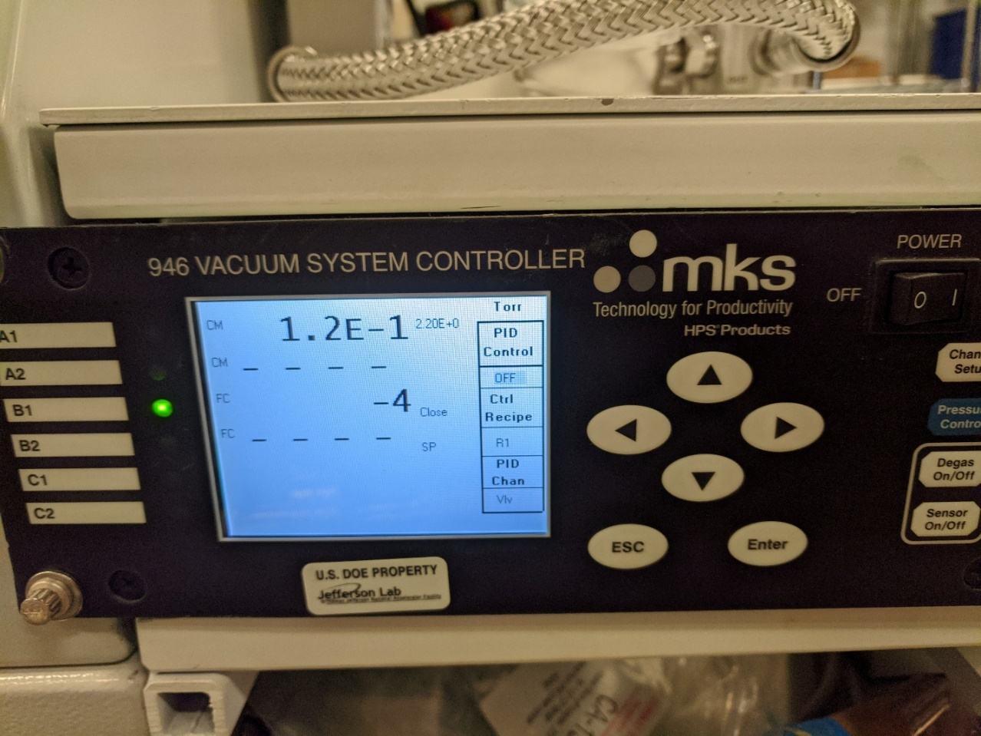
- Press pressure control button 2x and verify the operating mode has changed to PID.
- Press the ESC button to view the metering valve position and verify the position is 0.0%.

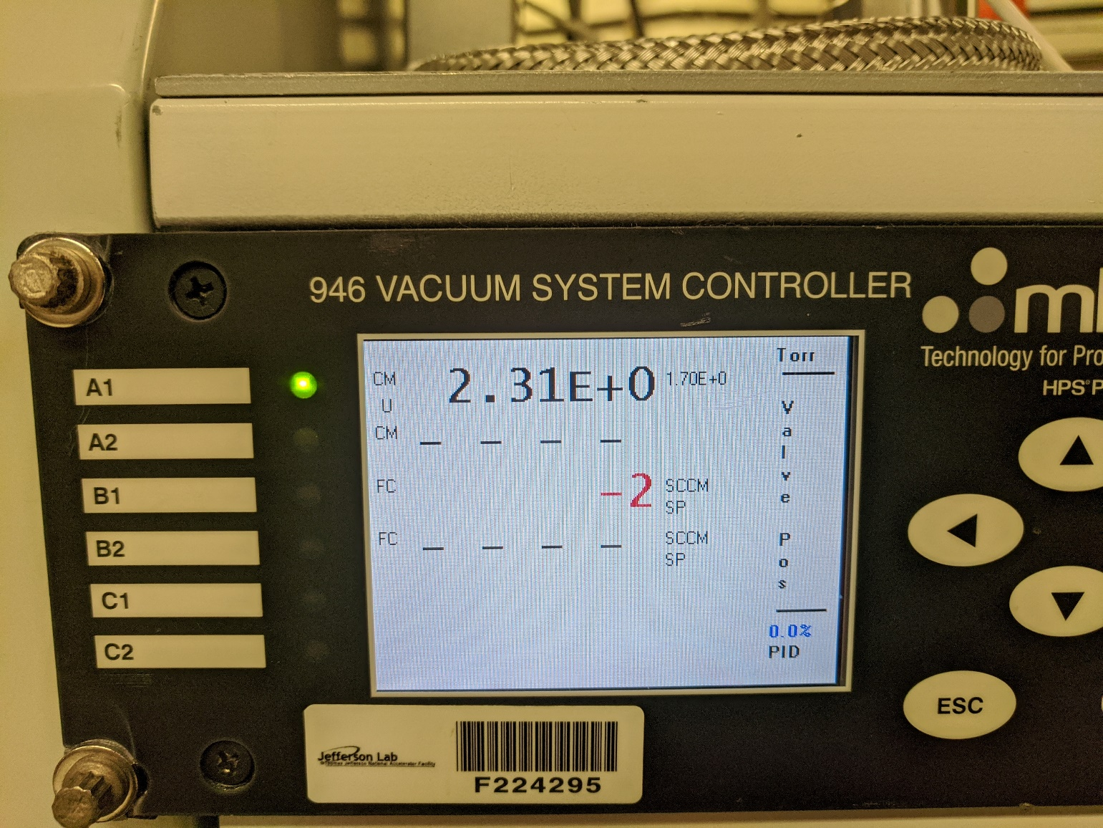
- Turn on the scroll pump using the turbo controller.
- Verify the PID valve position begins to open slowly. In the event the controller goes past 55% even for an instant immediately turn off the scroll pump and Contact Ari Palczewski as the control valve requires maintenance.
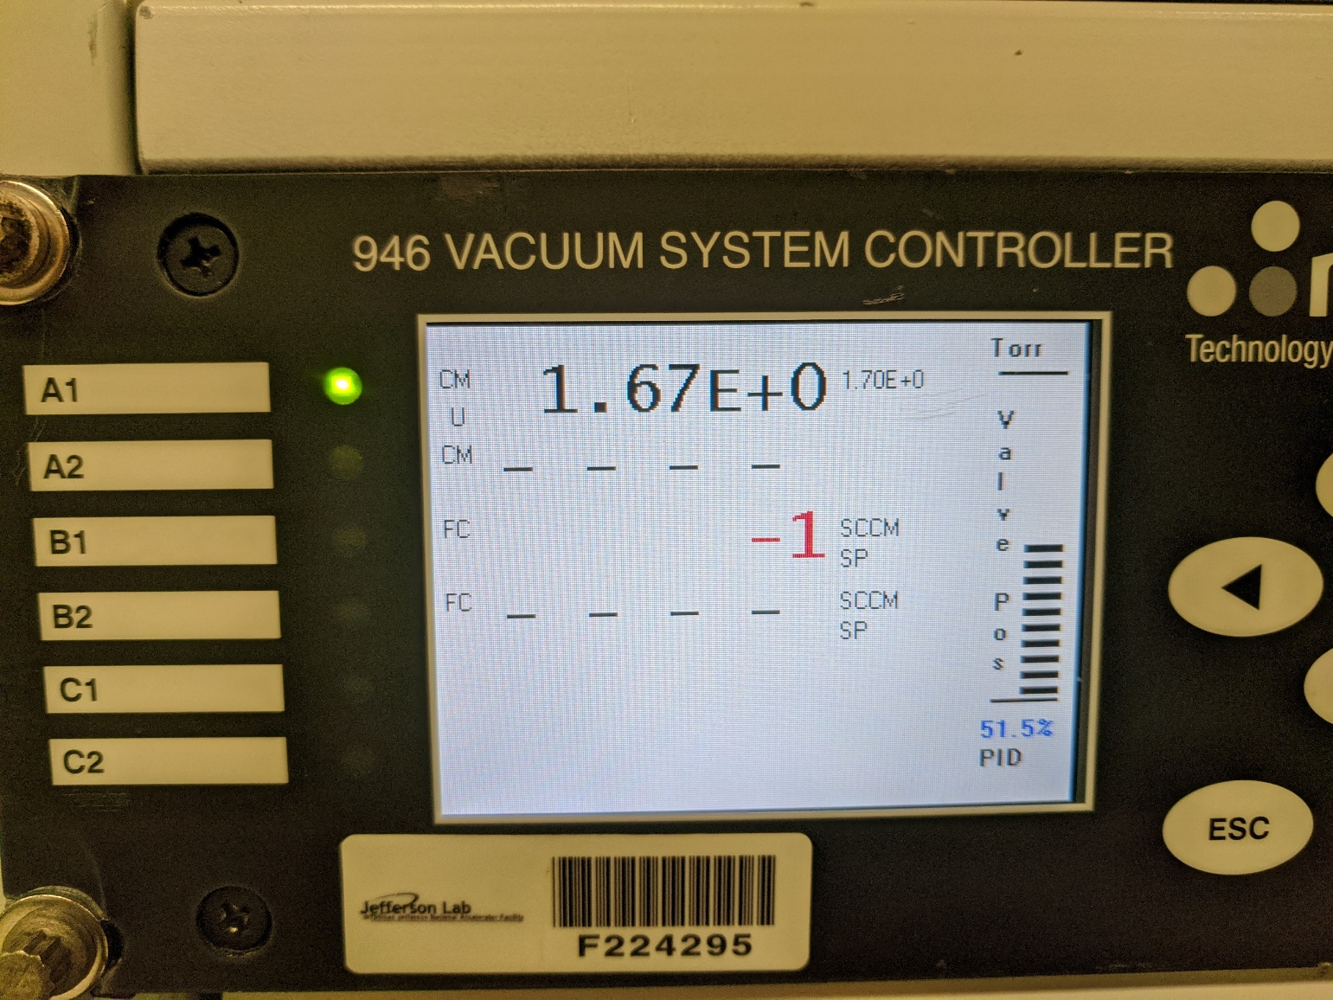
- Pump the cart down for at least 2 minutes and verify the PID set point is close to 50%, but below 55% and the set pressure is within 5% of the setpoint.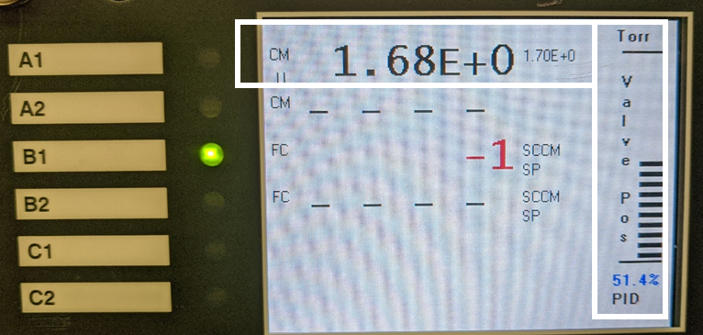
- Verify the pressure drop is ~1-2Torr/sec, if you are unexperienced with this STOP and seek help fitting/calculating the rate from the logging data.
- On the 946 controller: Press pressure control button 1x. PID control should be in the ON position. To change PID control to the off position highlight (On) press enter. Using up/down arrow key change PID from On to Off then press enter to except change. – do not touch anything of the other two screen under pressure control.
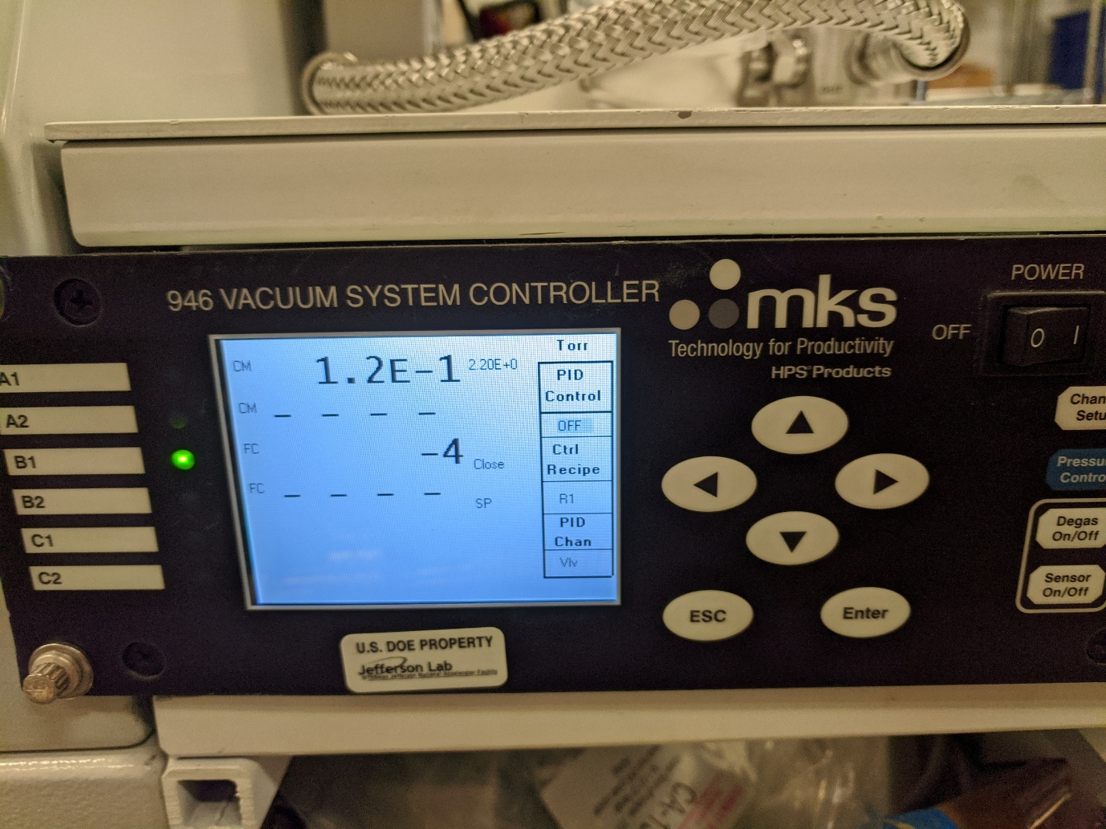
- Press the ESC button to view the metering valve position and verify the position is 0.0%.
- Turn off the scroll pump using the turbo cart controller.
- On the 946 controller home screen. Set to channel B1 using the up or down arrows on the home screen. The controller is now set to the mass flow controller.
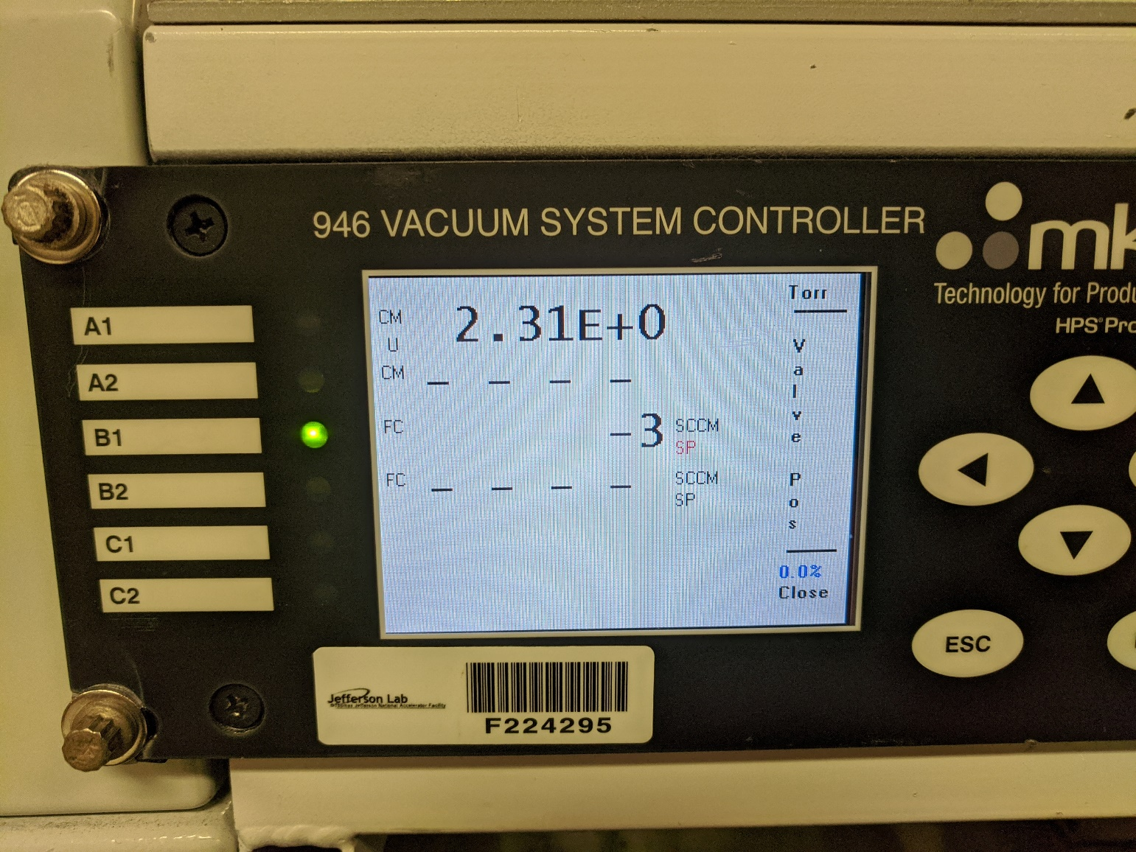
- Press the set point button and verify the B1 FC line flashed SP/3e+2. (NEVER use the Open button)
  - If the SP is NOT 3e+2, hit close and enter use the section below to change to the set point to 3e+2 and return to line 18.
  - If the SP is 3e+2 continue.
- Press enter to return the cart to the pressure P1, the pressure of the cart must be within 0.1Torr of P1. Getting the pressure within 0.1Torr of P1 is very difficult for a small volume such as the pump cart as the pressure rise is about 1Torr/sec. So return the cart to P1-~5Torr instead and lower the flow rate, instructions below.
  - Press the close button and then enter button when the pressure is P1-~5Torr. This will overshoot and about P1-~4Torr
  - Press channel setup button to go to the screen to change the flow.
  - Use the arrow to change the FlowRate SP to 2.5e1 to reduce the pressure change to ~ 0.1Torr per second and Press enter. 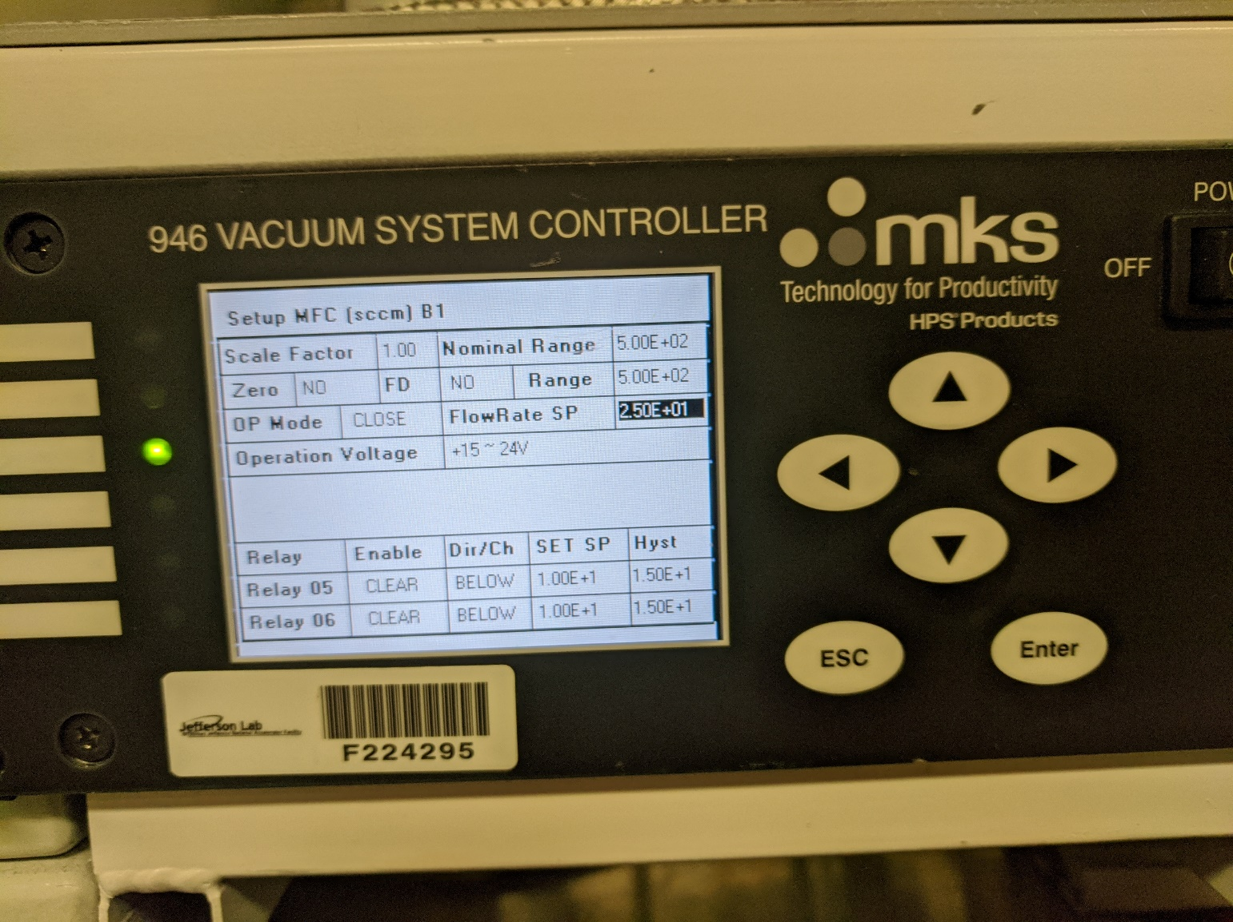
  - Press esc.
  - Press setpoint and verify the SCCM flashes SP/2.5e+1
  - Press enter.
  - Press close and wait until the pressure is 0.2Torr from P1
  - Press Enter.
- Wait 1 minute to verify the pressure is stable.
Use extreme caution in the next step, accidentally setting the control to open will contaminate the item being pumped.
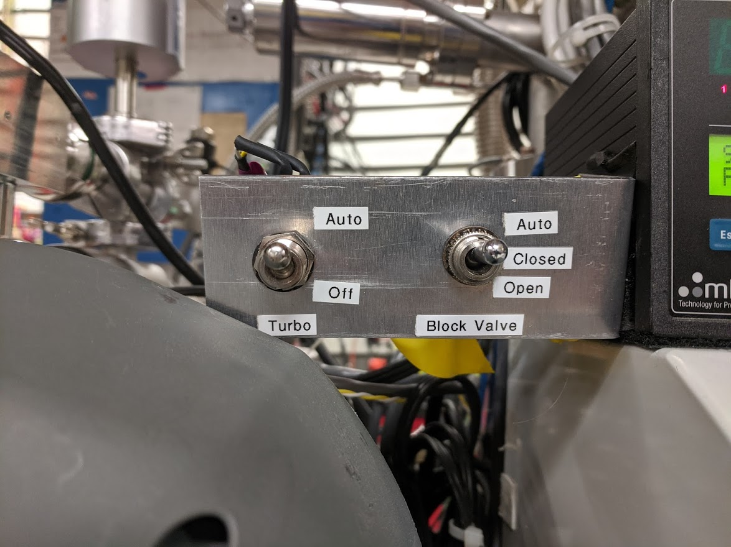
- Verify both block valve is in Auto and turn the turbo controller to Auto (image below).
- On the 946 controller. Set to channel A1 using the up or down arrow on the home screen. The controller is now set to the metering valve.
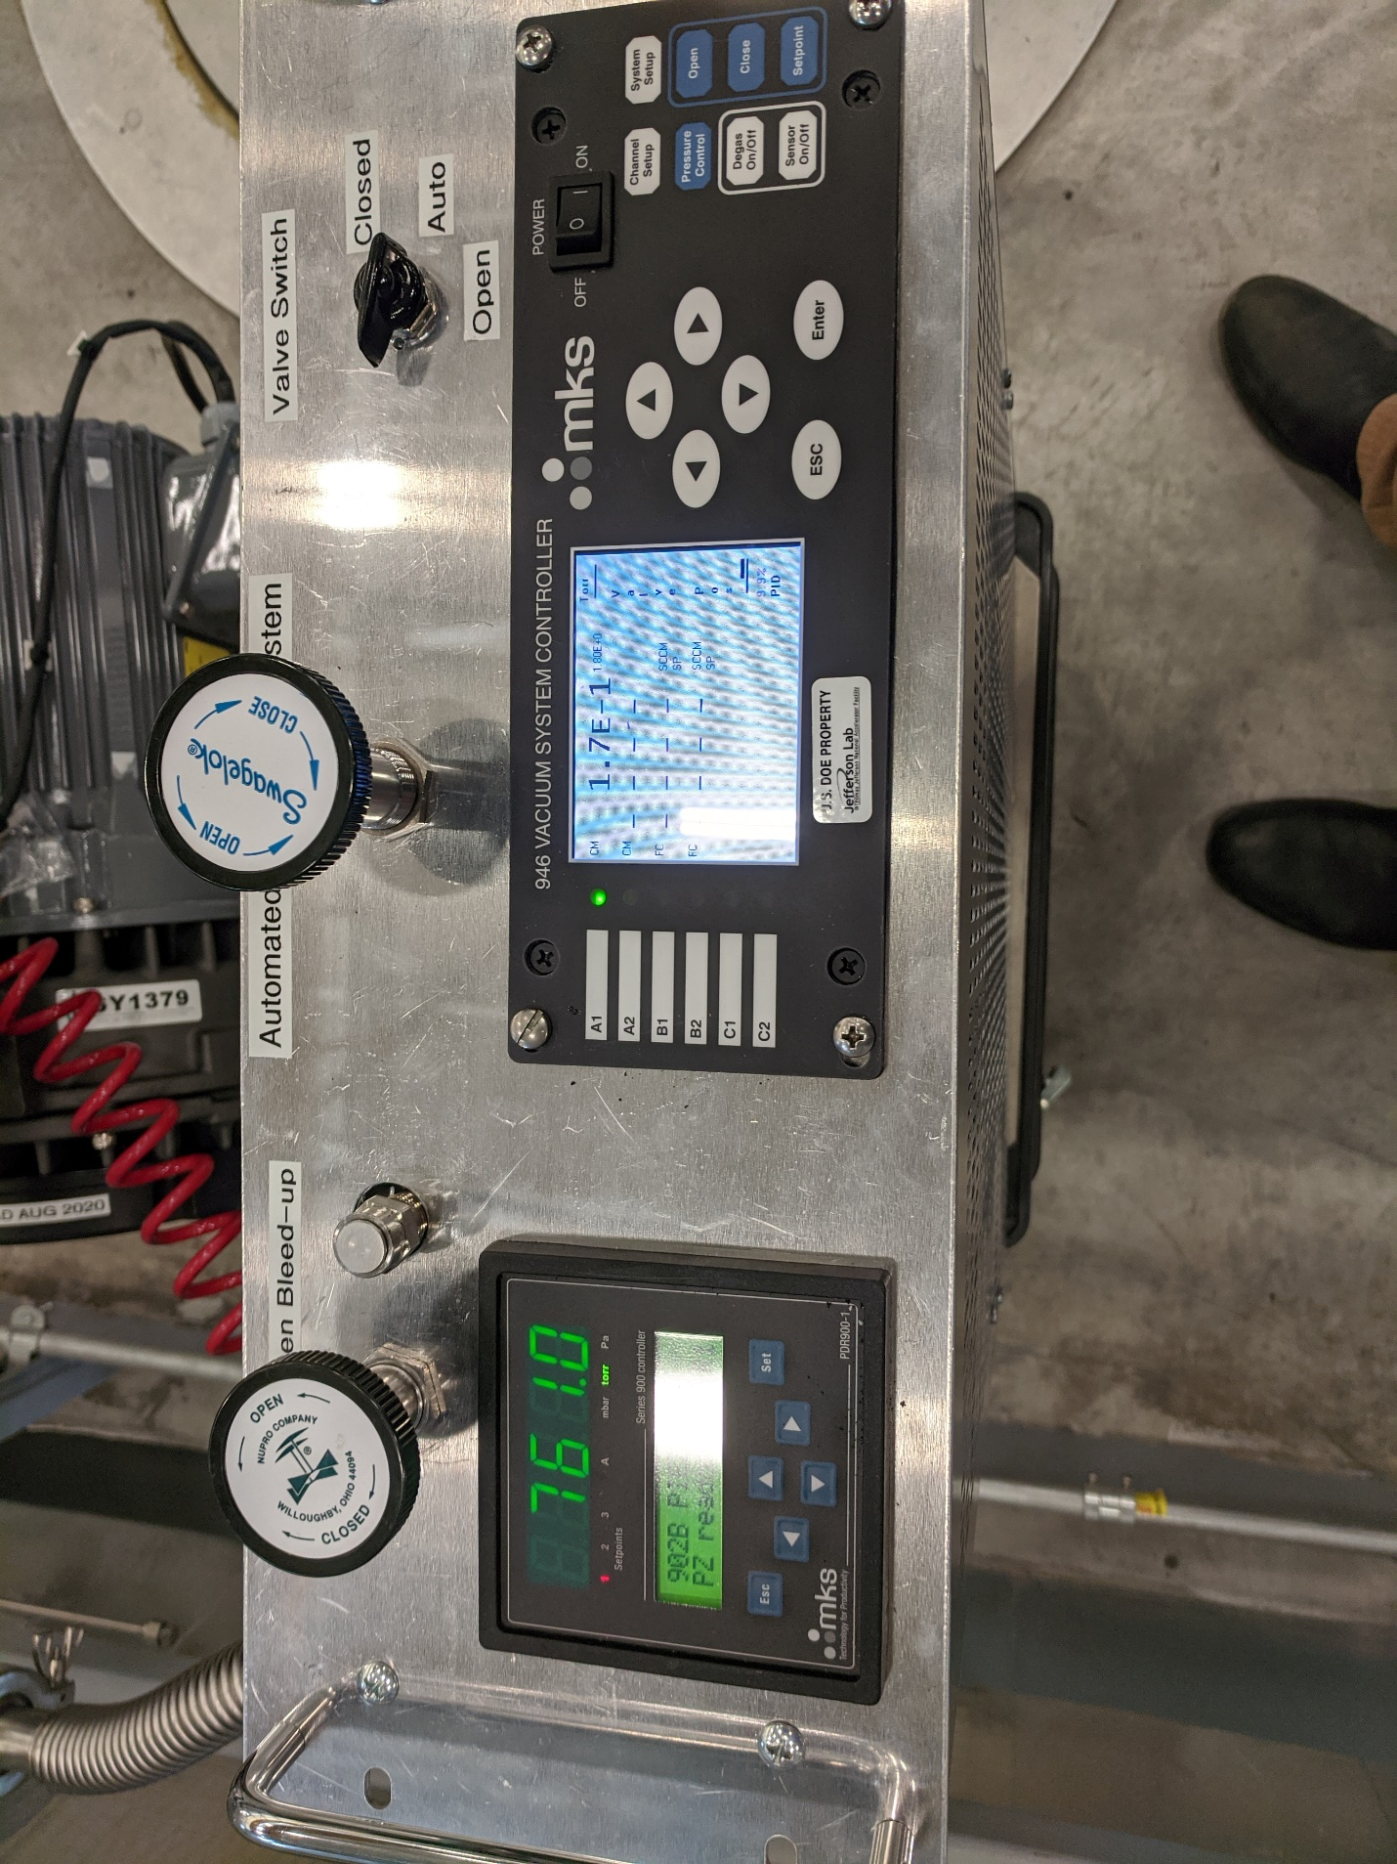
- On the 946 controller. Press pressure control button. PID control should be in the off position. To change PID control to the ON position highlight (OFF) using the control arrows and press enter. Using up/down arrow key change PID from OFF to ON then press enter to except change. – do not touch anything of the other two screen under pressure control.
- Press pressure control button 2x and verify the Op Mode under Valve Control menu operating mode has changed to PID.
- Press the ESC button to view the metering valve position and verify the position is 0.0% before moving on, and the pressure is above the setpoint (2.31E+0 > 1.70E+0 in the example below this may take up to 1 minute for the PID meter to cycle.

- Slowly open the CM or girder isolation valve.
- Close the ¼ turn or round metering nitrogen isolation valves attached to the N2 inlet, do no touch the regulator.
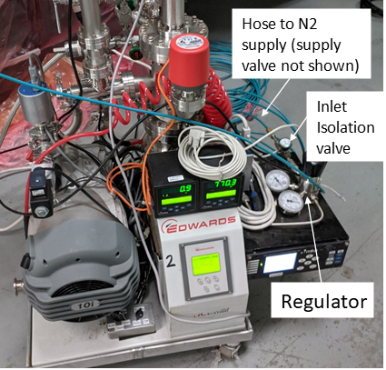
- On the 946 controller. Set to channel B1 using the up or down arrow on the home screen. The controller is now set to the mass flow controller.
- Press Channel setup and return the FlowRate SP to 3.00E+02, similar to what was done in line 19 b.-h.
- Press ESC to return to the home screen
- Press the set point button and verify the B1 FC line flashed SP/3e+2. (NEVER use the Open button)
- Press enter and allow the controller to open while monitoring the FC line on the controller.
- Verify the mass flow goes up and then back down to zero or negative valves; the mass flow may not reach 300sccm as the line pressure might be too low, this is ok – just leave as is. If the cycle does not complete in one minute, press close and Enter as there is an issue with the N2 line isolation valve.
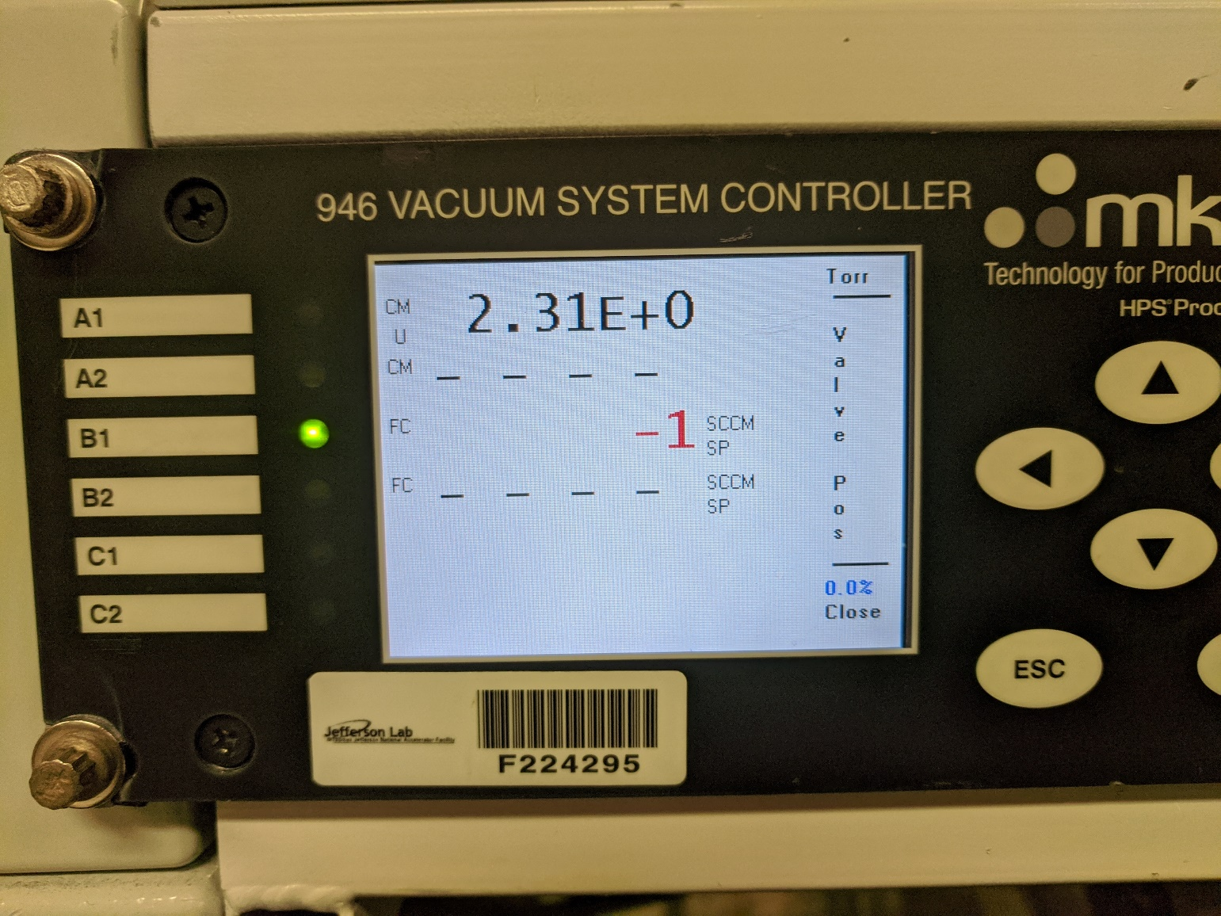
- On the 946 controller. Set to channel A1 using the up or down arrow on the home screen. The controller is now set to the metering valve.
- Verify the PID position reads zero.
- Turn on the scroll pump using the turbo controller enter button.
- Verify the PID valve position begins to open slowly. In the event the controller goes past 55% even for an instant immediately turn off the scroll pump and seek help as the control valve is faulty. Contact Ari Palczewski
- Wait 5 minutes to verify the pressure is dropping at a constant rate (liner drop on the pressure logging software) and the set point equals the pressure on the 946 read back. – for CM this should be 1Torr/minute and for a girder ~10 Torr/minute.
- Return after 8 hours for a CM or 2 hours for girder to verify the turbo has turned on and the block valve opened.

Process Workflow

References

Document No. | Title
QML-001 | SRF Ops Quality Manual

Release and Revision History

Rev # | Major Changes | Approval Date:
1 | Initial release | Feb 4, 2021

Approvals

Approved by: | Name: | Signature: | Date:
Process Owner | Ari Palczewski | DocuShare E-sign | Feb 4, 2021
Group lead | Mike Drury | DocuShare E-sign | Feb 4, 2021
Group lead | Anthony DiPette | DocuShare E-sign | Feb 4, 2021
Department Head | Tony Reilly | DocuShare E-sign | Feb 4, 2021

