**New Masterlist Guide**

**Color Counter and Status Colors**

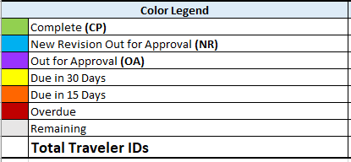

The colors have been updated from the previous template. Purple and green are essentially unchanged, meaning out for approvals and complete respectively. Blue is now for when a new version is out for approval. The most significant change is the color countdown. As travelers get closer to their due date, the color of their due date cells change. The first change is within 30 days of the traveler due date, when they change to yellow. They change to orange when within 15, then red when they are overdue. The countdown continues even if the traveler is out for approval, and is only stopped when the traveler is labeled as complete.

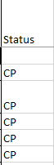

Changing the status of a traveler is no longer done by manually changing the color of cells. There is a new column on the far right side called Status. When a two letter code is entered, the status color automatically changes. CP for complete, NR for New Revision, and OA for Out for Approval.

**Adding New Rows and Sections**

The bottommost row of each section is intentionally left blank to make adding new rows for travelers easy. The process of adding rows is unchanged, save for a new addition. It begins by right clicking a row number and selecting "insert". The only change is with the A column. The A column has a section of code that helps run the automation, but does not copy over with the addition of a new cell. A cell with the formula must be selected and dragged by the lower right corner over any new cell.

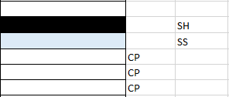

Adding new sections and subsections is mostly unchanged. The only difference is that several columns do not accept manual color changes. To work around this, the section column was added next to the status column. The same principle applies, but with different codes. SH is for the black Section Header. SS is for the light blue subsection.