Traveler Title | C75 Supply End Can Beam Pipe Pre-Assembly Traveler Part 2
Traveler Abstract | This Traveler is for Part 2 of the assembly of the supply end can beam pipe for a C75 Cryomodule. This is added to the bottom flange of the vacuum box (Part 1) once the Cryomodule is moved to WS5. This work is to be done cleanly by trained and authorized personel only.  These parts are NOT activated. They are all NEW out of the box and do not require RADCON.
Traveler ID | C75-CMA-BPIP-ASSY
Traveler Revision | R1
Traveler Author | Chris Wilcox
Traveler Date | Click or tap to enter a date.
NCR Informative Emails | macha,fischer.areilly
NCR Dispositioners
D3 Emails
Approval Names | Chris Wilcox | John Fischer | Ken Worland | Kurt Macha
Approval Signatures
Approval Dates
Approval Title | Author | Reviewer | Reviewer | Project Manager

References | List and Hyperlink all documents related to this traveler. This includes, but is not limited to: safety (THAs, SOPs, etc), drawings, procedures, and facility related documents.
C75 SEC Beam Pipe Assy Dwg | C75 SEC Beam Pipe Part 2 | SEC Beam Pipe Pic Part 2 | Ionized nitrogen cleaning procedure | JL0038622-A-SEC Beeam Pipe Mod Dwg
JL0096225---SUPPLY Pump Drop Mod

Revision Note
R1 | Initial release of this Traveler.

Step No. | Instructions | Data Input
1 | Gather Parts and Hardware:  Gather all parts and hardware indicated on drawings and send to the Chemistry Team for standard UHV cleaning and vacuum baking. Be sure to include a 4.5” CF Blank that is not shown in this drawing.  Items are then to be placed in the passthru for reception into the Clean Room  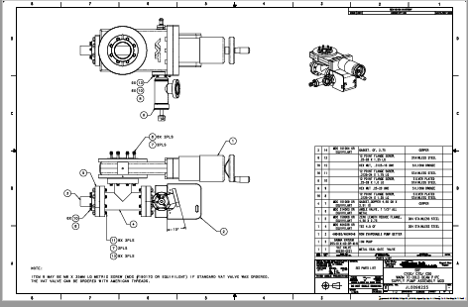 | [[CMATech]] <<SRFCMP>>  [[GatherDate]] <<TIMESTAMP>>  [[GatherComment]] <<COMMENT>>
2 | Preparation of Hardware and Components:  Enter the Clean Room, donning new garments as per protocol. Receive all cleaned hardware and components from the passthru into the Clean Room.  Clean the handles and upper shelf of a cleanroom cart with an isopropyl soaked wipe. Blow the cart with ionized nitrogen.  Individually remove each vacuum component from its bag and clean with ionized nitrogen as per the Ionized nitrogen cleaning procedure.  Note: When blowing valves, cycle them as you are blowing the internals to eliminate the possibility of trapped particles. | [[PREPTech]] <<SRFCMP>>  [[PrepDate]] <<TIMESTAMP>>  [[PREPComment]] <<COMMENT>>
3 | Assemble the Gate Valve Manifold:  Assemble the manifold using appropriate drawings and standard clean assembly practices. Install a conflat blank on the top side of the valve to function as a dust seal until installation | [[ASSYTech]] <<SRFCMP>>  [[ASSYDate]] <<TIMESTAMP>>  [[ASSYComment]] <<COMMENT>>
4 | Have parts assemblies prepared for storage outside the clean room:  Place the completed assemblies in the clean room pass thru. Call the Chem Room Supervisor and have the assemblies double bagged in N2. Exit the clean room as per protocol to immediately to receive parts | [[CHEMTech]] <<SRFCMP>>  [[CHEMDate]] <<TIMESTAMP>>  [[CHEMComment]] <<COMMENT>>
5 | Transport:  Assemblies are ready to store until installation on a cryomodule. | [[TRANSTech]] <<SRFCMP>>  [[TRANSDate]] <<TIMESTAMP>>  [[TRANSComment]] <<COMMENT>>  [[SECBeamPipeSN]] <<SN>>

