|  |  |  |  |
| --- | --- | --- | --- |
| **SRF Vacuum Monitoring Software Setup and Operation** | | | |
| **Document Number:** | CP-WMGRDR-VAC-LBVIEW | **Approval Date:** | Mmm DD, YYYY |
| **Revision Number:** | 3 | **Periodic Review Date:** | Mmm DD, YYYY |
| **Process Owner:** | Natalie Brock | **Department Owner:** | SRF Ops |

# Purpose

The purpose of this document is to outline the setup and use of vacuum monitoring software commonly utilized in SRF operations.

This procedure supports the Quality Management System as described in the Quality Manual QML-001.

# Scope

This procedure applies to LabVIEW software used to record vacuum data from a variety of controllers.

# Terms and Definitions

None

A list of general terms and definitions can be found in the Quality Manual QML-001.

# Roles and Responsibilities

The following roles have responsibilities described in this document.

|  |  |
| --- | --- |
| **Role** | **Responsibility** |
| Technician | Perform hardware connection and software setup. Run software and verify operation. |

# Procedure

**Setup and Operation**

## Hardware Setup

* 1. Verify the pump cart bypass valves are in **Off** for the turbo and **Close** for the bypass valve
  2. Plug in cart and turn all instruments.
  3. Verify the 9 pin serial cable for each instrument is connected to the serial-to-USB adapter and then plugged into a USB hub.
  4. Open StandardVacuumCart.exe and select the Setup Parameters tab. (the icon is located on the desktop.

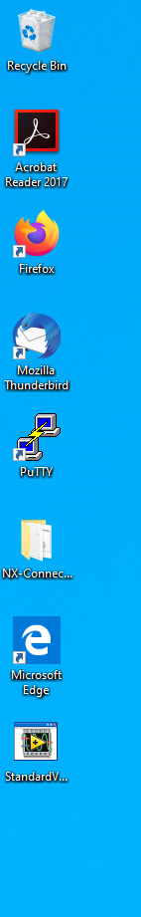

## Software setup

1. In the Setup Parameters tab, set the File Name Prefix to match the zone, cavity, string etc. being monitored. (for example CM_1L25 WMGRDR or Girder_1L22)
2. Make sure the Data Directory Path is set to C:\LabView Data\.
3. Set the Wait Between Samples time. The default value should be 1 second. This wait time can be changed while the software is running but for general operation should be left at 1sec.

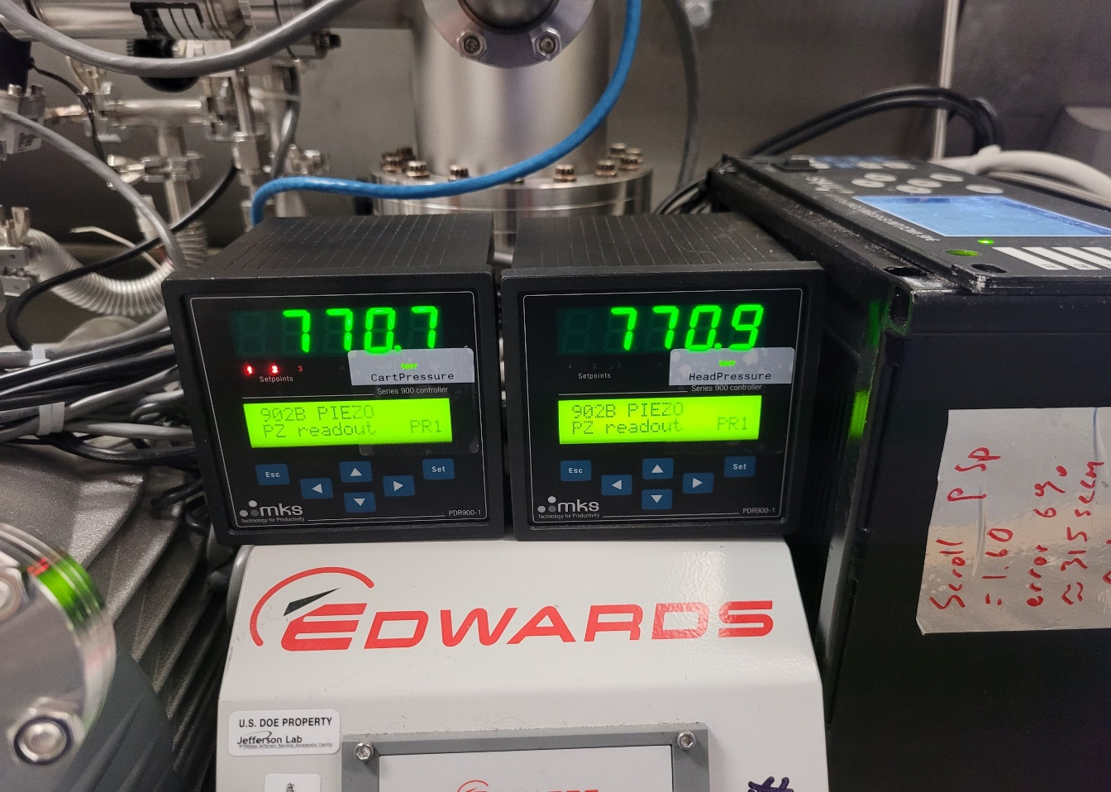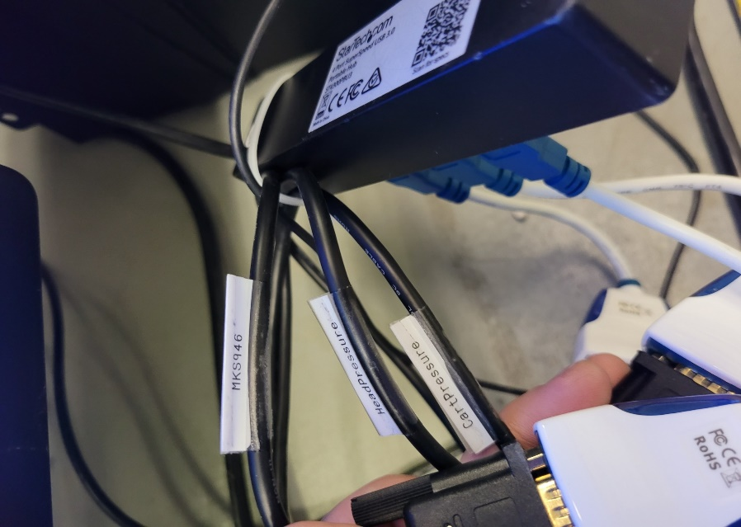

1. Flip the Instrument Setup switch to Auto.

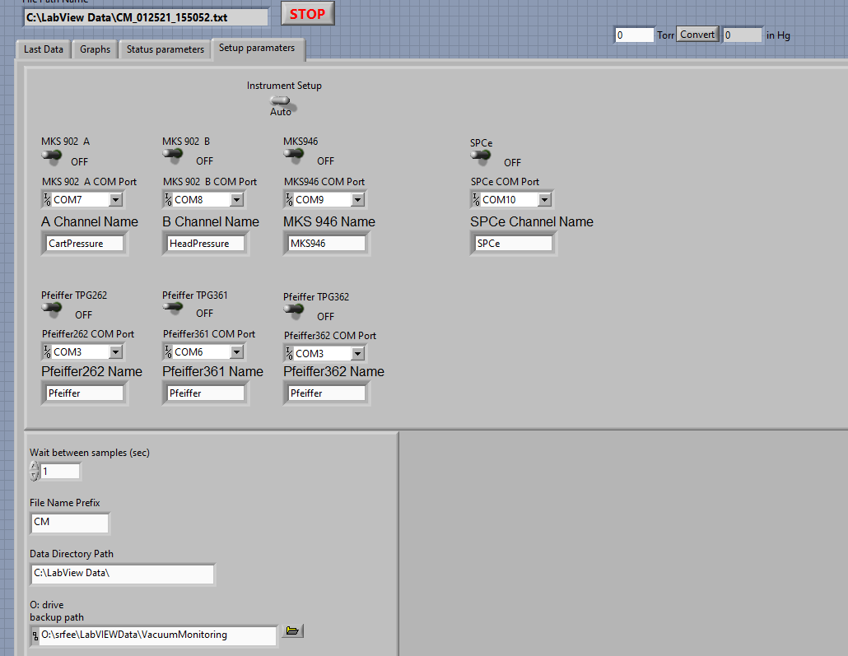

## Software Operation

#### Click the white arrow to run the program.

1. Wait approximately 60 seconds for Auto setup to assign COM ports to connected instruments.
2. Confirm that Auto setup has switched on and assigned COMs to all connected instruments.
3. Select the Last Data tab to view the pressure reading(s).
4. Select the Graphs tab and use the drop down menu to plot the data outputs for all controllers.
5. Verify that the file name at the top of the screen is correct.
6. Open Windows Explorer and navigate to C:\LabView Data.
7. Verify that a log file matching the file name has been created. If you need to read the file while the vacuum monitor is running, create a copy of the log file and open the copy.

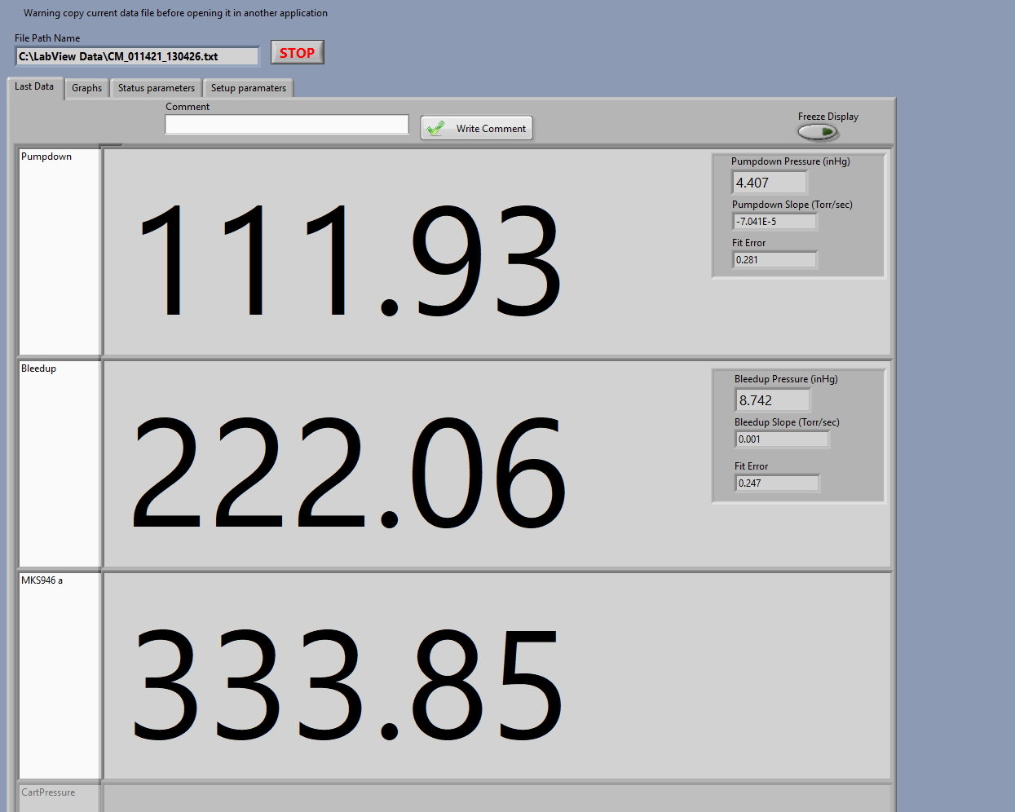

# Process Workflow

Vacuum Cart and PC running, not connected

Record the COM number assigned to the controller

Select controller Com port

Setup file parameters

Add another controller?

Switch controller to ON

Vacuum data is being logged

Connect the controller on the vacuum cart to the pc with a serial to usb cable

YES

NO

Open StandardVacuumCart.exe

Add another controller?

YES

NO

Run the software

Verify log file

# References

|  |  |
| --- | --- |
| **Document No.** | **Title** |
| QML-001 | SRF Ops Quality Manual |

# Release and Revision History

|  |  |  |
| --- | --- | --- |
| **Rev #** | **Major Changes** | **Approval Date:** |
| 1 | Initial version | Mmm DD, YYYY |
| 2 | After first use, multiple clarifications and new cable labels and checklist added. |  |

# Approvals

|  |  |  |  |
| --- | --- | --- | --- |
| **Approved by:** | **Name:** | **Signature:** | **Date:** |
| Process Owner | Natalie Brock | DocuShare E-sign | Mmm DD, YYYY |
| Engineer | Ari Palczewski | DocuShare E-sign | Mmm DD, YYYY |
| Group lead | Mike Drury | DocuShare E-sign | Mmm DD, YYYY |
| Group lead | Anthony DiPette | DocuShare E-sign | Mmm DD, YYYY |
| Department Head | Tony Reilly | DocuShare E-sign | Mmm DD, YYYY |