|  |  |  |  |
| --- | --- | --- | --- |
| SNSPPU Backtech Helium Vessel Lift Procedure | | | |
| **Document Number:** | CP-SNSPPU-CAV-ASSY-LFT | **Approval Date:** | 25- Feb-2021 |
| **Revision Number:** | - | **Periodic Review Date:** | 25-Feb-2025 |
| **Document Owner:** | K Macha |  |  |

## 

# Purpose and Scope

The purpose of this document is to demonstrate the proper intended procedure for using the backtech tooling for a tanked SNSPPU cavity.

# References

N/A

# Terms and Definitions

1. **Bachtech** –The electric lift cart tool.

# Process Details

1. Position backtech tooling as pictured so the lift arm pad is under the axial restraint block on the helium vessel. Ensure the lift is rotated about the helium vessel so each leveling pad is about equal distance to the helium vessel shell.
2. Adjust backtech pivot tool to make the lift arm pad parallel to axial restraint block on the helium vessel.
3. Install 1/2" bolt with thick 1/2" washers on both sides and secure had tight with wrenches, the fixture to helium vessel.
4. Adjust leveling pads to make light contact with the helium vessel shell. Do not push the helium vessel shell with the leveling pads.
5. Bring the wire rope around the helium vessel and secure the brass knob hand tight. Ensure the swivel washers seat into the bracket pocket. No need to over tighten the brass knob. The goal is to ensure the wire rope is relatively straight around the helium vessel, to have no gap between the level pads and the helium vessel shell and to have a snug wire rope. (The wire rope is not intended to do the lifting but only to keep the vessel into the leveling pads. The 1/2" bolt is intended to take the load.)

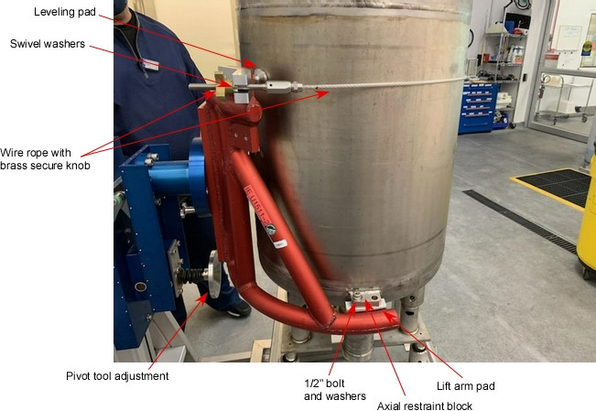

# **Revision History**

|  |  |  |
| --- | --- | --- |
| Rev # | Revision or update: | Effective: |
| Release | Initial Release | 2/25/2021 |
|  |  |  |

# **Approvals**

|  |  |  |
| --- | --- | --- |
| Approved by: | Signature: | Date: |
| **Document Owner** | Kurt Macha | 25Feb2021 |
| **Reviewer** | Ashley Mitchel |  |
| **Project lead** | Ed Daly |  |