Traveler Title | C75 Waveguide Assembly Traveler
Traveler Abstract | This traveler outlines the necessary steps and checkpoints to assemble the Waveguide and Tophat assembly for the Linac Cryomodule. It begins with an aligned Helium Vessel inside the Vacuum Vessel and ends with a completed Cryounit. The waveguide installation can be completed in the Cryounit assembly area or on the fixed assembly bench while the Cryomodule is being assembled. All work shall be performed by trained Cryomodule Assembly Technicians only.  Radiological controls are a critical component of the cryomodule rework assembly process. RCTs will be actively engaged in the movement, assembly, and consolidation of radioactive components. This will include the collection of individual RAM tags and associated "coupons" as the equipment is re-installed to produce the completed cryomodule. A member of the RadCon department should have a final sign-off prior to transporting to the tunnel.
Traveler ID | C75-CMACU-WG-ASSY
Traveler Revision | R1
Traveler Author | John Fischer
Traveler Date | 11-Feb-21
NCR Informative Emails | areilly,drury
NCR Dispositioners | macha,fischer.jjcamp
D3 Emails | wilcox,fischer,macha,jjcamp
Approval Names | John Fischer | Ken Worland | Kurt Macha | Gary Cheng
Approval Signatures
Approval Dates
Approval Title | Author/CMA Lead | Technical Reviewer | Project Manager | Engineering Review/ Mag Hygiene

References | List and Hyperlink all documents related to this traveler. This includes, but is not limited to: safety (THAs, SOPs, etc), drawings, procedures, and facility related documents.
Instrumentaion Plate 11140-0030 | Waveguide Assy 11140-0031 | 11141S0033 Large Leak Check Specification | Ionized nitrogen cleaning procedure | 11141S0029REV_A-Small Leak Check Specification
11141-0007 Waveguide Assy sh1 | 11141-0007 Waveguide Assy sh2 | 11141-0007 Waveguide Assembly sh3 | 11141-0052 Waveguide Instrumentation | 11141-0075 Waveguide Top View
Waveguide Mu Front 11141-0063 | Waveguide Mu Scallop 11141-0049 | CP-C75-CM-EVAC-NEG-R1 | CP-C75-CU-RBLD-RTFT | JL0064915 Neg Manifold Assy Dwg

Revision Note
R1 | Initial release of this Traveler.
R2 | Added RADCON abstract and modified steps for C75 changes.

Step No. | Instructions | Data Input
1 | Verify the Vaccum Vessel Traveler is complete. Record the Cryounit serial number. | [[VerifyTech]] <<SRFCMP>>  [[GatherDate]] <<TIMESTAMP>>  [[GatherComment]] <<COMMENT>>  [[CUSN]] <<CUSN>>
2 | Record the waveguide assy serial numbers.  Feedtrhu Flange, Left and Right warm windows, warm window assy’s, and waveguide extensions. | [[LeftWGDXSN]] <<WGDXSN>>  [[RightWGDXSN]] <<WGDXSN>>  [[INFFSN]] <<INFFSN>>  [[LeftWINWSN]] <<WINWSN>>  [[RightWINWSN]] <<WINWSN>>  [[LeftWINSN]] <<WINSN>>  [[RightWINSN]] <<WINSN>>  [[SNCMATech]] <<SRF>>  [[SNDate]] <<TIMESTAMP>>  [[SNComment]] <<COMMENT>>
3 | Clean and inspect the feedthrough plate. | [[INSPCMA]] <<SRF>>  [[INSPDate]] <<TIMESTAMP>>  [[INSPComment]] <<COMMENT>>
4 | Install the feedthrough plate onto the assembly fixture. | [[INSTCMA]] <<SRF>>  [[INSTDate]] <<TIMESTAMP>>  [[INSTComment]] <<COMMENT>>
5 | Weld two (2) rotary feedthroughs into the feedthrough plate in  accordance with drawing 11140-D-0030.  Rotary feedthoughs will be reworked using CP-C75-CU-RBLD-RTFT | [[Welder]] <<SRF>>  [[WELDDate]] <<TIMESTAMP>>  [[WELDComment]] <<COMMENT>>
6 | Install helical couplings (Item 29) and telescopic socket (Item 14) onto rotary feedthrough  shafts on helium vessel. Install roll pin (Item 34) as per drawing 11140-E-0031. | [[COUPLINGTech]] <<SRF>>  [[COUPLINGDate]] <<TIMESTAMP>>  [[COUPLINGComment]] <<COMMENT>>
7 | Assemble the Waveguide  - Visually inspect the components, note any findings.  - Install pre-tested infrared (IR) detectors onto upper instrumentation ports of  warm windows, sapphire windows onto the lower instrumentation ports of  warm windows and "N" connectors into 2 ports at center of feedthrough  plate.  Electrically check the IR sensors. Fluke meter only  Resistance range to be between >5 K <17 K; outside this range IR should be changed:  ____left IR sensor ____right IR sensor  - Install the warm window assemblies onto the feedthru plate. Torque fasteners to 70 in/lbs.  - Install the fundamental waveguides onto the warm window assemblies.  - Cleanly install indium seals to both ends of the waveguides.  - Attach the waveguide extension to the rear of the warm window assemblies, be sure to have the waveguide 50k intercept blocks turned outward.  ***Note-All indium seals joints require a minimum of 3 torque sequences each at least 8 hours apart.***  - Torque to 70 in./lbs. Following the torque pattern.  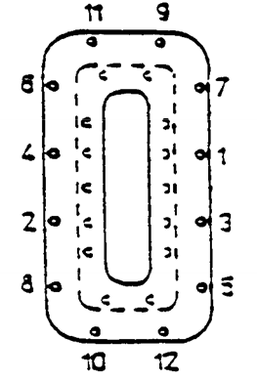  - Add the C75 Waveguide cooling blocks with indium to each of the Waveguide extensions. Torque to 70 in/lbs. See below.  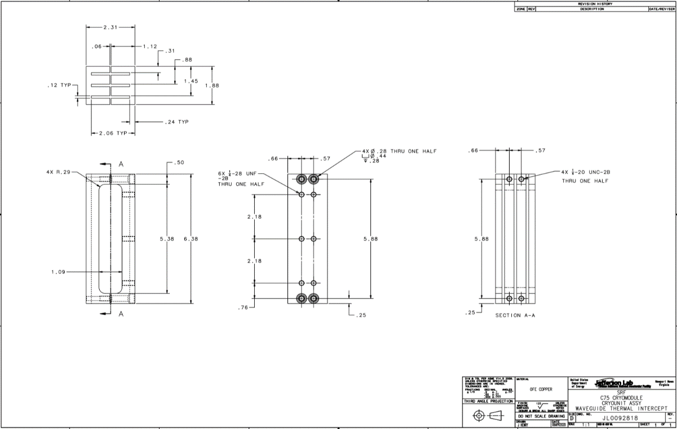  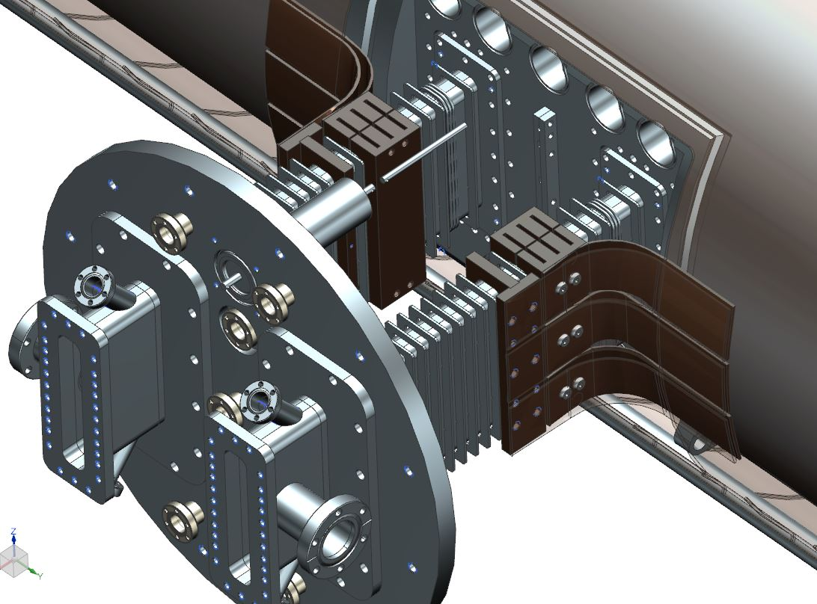  - Cover all open flanges, pump out ports and waveguide inner flanges with clean aluminum foil. | [[ASSYTech]] <<SRF>>  [[ASSYDate]] <<TIMESTAMP>>  [[ElectricalTech]] <<SRF>>  [[ASSYComment]] <<COMMENT>>
8 | Clean the cavity pair flanges. Install four (4) guide pins in cavity pair.  Make an entries in the Magnetic Hygiene “Activities Log Book” as components are added. | [[CLEANTech]] <<SRF>>  [[CLEANDate]] <<TIMESTAMP>>  [[CLEANComment]] <<COMMENT>>
9 | Attach the waveguide support fixture to the vacuum vessel top hat flange. | [[SupportTech]] <<SRF>>  [[STComment]] <<COMMENT>>
10 | Install the waveguide assembly onto the cavity pair, utilizing the guide pins for alignment.  Bolt the waveguide to cavity pair by installing 4 belleville spring washers (Item 20)  and 1 socket head cap screw (SHCS) (Item 21) through the waveguide flange and  into the cavity pair flanges. Belleville washers should be stacked parallel, four per  bolt as shown below. | [[WGTech]] <<SRF>>  [[WGDate]] <<TIMESTAMP>>  [[WGComment]] <<COMMENT>>
11 | Remove the four (4) guide pins and install the remaining hardware. Snug bolts in the  pattern shown then torque bolts to 30 in./lb., 50 in./lb., 70 in./lbs. following the pattern  shown above. | [[TorqueTech]] <<SRF>>  [[TTDate]] <<TIMESTAMP>>  [[TTComment]] <<COMMENT>>
12 | Install the waveguide leak-check manifold. Leak-check all connections on waveguide  assembly as per Specification #11141S0033. | [[LCTech]] <<SRF>>  [[LCDate]] <<TIMESTAMP>>  [[LCComment]] <<COMMENT>>  [[LCUpload]] <<FILEUPLOAD>>
13 | Retorque all the waveguide indium seals to 70 in/lbs.  ***Note-All indium seals joints require a minimum of 3 torque sequences each at least 8 hours apart.*** | [[RTTech]] <<SRF>>  [[RTDate]] <<TIMESTAMP>>
14 | Bolt the copper intercept straps from the 50 K shield to the intercept blocks on the  waveguides, torque to 40 in/lbs, as per drawing 11141-E-0007. | [[StrapTech]] <<SRF>>  [[StrapDate]] <<TIMESTAMP>>  [[StrapComment]] <<COMMENT>>
15 | Connect the helical couplings (Item 29) to the telescopic shafts (Item 31) and to the rotary  feedthroughs on the feedthrough plate with roll pins (Item 34) engaging the telescopic  socket (Item 14) on the helium vessel, as per drawing 11140-C-0031. Ensure that  linkages rotate freely. | [[CouplingTech]] <<SRF>>  [[CouplingDate]] <<TIMESTAMP>>  [[CouplingComment]] <<COMMENT>>
16 | Connect the coaxial cables onto the "SMA" type connectors on the He vessel. Connect  the opposite end to the "N" type connectors on the feedthrough plate, as per drawing  11141-D-0052. Make sure the rubber insert in the coaxial cable is removed. Have an  electrical technician perform T.D.R. test. | [[CAElectricalTech]] <<SRF>>  [[CADate]] <<TIMESTAMP>>  [[CAComment]] <<COMMENT>>  [[CAUpload]] <<FILEUPLOAD>>
17 | Connect the wiring harness and feedthrus from the He vessel to the feedthrough plate as  Per drawing,11141-D-0052. Install the copper instrumentation strap onto the coaxial  cables and the wiring harness. Do not pinch the wires, perform an electrical check on all  wiring. **Retain the plugs in sockets with Kapton tape.** | [[WHElectricalTech]] <<SRF>>  [[WHDate]] <<TIMESTAMP>>  [[WHComment]] <<COMMENT>>  [[WHUpload]] <<FILEUPLOAD>>
18 | Install the waveguide MLI, G10, and Mu metal. As per 11141-C-0076, 11141-D-0075. | [[WGMTech]] <<SRF>>  [[WGMDate]] <<TIMESTAMP>>  [[WGMComment]] <<COMMENT>>
19 | Leak-check the top hat. | [[WGLCTech]] <<SRF>>  [[WGLCDate]] <<TIMESTAMP>>  [[WGLCComment]] <<COMMENT>>  [[WGLCUpload]] <<FILEUPLOAD>>
20 | Perform the final wiring check. | [[FinalElectricalTech]] <<SRF>>  [[FinalDate]] <<TIMESTAMP>>  [[FinalComment]] <<COMMENT>>  [[FinalUpload]] <<FILEUPLOAD>>
21 | Install the Tophat. | [[THTech]] <<SRF>>  [[THDate]] <<TIMESTAMP>>  [[THComment]] <<COMMENT>>
22 | Install the NEG manifold assemblies and leak check.  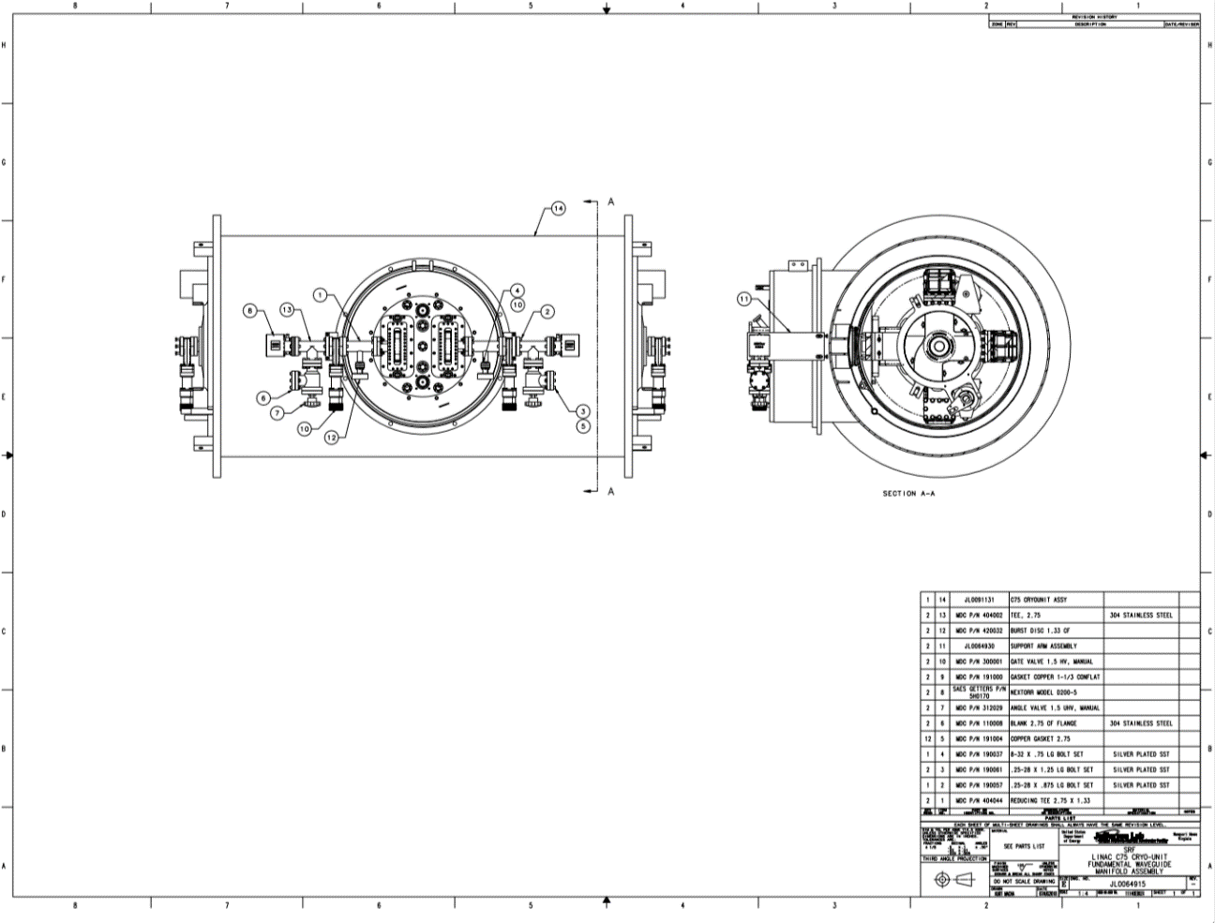 | [[NEGTech]] <<SRF>>  [[NEGDate]] <<TIMESTAMP>>  [[NEGComment]] <<COMMENT>>  [[NEGLCUpload]] <<FILEUPLOAD>>
23 | When pressure in the manifold is at 1 x 10-6 torr, activate the NEG pump, then start the ion pump.  Follow the attached Procedure. CP-C75-CM-EVAC-NEG-R1 | [[ACTTech]] <<SRF>>  [[ACTDate]] <<TIMESTAMP>>  [[ACTUpload]] <<FILEUPLOAD>>
24 | Upload any Magnetic Hygiene notes or Activity Log information if required. | [[MagHygTech]] <<SRFCMP>>  [[MHDate]] <<TIMESTAMP>>  [[MHComment]] <<COMMENT>>  [[MHUpload]] <<FILEUPLOAD>>
25 | ENSURE THAT ALL STEPS HAVE BEEN COMPLETED.  READY FOR SHIPMENT TO CRYOMODULE AREA. | [[EnsureTech]] <<SRF>>  [[EnsureDate]] <<TIMESTAMP>>  [[EnsureComment]] <<COMMENT>>
26 | Hold-point for supervisor's inspection | [[Supervisor]] <<SRF>>  [[Date]] <<TIMESTAMP>>  [[Comment]] <<COMMENT>>

